
Islamic University of Technology, Bangladesh (IUT)

Project CSE-4271

Title : Mini OS
Course : CSE-4271
Course Teacher : Tanjila Alam Sathi, Lecturer, CSE

- Submited by
Name : Omar Faruk
ID : 200021118
Dept : EEE
Section : A
Session : 2020-2021
Sub. Date : 28/04/2022

Project link: Github
How to build & run

File structure :
📁 Mini-OS
|
|---📁 sys_doc
| |
| |--- calculator_info.txt
| |--- developer_info.txt
| |--- excel_info.txt
| |--- help.txt
| |--- sys_info.txt
| |--- word_info.txt
| |--- software.c
| ---- software_reg.c
|
|
|---📁 tic_tac_toe
| |
| |--- tic_tac_toe_info.txt
| |--- tic_tac_toe.c
| ---- tic_tac_toe_reg.c
|
---- 200021118_Mini OS.c

Build & run:

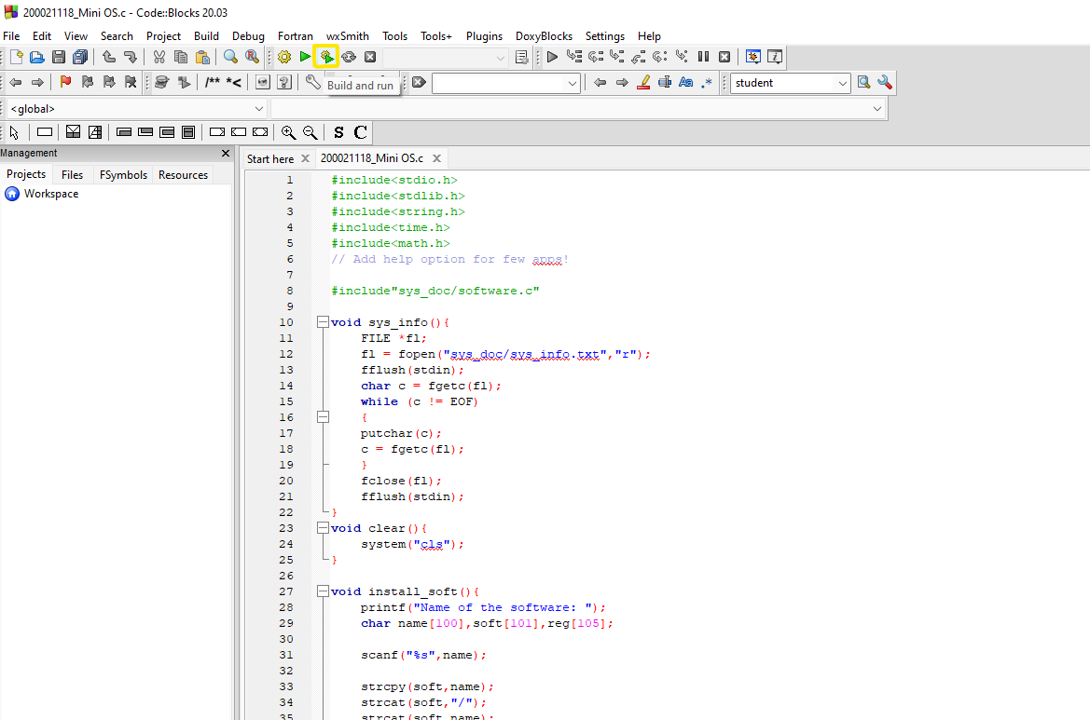
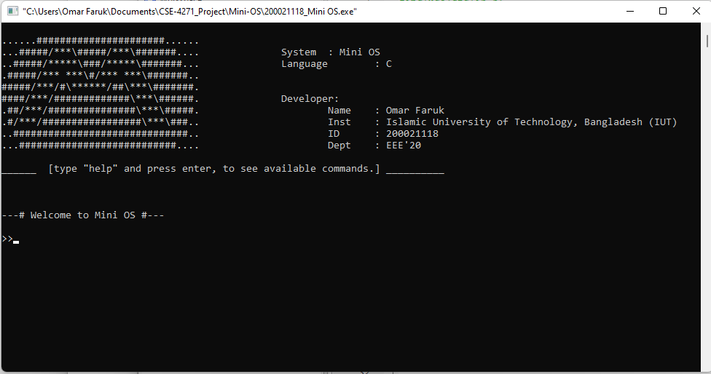
1) open the file “200021118_Mini OS.c” using Code::Blocks software.
2) Then build and run the program.
About Mini OS

- Mini OS is program based on C , that simulates an operating system.
- It’s interface is similar to Terminal Based Linux Operating Systems.
- This program takes string input as commands.
- Softwares for Mini OS is used as user defined functions , which are in software.c (sys_doc/software.c) file.
- Input commands are compared with predefined conditions . If the condition is fulfilled then if’s corresponding function is called. These conditions are in software_reg.c (sys_doc/software_reg.c) file.
- “software.c” & “software_reg.c” files are included using pre-processor of c programming.
- File management has be used to write and read files. Various designs and datas has be taken from files. Some applications of Mini OS are based on File management (like sysinfo , word , excel , install) .
- Tic Tac Toe game is created using 2 dimensional array and boolean conditions (if , else if , else) .
- Loops (for , while , do while) has been used in this project various times to repeat the program activity and to keep the program on until some kind of ending command comes.
- Pointers are also used in some places.

Commands

- help
- sysinfo
- clean/clear/cls
- exit
- calculator
- time
- word
- excel
- tic_tac_toe
- install
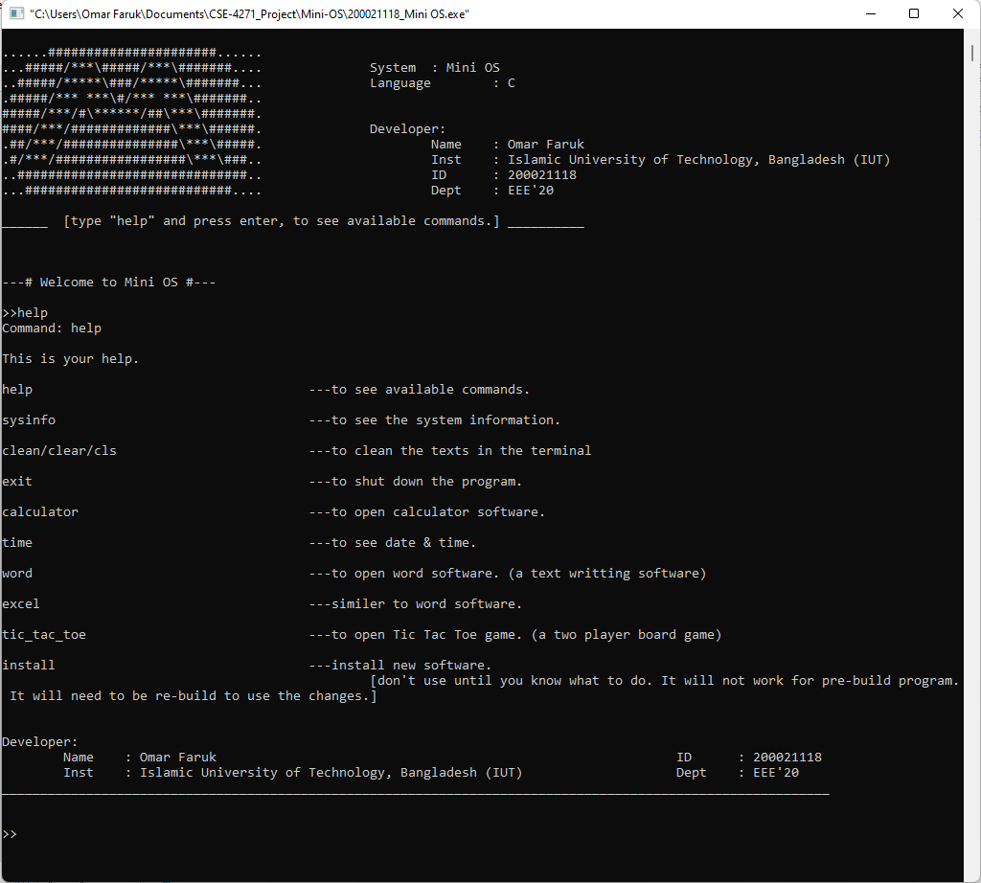
- help
*This command will will show available commands.
1) Type “help” then press enter.
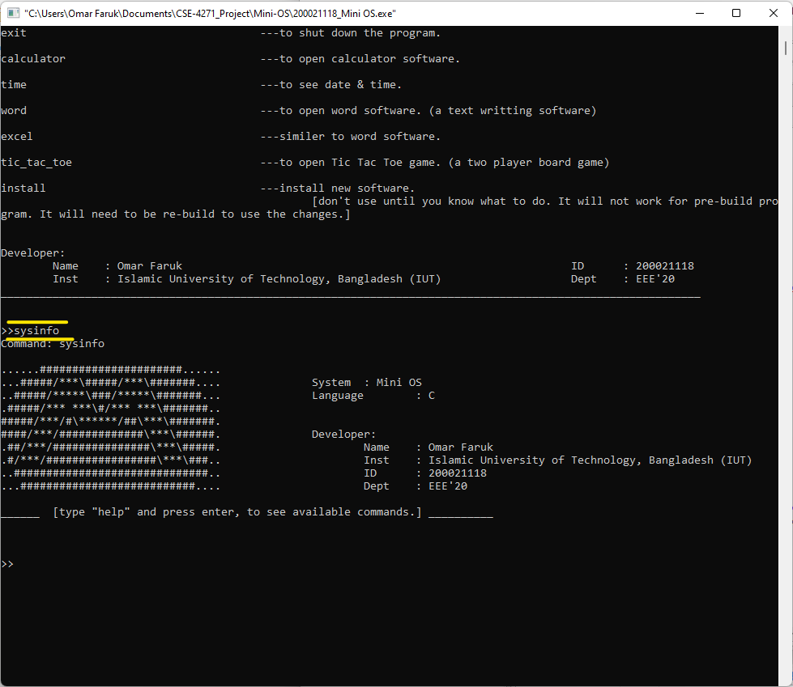
- sysinfo
*This command will show few information about Mini OS.
1) type “sysinfo” then press enter.
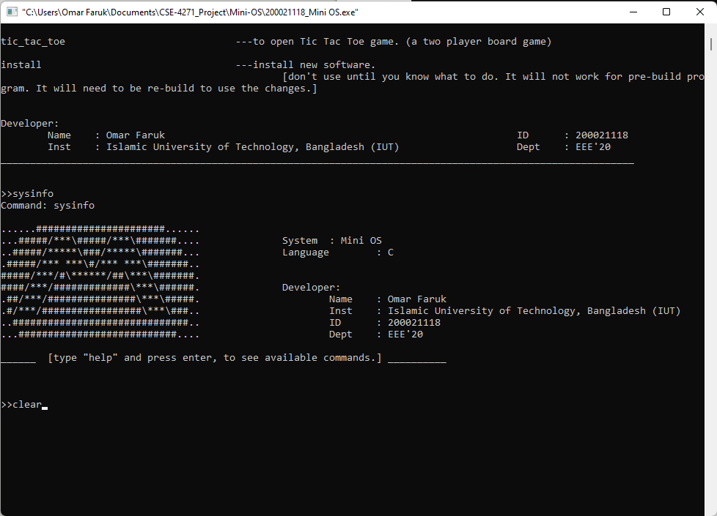
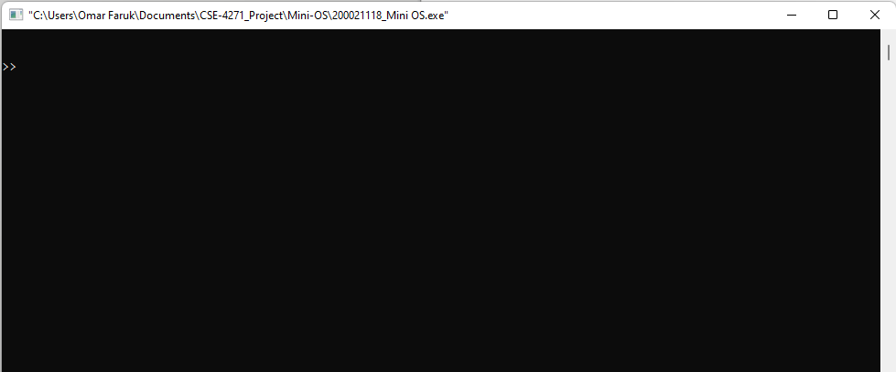
- clean/clear/cls
*This command will clear the terminal.
*after the command
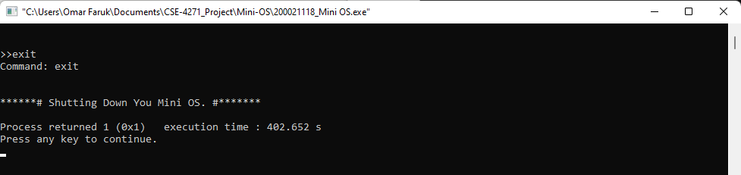
- exit
*This command will shut down the Mini OS.
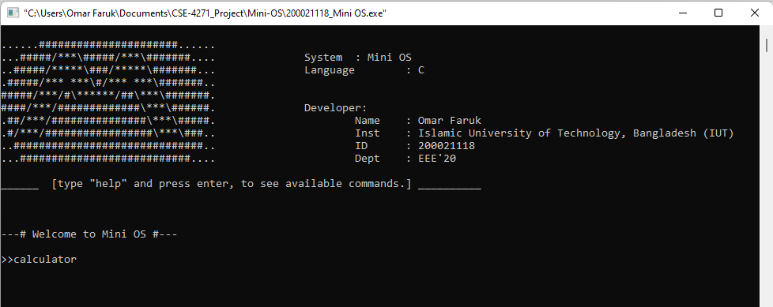
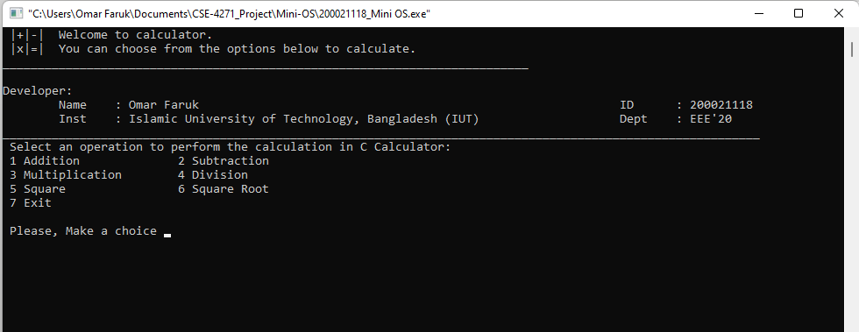
- calculator
*This command will open the Calculator software.
1) type “calculator” then press enter.
*After command
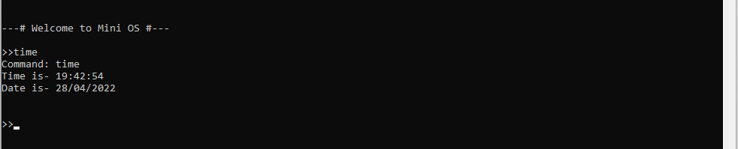
- time
*This command will show date & time.
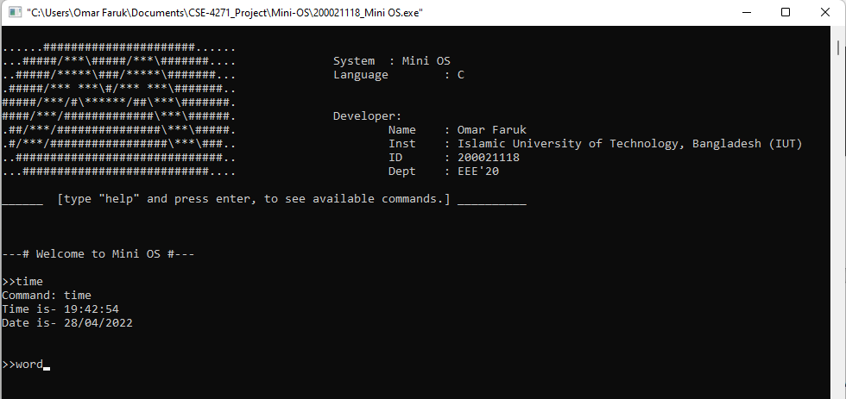
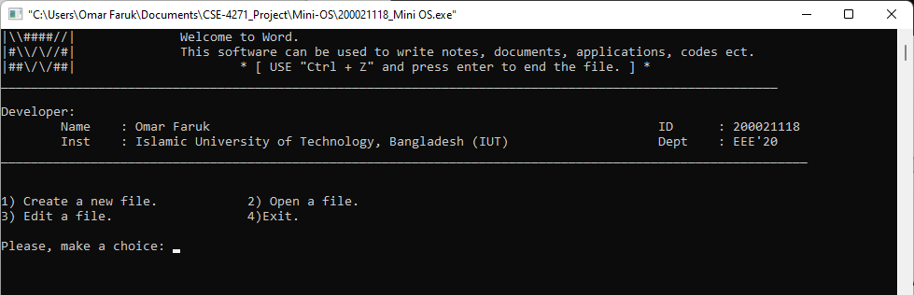
- word
*This command will open the word software. This is a text writing software. Any text file (like *.txt , *.c , *.cpp , *.html , etc.) can be written with this.
- excel
*similar to word software.
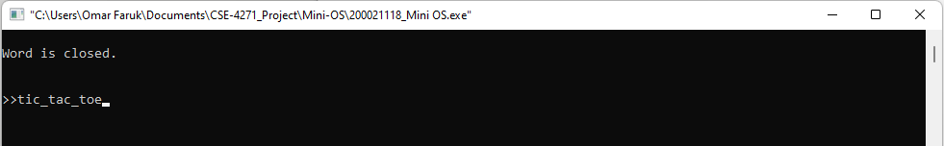
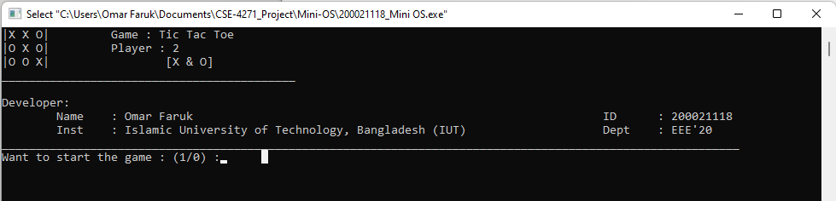
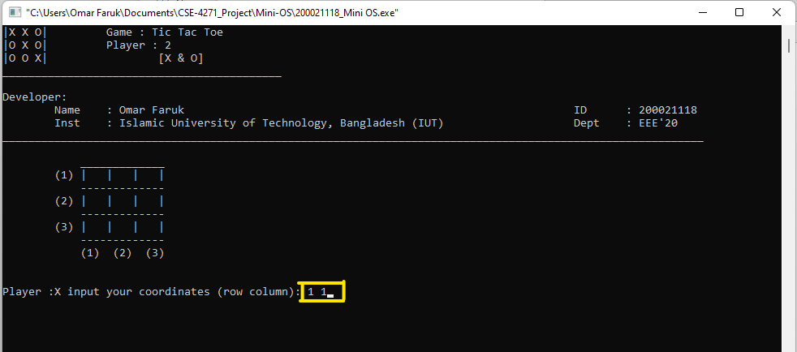
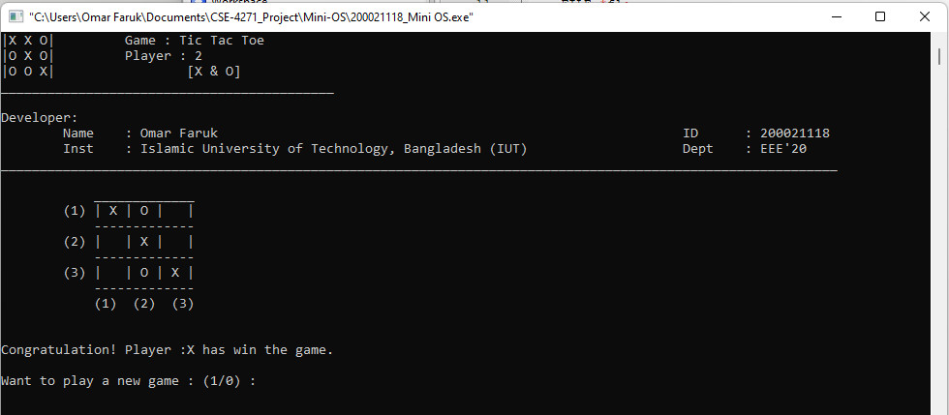
- tic_tac_toe
*This command will open Tic Tac Toe game installed into Mini OS.
- install

