Create a Mobile App that helps you to find the nearest restaurant and coffee with Watson Assistant and Google Places API:

Description:

In this developer experience, we will create an iOS mobile app using Swift, Watson Assistant and Google Places API. The Watson Assistant service will be used to be a Chabot. The Google Places API will use to locate the nearby restaurant and coffee.

When the reader has completed this experience, they will understand how to:

* Create a Chabot mobile app that can use to find the nearby restaurant and coffee.
* Use Google Place API to locate the nearby restaurant and coffee.

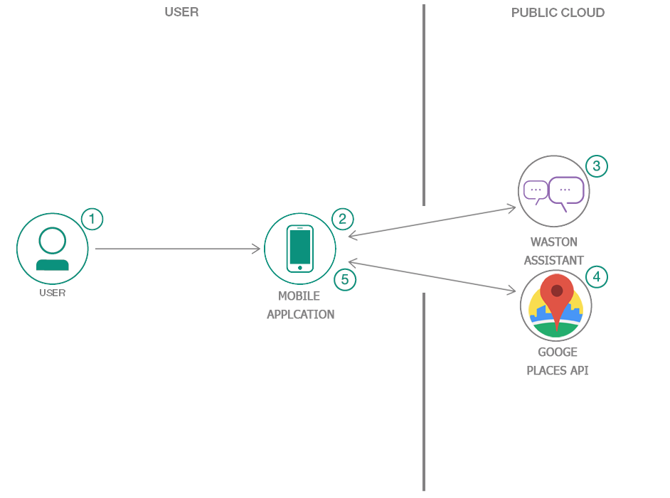

**Flow**

1. The user opens the iOS application then click start chat
2. User type “Restaurant or Coffee” via the mobile app.
3. Watson Assistant identified the word then active the action method to find nearby.
4. Google Places API search nearby restaurant or coffee.
5. Return the nearby result.