**Day 3 CSS Assignments**

1. 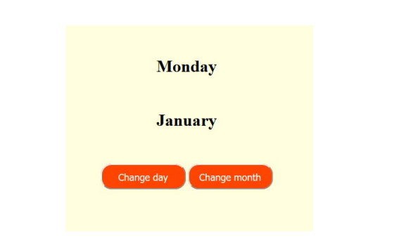Make the following design using HTML and CSS .

* When the mouse hover the buttons the background color of the button becomes white and the color become orange.

1. **Create a page named aboutme.html that describes you. On your page, include all of the following information:**

**a** - Your name

**b**- A description of yourself in two sentences or less. Emphasize the most important word(s) by

putting them in bold.

**c**- A list of Courses you are taking right now at ITI.

**d**- Your 3 favorite movies, books, or TV shows, in order. Make at least one link to an interesting

site about that tv show/movie/book.

**e-** Two images, one that represents you when you're happy and the other to represent you when

you're sad.

**f**- Something interesting about one or more of your neighbors.

**The page will look like the following**

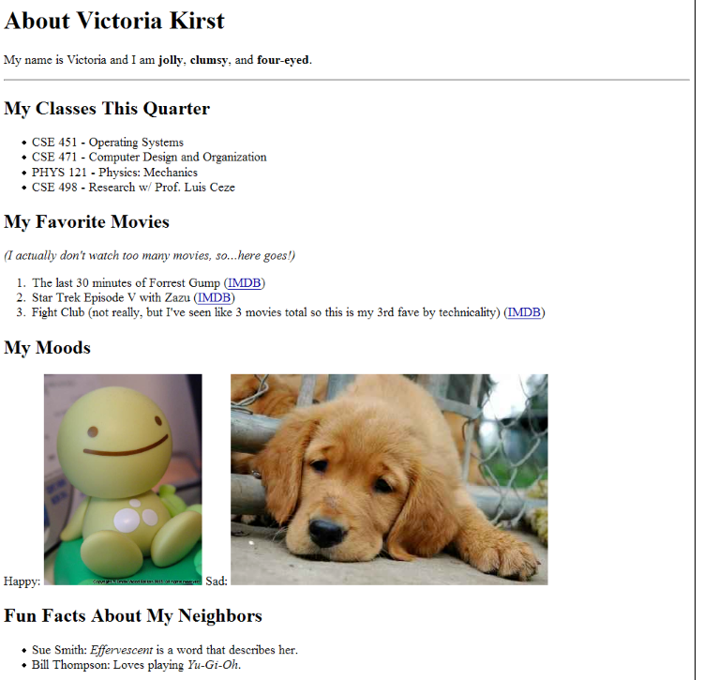

3- Create a stylesheet named aboutme-style.css to improve the appearance of your About Me page. Your stylesheet should do the following without any modification to your HTML code:

* Change the color of at least two elements
* Change the font properties of at least two elements (such as family, size, weight, style). Here are some standard fonts you may want to use:  
  Arial, Arial Black, Verdana, Trebuchet MS, Georgia, Tahoma, Courier New, Times New Roman
* Change at least one other thing of your choosing (such as background color, text alignment, etc.)

For example, this is TA Victoria's styled version of her page in Exercise 1 (between, but not including, the thick black lines):

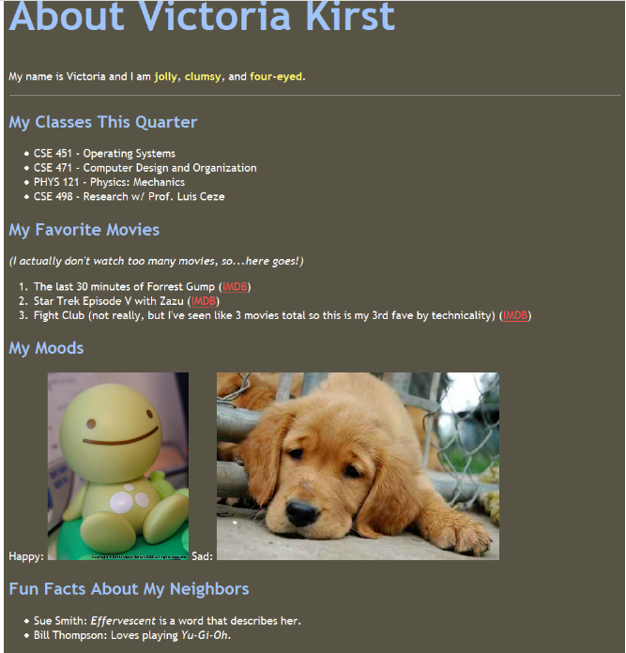

4-Design the following table

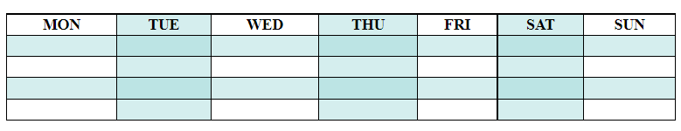

5-Design the following C.V

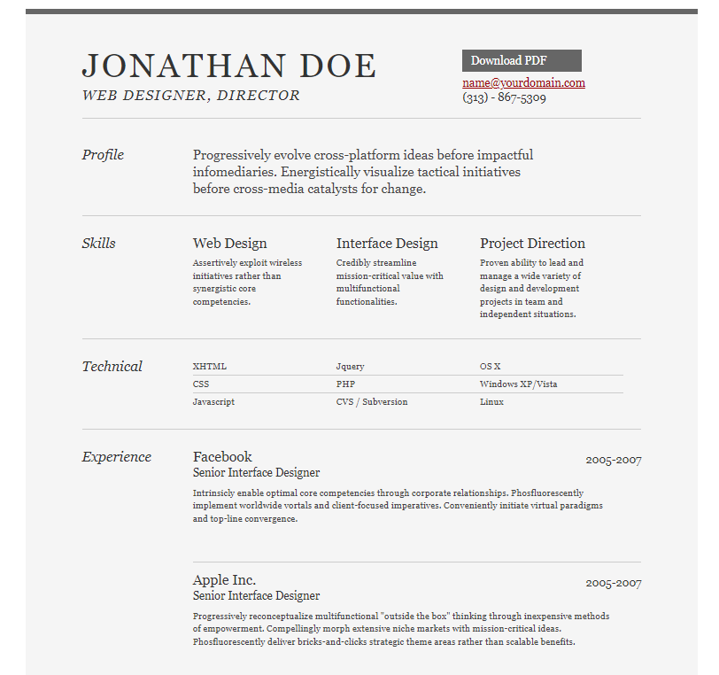

**Bonus assignments**

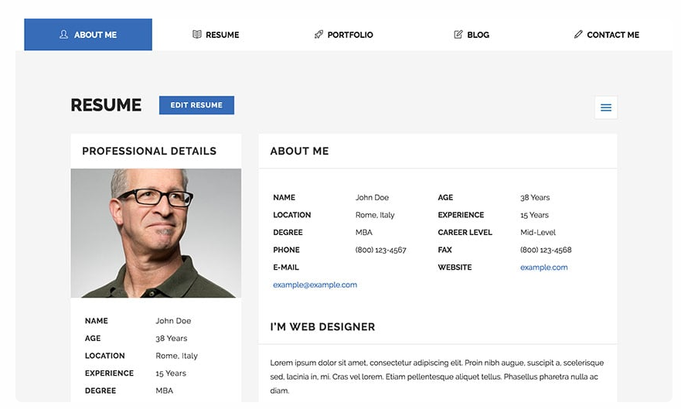 **1-Design the following CV (use font awesome library)**

**2-Design the home page of twitter website.**