Add a tags option
Add extraction Option
Add options of the categorization as we have products and projects
Change Name "Project" to "Projects/Products"
Add in the Main Menu a Delivery Note Section to have visibility of every Delivery Notes

Status of invoicing:
- Paid
- Invoiced
- Not Paid

Add action pending column to Milestones
- Pending Finance
- Pending PMs
- Pending POMs
- Closed

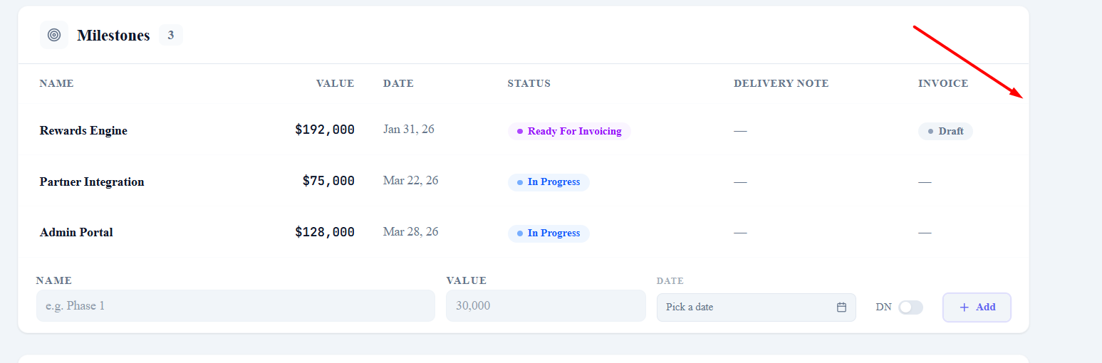

Add "%" of milestones of the

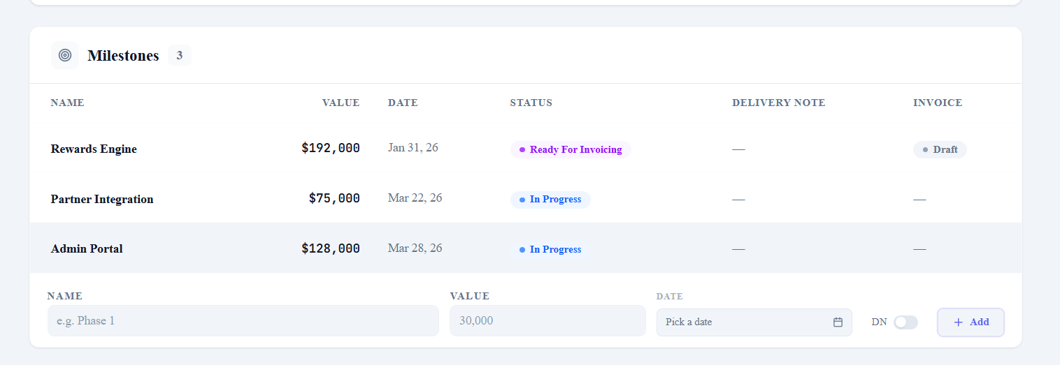

Delivery Note List:
Signed
Not Signed
Not Required

Add Follow-up here in the notes section
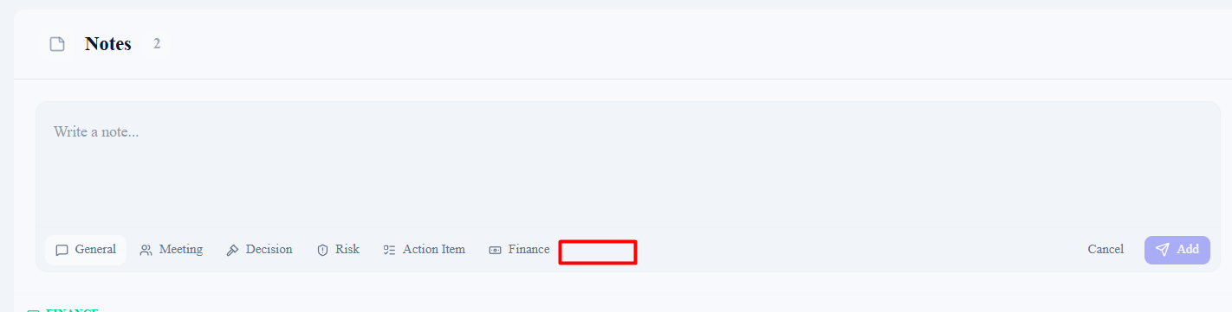

Add Delayed
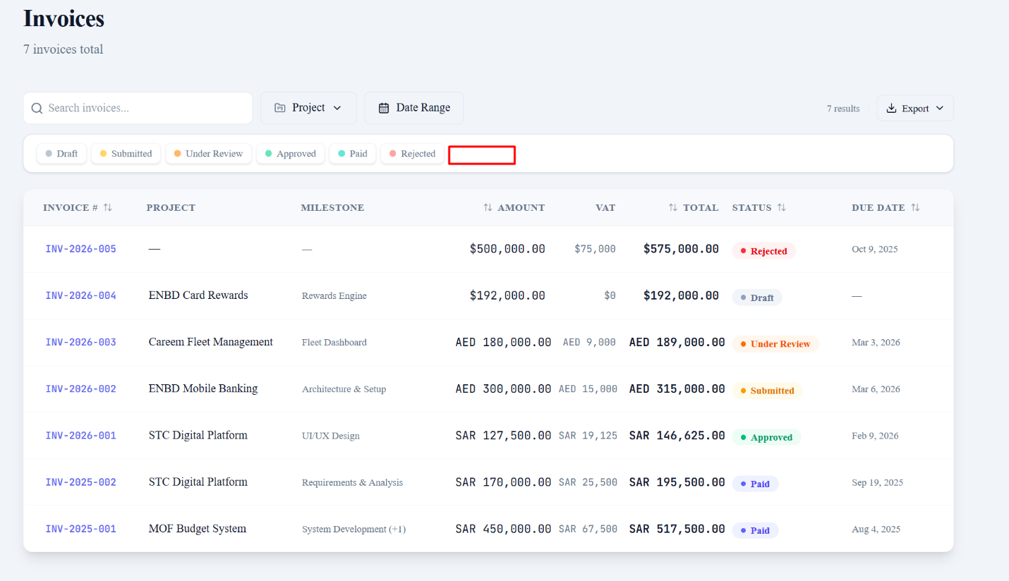

Remove
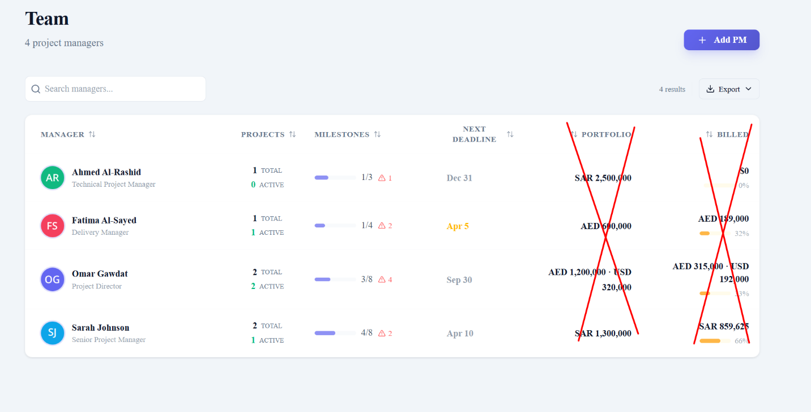

Remove as we don't need this page to have info about finances - Just the PM and his assigned projects, milestones, Delivery Notes, and notes.
