**Express Stocks Market**



CS 441 Final Project Report

By:Jade Richardson, Abisai Rodriguez, & Omar Gonzalez.

May 7th , 2018

# 

# 

# **Table of Contents**

1) **Overview**.……………………………………………………………….…**2**

Problem Statement…………………………………………………...2

Target Users…………………………………………………………....2

Expected Outcome…………………………………………………....3

2) **The Team Structure**………………………………………………….…**3**

Team Member Roles………………………….………………….…...3

Team Contact Information……………………………………….....3

Quality Assurance & Testers……………………………………......3

Technical Writer……………………………………………………...4

3) **Project Proposal**………………………………………………………....**4**

User Requirements …………………………………………….….....4

Scrum Product Backlog………..……………………………………..5

Project Objectives ……………………………………………….……5

Workflow ………………………………………………..………..…...5

Methodology ………………………………………………….……….6

Scope………………………………………………………….………...6

Vision …………………………………………………………………..6

Constraints and Challenges………………………………………...6

4) **System Design**………………………….………………………………..**7**

Software Architecture………………………………………….……7

5) **Unified Modeling Language Diagram**………………………….….**8**

Use​ ​Case​ ​Diagrams…………..……………………………...……….8

Formal Use Cases…………………………...……………….……….9-10

6) **Partial Analysis Model**………………..………………………..……..**11**

Class​ ​Case​ ​Diagram………………………………………….……….11

Sequence Diagram……………………………………..…..………...11

Testing and Analysis……………………………………..…..……12-13

7) **Implementation Milestones**………………………..…...…...….…**13-14**

8) **Sprint Meeting Logs**………………………………………………..…**14-23**

9) **Closing** …………………………………………………….………..…...**23**

10) **References** ……………………………………….……………...….....**24**

Resources…………………………….……………………..…………24

Official Links………………………………………………………….24

11) **Change History** ………………………………….……………...…...**25-26**

**Overview**

Express Market will be a personal investment portfolio for anyone who would like to invest. This (currently) web-based application will notify you when it's time to invest and what you should invest in. The core functionality of this product will be its ability to scan news articles and press releases of companies that you select to invest in. The application will gather all this information and understand, based on our text parsing algorithms, whether to sell or buy the stock in question. We would also like it to understand how much money is appropriate to invest given a user's current finances.

**Problem Statement:**

Time, confusion, and risk are challenges that the average stock market trader will face. We aim to expand the market for both the beginning traders and the veterans. We want to simplify this process which in turn will make the market easier for people to take advantage of. Time is the universal resource that has us all wishing we had more. Having to read and analyze tens of articles to predict the market is painful and a huge time consumer. With the help of our processors and Express algorithms, we could have the needed information to make the right investment decision.

**Target Users:**

The target users for Express Market are primarily for Financial intermediaries, for those who seek to invest in the stock market and for those who already have stocks. Express Market is an excellent solution for investors who are looking for an easier way to help them to make decisions and to help investors save valuable time. Many investors dedicate an excessive amount of time looking through articles observing and searching for their stocks or stocks they wish to buy or sell. Express Market is the solution to help investors do the thorough searching for them, and offer investors advice about their stocks and stocks they are interested in to buy or sell in the future.

**Expected Outcome:**

Our expected outcome of Express Market will include the following:

· Full functional website.

· Database to check authenticity and to allow users to login securely.

· Allow users to build a personal stock portfolio.

· Stock sale/buy predictor.

**The Team Structure**

**Team Member Roles:**

Abisai Rodriguez - Database Developer

Jade Richardson - Web/Front End Developer

Omar Gonzalez - Web/Front End Developer

**Team Contact Information:**

|  |  |
| --- | --- |
| **Name** | **Email** |
| Abisai Rodriguez | abisai.rodriguez13@gmail.com |
| Jade Richardson | richa103@cougars.csusm.edu |
| Omar Gonzalez | omargb22@gmail.com |
|  |  |

**Quality Assurance & Testers:**

All team members worked collectively together to test and debug all facets of the project.

**Technical Writer:**

All team members worked collectively together to write and record for each part of the project.

**Project Proposal**

**User Requirements:**

The user requirements necessary to be able to use the product is a precursory understanding of how to use a website and an interest in investing money. The most straightforward mechanism for an end user to be able to use the integrated tools within the website to successfully predict the price of a particular stock is for the user to enter the stock symbol name from a drop-down menu accessible from the homepage. From there, the user will enter the time frame of the stock for which they would preferably like to predict the price of the stock. Be it three days from now or three months from now. After entering the information into the website, the user will have the option to see a projected graph of the price of the stock they chose over the timeline they picked. Other indicators for the stock such as P/E ratio will be displayed, along with a rudimentary risk factor for that certainty of the predicted stock price to be correct. Apart, from the simplicity for the user to be able to navigate the site, a similar objective in simplicity will be met by explicit descriptions of stocks and the risks included in predicting stock prices. In addition, to the ability for the user to predict the price of stocks; from the homepage, users will see a long-term projection of the Dow Jones, S&P 500, and NASDAQ, incrementally by one day, up to three months. A drop down side menu on the homepage will be present, to further customize the stocks they wish to see by industry. After picking an industry from the side menu, a collection of different stock symbols within that industry will be generated for which the user can select and see future projections. The generated stocks within the industry can be sorted by lowest/ highest risk factor and most promising return over three days or a three months prediction.

**Scrum Product Backlog:**

|  |  |  |  |  |
| --- | --- | --- | --- | --- |
| **Scrum Product Backlog** | **Priority** | **Category** | **Accomplished** | **Item ID** |
| As a user, I want easy to use navigation to find stock predictions | 2 | Front-end Website | Yes | 1 |
| As a user, I want to login using  Username and email. | 1 | Full stack dev | Yes | 2 |
| As a system administrator, I want graphs to update on the site in real time | 3 | Front-end Website | Yes | 3 |
| As a backend Developer, I want the data parsing to automatically pull from different articles | 4 | Back-end Development | Yes | 4 |

**Project Objectives:**

Our Objective for this project is to create an effective data parsing methods, that would allow us to make better predictions of the stock market and to help users make decisions.

**Workflow:**

All meetings are documentation of work put into to this project are compiled and referred to on our github commit messages and comment and also on your chat platform Slack. Some problems we have already begun to see is the factor of time. We all have very busy schedules and are not provided class time to collaborate with our groups. Another is fitting all the “puzzle” pieces together, for example interacts with our web server, the client, and other servers that we need to interact with is a new challenge for all of us. We have not ever done any serious web development work.

**Methodology:**

We will be using a Waterfall Model to complete our project within the given timeframe. To start, we will gather requirements to know how the project will function. Next, Analysis is required to generate the logic and business model that will be needed for the project. Once understanding the requirements and logic for our project, we can finally start designing our model. Coding is our next step, implementing all of the functions, logic, and design of the project. After coding, we will beta test our code to see if any bugs come up. If needed we will review our system and fix any bugs we find along the way. Finally, we will deploy our project and will work on updates to keep the project up and running efficiently.

**Scope:**

For this group assignment, we will focus exclusively on creating and implementing our database and website. Our unique skill sets will help us determine the specifications and requirements to be used for this projects completeness. Throughout the process of building this project, we will gain a better understanding of what needs to be improved, whether it be user friendliness or functionality. By the end of this project, we will have an up and running stock market website predictor with a fully functioning database behind it.

**Vision:**

The team's vision for this project is to create a reliable, secure, well working website and database that will allow us to pitch it to investors and hopefully be a financially stable company one day

**Constraints and Challenges:**

Somethings that we might run into are accuracy, problems with relying on other news outlets for data, and integration with those websites. We’re aiming to have our programs receive ASCII characters as input. We must sift through what is essential and what can be dismissed, in both the news sources and the articles themselves. Another real-world constraint is our schedules. This project will consume a significant amount of our time.

We’re not the only ones out there. We’re going to need to be different and better than the competition.

**System Design**

**Software Architecture:**

Our software architecture for this project would be web base. We will create a website for the users to access. And we will create a database to allow the users to log in to their profile and log out safely.

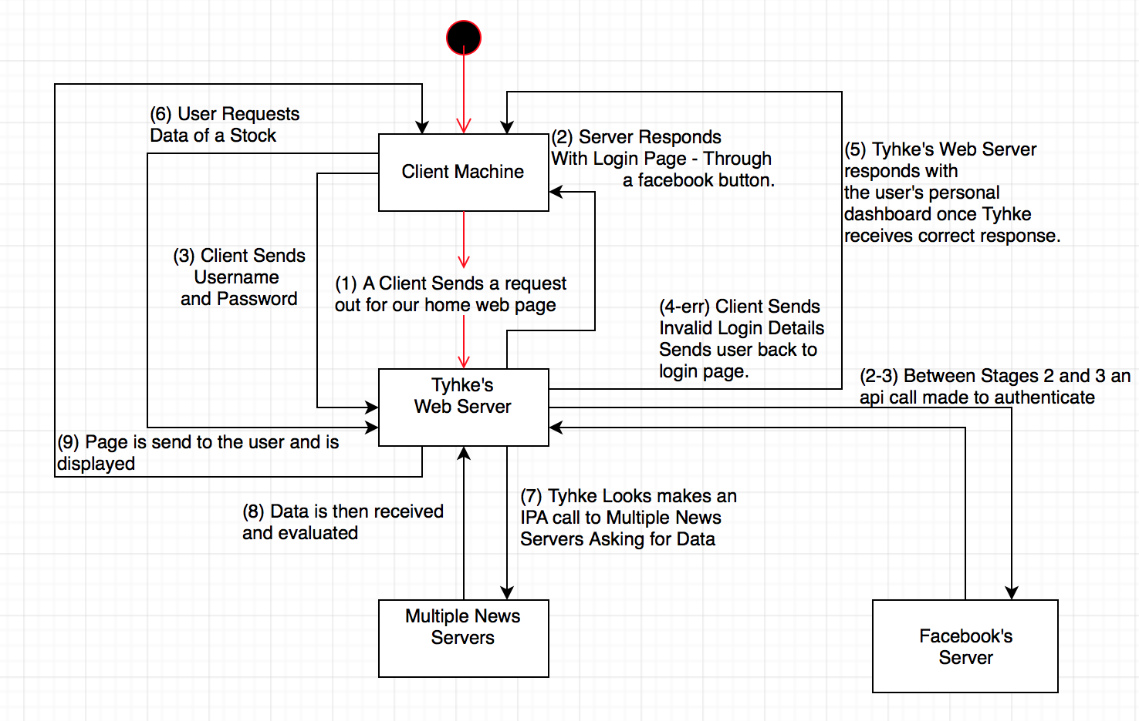

As of right now the main languages that will interact with each other will be Javascript for the implementation of the web server and interactions between other servers. HTML for user’s display. Node Javascript to talk to Taffy Database.

**Unified Modeling Language Diagram**

**Use Case Diagrams:**

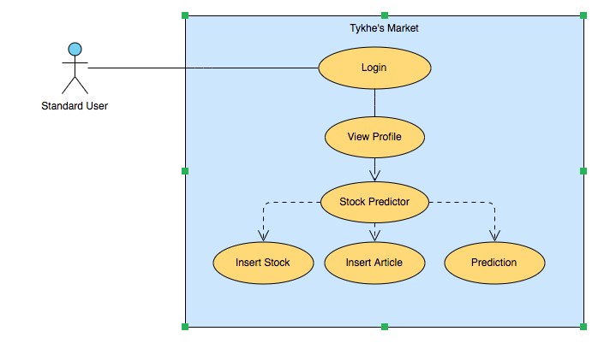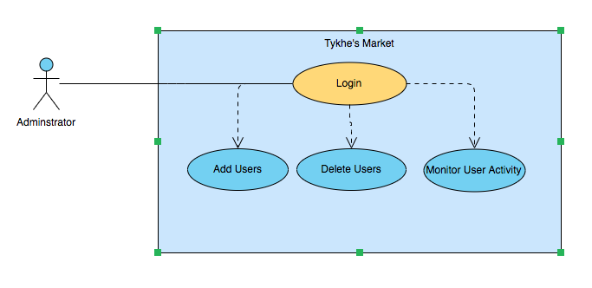

**Formal Use Cases:**

**Standard User or Administrative User**

**Name:** Login

**Priority:** High

**Entry Condition:** User has access to Express Market through web browser

**Exit Condition:** User successfully logs in

**Flow of Events:**

1. User has access to Express Market through web browser
2. User logs in using Username and Password
3. Validate login information, server checks with database
4. User gains access to Express Market through web server
5. Express Market displays user’s profile

**Standard User**

**Name:** Stock Predictor

**Priority:** High

**Entry Condition:** User searches stock

**Exit Condition:** User receives information about stock

**Flow of Events:**

1. User has access to profile
2. User enters stock and article to search
3. Web-Server runs algorithm for the stock entered
4. User receives information about the stock searched

**Administrative User**

**Name:** Add User

**Priority:** High

**Entry Condition:** Enter User in Database

**Exit Condition:** User Saved in Database

**Flow of Events:**

1. Administrator adds user with username and password
2. Database checks if user exists, if user is new then save
3. New user is then added to user

**Administrative User**

**Name:** Delete User

**Priority:** High

**Entry Condition:** Delete User in Database

**Exit Condition:** User removed from Database

**Flow of Events:**

1. Administrator removes user with username
2. Database checks if user exists, if user exists then removes
3. User is then removed from Database

**Partial Analysis Model**

**Class​ ​Case​ ​Diagram:**

Express Market does not use an Object Oriented Programming paradigm. Therefore, we do not have any classes in our project. The base of Express Market is our web-server that interacts with our Taffy Database.

We have instead used a Model-View-Controller structure design. Where our web-server and database act as our Model. The Model is responsible for managing the data of the application. It responds to the request from the view and it also responds to instructions from the controller to update itself. The view is all of our various HTML templates that help display the data in a specific format to the user. The javascript functions work as our controller helping to respond to the user input and perform interactions on the data model objects.

**Sequence​ ​Diagram:**

**Diagram:***Sequence Diagram of Logging in*

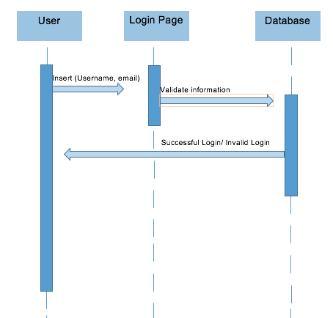

**Testing and Analysis**

|  |  |  |  |  |
| --- | --- | --- | --- | --- |
| **Functions for Test:** User Login | | | | |
| **Applicable Users:** Test cases for Administrator and Standard User | | | | |
| **ID #** | **Test Cases** | **Input Data** | **Result** | **Satisfied** |
| 1 | Secure Login | -Username  -Password | User and Administrator successfully login | Yes |
| 2 | Invalid Login | -Username  -Password | User is unsuccessful in logging in | Yes |

|  |  |  |  |  |
| --- | --- | --- | --- | --- |
| **Functions for Test:** Add, Delete Users | | | | |
| **Applicable Users:** Test cases for Administrator | | | | |
| **ID #** | **Test Cases** | **Input Data** | **Result** | **Satisfied** |
| 3 | Add User | -Username  -Password | Administrator successfully adds User | Yes |
| 4 | Delete User | -Username | Administrator successfully deleted User | Yes |

|  |  |  |  |  |
| --- | --- | --- | --- | --- |
| **Functions for Test:** Stock Predictions | | | | |
| **Applicable Users:** Test cases for Standard User | | | | |
| **ID #** | **Test Cases** | **Input Data** | **Result** | **Satisfied** |
| 5 | Stock Predictor | -Stock  -Article | Express Market successfully predicts the stock searched | Yes |

**Implementation Milestones**

**Milestone 1 - Design User Interface**

* Determine Web Page Navigation

**Milestone 2 - Database Design**

* Determined to use Taffy DB
* Determined User Attributes

**Milestone 3 - Create System Architecture**

* Create Web Server using Node JS
* Create Database using Taffydb

**Milestone 4 - Implement Initial Web Pages**

* Created initial web pages with HTML
* Styled HTML with CSS
* Integrated Express
* Integrated Bootstrap

**Milestone 5 - Implement Database**

* Added Database to the Web Server

**Milestone 6 - Connect Front-End with Back-End**

* Connected the HTML Pages with the Web Server

**Milestone 7 - Create Algorithm**

* JS code that scans article and predicts to buy/sell stock

**Milestone 8 - Retrieve and Display Data**

* Retrieve data from article and display information to user on screen

**Milestone 9 - Enhance Website Functionality**

* Inner JS
* Integrated Ajax

**Sprint Meeting Logs**

|  |  |  |
| --- | --- | --- |
| **Week 3 Meeting**  February 5th, 3:45pm-4:45pm | | |
| **Team Members** | **Roles** | **Attended Meeting** |
| **Abisai Rodriguez** | **Database Developer** | **Yes** |
| **Jade Richardson** | **Front-End Developer** | **Yes** |
| **Omar Gonzalez** | **Front-End Developer** | **Yes** |

|  |  |  |
| --- | --- | --- |
| **Week 3 Agenda** | | |
| **Agenda Item** | **Completed** | **Summary of Accomplishments** |
| Determine Project Scope | Yes | Created a google doc to define scope of project |
| Define Preliminary Resources | Yes | Listed various resources to use |
| Begin Project Proposal | No | Initial outline of project |

|  |  |  |
| --- | --- | --- |
| **Week 4 Meeting**  February 12th, 3:45pm-4:45pm | | |
| **Team Members** | **Roles** | **Attended Meeting** |
| **Abisai Rodriguez** | **Database Developer** | **Yes** |
| **Jade Richardson** | **Front-End Developer** | **Yes** |
| **Omar Gonzalez** | **Front-End Developer** | **Yes** |

|  |  |  |
| --- | --- | --- |
| **Week 4 Agenda** | | |
| **Agenda Item** | **Completed** | **Summary of Accomplishments** |
| Review Project Proposal Requirements | Yes | Summary of project requirements |
| Final Project Proposal | Yes | Finished project proposal |
| Practice Project Proposal | Yes | Practiced and went over finished project proposal |

|  |  |  |
| --- | --- | --- |
| **Week 5 Meeting**  February 19th, 3:45pm-4:45pm | | |
| **Team Members** | **Roles** | **Attended Meeting** |
| **Abisai Rodriguez** | **Database Developer** | **Yes** |
| **Jade Richardson** | **Front-End Developer** | **Yes** |
| **Omar Gonzalez** | **Front-End Developer** | **Yes** |

|  |  |  |
| --- | --- | --- |
| **Week 5 Agenda** | | |
| **Agenda Item** | **Completed** | **Summary of Accomplishments** |
| Gather information for database | Yes | Gathered and uploaded info to google docs |
| Start user interface design | Yes | Made an outline of user interface |
| Review project requirements | Yes | Updated requirements |

|  |  |  |
| --- | --- | --- |
| **Week 6 Meeting**  February 26th, 3:45pm-4:45pm | | |
| **Team Members** | **Roles** | **Attended Meeting** |
| **Abisai Rodriguez** | **Database Developer** | **Yes** |
| **Jade Richardson** | **Front-End Developer** | **Yes** |
| **Omar Gonzalez** | **Front-End Developer** | **Yes** |

|  |  |  |
| --- | --- | --- |
| **Week 6 Agenda** | | |
| **Agenda Item** | **Completed** | **Summary of Accomplishments** |
| Establish Team Roles | Yes | Every member was designated a role |
| Review Database Design | Yes | Updated design of Database |

|  |  |  |
| --- | --- | --- |
| **Week 7 Meeting**  March 5th, 3:45pm-4:45pm | | |
| **Team Members** | **Roles** | **Attended Meeting** |
| **Abisai Rodriguez** | **Database Developer** | **Yes** |
| **Jade Richardson** | **Front-End Developer** | **Yes** |
| **Omar Gonzalez** | **Front-End Developer** | **Yes** |

|  |  |  |
| --- | --- | --- |
| **Week 7 Agenda** | | |
| **Agenda Item** | **Completed** | **Summary of Accomplishments** |
| Meeting Summary | Yes | Review project goals |
| Create Use Case Diagram | No | Talked about use case diagrams |
| Report 2 | Yes | Complete sections of report |
| Sprint Meet Logs | Yes | Tracking meetings |

|  |  |  |
| --- | --- | --- |
| **Week 8 Meeting**  March 12th, 3:45pm-4:45pm | | |
| **Team Members** | **Roles** | **Attended Meeting** |
| **Abisai Rodriguez** | **Database Developer** | **Yes** |
| **Jade Richardson** | **Front-End Developer** | **Yes** |
| **Omar Gonzalez** | **Front-End Developer** | **Yes** |

|  |  |  |
| --- | --- | --- |
| **Week 8 Agenda** | | |
| **Agenda Item** | **Completed** | **Summary of Accomplishments** |
| Sprint Meet Logs | Yes | Update sprint meet logs |
| Bootstrap | Yes | Web Page Navigation |
| Finish Use Case Diagrams | Yes | User Cases |
| Update Project Plan | Yes | Review and update |

|  |  |  |
| --- | --- | --- |
| **Week 9 Meeting**  March 19th, 3:45pm-4:45pm | | |
| **Team Members** | **Roles** | **Attended Meeting** |
| **Abisai Rodriguez** | **Database Developer** | **Yes** |
| **Jade Richardson** | **Front-End Developer** | **Yes** |
| **Omar Gonzalez** | **Front-End Developer** | **Yes** |

|  |  |  |
| --- | --- | --- |
| **Week 9 Agenda** | | |
| **Agenda Item** | **Completed** | **Summary of Accomplishments** |
| Fill out week sprint meet logs | Yes | Update |
| Database Update | Yes | Update |
| Update Project Plan | Yes | Update |

|  |  |  |
| --- | --- | --- |
| **Week 10 Meeting**  March 26th, 3:45pm-4:45pm | | |
| **Team Members** | **Roles** | **Attended Meeting** |
| **Abisai Rodriguez** | **Database Developer** | **Yes** |
| **Jade Richardson** | **Front-End Developer** | **Yes** |
| **Omar Gonzalez** | **Front-End Developer** | **Yes** |

|  |  |  |
| --- | --- | --- |
| **Week 10 Agenda** | | |
| **Agenda Item** | **Completed** | **Summary of Accomplishments** |
| Fill out week sprint meet logs | Yes | Update |
| Website Pages | No | Created HTML pages |
| Meeting Summary | Yes | Review and plan for next meeting |

|  |  |  |
| --- | --- | --- |
| **Week 11 Meeting**  April 2nd, 3:45pm-4:45pm | | |
| **Team Members** | **Roles** | **Attended Meeting** |
| **Abisai Rodriguez** | **Database Developer** | **Yes** |
| **Jade Richardson** | **Front-End Developer** | **Yes** |
| **Omar Gonzalez** | **Front-End Developer** | **Yes** |

|  |  |  |
| --- | --- | --- |
| **Week 11 Agenda** | | |
| **Agenda Item** | **Completed** | **Summary of Accomplishments** |
| Fill out week sprint meet logs | Yes | Update |
| Website | No | Added CSS to format html |
| Meeting Summary | Yes | Review project, plan ahead |

|  |  |  |
| --- | --- | --- |
| **Week 12 Meeting**  April 9th, 3:45pm-4:45pm | | |
| **Team Members** | **Roles** | **Attended Meeting** |
| **Abisai Rodriguez** | **Database Developer** | **Yes** |
| **Jade Richardson** | **Front-End Developer** | **Yes** |
| **Omar Gonzalez** | **Front-End Developer** | **Yes** |

|  |  |  |
| --- | --- | --- |
| **Week 12 Agenda** | | |
| **Agenda Item** | **Completed** | **Summary of Accomplishments** |
| Fill out week sprint meet logs | Yes | Update |
| Implement Web Server | No | Check how html pages work with local web server |
| Implement Database | Yes | Add DB to web server |
| Meeting Summary | Yes | Review project and plan ahead |

|  |  |  |
| --- | --- | --- |
| **Week 13 Meeting**  April 16th, 3:45pm-4:45pm | | |
| **Team Members** | **Roles** | **Attended Meeting** |
| **Abisai Rodriguez** | **Database Developer** | **Yes** |
| **Jade Richardson** | **Front-End Developer** | **Yes** |
| **Omar Gonzalez** | **Front-End Developer** | **Yes** |

|  |  |  |
| --- | --- | --- |
| **Week 13 Agenda** | | |
| **Agenda Item** | **Completed** | **Summary of Accomplishments** |
| Fill out week sprint meet logs | Yes | Update |
| Website | No | Web Server hosts html pages and hosts the DB |
| Meeting Summary | Yes | Review project and plan ahead |

|  |  |  |
| --- | --- | --- |
| **Week 14 Meeting**  April 23rd, 3:45pm-4:45pm | | |
| **Team Members** | **Roles** | **Attended Meeting** |
| **Abisai Rodriguez** | **Database Developer** | **Yes** |
| **Jade Richardson** | **Front-End Developer** | **Yes** |
| **Omar Gonzalez** | **Front-End Developer** | **Yes** |

|  |  |  |
| --- | --- | --- |
| **Week 14 Agenda** | | |
| **Agenda Item** | **Completed** | **Summary of Accomplishments** |
| Fill out week sprint meet logs | Yes | Update |
| Website | No | Connecting html pages with DB |
| Meeting Summary | Yes | Review project and plan ahead |

|  |  |  |
| --- | --- | --- |
| **Week 15 Meeting**  April 30th, 3:45pm-4:45pm | | |
| **Team Members** | **Roles** | **Attended Meeting** |
| **Abisai Rodriguez** | **Database Developer** | **Yes** |
| **Jade Richardson** | **Front-End Developer** | **Yes** |
| **Omar Gonzalez** | **Front-End Developer** | **Yes** |

|  |  |  |
| --- | --- | --- |
| **Week 15 Agenda** | | |
| **Agenda Item** | **Completed** | **Summary of Accomplishments** |
| Discuss Final Report | Yes | Talk about who writes it |
| Discuss Final Presentation | Yes | Talk about how and what to present |
| Review Website Functionality | Yes | Look at the methods of the website |
| Finalizing Website | No | Working out the kinks |

|  |  |  |
| --- | --- | --- |
| **Week 16 Meeting**  May 7th, 3:45pm-4:45pm | | |
| **Team Members** | **Roles** | **Attended Meeting** |
| **Abisai Rodriguez** | **Database Developer** | **Yes** |
| **Jade Richardson** | **Front-End Developer** | **Yes** |
| **Omar Gonzalez** | **Front-End Developer** | **Yes** |

|  |  |  |
| --- | --- | --- |
| **Week 16 Agenda** | | |
| **Agenda Item** | **Completed** | **Summary of Accomplishments** |
| Fill out sprint log | Yes | Update |
| Finalize Website | Yes | Finished Website |
| Meeting summary | Yes | Planning for presentation |

**Closing**

GIven the expansiveness and volatility of the stock market, it is easy to be lost in the rising and falling waves of prices. Express Market maintains an even prediction, be it a bullish rush, or a grim bear market. Our predictive model takes the emotion of the stock market and extrapolates the current rise and fall given these speculative roller coasters.

**References**

**Resources:**

Resources used for this project will be our time, and creative brain power to overcome exciting and new challenges. The time spent on the project over the course of one semester should be more or less one hundred hours per person. Therefore the project should be the exponential creative factor of four hundred hours of work over the course of a semester by four people.

The hardware we will be using to get Express Market up and running is coding on three Apple Laptops and one Windows Laptop. From these computers, we will utilize our individual's skills in web development, front end and back end, our experience in database management, and machine learning. Most importantly, we will utilize our knowledge of the stock markets bullish and bearish tendencies. Various IDE’s and Compilers such as Atom, Notepad++, Visual Studios, and Putty will be used to write our code. Other programs in the project used will be Amazon Web Services, Google Documents, Excel, Github, Slack, and various other learning sites to fill in our gaps of knowledge.

**Official Links:**

GitHub Express Market - https://github.com/omargb760/ExpressMarket

**Change History**

|  |  |  |
| --- | --- | --- |
| **Date** | **Member** | **Changes Done** |
| **Project Requirements Report** | | |
| February 12, 2018 | Abisai Rodriguez | Create google doc for team members |
| February 26, 2018 | Omar Gonzalez | Slack Group Chat |
| February 26, 2018 | Jade Richardson | Meeting times |
| March 5, 2018 | Abisai Rodriguez | UML |
| March 5, 2018 | Omar Gonzalez | Update Sprint logs |
| **Design and Implementation** | | |
| March 12, 2018 | Omar Gonzalez | Outline design of Web Pages |
| March 19, 2018 | Abisai Rodriguez | Update Sprint logs |
| March 26, 2018 | Jade Richardson | Creating HTML pages |
| April 2, 2018 | Omar Gonzalez | Added CSS to html pages |
| April 9, 2018 | Abisai Rodriguez | Update Sprint logs |
| April 9, 2018 | Jade Richardson | Implement Web Server |
| April 16, 2018 | Omar Gonzalez | Update WebSite |
| **Final Report** | | |
| April 30, 2018 | Abisai Rodriguez | Create Final Report |
| May 7, 2018 | Group | Finalize Website |
| May 7, 2018 | Abisai Rodriguez | Finalize Report |