 | 
Benha university
Benha Faculty of Engineering
Electrical Engineering Department
Communication and Computer Engineering

LRU Cache

Under supervision of

Dr. Nada El-Meliegy
Eng. Mariam Maged
Eng. Hend Ali

Students

- Omar Mohamed Eldesawy
- Abdallah Said Mohamed
- Essam Mohamed Ibrahim
- Abdallah Adel Abdallah

Abstract
This report presents the design and implementation of a Least Recently Used (LRU) Cache in C++, achieving constant O(1) time complexity for both retrieval (Get) and insertion (Put) operations. The core challenge of an LRU Cache lies in simultaneously supporting fast key-based lookup and efficient tracking of access recency two requirements that no single classical data structure satisfies in constant time [1], [2].
The solution combines two complementary data structures: a Hash Map for O(1) key-to-node lookup, and a Doubly Linked List (DLL) to maintain access order with O(1) node relocation. A custom generic LinkedList serves as the hash map's collision-chaining bucket, and a Key-Value Pair template class encapsulates key-value storage with key-based equality semantics.
The report covers the theoretical motivation for each design decision, a detailed walkthrough of the Put, Get, and eviction algorithms, annotated code for all five classes, time and space complexity analysis, and verification through a multi-step test case. The implementation correctly handles cache hits, cache misses, in-place value updates, and LRU eviction, as confirmed by all test outputs matching expected results.
Table of Contents

Abstract 2
List of Abbreviations 4
1. Introduction 5
2. Background & Theory 5
2.1 What is an LRU Cache? 5
2.2 Why a Doubly Linked List? 5
2.3 Why a Hash Map? 6
3. Data Structures & Classes Designs 7
3.1 & 3.2 SingleLinkedList & Internal Node 7
Code 7
3.3 KeyValuePair<K, V> — Key-Value Entry 9
3.4 HashMap<K, V> — Hash Table with Separate Chaining 10
3.5 DoubleNode — Doubly Linked List Node 10
3.6 LRUCache — The Main Cache 11
4. Core Algorithms 11
4.1 Get(key) 11
4.2 Put(key, value) 12
4.3 Track(key) — Move Node to MRU 12
5. Time & Space Complexity 13
5.1 Why O(1)? 13
5.2 Space Complexity 14
6. Test Cases & Verification 14
6.2 Code: 14
6.3 Output terminal: 17
6.3.1 Filling up the cache: 17
6.3.2 Evicting the oldest: 17
6.3.3 recalling an item in cache: 17
7. Known Limitations & Possible Improvements 18
7.1 Hash Function 18
7.2 LinkedList vs. std::unordered_map 18
7.3 Memory Management 18
7.4 Thread Safety 18
8. Conclusion 18
References 19

List of Abbreviations

- LRU: Least Recently Used
- MRU: Most Recently Used
- DLL: Doubly Linked List
- DS: Data Structure
- DSA: Data Structures & Algorithms
- O(1): Constant Time Complexity (Big-O notation)
- O(n): Linear Time Complexity (Big-O notation)
- CPU: Central Processing Unit
- RAM: Random Access Memory
- KVP: Key-Value Pair
- API: Application Programming Interface
- STL: C++ Standard Template Library
- OOP: Object-Oriented Programming

1. Introduction
Caching is a fundamental technique in computer science used to speed up repeated data access by storing recently-used items in fast, limited-capacity memory. When the cache becomes full, a replacement policy decides which item to evict. One of the most widely-used policies is the Least Recently Used (LRU) policy: the item that has not been accessed for the longest time is the first to be removed.
Goal: Design and implement an LRU Cache that performs both Get(key) and Put(key, value) in O(1) time complexity, regardless of cache size [1], [2].
This report explains the theory behind the design choices, documents the key data structures and classes implemented in C++, and walks through test cases that verify correctness.

2. Background & Theory

2.1 What is an LRU Cache?
An LRU Cache stores a fixed number of key-value pairs. When a new item is inserted into a full cache, the item that was least recently accessed (either read or written) is evicted to make room. This mirrors real-world memory hierarchies such as CPU caches and browser page caches [3], [5].
The two core operations are:
- Get(key): Return the value associated with key if it exists in the cache, otherwise return -1. Accessing an item marks it as most recently used.
- Put(key, value): Insert or update the key-value pair. If inserting causes the cache to exceed its capacity, evict the least recently used item first.

2.2 Why a Doubly Linked List Node?
To track access order efficiently, we need a data structure that supports:
- Moving an arbitrary node to the end (most-recently-used position) in O(1)
- Removing the node at the front (least-recently-used position) in O(1)
A singly linked list cannot do this because removing a node requires knowledge of its predecessor. A doubly linked list stores both
A doubly linked list stores both next and prev pointers in each node, making all pointer re-wiring operations O(1) without traversal.

2.3 Why a Hash Map?
A doubly linked list alone supports O(1) insertions and deletions only when you already have a pointer to the node. Finding a node by key in a linked list takes O(n). To solve this, we pair the list with a hash map that maps each key directly to its corresponding node pointer. This combination achieves true O(1) for every cache operation [6].

Key Insight
HashMap: O(1) lookup of key → node pointer
Doubly Linked List: O(1) move-to-back and remove-from-front
Together: O(1) Get and Put — impossible with either structure alone.

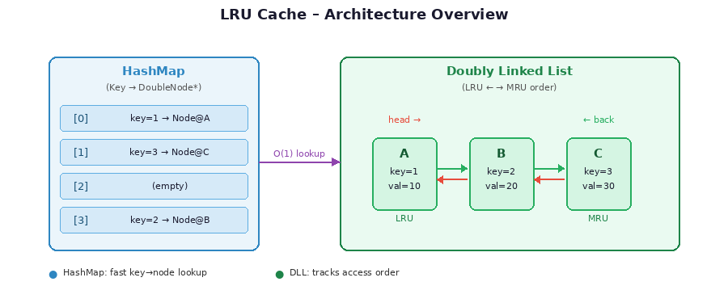
Figure 1: LRU Cache Architecture — HashMap provides O(1) lookup; DLL tracks access order

3. Data Structures & Classes Designs
The implementation is composed of five classes arranged in two layers. The lower layer provides general-purpose data structures [4] (a singly linked list and a hash map), and the upper layer builds the LRU Cache on top of them using a doubly linked list. Each class is documented below with its role, data members, and every function it exposes.

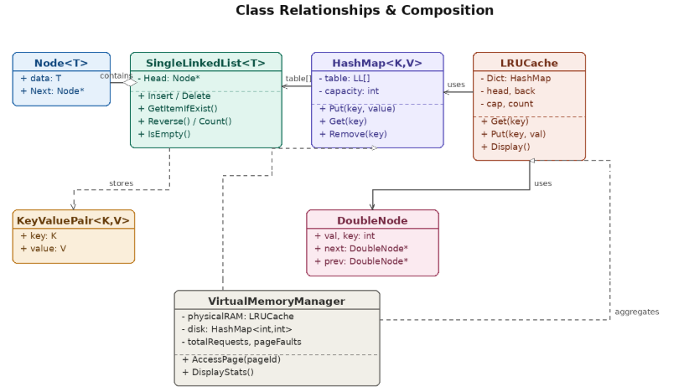
Figure 2: Class relationship diagram — LRUCache composes HashMap and DoubleNode; HashMap stores KeyValuePair* chains in LinkedList buckets

3.1 & 3.2 SingleLinkedList & Internal Node
This generic singly linked list serves as the collision-chaining bucket for the Hash Map. It contains an internal Node struct.

Code
template <typename T>
class SingleLinkedList
{
struct Node
{
T data;
Node* Next;
};
Node* Head;
public:
SingleLinkedList() { Head = NULL; }
bool IsEmpty() { return Head == NULL; }

int Count() {
int i = 0;
Node* temp = Head;
while (temp != NULL) {
i++;
temp = temp->Next;
}
return i;
}

void InsertAtFirst(T item) {
Node* newNode = new Node;
newNode->data = item;
newNode->Next = Head;
Head = newNode;
}

void InsertAtLast(T item) {
if (IsEmpty()) { InsertAtFirst(item); return; }
Node* temp = Head, * newNode = new Node;
newNode->data = item;
newNode->Next = NULL;
while (temp->Next != NULL) temp = temp->Next;
temp->Next = newNode;
}

void InsertAtAnyPosition(int pos, T item) {
int size = Count();
if (pos < 0 || pos > size) cout << "the index out of range" << endl;
else if (pos == 0) InsertAtFirst(item);
else if (pos == size) InsertAtLast(item);
else {
Node* temp = Head, * newNode = new Node;
newNode->data = item;
for (int i = 0; i < pos - 1; i++) temp = temp->Next;
newNode->Next = temp->Next;
temp->Next = newNode;
}
}

void Display() {
Node* temp = Head;
while (temp != NULL) {
cout << temp->data << " ";
temp = temp->Next;
}
cout << endl;
}

T* GetItemIfExist(int Key) {
Node* temp = Head;
while (temp != NULL) {
if (temp->data.key == Key) return &(temp->data);
temp = temp->Next;
}
return NULL;
}

int GetIndexOfItem(int key) {
Node* temp = Head;
int pos = 0;
while (temp != NULL) {
if (temp->data.key == key) return pos;
temp = temp->Next;
pos++;
}
return -1;
}

bool IsExist(int key) {
Node* temp = Head;
while (temp != NULL) {
if (temp->data.key == key) return true;
temp = temp->Next;
}
return false;
}

void DeleteAtFirst() {
if (IsEmpty()) { cout << "the SingleLinkedList is empty" << endl; return; }
Node* deleted = Head;
Head = Head->Next;
delete deleted;
}

void DeleteAtLast() {
if (IsEmpty()) { cout << "the SingleLinkedList is empty" << endl; return; }
Node* deleted = Head, * prev = NULL;
while (deleted->Next != NULL) {
prev = deleted;
deleted = deleted->Next;
}
if (prev == NULL) DeleteAtFirst();
else {
prev->Next = NULL;
delete deleted;
}
}

void DeleteAtAnyPosition(int pos) {
int size = Count();
if (pos < 0 || pos >(size - 1)) cout << "the index out of range" << endl;
else if (pos == 0) DeleteAtFirst();
else if (pos == size - 1) DeleteAtLast();
else {
Node* prev = Head, * deleted = NULL;
for (int i = 0; i < pos - 1; i++) prev = prev->Next;
deleted = prev->Next;
prev->Next = deleted->Next;
delete deleted;
}
}

void Reverse() {
if (IsEmpty()) return;
Node* prev = NULL, * cur = Head, * next = Head;
while (cur != NULL) {
next = cur->Next;
cur->Next = prev;
prev = cur;
cur = next;
}
Head = prev;
}
};

3.3 KeyValuePair<K, V> — Key-Value Entry
A template class representing a Key-Value Entry, vital for equality checks during searches inside the hash map's buckets.
template <typename K, typename V>
class KeyValuePair
{
public:
K key;
V value;
KeyValuePair() { }
KeyValuePair(K key ,V value)
{
this->key = key;
this->value = value;
}
};

3.4 HashMap<K, V> — Hash Table with Separate Chaining
A Hash Table implemented with separate chaining to handle collisions, offering O(1) average time complexity for data operations.
template <typename K, typename V>
class HashMap
{
private:
SingleLinkedList<KeyValuePair<K, V>>* table;
int capacity;
int hashFunction(K key) {
return (int)key % capacity;
}

public:
HashMap(int cap) {
capacity = cap;
table = new SingleLinkedList<KeyValuePair<K, V>>[capacity];
}

void Put(K key, V value) {
int index = hashFunction(key);
KeyValuePair<K, V>* SearchResult = table[index].GetItemIfExist(key);
if (SearchResult != NULL) {
SearchResult->value = value;
return;
}
KeyValuePair<K, V> kv( key, value);
table[index].InsertAtLast(kv);
}

V Get(K key) {
int index = hashFunction(key);
if(table[index].IsEmpty()) return NULL;
KeyValuePair<K, V>* kv = table[index].GetItemIfExist(key);
return (kv != NULL) ? kv->value : NULL;
}

void Remove(K key) {
int index = hashFunction(key);
if(table[index].IsEmpty()) return;
int pos = table[index].GetIndexOfItem(key);
if (pos != -1) table[index].DeleteAtAnyPosition(pos);
}

~HashMap() {
delete[] table;
}
};

3.5 Double Node — Doubly Linked List Node
The node for the Doubly Linked List, holding the key, value, and pointers to track recency.
struct DoubleNode
{
int val;
int key;
DoubleNode* next;
DoubleNode* prev;

DoubleNode(int val = 0, int key = 0, DoubleNode* next = NULL, DoubleNode* prev = NULL) {
this->val = val;
this->key = key;
this->next = next;
this->prev = prev;
}
};

3.6 LRUCache — The Main Cache
The main cache class that orchestrates the HashMap and Doubly Linked List to execute fast operations.
class LRUCache
{
private:
HashMap<int, DoubleNode*> Dict;
DoubleNode* head, * back;
int cap, count;

void Track(int key); // Defined in section 4.3

public:
LRUCache(int capacity) : Dict(capacity) {
cap = capacity;
count = 0;
head = back = NULL;
}
int Get(int key); // Defined in section 4.1
void Put(int key, int value); // Defined in section 4.2
void Display() {
DoubleNode* current = back;
cout << "[ RAM Content (Top:Back/Newest -> Bottom:Head/Oldest) ]: ";
if (current == NULL) cout << "Empty";
cout << endl;
while (current != NULL) {
cout << "[Page " << current->key << ": " << current->val << "]";
if (current->prev != NULL) cout << endl;
current = current->prev;
}
cout << endl;
}
~LRUCache() {
DoubleNode* current = head;
while (current != nullptr) {
DoubleNode* next = current->next;
delete current;
current = next;
}
}
};

4. Core Algorithms

4.1 Get(key)
The Get operation retrieves a value by key and updates the node to most-recently-used status:
int LRUCache::Get(int key)
{
DoubleNode* nodePtr = Dict.Get(key);
if (nodePtr != NULL)
{
Track(key);
return nodePtr->val;
}
return -1;
}

4.2 Put(key, value)
Put handles two cases: updating an existing key, and inserting a new key (with possible eviction):
void LRUCache::Put(int key, int value) {
DoubleNode* existingNode = Dict.Get(key);
if (existingNode != NULL) {
existingNode->val = value;
Track(key);
} else {
DoubleNode* node = new DoubleNode(value, key);
if (count == cap) {
Dict.Remove(head->key);
DoubleNode* toDelete = head;
if (count == 1)
back = head = NULL;
else {
head = head->next;
head->prev = NULL;
}
delete toDelete;
count--;
}
if (back == NULL)
back = head = node;
else {
back->next = node;
node->prev = back;
back = node;
}
Dict.Put(key, node);
count++;
}
}

4.3 Track(key) — Move Node to MRU

- Node is already MRU (back): No action needed.
- Node is LRU (head): Advance head to head->next, detach node, append to back.
- Node is in the middle: Bridge its neighbors together, then append to back.
void LRUCache::Track(int key){
if (count > 1) {
DoubleNode* temp = Dict.Get(key);
if (temp == head) {
head = head->next;
head->prev = NULL;
temp->next = NULL;
back->next = temp;
temp->prev = back;
back = temp;
} else if (temp != back) {
temp->prev->next = temp->next;
temp->next->prev = temp->prev;
temp->prev = back;
back->next = temp;
temp->next = NULL;
back = temp;
}
}
}

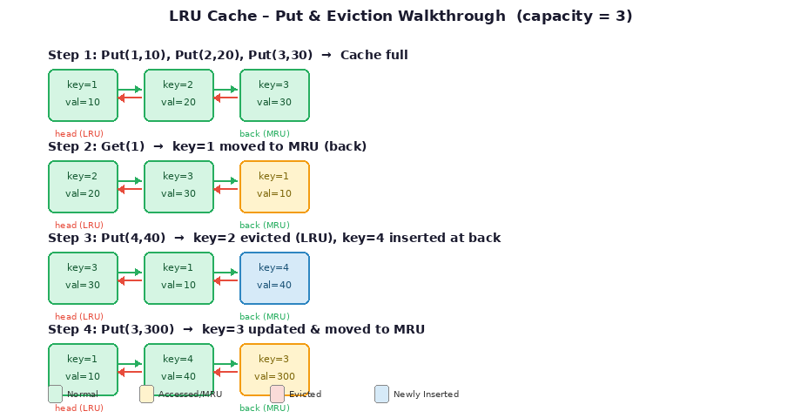
Figure 3: Step-by-step walkthrough of Put and Get operations on a capacity-3 cache

5. Time & Space Complexity
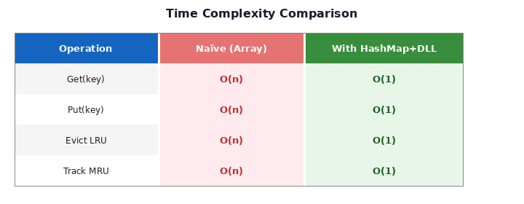
Figure 4: Time complexity comparison — Naïve array vs. HashMap+DLL approach

5.1 Why O(1)?
Every cache operation decomposes into:
- One HashMap call (Get, Put, or Remove) O(1) average with a well-sized hash table [1].
- At most a fixed number of pointer assignments (Track, eviction wiring) O(1) always
No loops, no searching, no sorting. The constant-time guarantee holds regardless of cache size.

5.2 Space Complexity

- HashMap backing array: An array of n LinkedList objects is allocated on the heap at construction time. Each LinkedList is empty initially, occupying only its Head pointer. This costs O(n) space regardless of how many entries have been inserted.
- KeyValuePair nodes (LinkedList chain entries): Each live cache entry creates one heap-allocated KeyValuePair<int, DoubleNode*> object stored inside its bucket's linked list. At most n such objects exist at any time, contributing O(n) space.
- DoubleNode objects (DLL nodes): Each live cache entry also creates one heap-allocated DoubleNode holding the key, value, and two pointers. Again at most n exist simultaneously, contributing O(n) space.

6. Application
To verify the caching logic, a VirtualMemoryManager simulation was implemented to emulate CPU memory fetching behaviors, demonstrating page faults, hits, and cache eviction.

6.2 Code:

class VirtualMemoryManager
{
LRUCache physicalRAM;
HashMap<int, int> disk;
int ramCapacity;
int totalRequests;
int pageFaults;

public:
VirtualMemoryManager(int capacity): physicalRAM(capacity), disk(200)
{
ramCapacity = capacity;
totalRequests = 0;
pageFaults = 0;
for (int i = 0; i < 200; ++i)
disk.Put(i, i * 10);
}

void AccessPage(int pageId)
{
totalRequests++;
cout << "\n[CPU Request]: Accessing Page " << pageId << "..." <<endl;
int data = physicalRAM.Get(pageId);

if (data != -1)
cout << ">> Result: PAGE HIT. Data: " << data << " (Fetched from RAM)" <<endl;
else
{
pageFaults++;
cout << ">> Result: PAGE FAULT! Page " << pageId << " not in RAM." << endl;

cout << " (Simulating custom HashMap Disk Read - 200ms) ";
for (int i = 0; i < 10;i++)
{
cout << ".";
this_thread::sleep_for(chrono::milliseconds(50));
}
cout << endl;
int diskData = disk.Get(pageId);
physicalRAM.Put(pageId, diskData);
cout << "Page " << pageId << " loaded into RAM." << endl;
}
DisplayStats();
}

void DisplayStats()
{
double hitRate = 0;
if (totalRequests > 0)
hitRate = ((double)(totalRequests - pageFaults) / totalRequests) * 100;
cout << "------------------------------------------" <<endl;
cout << "STATS | Total Requests: " << totalRequests << " | Faults: " << pageFaults << " | Hit Rate: " << hitRate << "%" <<endl;
cout << "------------------------------------------" << std::endl;
physicalRAM.Display();
}
};

int main()
{
VirtualMemoryManager vmm(3);
cout << "<<< Virtual Memory Simulation >>>" << endl;
int inputPage;
while (true)
{
cout << "\nEnter Page ID (0-99) or -1 to quit: ";
cin >> inputPage;

if (inputPage == -1) break;
if (inputPage < 0 || inputPage > 99) {
cout << "Invalid ID." << endl;
continue;
}
vmm.AccessPage(inputPage);
}
} class VirtualMemoryManager
{
LRUCache physicalRAM;
HashMap<int, int> disk;
int ramCapacity;
int totalRequests;
int pageFaults;

public:
VirtualMemoryManager(int capacity): physicalRAM(capacity), disk(200)
{
ramCapacity = capacity;
totalRequests = 0;
pageFaults = 0;
for (int i = 0; i < 200; ++i)
disk.Put(i, i * 10);
}

void AccessPage(int pageId)
{
totalRequests++;
cout << "\n[CPU Request]: Accessing Page " << pageId << "..." <<endl;
int data = physicalRAM.Get(pageId);

if (data != -1)
cout << ">> Result: PAGE HIT. Data: " << data << " (Fetched from RAM)" <<endl;
else
{
pageFaults++;
cout << ">> Result: PAGE FAULT! Page " << pageId << " not in RAM." << endl;

cout << " (Simulating custom HashMap Disk Read - 200ms) ";
for (int i = 0; i < 10;i++)
{
cout << ".";
this_thread::sleep_for(chrono::milliseconds(50));
}
cout << endl;
int diskData = disk.Get(pageId);
physicalRAM.Put(pageId, diskData);
cout << "Page " << pageId << " loaded into RAM." << endl;
}
DisplayStats();
}

void DisplayStats()
{
double hitRate = 0;
if (totalRequests > 0)
hitRate = ((double)(totalRequests - pageFaults) / totalRequests) * 100;
cout << "------------------------------------------" <<endl;
cout << "STATS | Total Requests: " << totalRequests << " | Faults: " << pageFaults << " | Hit Rate: " << hitRate << "%" <<endl;
cout << "------------------------------------------" << std::endl;
physicalRAM.Display();
}
};

int main()
{
VirtualMemoryManager vmm(3);
cout << "<<< Virtual Memory Simulation >>>" << endl;
int inputPage;
while (true)
{
cout << "\nEnter Page ID (0-99) or -1 to quit: ";
cin >> inputPage;

if (inputPage == -1) break;
if (inputPage < 0 || inputPage > 99) {
cout << "Invalid ID." << endl;
continue;
}
vmm.AccessPage(inputPage);
}
};

6.3 Testing & Output terminal:

6.3.1 Filling up the cache:

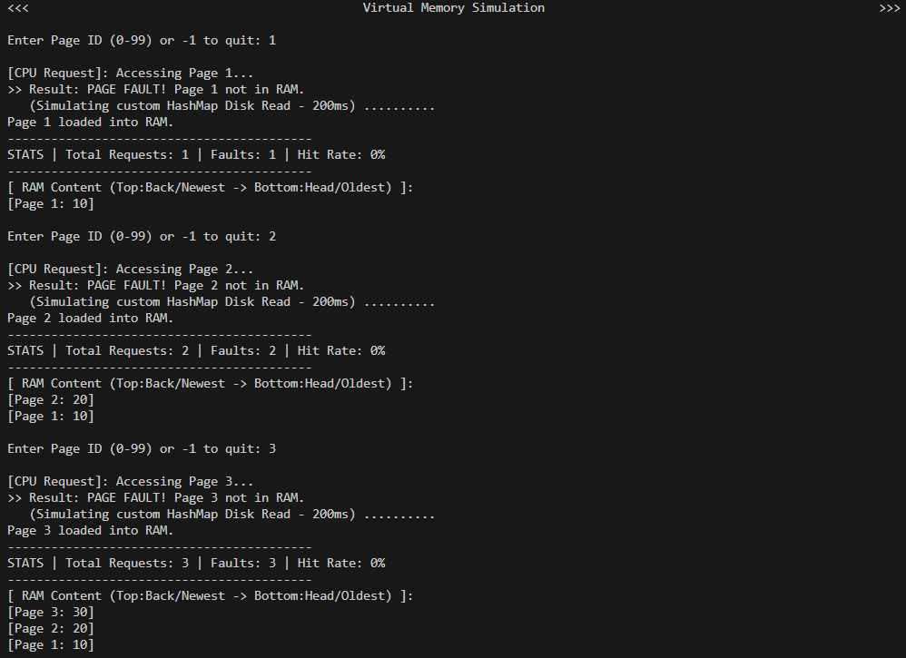

6.3.2 Evicting the oldest:

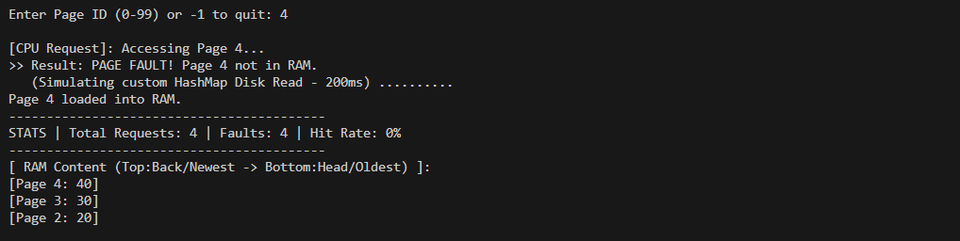


6.3.3 recalling an item in cache:

7. Known Limitations & Possible Improvements

7.1 Hash Function
Beyond type restriction, the modulo hash function has poor distribution properties when keys cluster around multiples of the capacity. For example, with capacity = 10, keys 10, 20, 30, and 40 all hash to bucket 0, producing a chain of length 4 in that bucket while all other buckets remain empty. This degrades the average-case O(1) lookup to O(n) for those keys.

7.2 LinkedList vs. HashMap
The custom LinkedList provides educational value but introduces linear-time worst-case behavior when many keys hash to the same bucket. Using C++'s HashMap would guarantee amortized O(1) with a robust hash and load-factor management.

7.3 Memory Management
The current implementation allocates nodes with new and relies on manual delete calls in the destructor. A production system would benefit from RAII smart pointers (std::unique_ptr / std::shared_ptr) to prevent memory leaks on exception paths [4].

7.4 Thread Safety
The cache is not thread-safe. Concurrent access from multiple threads would require mutex locks around Get and Put, or a lock-free design using atomic operations.

8. Conclusion
This project demonstrates that the right combination of data structures can transform an algorithm from linear to constant time. The key insight is that no single structure suffices:
- A hash map alone gives O(1) lookup but cannot track recency order
- A doubly linked list alone tracks order but requires O(n) search to find a key
- Together, they complement each other perfectly — O(1) for every cache operation
The implementation covers all core scenarios: cache hits, cache misses, LRU eviction, in-place value updates, and access-order promotion. The test cases in main.cpp validate each scenario, and all results match the expected outputs.

Summary
LinkedList<T> — generic singly linked list (chaining buckets)
KeyValuePair<K,V> — typed key-value entry with key-based equality
HashMap<K,V> — hash table with chaining, O(1) average operations
DoubleNode — DLL node storing key+value+prev+next
LRUCache — orchestrates HashMap + DLL for O(1) Get & Put

References
[1] T. H. Cormen, C. E. Leiserson, R. L. Rivest, and C. Stein, Introduction to Algorithms, 4th ed. Cambridge, MA, USA: MIT Press, 2022.

[2] R. Sedgewick and K. Wayne, Algorithms, 4th ed. Upper Saddle River, NJ, USA: Addison-Wesley, 2011.

[3] M. A. Weiss, Data Structures and Algorithm Analysis in C++, 4th ed. Boston, MA, USA: Pearson, 2014.

[4] B. Stroustrup, The C++ Programming Language, 4th ed. Upper Saddle River, NJ, USA: Addison-Wesley, 2013.

[5] GeeksforGeeks, "LRU Cache Implementation," GeeksforGeeks.org, 2024. [Online]. Available: https://www.geeksforgeeks.org/lru-cache-implementation/ [Accessed 29 4 2026]

[6] CP-Algorithms, "LRU Cache - Least Recently Used Cache Data Structure," CP-Algorithms.com, 2023. [Online]. Available: https://cp-algorithms.com/ [Accessed 3 5 2026]

