Chapter 6: Conclusions and Future Directions
6.1 What Have I Done in This Thesis?
In this thesis, I developed a multilingual OCR-based translation system called Translate Studio. The system was designed as a user-friendly web application using Streamlit, allowing users to translate text from different input sources such as typed text, uploaded images, camera images, videos, handwritten documents, and PDF files.
The project combines several important technologies. For optical character recognition, it uses OCR engines such as EasyOCR, PaddleOCR, and TrOCR. For translation, it supports local translation using the NLLB-200 model, as well as optional cloud-based translation services such as Google Translate and OpenAI. The system also includes image preprocessing, text detection, bounding-box extraction, translated text overlay, video frame processing, and export features for translated images, videos, and bilingual documents.
The main aim of the thesis was to build a practical system that can detect text from visual media, translate it into another language, and present the translated output in a clear and accessible way.
6.2 Results in Brief
The final system successfully performs text extraction and translation across multiple formats. It can translate normal typed text, extract text from images, process video frames, handle handwritten input, and generate translated outputs that users can view, copy, download, or save.
The results show that OCR and machine translation can be integrated into one application to solve real-world language accessibility problems. The system is especially useful for translating signs, documents, screenshots, subtitles, handwritten notes, and visual text in videos. The application also improves usability by providing history, saved translations, annotated previews, translated photo output, and translated video export.
Although the accuracy depends on image quality, handwriting clarity, font style, lighting, and the selected OCR or translation model, the system demonstrates that combining preprocessing, OCR, translation, and visual rendering can produce useful and meaningful translation results.

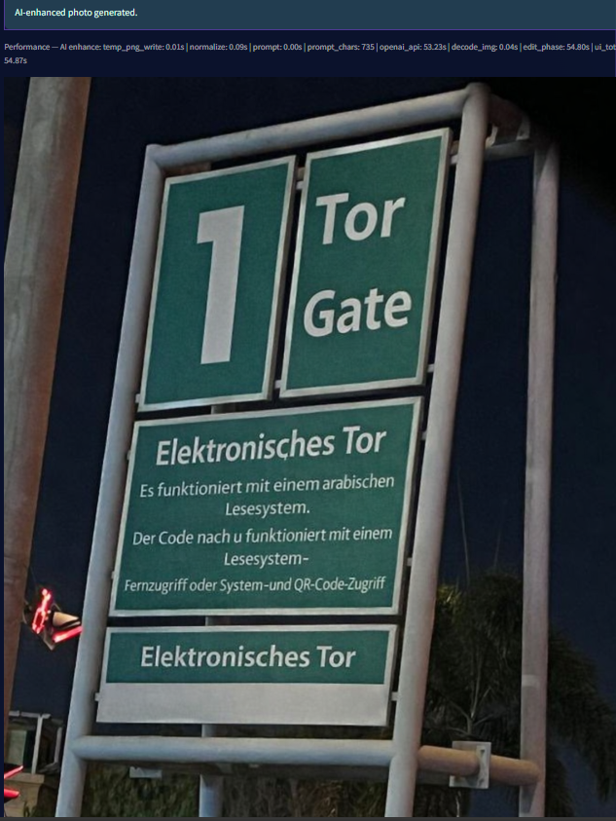

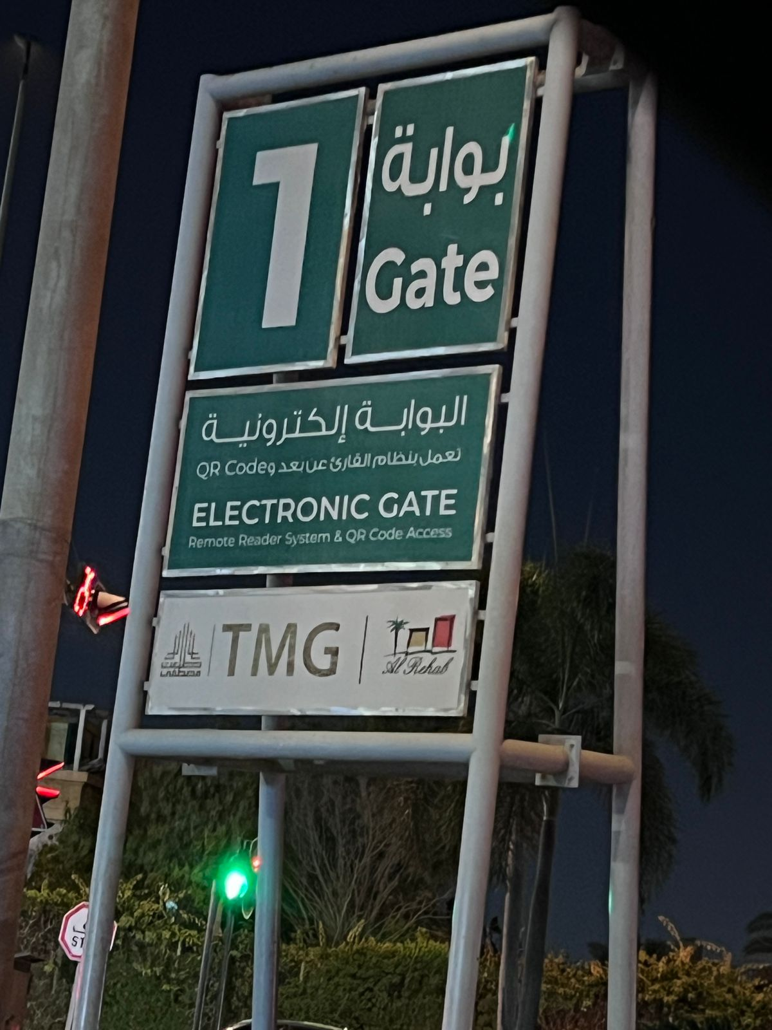
6.3 What Have I Learned?
Through this thesis, I learned how to combine computer vision, natural language processing, and web application development into one complete system. I learned that OCR is not only about reading text, but also about preparing the image correctly, detecting text regions accurately, handling different languages, and managing noisy or unclear inputs.
I also learned that translation quality depends heavily on the quality of the extracted text. If the OCR result contains errors, the translation result may also be affected. This made preprocessing, confidence filtering, and language handling important parts of the project.
Another important lesson was the challenge of working with video translation. Unlike image translation, video requires frame extraction, text tracking, inpainting, rendering translated text, and rebuilding the final video. This showed that real-time or near-real-time visual translation is more complex than simple text translation.
Finally, I learned the importance of building a usable interface. A good AI system should not only produce results, but should also make those results easy for users to understand, preview, save, and reuse.
6.4 Future Directions
In the future, the system can be improved in several ways. First, OCR accuracy can be enhanced by training or fine-tuning OCR models on more real-world datasets, especially for handwritten text, Arabic text, low-quality images, and mixed-language scenes.
Second, the system can be extended to support real-time camera translation. This would allow users to point a camera at signs, menus, books, or documents and receive instant translated output.
Third, video translation can be improved by using stronger object tracking and scene consistency techniques so that translated text remains stable across frames. This would make translated videos look more natural and professional.
Fourth, the system can include better evaluation metrics, such as OCR accuracy, word error rate, translation quality, processing time, and user satisfaction. These measurements would make it easier to compare different OCR engines and translation providers.
Finally, the application can be deployed as a cloud service or mobile application, making it more accessible to users who need translation support in education, travel, business, and daily communication.
6.5 Conclusion
This thesis presented a complete OCR-based translation application that combines text recognition, machine translation, image processing, and an interactive web interface. The developed system demonstrates how AI technologies can reduce language barriers by translating text from images, videos, documents, and handwriting.
Overall, the project achieved its main goal: creating a practical translation tool that supports different input types and provides useful translated outputs. Future improvements can make the system more accurate, faster, and more suitable for real-time and large-scale use.

