**SW2 – Project Evaluation Form**

* **Each team must submit the following Documentation that contains:**

**- Project Description in detail.**

**- Class Diagram. And Database Schema.**

* **Each team must submit the project via GitHub:**
* **Source Code.**
* **Video Demo for running ( 2 – 5 Minutes ).**
* **Documentation and Evaluation Form.**
* **The Evaluation will start with giving all teams 30 marks then check the following criteria:**

|  |  |  |  |  |
| --- | --- | --- | --- | --- |
| **Violation Level** | **Full** | **Medium** | **Small** | **Grade** |
| **Documentation** | **-5** | **-2** | **-1** |  |
| **Not Apply MVC (it does not Separate Business logic from GUI ). Example of violation: write an implementation for a method such as an inset item into the database inside the Button Action method** | **-6** | **- 3** | **-1** |  |
| **Violate clean code – Variables** | **-2** | **-1** | **-.05** |  |
| **Violate clean code – Functions** | **-2** | **-1** | **-.05** |  |
| **Violate Single-responsibility Principle** | **-2** | **-1** | **-.05** |  |
| **Violate Open-closed Principle** | **-2** | **-1** | **-.05** |  |
| **Violate the Liskov Substitution Principle** | **-2** | **-1** | **-.05** |  |
| **Violate Interface Segregation Principle** | **-2** | **-1** | **-.05** |  |
| **Violate Dependency Inversion Principle** | **-2** | **-1** | **-.05** |  |
| **Not Upload code to GitHub** | **-1** | | |  |
| **Only One Branch Without Merge (GitHub)** | **-2** | | |  |
| **Only One Contribution (GitHub)** | **-2** | | |  |
| **Total Minus from Grade** |  |  |  |  |

|  |  |  |
| --- | --- | --- |
| **Design Pattern Bounce** | **+4** |  |
| **Bounce on Overall Work** | **+2** |  |
| **Total Team Grade / 30** |  | |

|  |  |  |  |
| --- | --- | --- | --- |
| **Name (Arabic)** | **ID** | **Individual Bounce +2** | **Grade** |
| **عمر حامد عبدالنبي سند** | **201900505** |  |  |
| **انجي محمد عبدالله شعبان** | **201900188** |  |  |
| **اسماء محمود عبدالجبار محمود** | **201900150** |  |  |
| **محمد عبدالرحمن ابراهيم عبدالرحمن** | **201900397** |  |  |
| **صلاح بكر فاروق** | **201900382** |  |  |
| **محمود سعد محمد بكر** | **201900768** |  |  |
|  |  |  |  |

##### **Description**

##### The Pharmacy Management system otherwise referred to as the pharmacy information system stores data systemizes and controls the use of the medication process with the pharmacies.

# Functional requirements

o The system shall allow for on-line product ordering by either the customer or sale agent. For customers, this will eliminate the current delay between their decision to buy and the placement of the order. This will reduce the time a sales agent spends on an order by x%. The cost to process an order will be reduced to $y.

o The system shall reflect a new and changed product description within x minutes of the database being updated by the product owner. This will reduce the number of incidents of incorrectly displayed information by x%. This eliminates the current redundant update of information, saving $y dollars annually.

o The system shall provide accounting with accurate purchase transaction data. This will improve customer service by reducing billing complaints by x% and save $y in correcting inaccurate accounts.

o The system shall provide searching into the database to help the customers finding the product they want, faster and easily.

o The system shall provide both supplier information, customer information for the sells agent.

o The system shall allow the customer to know whether the product is available or out of stock.

o The system shall show the customer the total cost before placing the order, this will reduce returning orders, because the customer will be fully aware of what he will be paying.

o The system shall provide shipping with accurate order data. This will allow the order to be processed in x days and inventory to be updated within y hours.

* + **Non-Functional requirements**

## Usability

A user should know how to use the website from the first time.

A user who already knows what product he is interested in should be able to locate and view that page in x seconds.

The final payment transaction shall be done in one click.

* **Security**

The system shall provide password protected access to web pages that are to be viewed only by employees.

Transaction data must be transmitted in encrypted form.

## Interfaces

* **The system must interface with**

The current phpmyadmin database systems for product and order information.

### System capabilities

### .Login Module

* In order, to get personalized or restricted information, place orders or do other specialized transactions a user must login so that the system can determine his access level.

### There are two types of users:

* + User.
  + Admin.

## User Level Features

* + A user must have an account to complete the order process.
  + if the user does not have an account he needs to register.
  + Registration Form

o

o

**User enters a valid user name at least 5 letters and at most 16.**

**User enters a password consists of 8 digits at least. User enters a valid email and not taken.**

* If registration was successful, user’s data will be stored into the database and a registration succeed message will appear to the user.
* If the user already has an account, he must log in.

o Log in form

* **User must enter an email that is already stored in the database.**
* **User enters a password that is already stored in the database with the same email.**
* If logging in was successful, user will be able to use all the user’s
* features.
* **User Search/Look for a product and add it to the cart.**

User can either view the products in a random way from the Medicine

page, can search for a particular product.

User can read the product’s description by placing the mouse on the

product’s scope.

* + Search Form
* **User can search by the search bar, by entering the name of the product.**
* **If the product is found the system will display the product, if not found the system will display not found.**
* If user have found the product he was looking for, he can place his order successfully.

o Placing Order Form

* **User can add to cart by clicking “add to cart.”**
* **User can add products of different types in the same order.**
* **User can not add more than 3 product.**
* If the user added to his cart successfully, he will be able to go to the next stage, to finalize his order.

## Delivery information and order confirmation

* + Order confirmation Form
* **User can view it’s cart.**
* **User can view it’s cart, by clicking the cart mark.**
* **User can delete his cart, by clicking the deletion mark.**
* If the payment process went successfully, bill will be printed.
  + Bill Information Form
    - Form
* **Bill will contain customer’s information, order total cost, product name, product price.**
* **Once the bill has been created, it will be stored in the database.**
* **Each bill has it is own id.**
* **User can view it is bill anytime.**

## 2-Admin Level Features

* + Admin Log in Form

o Form

* **Admin must enter an email that is already stored in the database.**
* **Admin enters a password that is already stored in the database with the same email.**
* If logging in was successful, admin will be able to use all the admin’s features.
* Admin View Users/Orders Form
  + Form
* **Admin can view the users details, their information.**
* **Admin can view the orders placed by the customers, their bills.**
* Admin Product Entry Form
  + Form
* **Admin can add new product by clicking on “add new product”.**
* **Admin must add a description, id, name, picture , quantity, price, SupplierID.**
* **Each product has its own ID.**
* **Product description will be stored in the database.**
* If adding was successful, it will automatically reflect on the system and the database

## Class Diagram

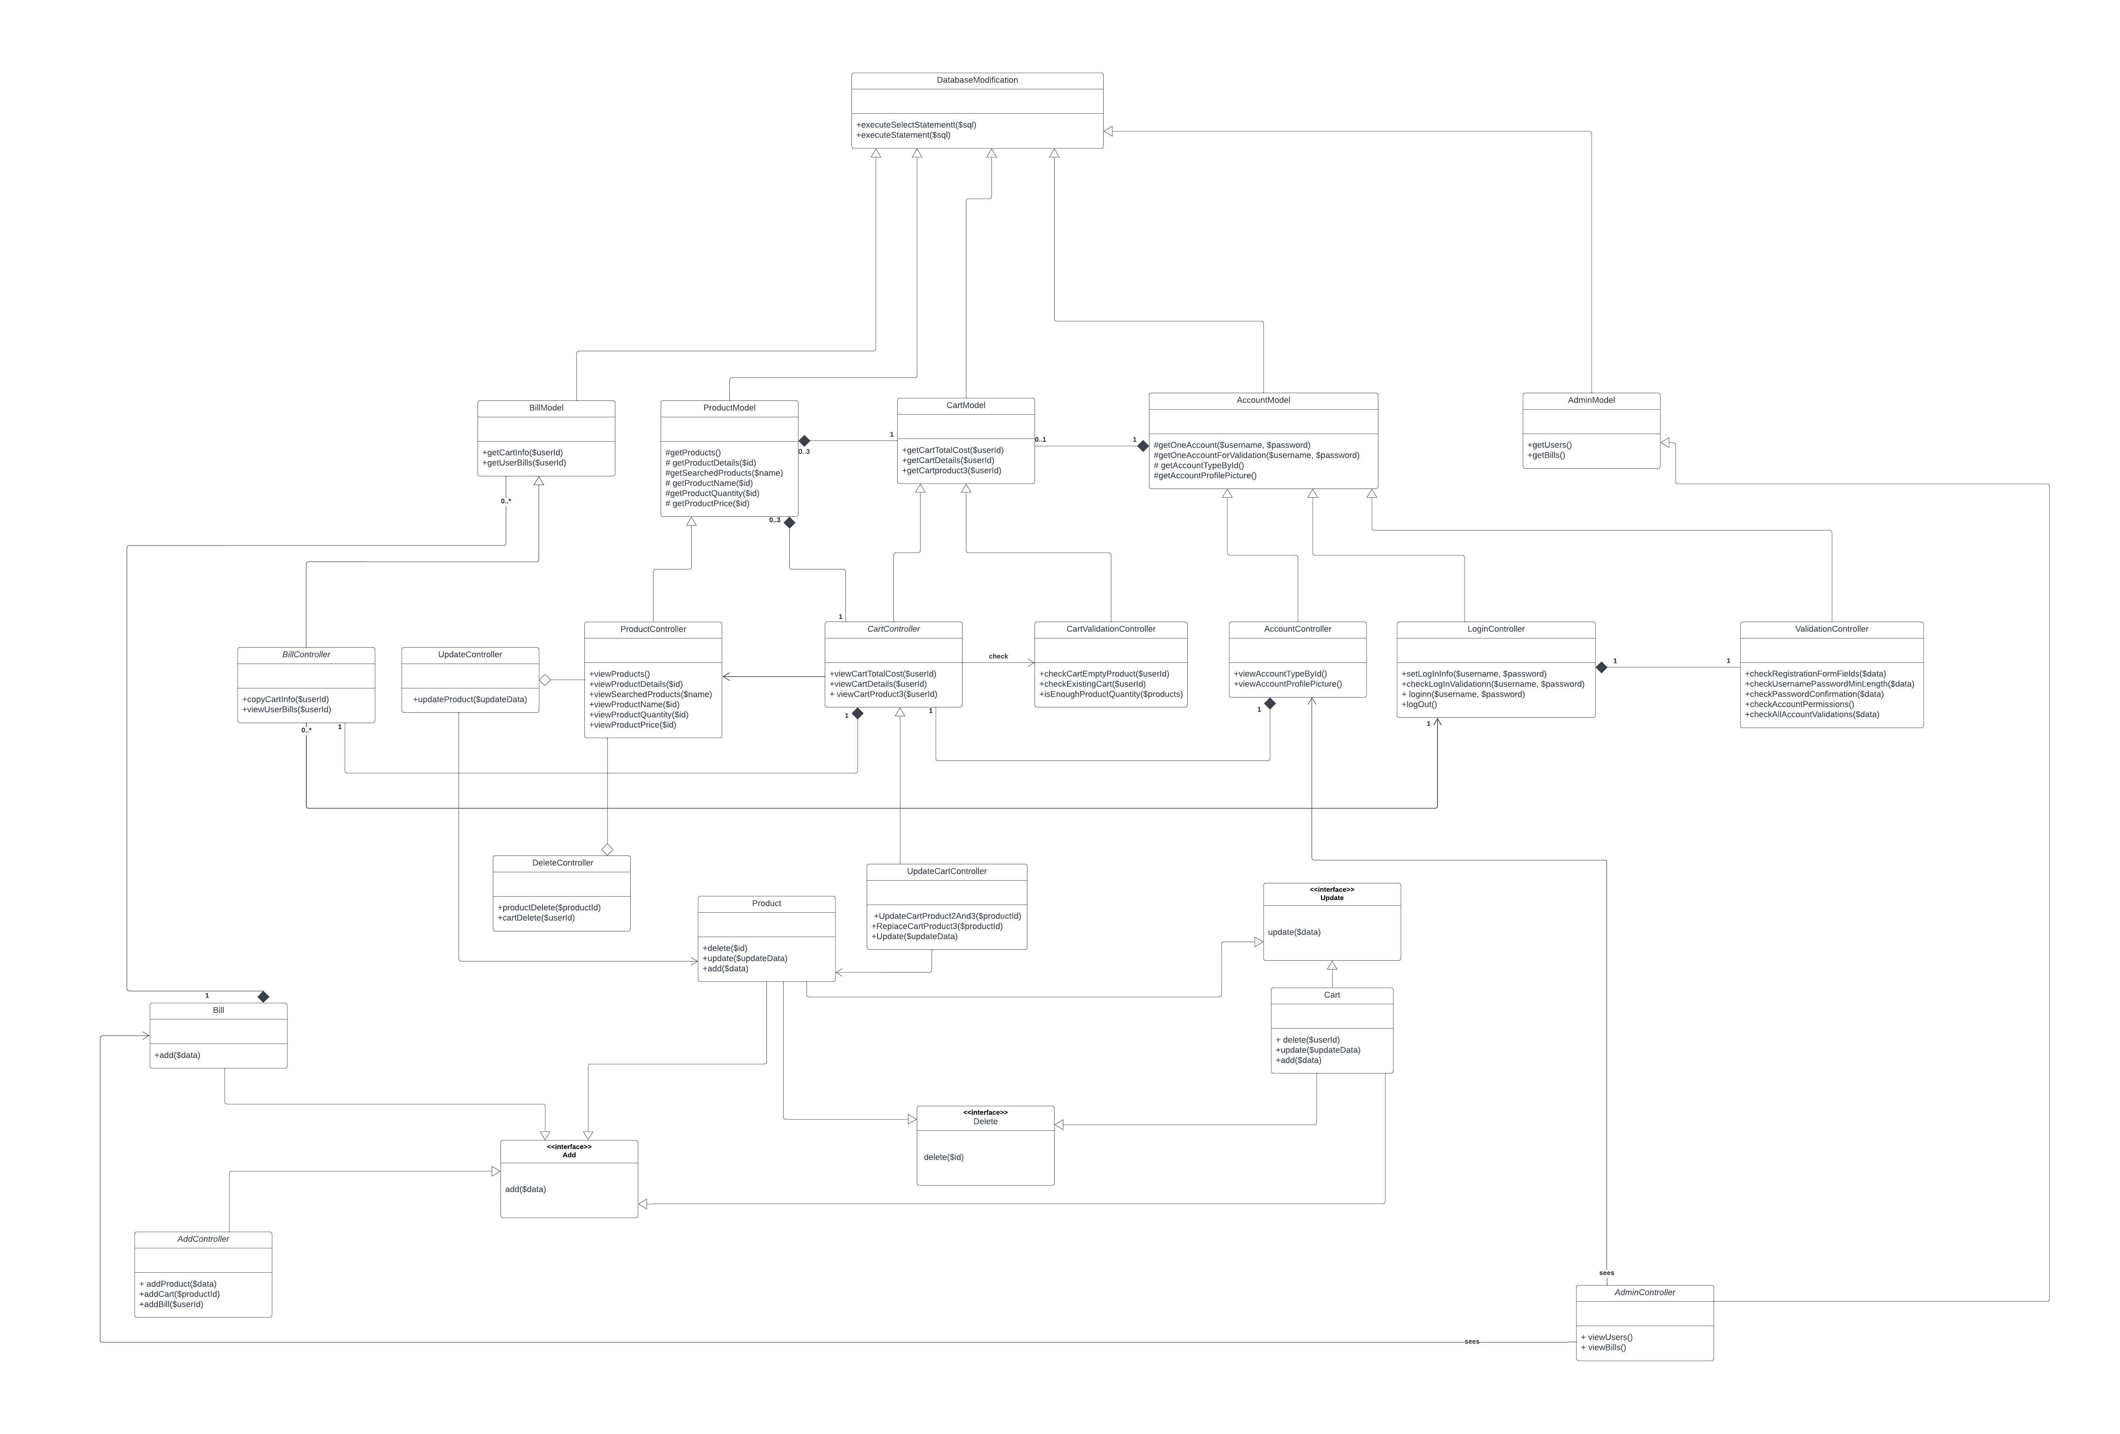

# Database Scheme

