Windows 11 Virtualization and Command-Line Fundamentals
Omar Khalil | Portland Community College | CIS 140M
Guided academic lab • Entry-Level IT Support Portfolio

Overview
Set up and explored Windows 11 in a Hyper-V virtual machine and practiced foundational Command Prompt tasks.

Tools and environment
Hyper-V Manager, Windows 11, XtremeLabs, Command Prompt

Work demonstrated
- Windows 11 virtual machine installation and system information
- Hyper-V Manager checkpoints and applying a checkpoint
- Command Prompt navigation using `cd` and directory listings
- Filtering file listings with wildcards, creating folders and viewing text output
- Reviewing Windows licensing and version information

Relevance to IT support
This coursework demonstrates familiarity with Windows administration interfaces, following technical procedures, documenting results, and basic troubleshooting concepts used in entry-level Help Desk and Desktop Support roles.

Selected Lab Screenshots
Screenshots captured during the guided virtual lab. Original XtremeLabs interface is visible in some images.
Lab evidence — Screenshot 01
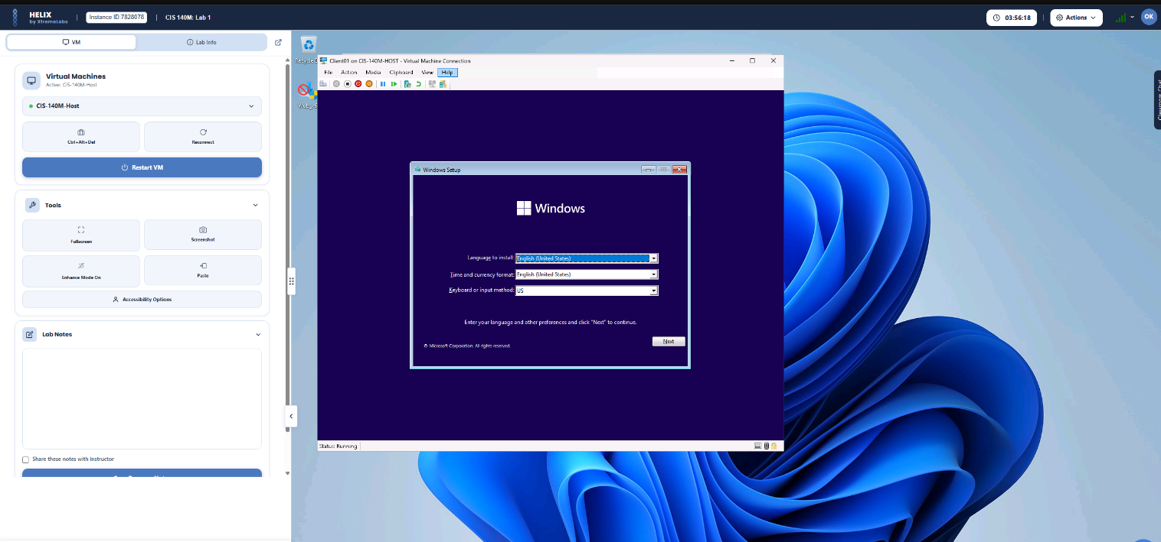
Lab evidence — Screenshot 03
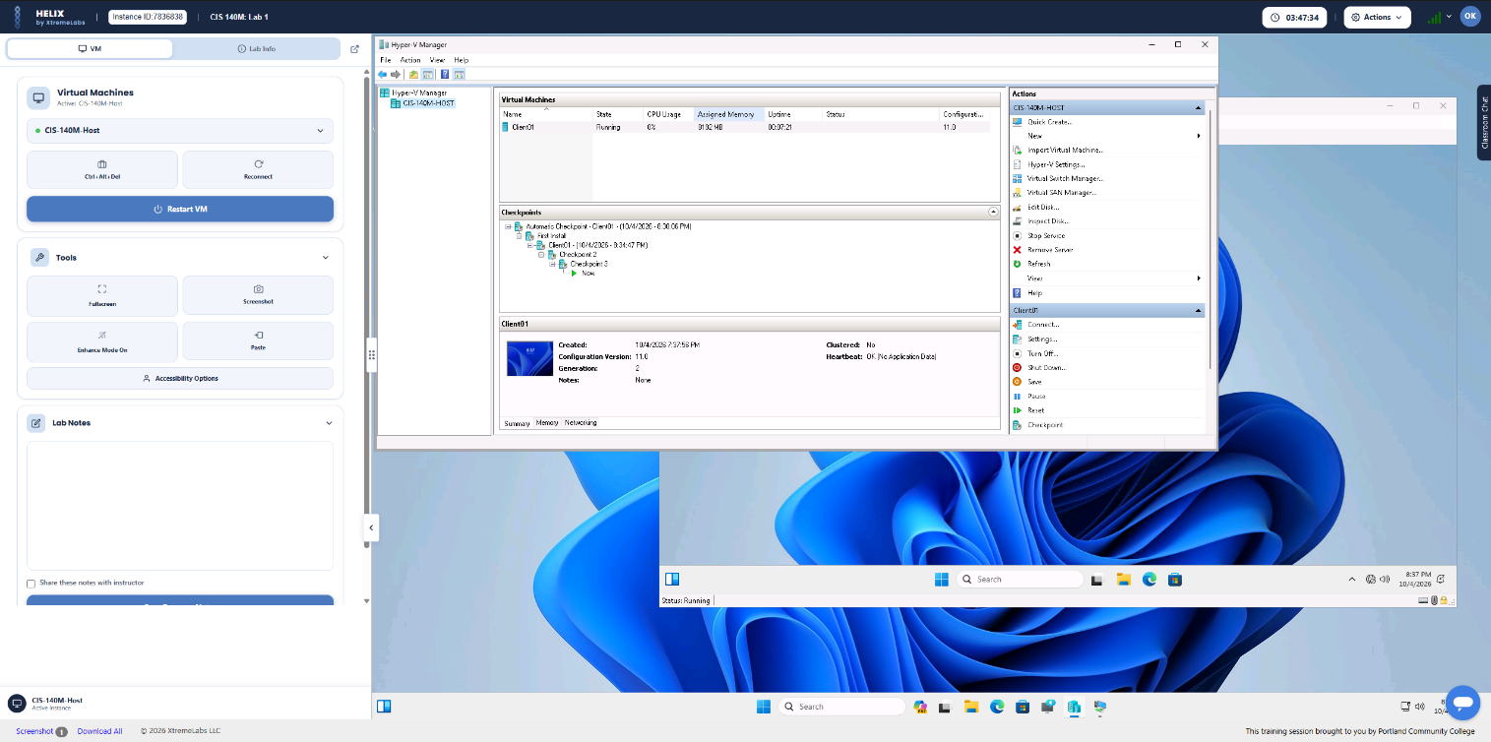
Lab evidence — Screenshot 05
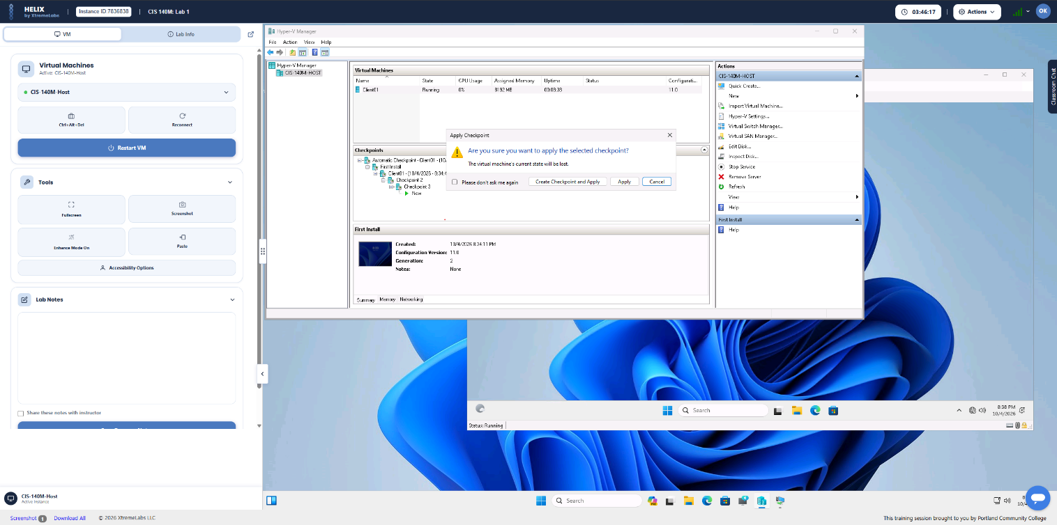

Project Scope
This work was completed as guided academic coursework in a virtual lab, not as a production deployment or paid IT role. The images document practical tasks performed during the lab.

