Windows 11 Configuration and User Support
Omar Khalil | Portland Community College | CIS 140M
Guided academic lab • Entry-Level IT Support Portfolio

Overview
Explored Windows 11 personalization and common end-user support settings through guided support scenarios.

Tools and environment
Windows 11 Settings, Hyper-V/XtremeLabs, File Explorer

Work demonstrated
- Windows 11 desktop organization and personalization
- Accessibility guidance for text size, Magnifier, contrast themes and pointer appearance
- Locating printer and scanner setup options
- Finding display-language and lock-screen settings
- Organizing files and folders in File Explorer

Relevance to IT support
This coursework demonstrates familiarity with Windows administration interfaces, following technical procedures, documenting results, and basic troubleshooting concepts used in entry-level Help Desk and Desktop Support roles.

Selected Lab Screenshots
Screenshots captured during the guided virtual lab. Original XtremeLabs interface is visible in some images.
Lab evidence — Screenshot 01
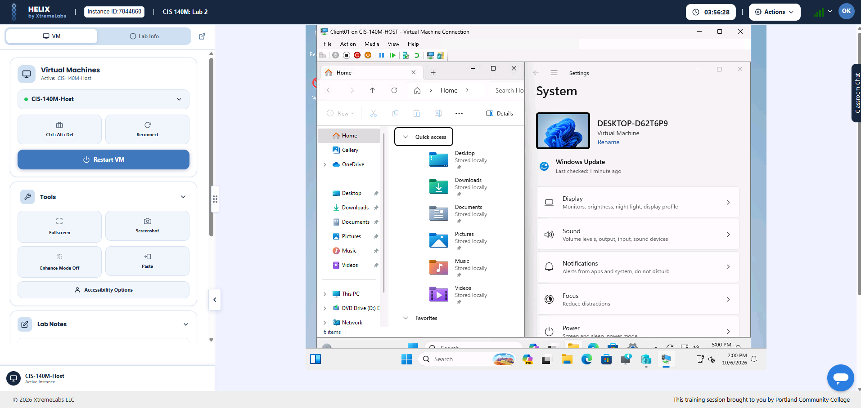
Lab evidence — Screenshot 03
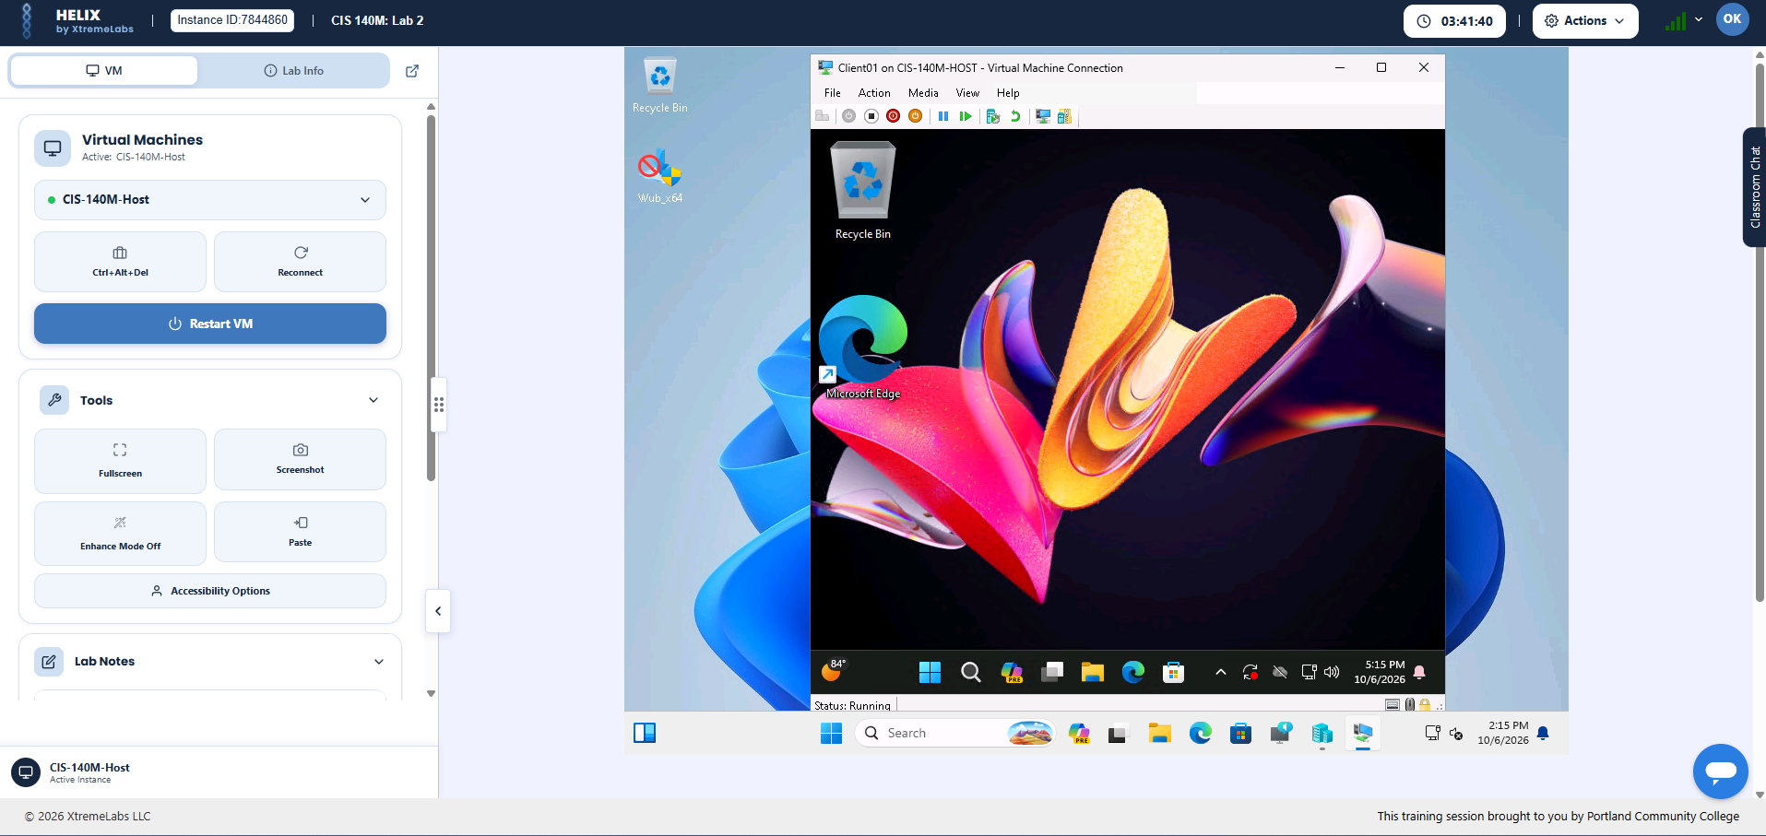
Lab evidence — Screenshot 05
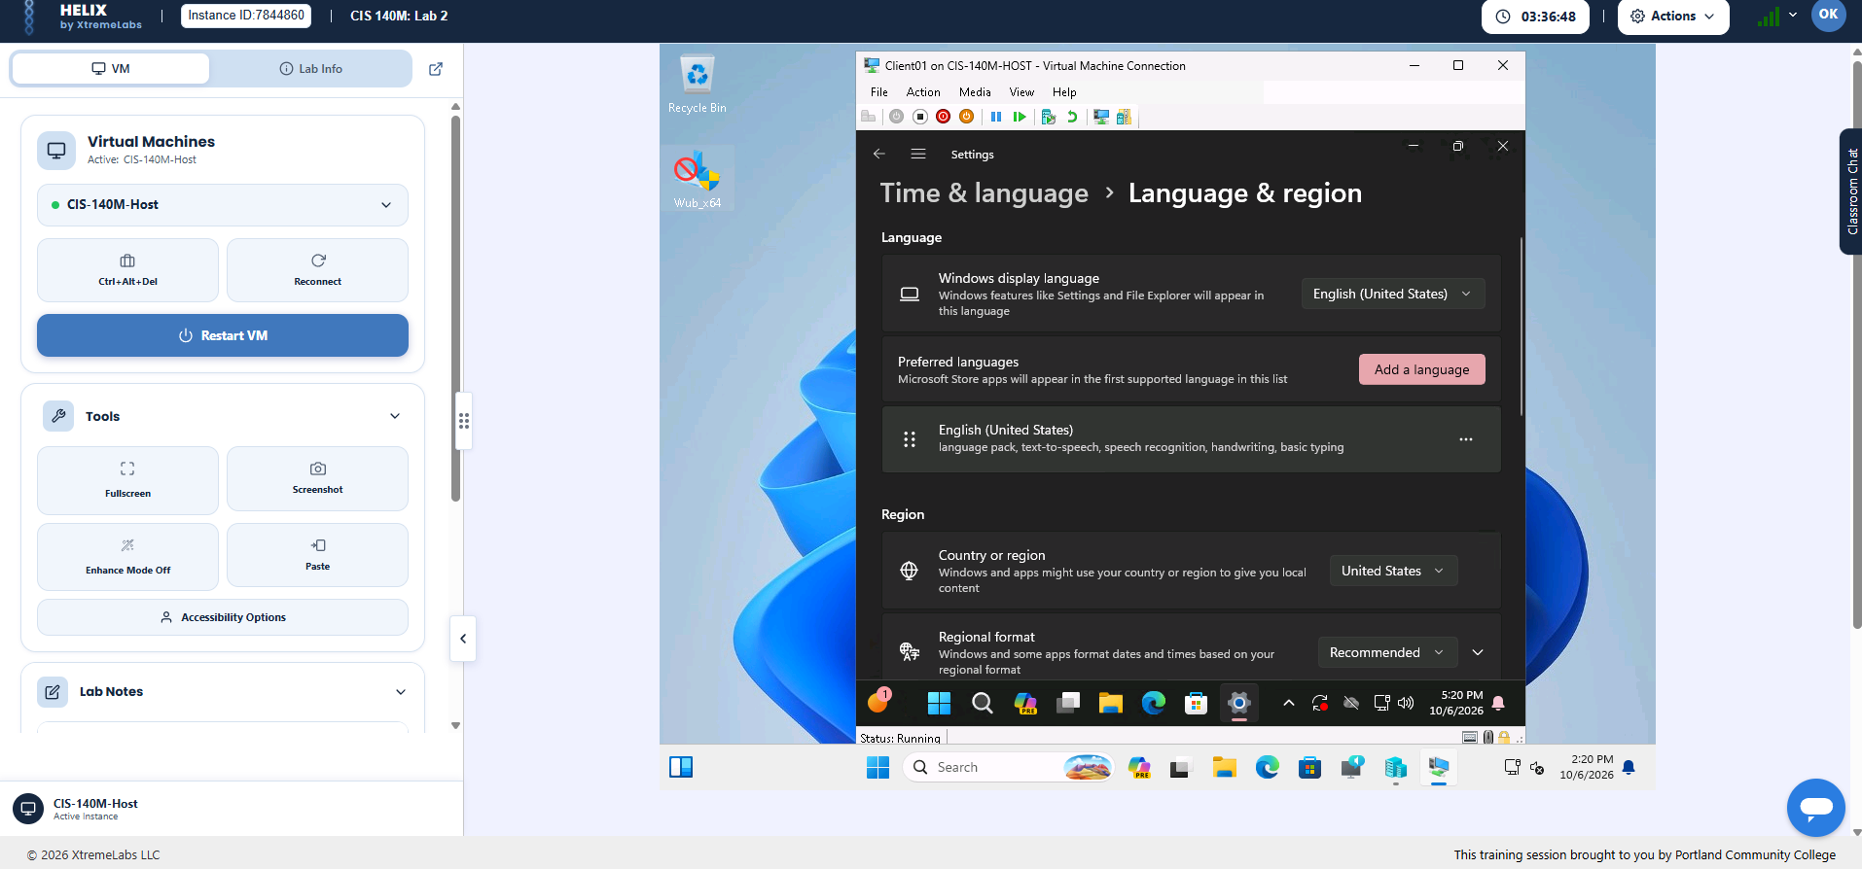

Project Scope
This work was completed as guided academic coursework in a virtual lab, not as a production deployment or paid IT role. The images document practical tasks performed during the lab.

