Windows System Performance and Maintenance
Omar Khalil | Portland Community College | CIS 140M
Guided academic lab • Entry-Level IT Support Portfolio

Overview
Practiced Windows system maintenance and monitoring tasks in a guided virtual lab.

Tools and environment
Windows 11, Task Manager, Disk Cleanup, Resource Monitor, XtremeLabs

Work demonstrated
- Examining Windows Update Delivery Optimization settings and tradeoffs
- Inspecting and ending a test application using Task Manager
- Reviewing process details and storage usage
- Estimating reclaimable disk space using Disk Cleanup (584 MB in the lab)
- Reviewing advanced power settings and Resource Monitor

Relevance to IT support
This coursework demonstrates familiarity with Windows administration interfaces, following technical procedures, documenting results, and basic troubleshooting concepts used in entry-level Help Desk and Desktop Support roles.

Selected Lab Screenshots
Screenshots captured during the guided virtual lab. Original XtremeLabs interface is visible in some images.
Lab evidence — Screenshot 01
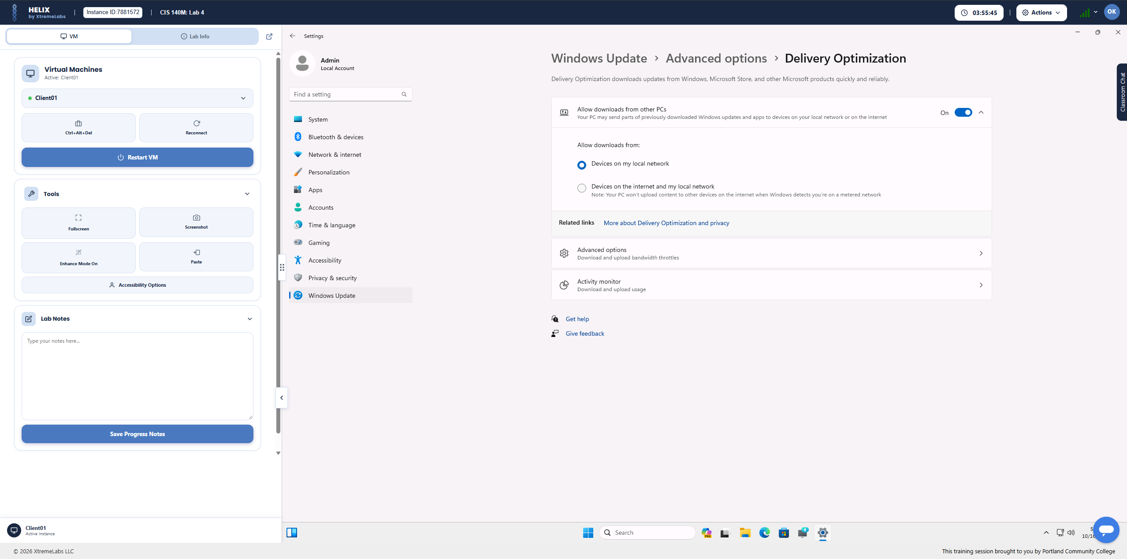
Lab evidence — Screenshot 03
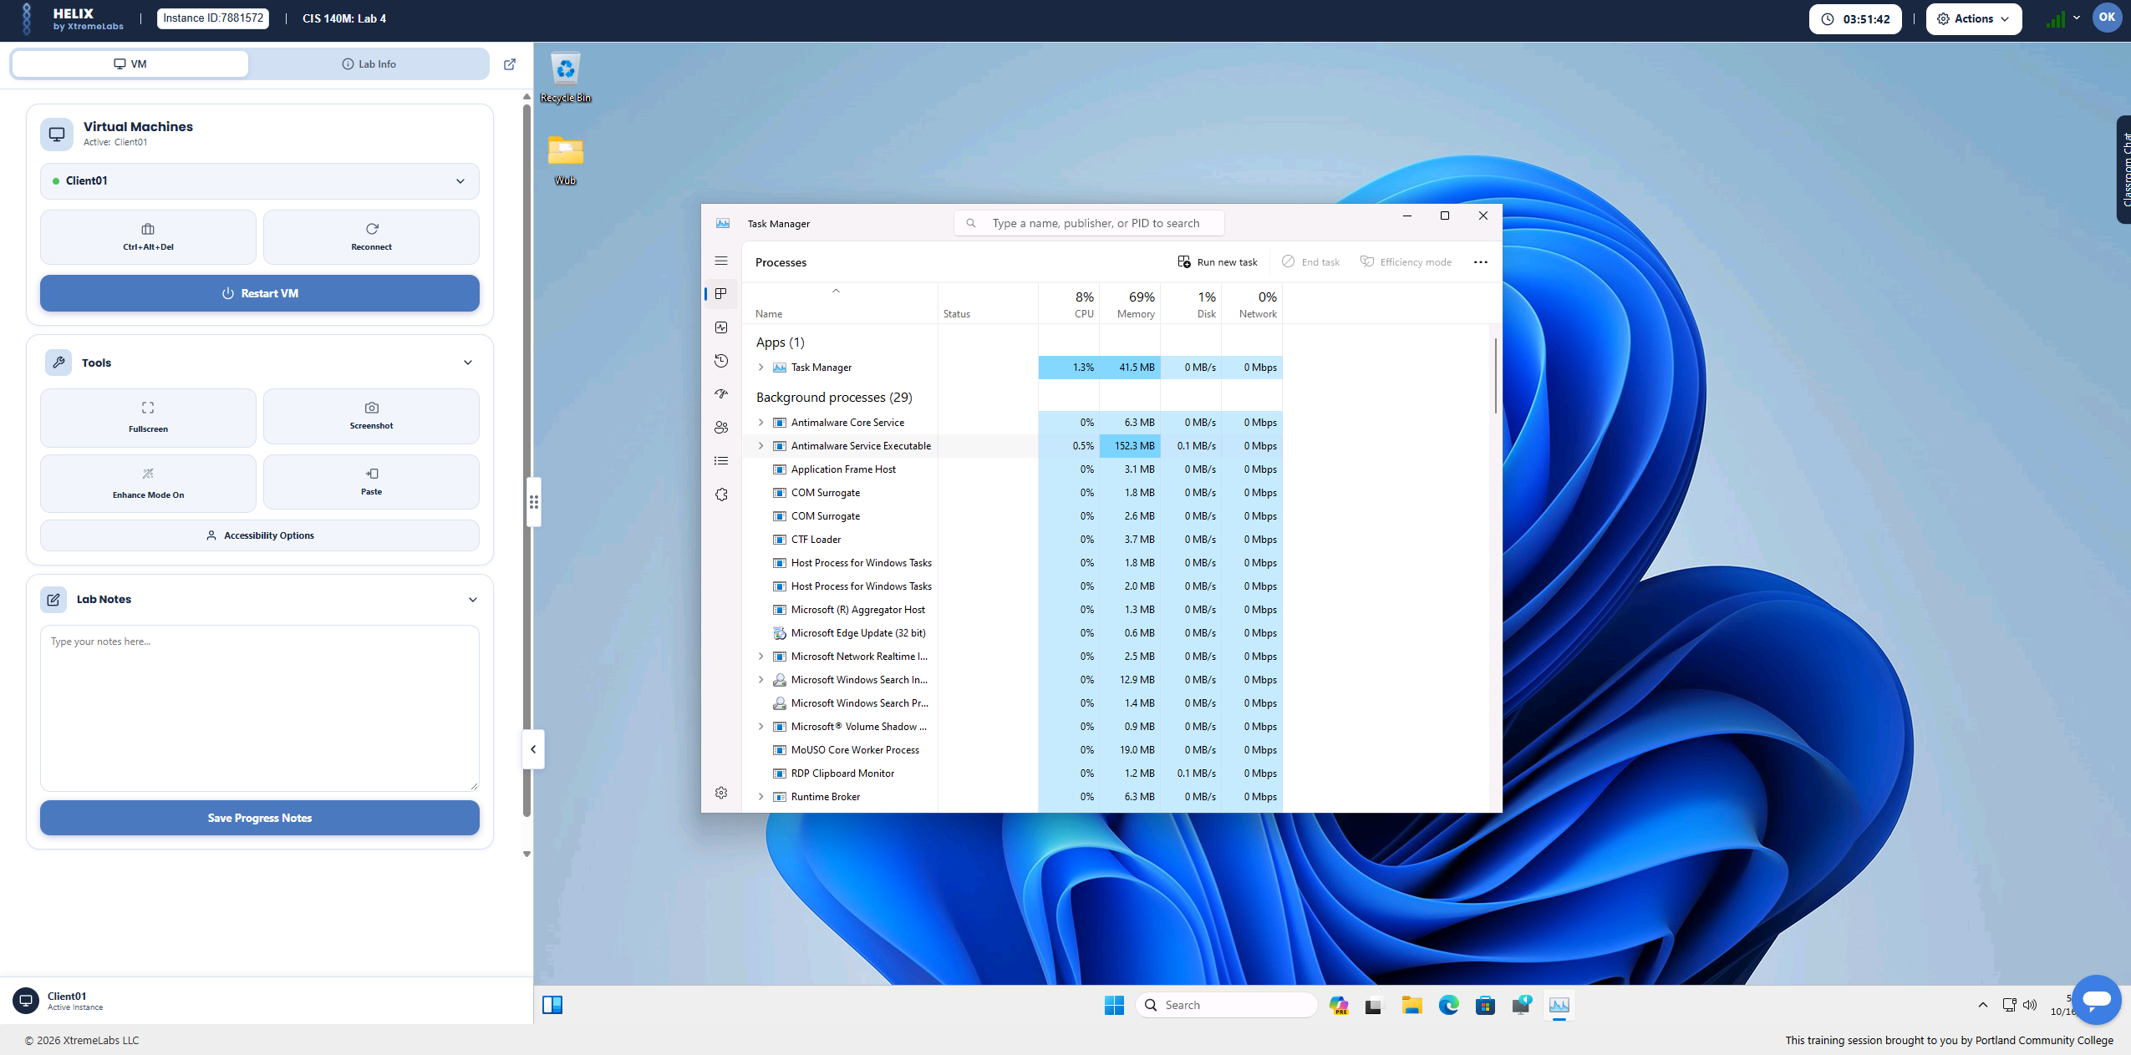
Lab evidence — Screenshot 05
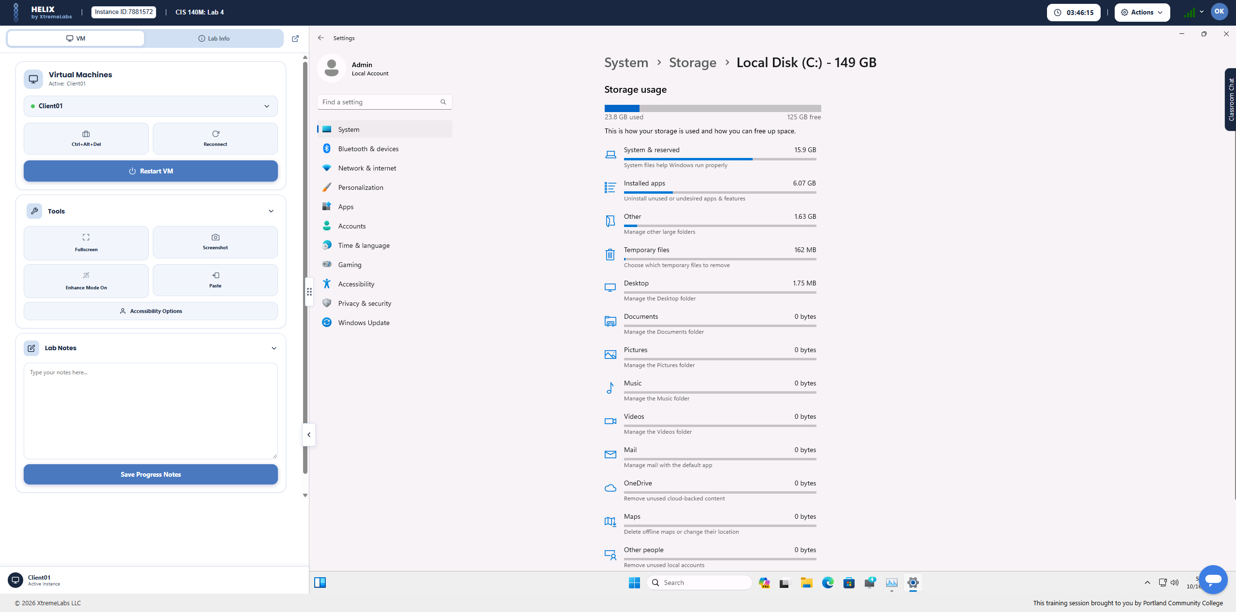

Project Scope
This work was completed as guided academic coursework in a virtual lab, not as a production deployment or paid IT role. The images document practical tasks performed during the lab.

