Windows Hardware & Disk Management
  - Technical Lab Portfolio | Omar Khalil | CIS 140M · Portland Community College

Project overview
I completed a hands-on Windows administration lab in the XtremeLabs training environment. I used Disk Management, drive health and optimization tools, Command Prompt, Windows storage settings, and Device Manager to examine and document storage and hardware status. This project demonstrates foundational tasks relevant to entry-level IT support.

Tools and skills
Windows 11 virtual lab · Disk Management · Optimize Drives · Command Prompt · Disk checking · Windows Storage settings · Device Manager · Screenshot documentation

1. Inspecting and preparing a disk
I inspected the Windows Disk Management console and documented the newly created Disk 1. I then checked the disk configuration and its status as a basic disk. This is a common starting point when preparing or troubleshooting storage devices.
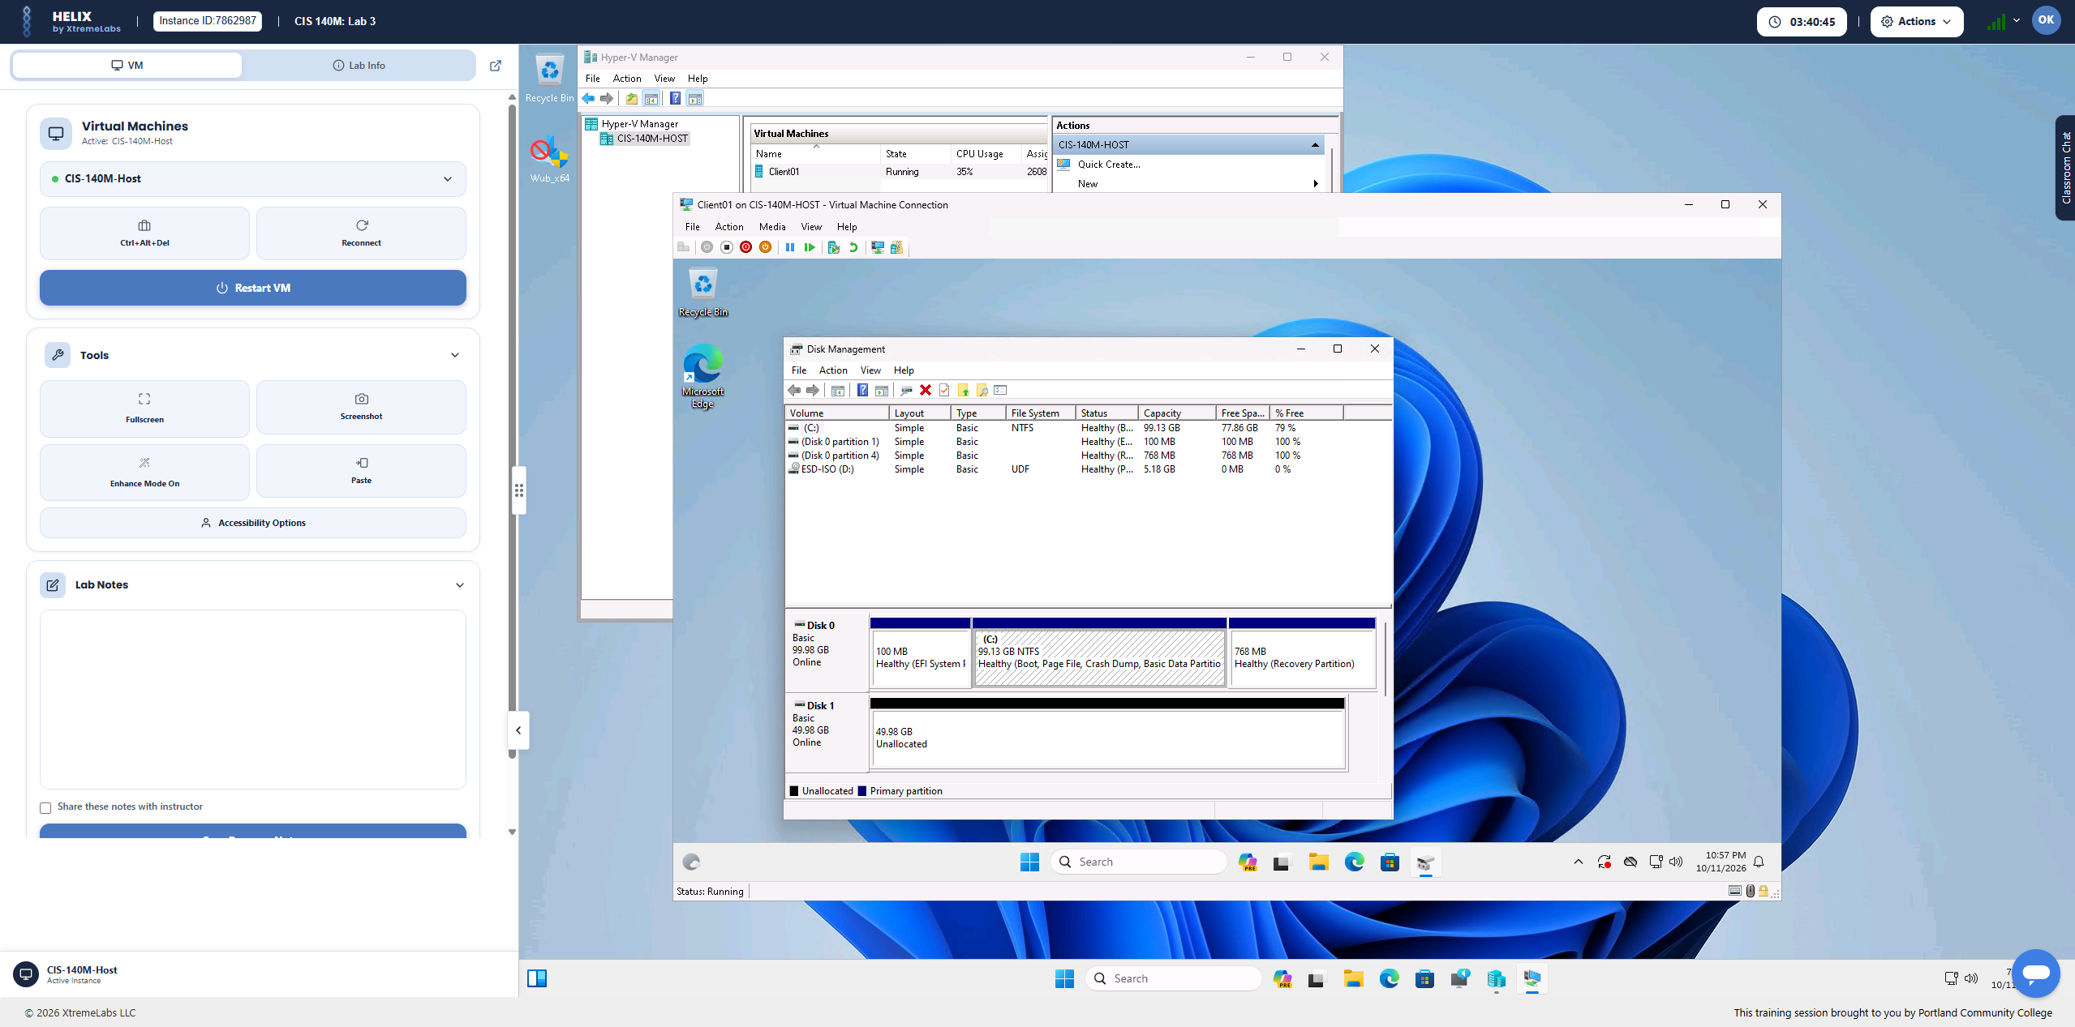
Evidence 1: Disk Management showing the lab disk

2. Verifying disk configuration
I reviewed the updated disk layout in Disk Management after the lab configuration steps. The screenshot records the disk and volume layout inside the training environment.
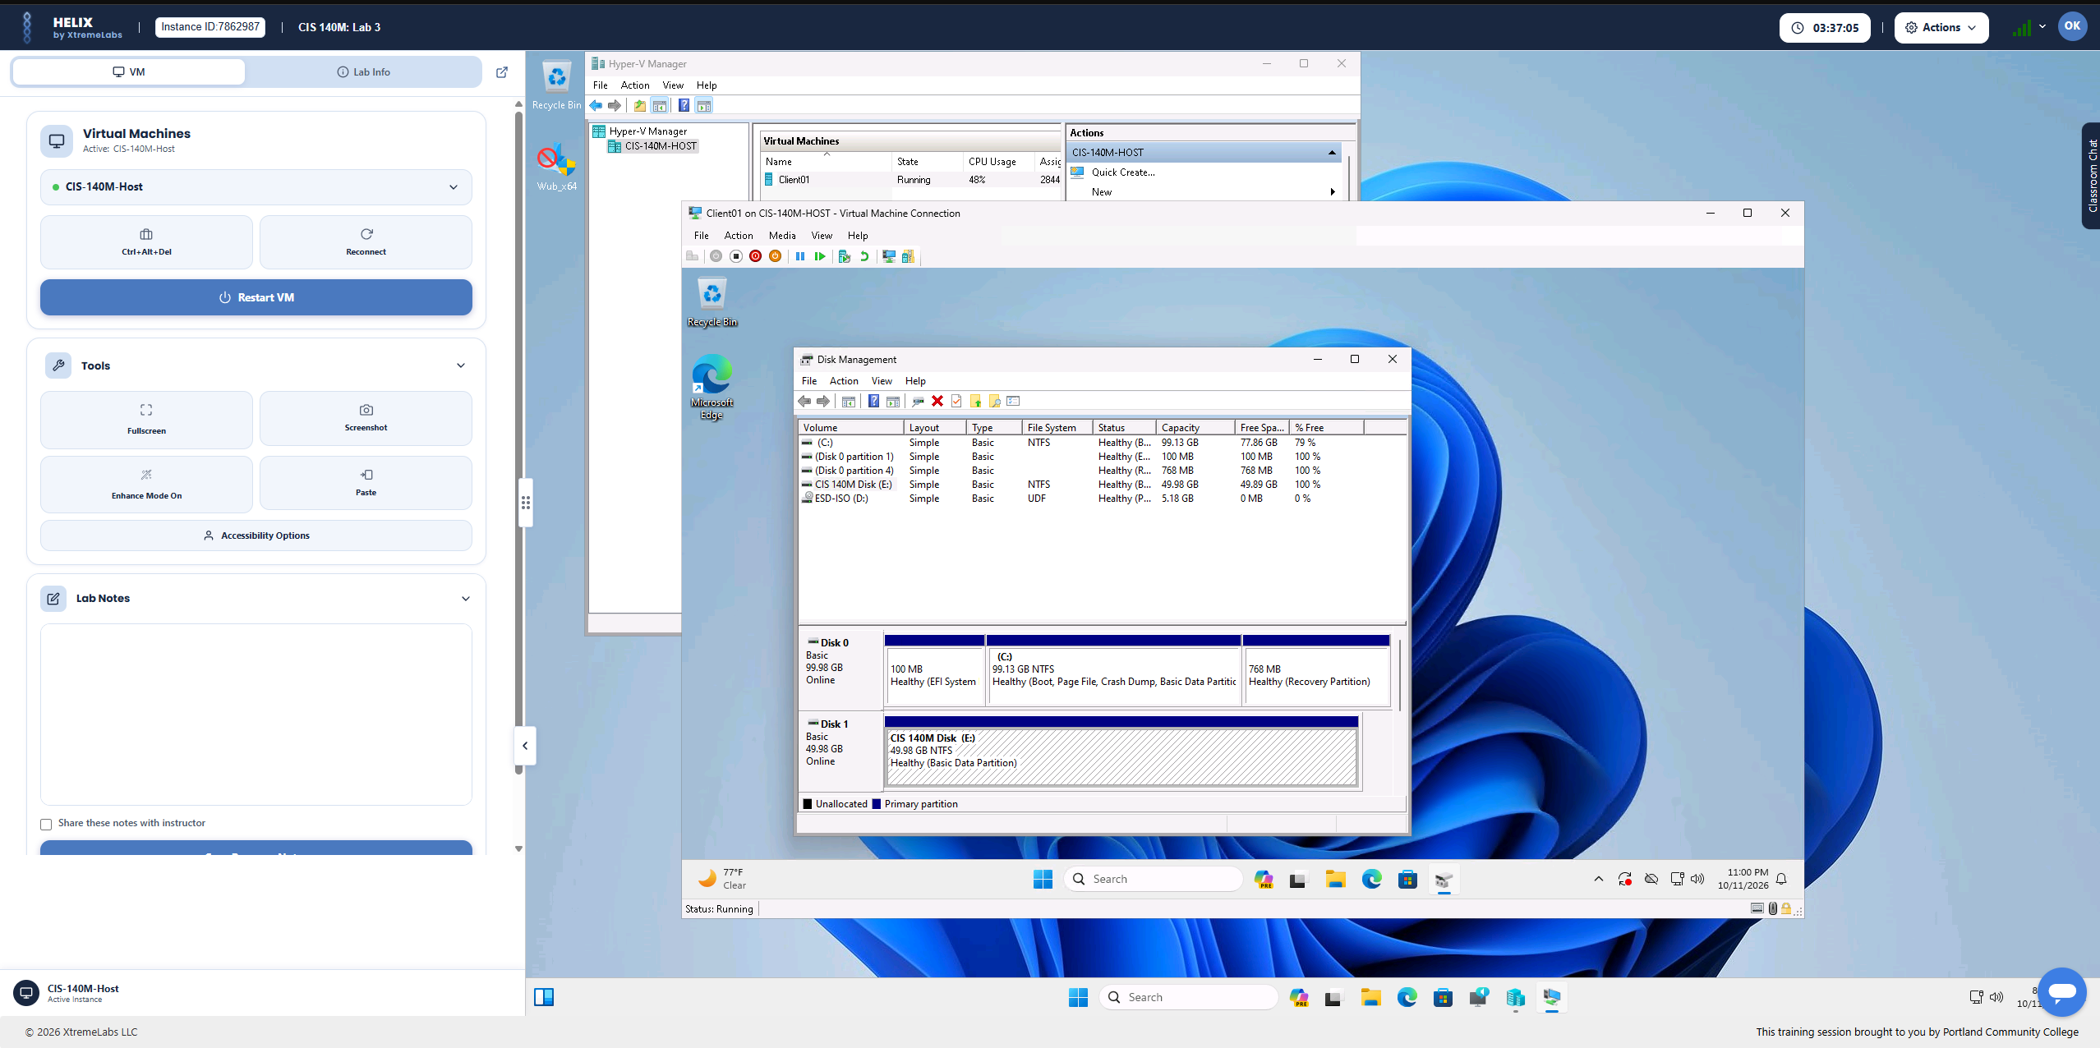
Evidence 2: Disk Management after disk configuration

3. Checking drive health
I used the Windows drive error-checking interface to scan a drive and review the successful scan message. This is useful for checking whether Windows reports file-system problems.
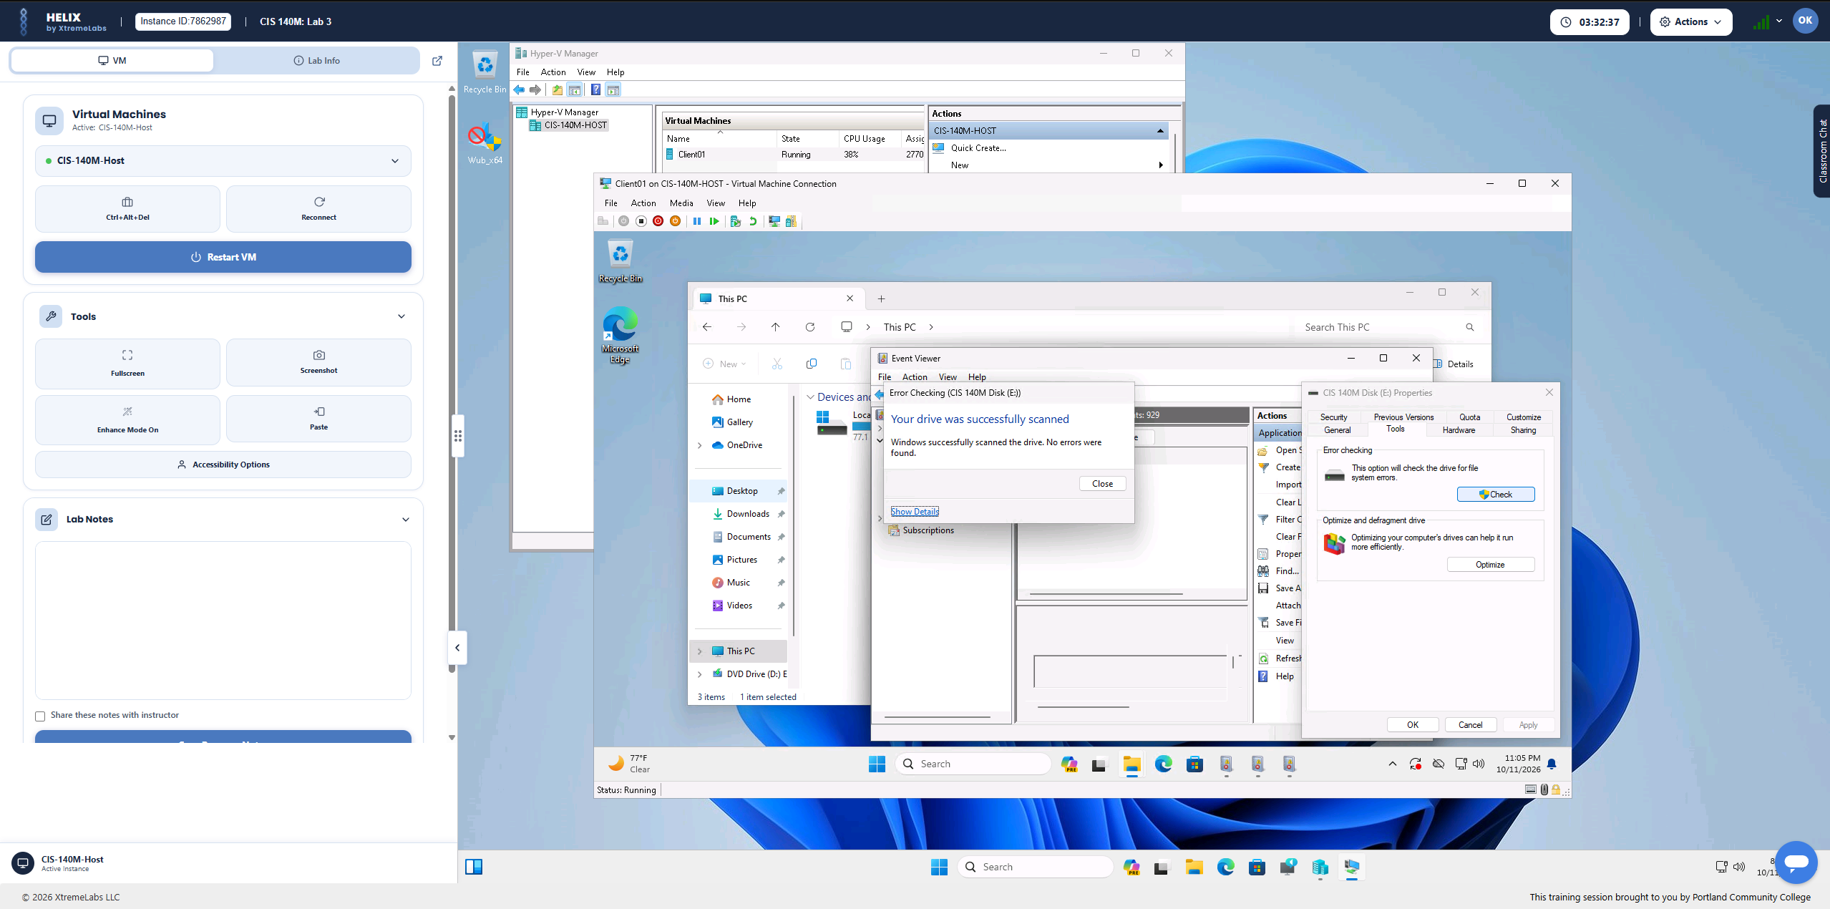
Evidence 3: Windows drive scan result

4. Reviewing drive optimization
I opened Optimize Drives and reviewed the status of drives C: and E:. Both were reported as OK with 100% space efficiency in the lab, so I concluded that no optimization was needed at that time. The appropriate optimization method depends on the drive type.
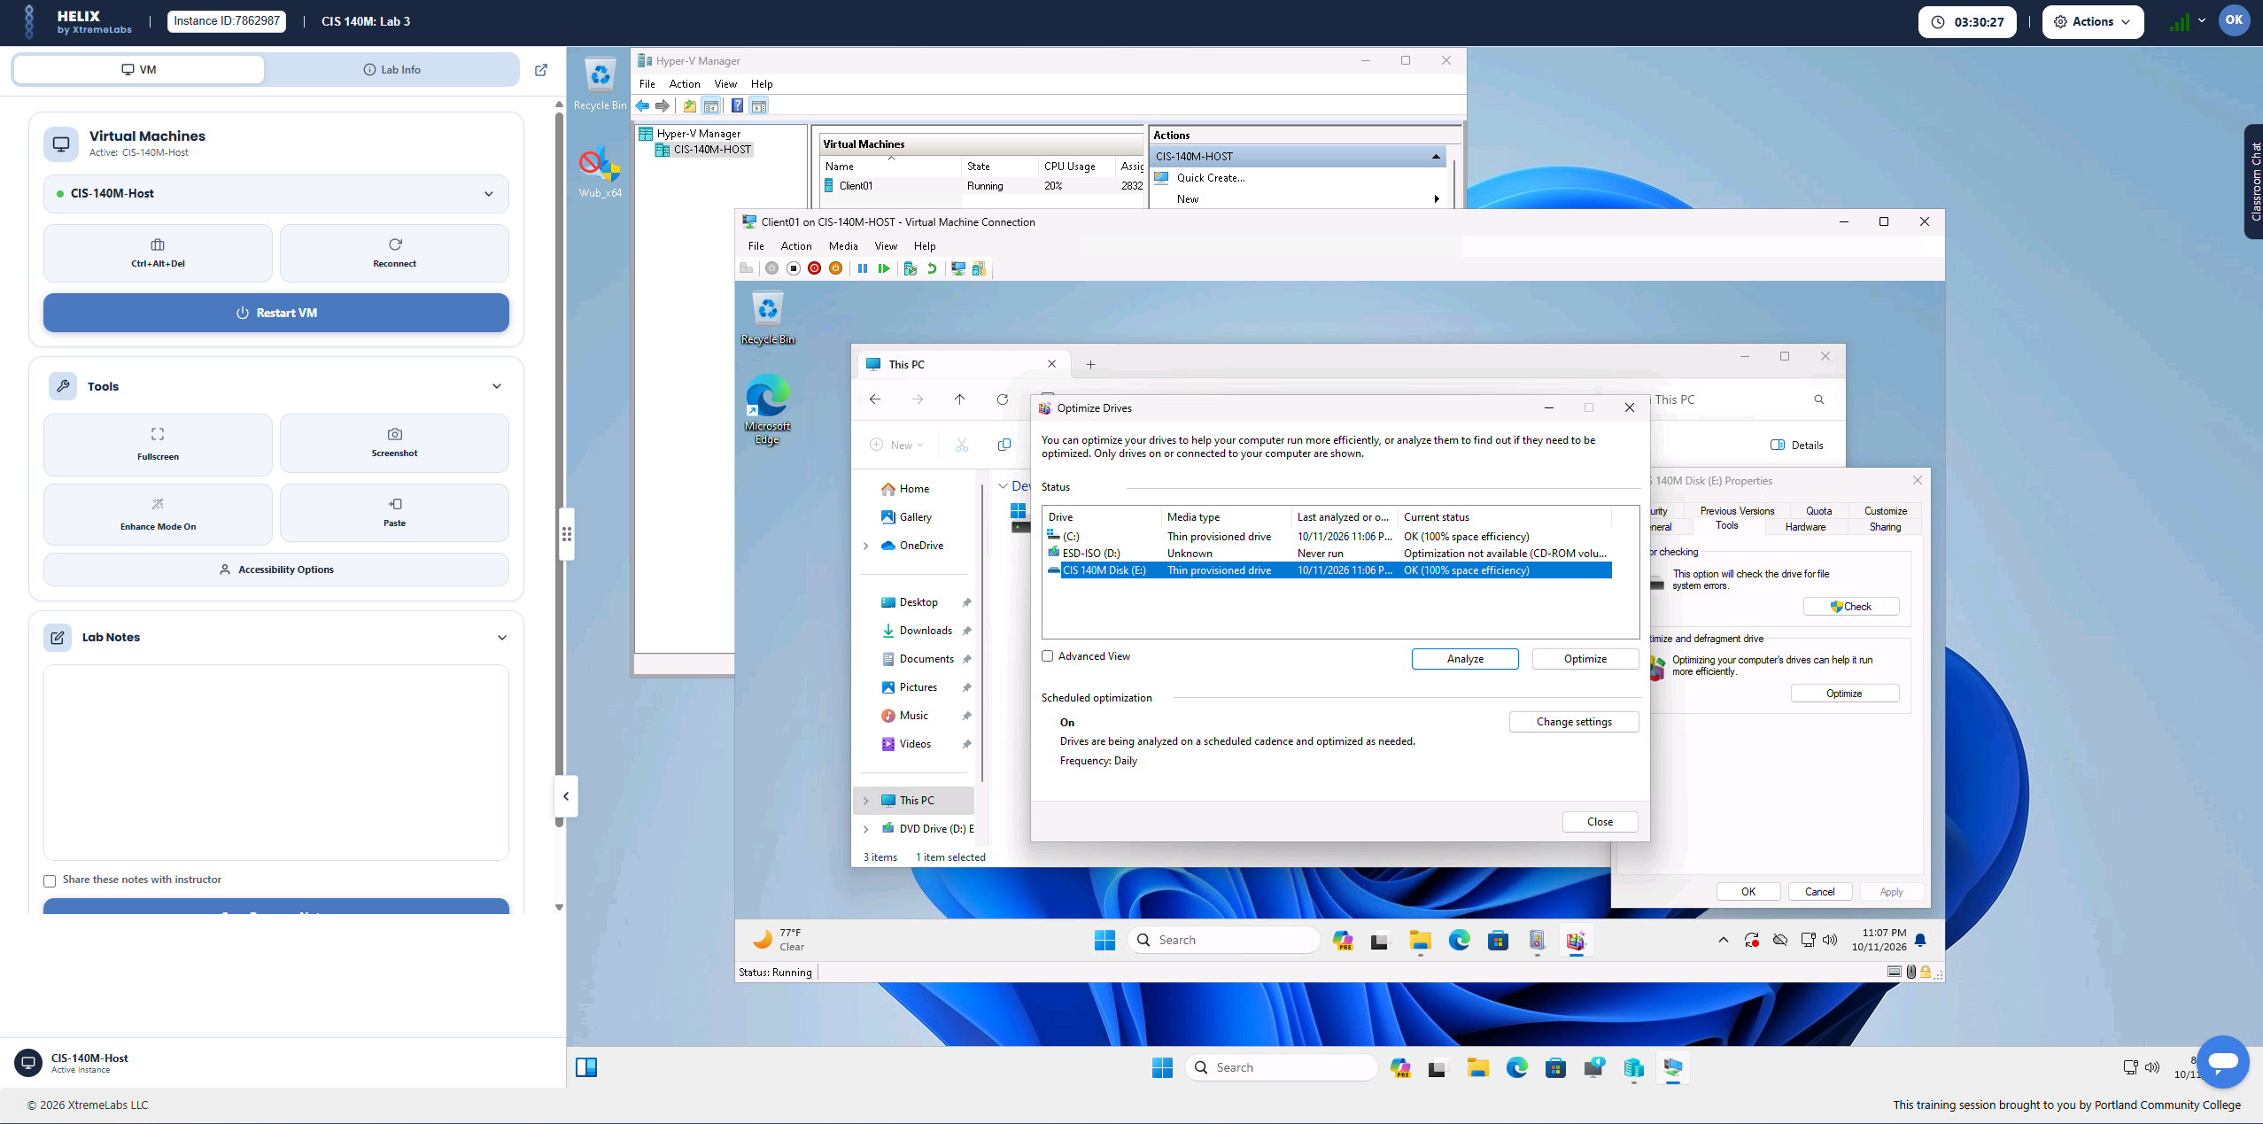
Evidence 4: Optimize Drives status window

5. Reading disk-check output
I used Command Prompt to display the disk-check results with the `type` command. I reviewed the three stages reported in the lab: file-system structure, file-name linkage, and security descriptors. The reported output showed 0 KB in bad sectors.
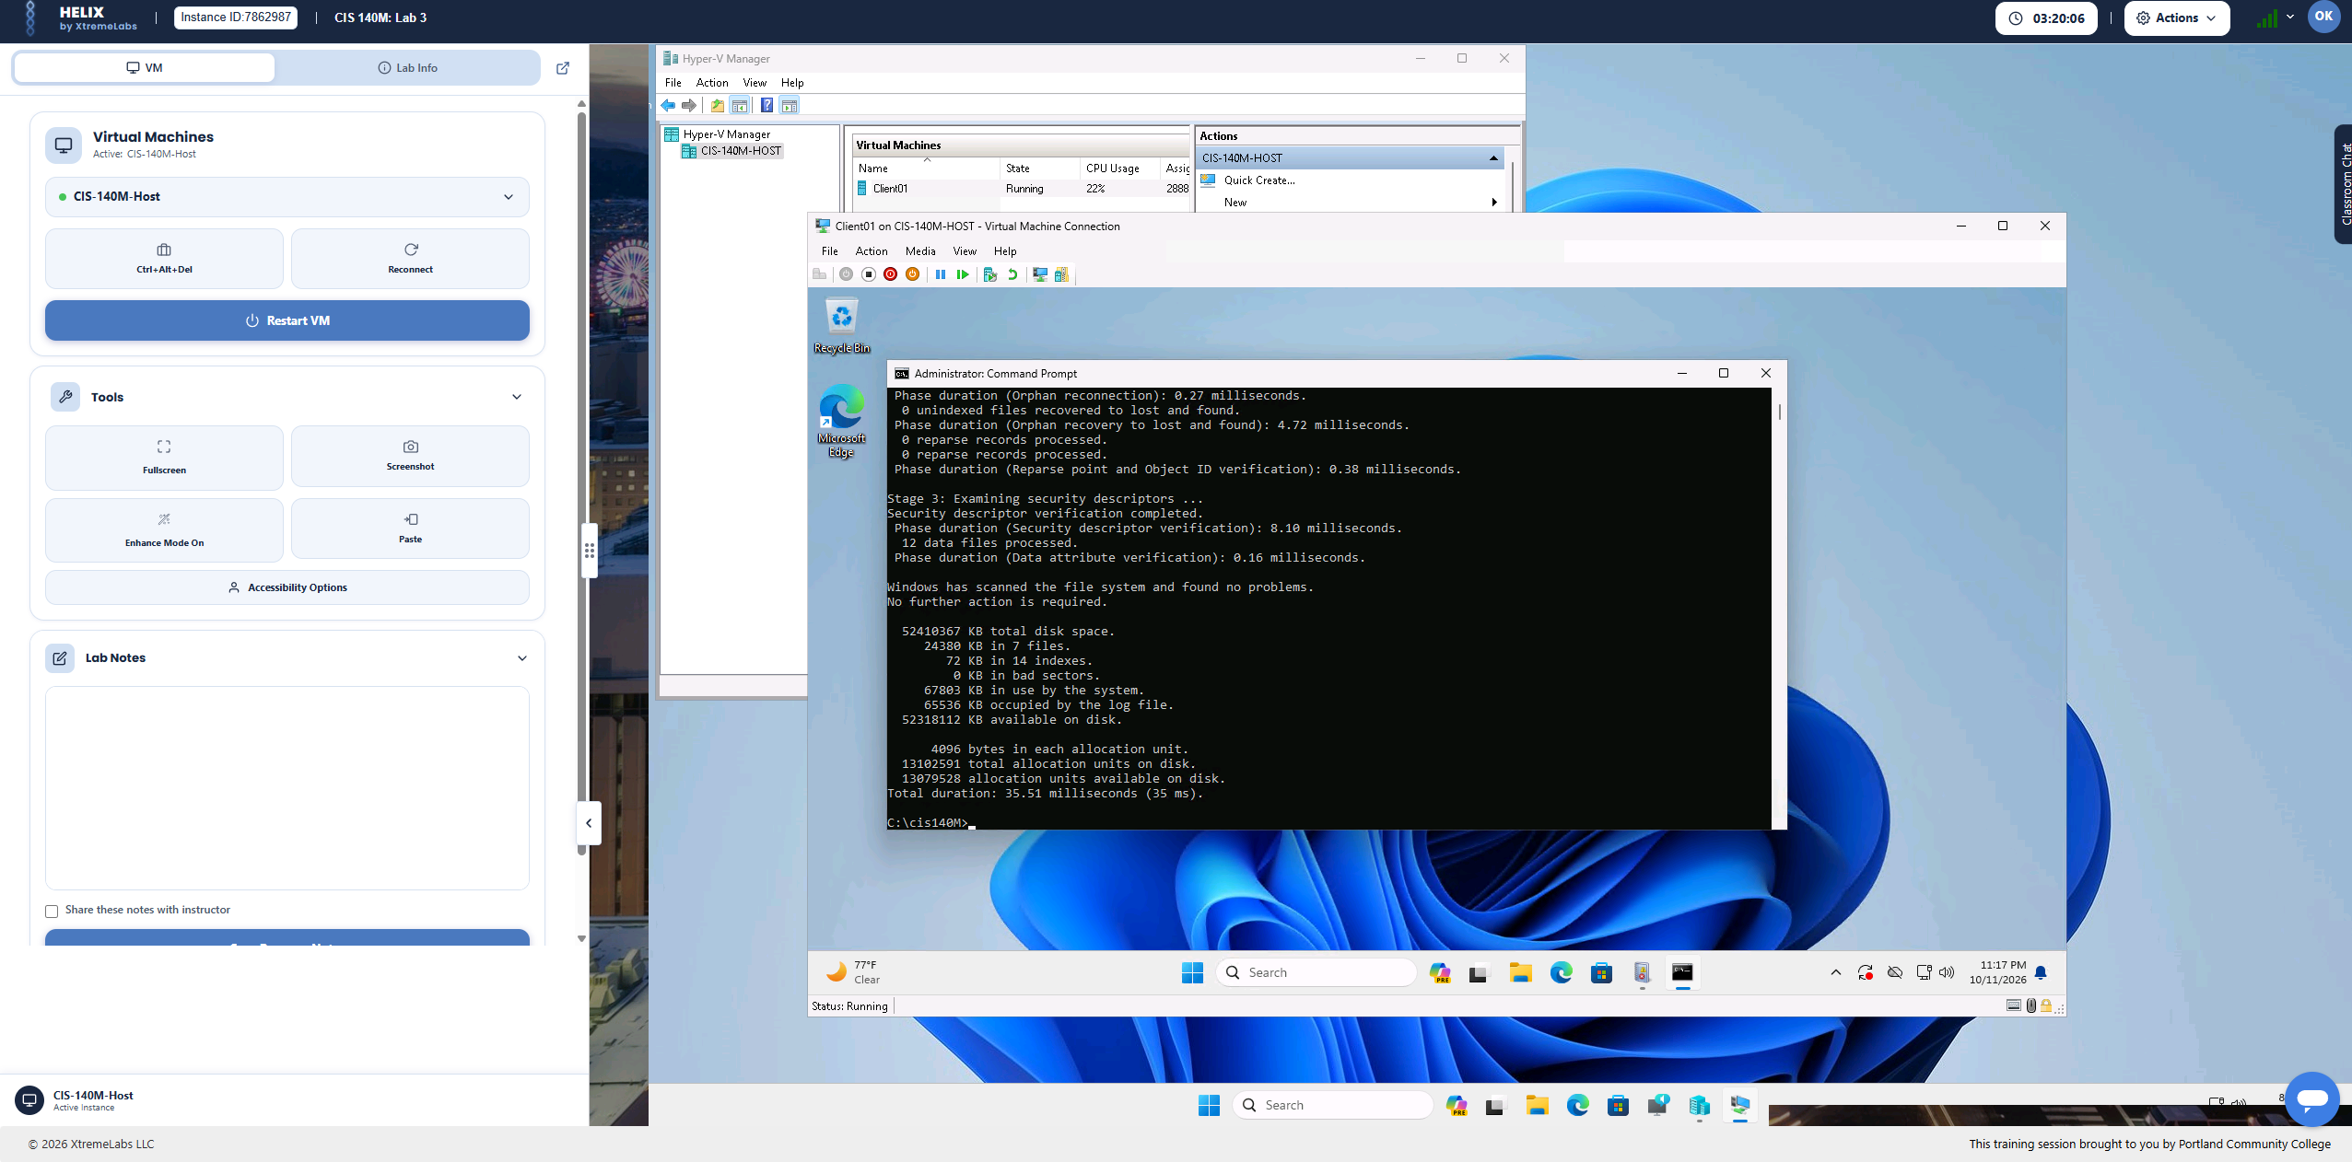
Evidence 5: Command Prompt displaying disk-check results

Additional system findings
C: total capacity | 99.1 GB
C: used space | 22.5 GB
C: free space | 76.6 GB
Display adapter manufacturer | Microsoft
Device status | This device is working properly
Driver date | June 21, 2006
Driver version | 10.0.22621.2861

Outcome and relevance to IT support
The lab gave me practical experience navigating Windows administrative tools, documenting disk configuration, interpreting basic disk-health results, checking available storage, and locating driver information. These are useful foundations for diagnosing user device and storage issues in a help desk or desktop support role.
Environment: Supervised academic lab simulation (XtremeLabs). Screenshots are from my completed coursework, not a production system.

