Boost for Climate Action as University, County Unveil New Strategy.
Efforts toward climate action in the Lake Basin region have gained momentum after Kaimosi Friends University (KAFU), in partnership with the Vihiga County Government, launched its Strategic Plan for the Center of Excellence in Climate Action and Research, which is domiciled at the University.
The launch of the Strategic Plan, which coincided with the commemoration of World Environment Day 2026 and was graced by Vihiga Governor Dr. Wilber Ottichilo, positions KAFU among the few institutions of higher learning in Kenya with a dedicated framework for climate action, research, innovation and community engagement.
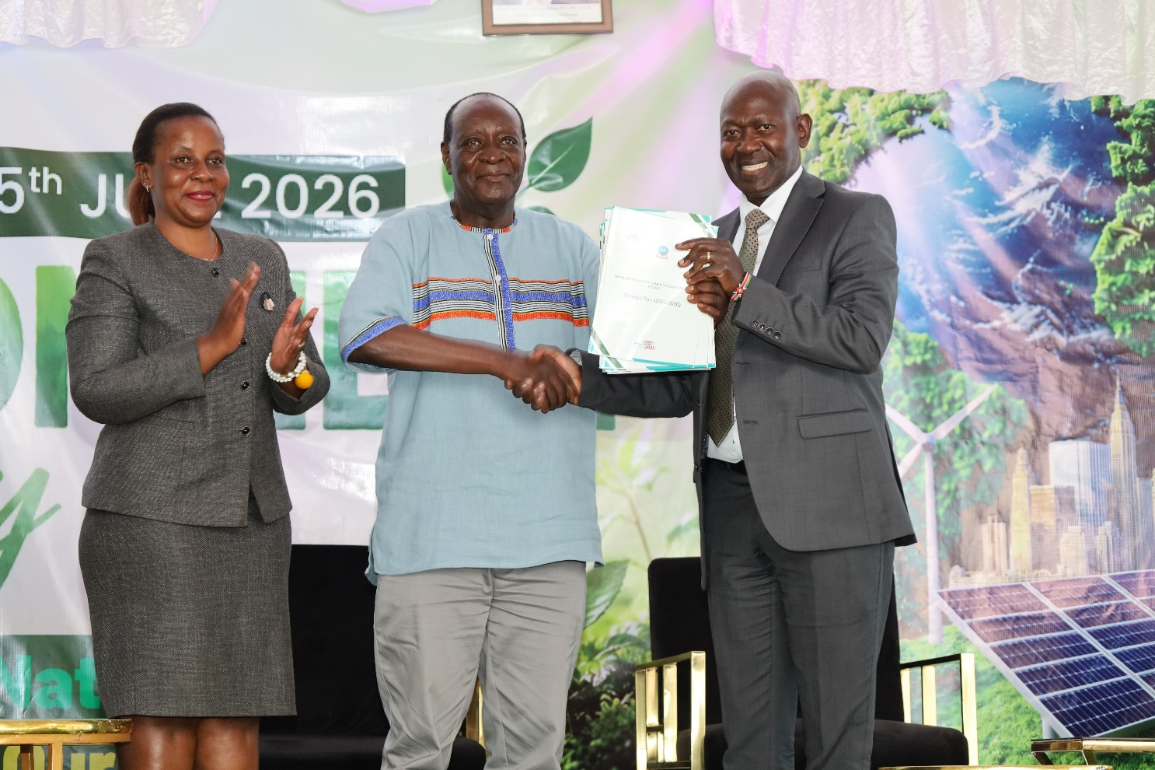
From right to left; Vice Chancellor Prof. Peter Mwita exchanges the launched Strategic plan with Vihiga Governor Dr. Wilber Ottichilo, looking on is CECARE Director Prof. Carolyne Mulinya.
The comprehensive plan provides a framework that addresses critical issues such as conservation, protection and restoration of biodiversity, resource diversification, revenue generation and strategic partnerships, impactful climate research, climate change adaptation and mitigation, innovative technologies, effective knowledge management and institutional capacity development.
Speaking during the launch of the Strategic plan, Vihiga County Governor Dr. Wilber Ottichilo who was the Chief guest lauded Kaimosi Friends University for impactful efforts towards climate mitigation and adaptation.
"KAFU has demonstrated leadership by providing a platform where research can be translated into practical solutions for communities. This strategic plan is a crucial document that will position the University among the very few institutions that are having meaningful impact in Climate action," he said.
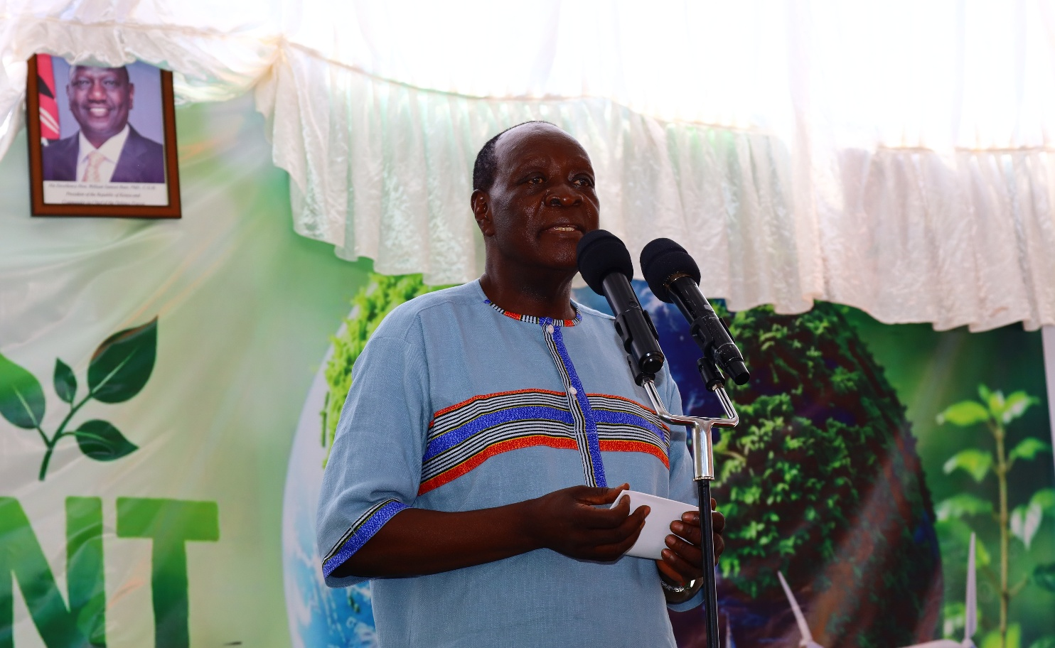
Vihiga Governor Dr. Wilber Ottichilo gives his remarks during the World Environment Day 2026 celebrations held at Kaimosi Friends University.
The Governor further pledged full support, emphasizing the importance of collective responsibility in combating climate change, noting that meaningful environmental conservation can only be achieved through partnerships involving government, academic institutions, communities and the private sector.
Kaimosi Friends University Vice Chancellor Prof. Peter Mwita highlighted the institution's efforts to position community members as champions of climate action through capacity-building initiatives and active participation in environmental conservation programmes.
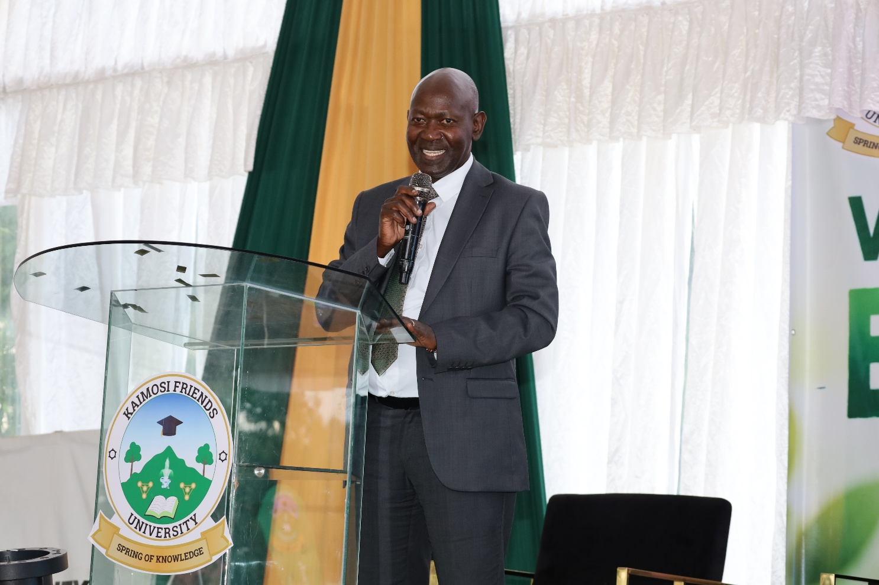
Kaimosi Friends University Vice Chancellor Prof. Peter Mwita addresses dignitaries and residents attending the World Environment Day 2026 and the launch of the CECARE Strategic plan.
"The Strategic Plan provides a roadmap for strengthening climate research, innovation, capacity building and partnerships. Through the Citizen Science Project, we are committed to working directly with the community to generate knowledge and provide solutions that contribute to sustainable development and environmental resilience," said Prof. Mwita.
Additionally, the Vice Chancellor hailed the University’s success in tree planting exercises noting that over 130,000 indigenous and exotic tree seedlings have been planted within the last two financial years. He assured that the University will continue to partner with the government and the community in improving forest cover.
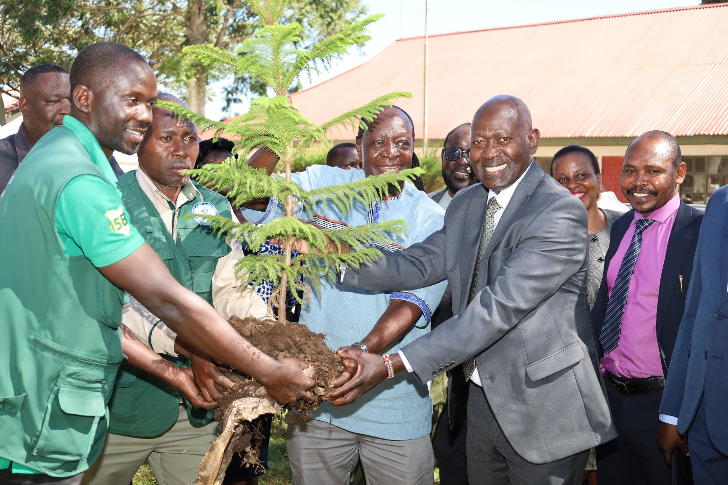
Vihiga Governor Dr. Wilber Ottichilo and the Vice Chancellor Prof. Peter Mwita lead participants in tree planting at the University grounds.
Highlighting the objectives of the Strategic Plan, the Director of the Centre of Excellence in Climate Action and Research Prof. Carolyne Mulinya expressed the Centre’s readiness in addressing Climate Change by fostering meaningful research and community engagements.
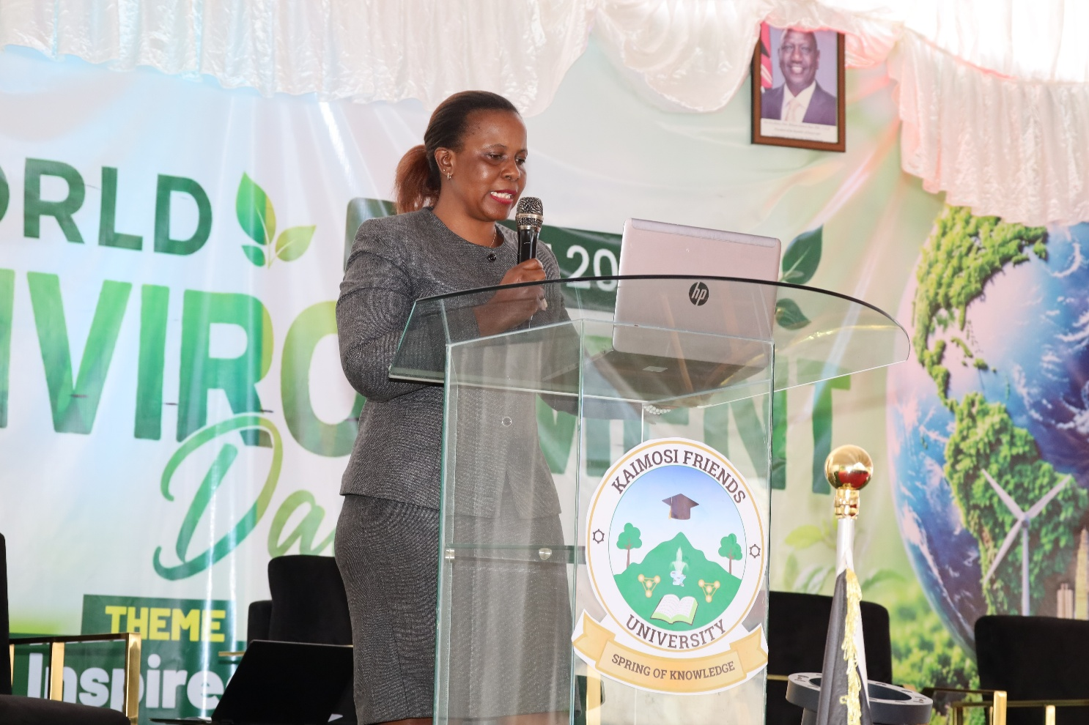
Director Centre of Excellence in Climate Action and Research Prof. Carolyne Mulinya presents the highlights of the CECARE Strategic Plan.
The Strategic Plan, which will guide the Centre's activities over the next four years, seeks to strengthen climate change research, promote sustainable environmental practices, enhance community resilience, support policy development and foster partnerships that drive climate action at local, national and global levels.
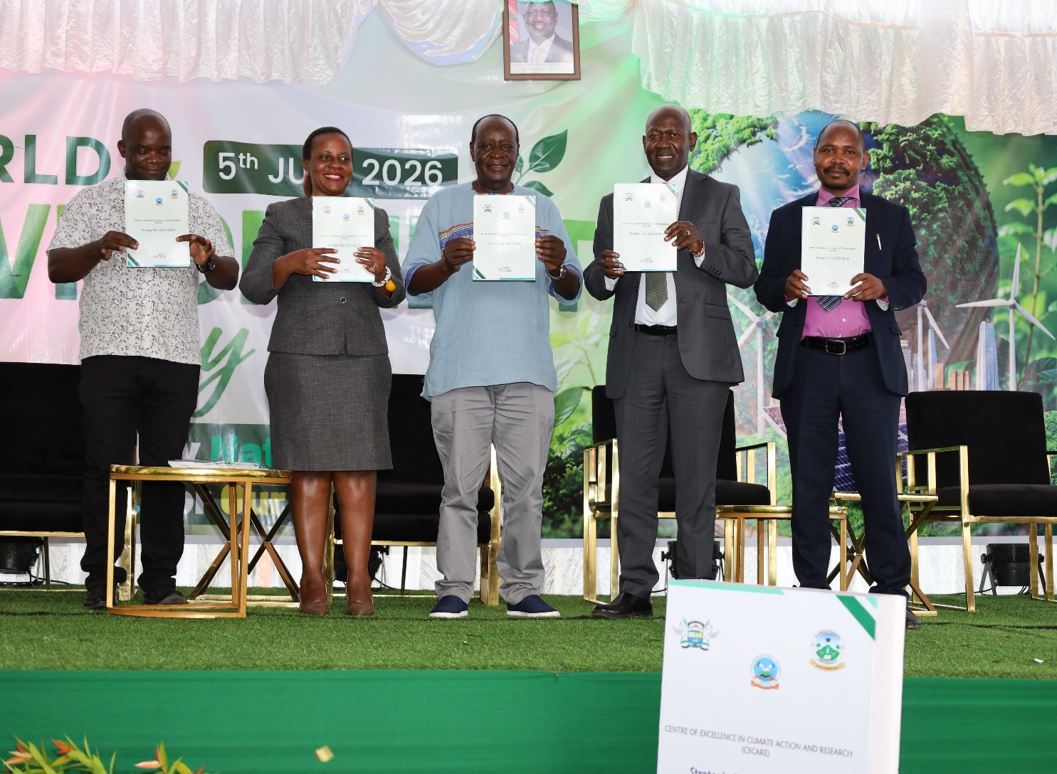
The Vice Chancellor Prof. Peter Mwita and Vihiga Governor Dr. Wilber Ottichilo display the newly launched Strategic Plan for the Center of Excellence in Climate Action and Research during the World Environment Day 2026 celebrations at KAFU.
This year's World Environment Day, commemorated under the theme "Rethinking the Systems that Power Our Economies and Repairing Our Relationship with Climate," brought together county leaders, researchers, environmental advocates, students and members of the public. Participants echoed the need for joint efforts in addressing climate-related challenges such as deforestation, biodiversity loss, extreme weather events and environmental degradation.
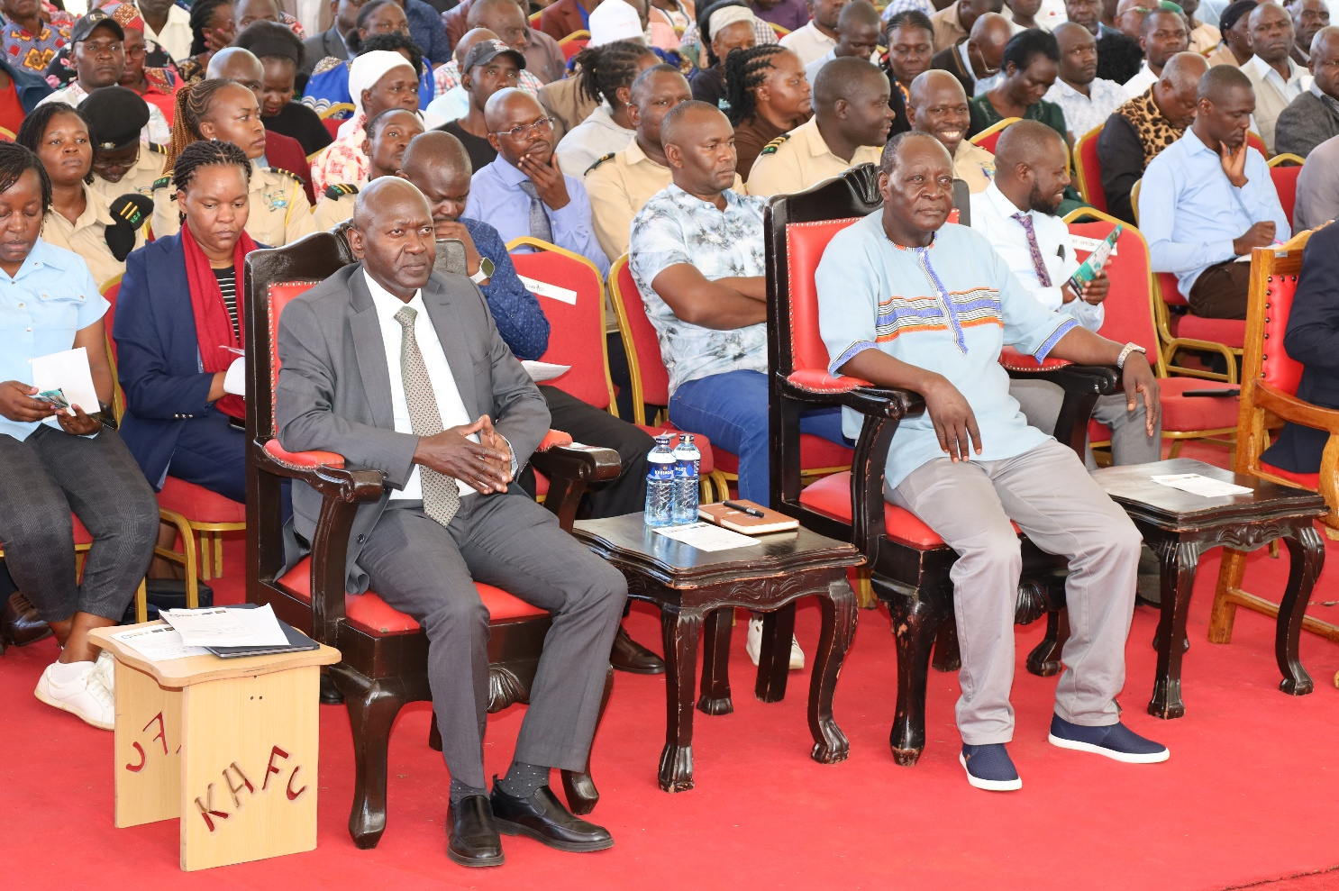
A section of participants follow keenly a panel discussion during the World Environment Day 2026 celebration at Kaimosi Friends University.
With the unveiling of the Strategic Plan for Climate Action and Research, Kaimosi Friends University has reinforced its position as a leading institution in climate research and sustainability while strengthening its partnerships with other institutions in the pursuit of a greener, more resilient future.

