Section 7. Terms of Reference

BACKGROUND
Water Sector Trust Fund (WaterFund) is a State Corporation under the Ministry of Water, Sanitation, and Irrigation (MoWSI) and established under the Water Act, 2016, with the mandate to assist in financing the provision of water services in areas of Kenya without adequate services. The WaterFund was first established under the Water Act, 2002, as the Water Services Trust Fund with the mandate to provide funding assistance towards water and sanitation projects to underserved low-income rural and urban areas.

WaterFund has continued to invest in the implementation of Water, Sanitation Services and Water Resource Management activities through the following investment programmes.

Rural Investments: These are programmes providing financial support to Implementing Agents in the underserved rural areas to apply for, manage, implement, and maintain their own water and sanitation facilities. The main stakeholders are the Community Based Organisations (CBOs) and Rural Water Services Providers in collaboration with the County Governments.

Urban Investments: These are programmes applied towards improvement of access to underserved Low-Income Areas in Urban Areas of Kenya. The key implementing partners in this approach are the Water Service Providers (WSPs) in collaboration with the County Governments.

Water Resources Investments: These are programmes for supporting Water Resource Users Association (WRUAs), promoted by the Water Resources Authority (WRA), to manage their water resources within sub catchments.

Results-Based Financing: In this investment programme, Water Services Providers and other implementing partners obtain project loans from commercial banks against bankable proposals. The WaterFund then subsidizes the implementer for the loan at an agreed percentage once deliverables / milestones are attained.

Research and Innovation Financing: Support towards financing of research and innovation initiatives within the sector. The outputs of these initiatives are geared towards generation of new knowledge in the sector, provision of innovative, practical, and cost-effective solutions in the realization of sustainable provision of water, sanitation, and sewerage services, in addition to water resources management as well as addressing gaps through collaborations and adaption of innovative models for better service delivery.

HORN OF AFRICA GROUNDWATER FOR RESILIENCE PROJECT (GW4R)

  - Problem Context – The Groundwater management and governance challenge
Although groundwater accounts for more than 97% of the world's freshwater supply, the general understanding of its availability, occurrence, and sustainable use remains limited and is still evolving. Its invisibility (being buried beneath the earth's surface) compounds the technical and political difficulty of its sustainable quantification, abstraction, and utilization for human development. While there have been significant investments in the abstraction of groundwater, the acquisition of knowledge on the status of groundwater resource base in most countries or the threats posed by poor land use, pollution, over abstraction, seawater intrusion, and even poor drilling techniques have frequently received inadequate investments. In Kenya, the unsustainable management and governance of groundwater presents numerous challenges. The majority of water policies favor surface water. Over the past two decades, the global development community has engaged in a variety of efforts to elevate and improve knowledge about groundwater at both the technical and policy levels, including the vast opportunities groundwater offers for enhancing adaptive capacity and resilience. Numerous global forums, such as the 9th World Water Forum, which was held in Dakar, Senegal, where the 2022 UN World Water development Report: Making the Invisible Visible was released, demonstrate the growing awareness of the importance of groundwater in water supply.

Regional Context of the Project
The Government of the Republic of Kenya (GoK), through the Ministry of Water, Sanitation, and Irrigation (MoWSI), has received a credit by the International Development Association (IDA) of the World Bank Group to implement the HORN OF AFRICA GROUNDWATER FOR RESILIENCE PROJECT (GW4R). The preparation of the GW4R project is built on the foundations of the Horn of Africa (HoA) Initiative. During the World Bank Group/IMF Annual Meetings held in October 2019 in Washington, D.C., the Ministers of Finance, and other representatives of the Horn of Africa (HoA) countries highlighted the importance of developing a coordinated approach and came together in the Horn of Africa Initiative, bringing the nations together to address shared regional challenges. The Intergovernmental Authority for Development (IGAD) convened the Finance Ministers of the Horn of Africa (HoA) countries on October 28, 2020, under the auspices of the Horn of Africa Initiative. As part of the HoA Initiative's Resilience Pillar, this meeting emphasized and ranked the importance of groundwater in the HoA region. Following the meeting, the Finance Ministries of Djibouti, Ethiopia, Kenya, and Somalia issued a communiqué in which they committed to continuing investment and policy action and urged development partners to accelerate the preparation and approval of projects they intend to support.

Project Scope and Components

The Development Objective of the GW4R project is to increase the sustainable access and management of groundwater in the Horn of Africa borderlands. The primary project beneficiaries will be an estimated 1,500,000 people in the rural communities of the five counties of Turkana, Wajir, Garissa, Marsabit and Mandera through the rehabilitation, construction, and sustainable management of boreholes as well as from aquifer restoration, recharge, and conservation activities. The project is also envisioned to benefit the institutions of Kenya that work on groundwater at the National, County, and transboundary levels. These include the Ministry of Water Sanitation and Irrigation, the Water Resources Authority, Water Sector Trust Fund, the Regional Center on Groundwater, the National Drought Management Authority, the County Water Departments of participating counties and Water Service Providers. By giving more visibility to groundwater through policies, strategies, regulations and guidelines, the institutions and groundwater management will be strengthened. These institutions will also benefit from training, capacity building programs and the acquisition of equipment required to undertake their mandate. The Project is structured to be implemented through the four components as shown in figure 1.

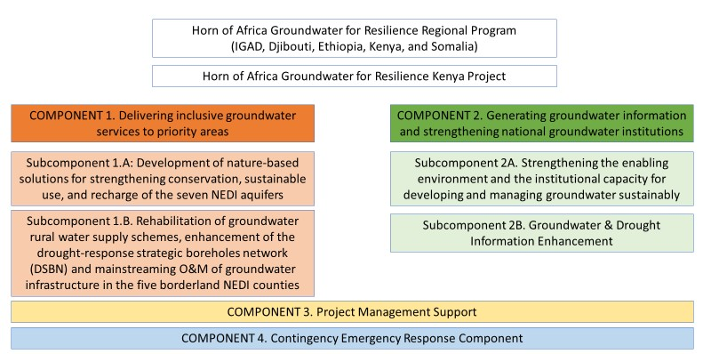
Figure 1 - Kenya GW4R Project Components

Rural Water supply management and governance in the ASALs of Kenya

In the Arid and Semi-Arid Lands (ASALs) of Kenya, groundwater plays a critical role towards building drought resilience. In times of drought, when surface water dries or pans silt up, communities particularly women and children, walk long distances in search of the few available productive boreholes. Drought does not only threaten the livelihoods and food security of these

71 | P a g e

communities (it is estimated that in the last decade drought related livestock losses amounted to US $1.08 billion), but also creates water tensions at the few available water points. This exacerbates conflict and fragility within Kenya, particularly in the borderlands.

The Kenyan ASALs remain historically the most under-developed part of the country and are the most vulnerable areas in terms of climate shocks and water scarcity. In order to build the resilience of vulnerable communities living in these areas, tapping the region’s groundwater’s potential is key. Strengthening the ability of these communities to better prepare for and respond to the impact of shocks and stressors, to adapt to change, and to potentially transform is of paramount importance. This requires robust groundwater development and disaster risk management that tackles the information and infrastructure challenges, as well as institutional and inclusion aspects at local, national, and transboundary levels.

Sustainable management of existing water supply systems is one of the main problems facing dry lands in sub-Saharan Africa and in particular the ASALs of Kenya today. Despite increased investments in rural water infrastructure in the region, the persistent lack of an effective approach to Operations and Maintenance (O&M) has led to a high failure rate of the existing groundwater- based small piped systems, often consisting of stand-alone boreholes, diesel generators and/or solar PV powered pumping systems, water storage tanks and short distribution networks to water kiosks and/or public taps. Various studies indicate that up to about two-thirds of rural water systems in the ASALs of Kenya become non-functional within 3-5 years post-construction.

The Kenya Water Services Regulatory Board (WASREB) recognizes that while the voluntary community-based management of small-scale water systems has been the de facto practice in rural Kenya for over three decades, the approach has failed to ensure sufficient post construction good management practices leading to the high failure rate of installed systems1. Additionally, these operational sustainability challenges are exacerbated by significant reduction of well yield during periods of intense drought coupled with increased demand arising from population and livestock migration.

In summary, key challenges to sustainably managing rural water supply systems (RWWSS) and strategic boreholes include: (i) the lack of preventive maintenance with the prevalence of a costly “Fix upon Failure” approach; (ii) underfunding of O&M by County Governments, with local budgets mostly allocated for capital investments; (iii) lack of user contribution to cost of service delivery and where present, inadequate tariffs limited by affordability of services, lack of economies and inadequate tariff collection; (iv) use of diesel pumping systems and other complex technologies that attracts high O&M costs beyond the ability of the users to fully pay for, (v) lack of an adequate information management system for rural WSS limiting sector-wide planning and evidence-based policies and decision making in day-to-day operations, (vi) lack of

1 WASREB, 2019. Guideline for provision of water and sanitation services in rural and underserved areas

enabling environment for professionalized water services delivery, capacity limitations, and poor accountability and oversight structures for the predominant community-based approach to O&M; and (v) lack of political commitment for O&M with a greater emphasis on access through new infrastructure as opposed to service delivery linked to affordability, reliability and safety of water services.

Women and children disproportionately bear the devastating burden of these water system failure. It is estimated that women and girls are responsible for water collection in up to 80% of the households with no water service on premises. These infrastructure failures further weaken community resilience to climate change-induced recurrent droughts in the ASAL regions. Therefore, rehabilitating existing RWSS and addressing the root causes of low reliability/functionality of RWSS, through institutional reforms on the systems for Operation and Maintenance (O&M) in place, and systematically aligning strategic borehole networks to effectively and efficiently respond to predictable emergencies presents a low-hanging fruit for immediate implementation under the GW4R. This is true, among others, since it is more economical (as it utilizes sunk costs) and could quickly deliver the scarce and much required water service. In addition, the spillover effect of such investments may further influence other stakeholders to make similar new investments. In turn, this may contribute to national efforts of instilling sustainability by planning and working towards sustainability as part of programmes design.

Project Background

The Government of the Republic of Kenya (GoK), through the Ministry of Water, Sanitation, and Irrigation (MoWSI), and with financial support from the International Development Association (IDA) of the World Bank Group, is implementing the HORN OF AFRICA GROUNDWATER FOR RESILIENCE PROGRAMME (GW4R). The overarching Project Development Objective (PDO) is to increase the sustainable access and management of groundwater in the Horn of Africa borderlands. The primary project beneficiaries will be an estimated 1,500,000 people in Kenya living in the rural communities of the five counties of Turkana, Wajir, Garissa, Marsabit, and Mandera. This will be achieved through the rehabilitation, construction, and sustainable management of groundwater-based sources as well as aquifer restoration, recharge, and conservation related investments.

The project will also benefit the government institutions in Kenya that work on groundwater at the transboundary, National, and County levels. These include the Ministry of Water Sanitation and Irrigation, the Water Resources Authority, the Water Sector Trust Fund, the Regional Center on Groundwater, the National Drought Management Authority, County Water Departments (CWDs) and Water Service Providers of the participating ASAL Counties. By giving more visibility to groundwater through policies, strategies, regulations, and guidelines, the institutions and groundwater management will be strengthened. These institutions will also benefit from

73 | P a g e

training, capacity-building programs, and the acquisition of equipment/tools required in carrying out their respective mandates. GW4R is structured to be delivered in four components as follows.

Component 1: Delivering inclusive groundwater services to priority areas

This component will fund groundwater conservation, infrastructure development and service delivery improvement activities in the five borderland counties of Turkana, Marsabit, Mandera, Wajir, and Garissa. The component comprises two interrelated sub-components:

    - Sub-component 1.A: Development of nature-based solutions for strengthening groundwater conservation, sustainable use, and recharge of seven selected aquifers in the ASALs of Kenya including (i) Elwak aquifer, (ii) Merti aquifer, (iii) Neogene (Lamu Embayment) aquifer system, (iv) Lotikipi Basin aquifer system, (v) Lodwar/Napuu aquifer system, (vi) Walda/Rawana aquifer system, and (vii) the Logologo-Shuur aquifer system.
    - Subcomponent 1.B: Rehabilitation of an estimated 400 number groundwater-based rural water supply schemes, enhancement of the designated drought-response strategic boreholes network, and mainstreaming Operations and Maintenance (O&M) of groundwater infrastructure in the targeted five counties.

Component 2: Generating groundwater information and strengthening regional and national groundwater institutions

This component will finance activities focused on strengthening the enabling environment for sound groundwater development and management through two interlinked subcomponents:

    - Subcomponent 2.A: Strengthening the enabling environment and the institutional capacity for developing and managing groundwater sustainably. The aim is to (i) support the development of a groundwater management and development Strategy, Guidelines and Regulations; (ii) Address institutional gaps in transboundary instruments for the management of shared aquifers through the completion of Transboundary Waters Policy, and related Memorandum of Understanding (MoUs) with riparian countries; and (iii) Support groundwater management capacity improvements across national and subnational institutions.
- Subcomponent 2.B: Groundwater and Drought Information Enhancement: Enhancing the knowledge base on the aquifer systems and the usability of this knowledge for management and development purposes through (i) comprehensive Aquifer assessments, and the preparation of development and management plans for the (i) Elwak aquifer, (ii) Merti aquifer, (iii) Neogene (Lamu Embayment) aquifer system, (iv) Lotikipi Basin aquifer system, (v) Lodwar/Napuu aquifer system, (vi) Walda/Rawana aquifer system, and (vii) the Logologo-

Shuur aquifer system; and (ii) enhancing groundwater knowledge and information sharing through the upgrade of the existing groundwater database and the development of a mobile App to improve users’ interface with the database. The project will also include development of Nairobi and Nakuru aquifer management and development plans.

Component 3: Project Management Support

This component will fund operational costs of the National Project Coordination Unit (PCU) at MoWSI and the Project Implementation Units (PIUs) at WRA, and WSTF, and the Sub-PIUs at the five target County Governments to manage the project efficiently.

Component 4: Contingent Emergency Response Component
This component is provided as contingency measure to finance eligible expenditures under the Immediate Response Mechanism (IRM) in case of natural or man-made crises or disasters, severe economic shocks, or other crises and emergencies in the project area.

GW4R will be implemented over a period of five years, with the tentative start and end dates being July 2022 and December 2028 respectively.

Onboarding and M&E System of the Regional Program
To ensure effective supervision and monitoring in this complex environment, the World Bank team with CIWA donor support is developing, an onboarding and monitoring tool to register all project sites, cross-check their eligibility, and allow quarterly monitoring of its progress. This tool develop in close consultation with the client will allow supervision and aggregation of data from the three participating countries and IGAD. The data generated from this tool will become key for the project quarterly and annual monitoring reports, to ensure adaptive management and inform upcoming projects. This digital and georeferenced project monitoring dashboard (GW4R dashboard) will feed from a variety of questionnaires as well as County owned datasets. All project actors will be trained and familiarized with these tools for cohesive and coordinated implementation. The consultant is expected to actively interact with these tools and monitoring dashboard.

75 | P a g e

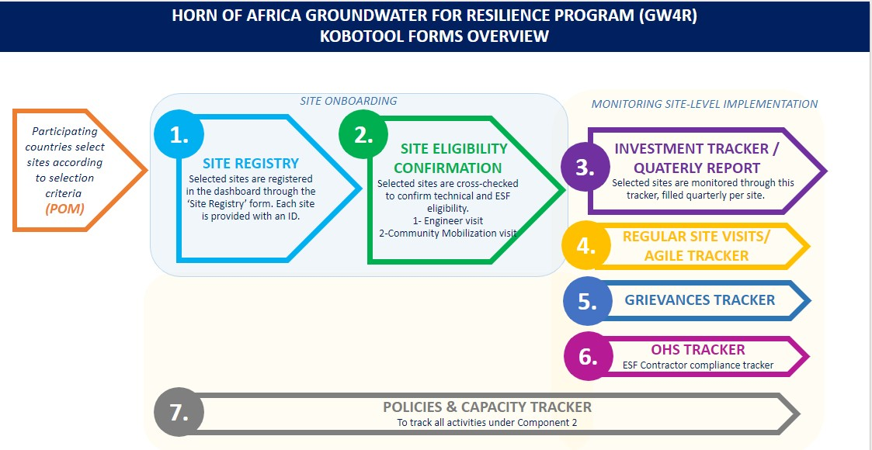

Introduction to Sub-Component 1B of the GW4R

Subcomponent 1B of the GW4R will support: (1) rehabilitation of groundwater rural water supply schemes (RWSS), (2) enhancement of the designated drought-response strategic boreholes network (DSBN), and (3) mainstreaming of operation and maintenance (O&M) of groundwater infrastructure through a Performance-Based Grants (PBGs) mechanism. The aim is to build resilience of rural communities and water service providers by supporting the establishment of institutional measures for guaranteeing O&M of rural water, for reliable and sustainable services.
Further details on specific investments to be financed through the PBG mechanism under Subcomponent 1B are provided below:

- Rehabilitation and upgrading of groundwater rural water supply schemes - This activity will finance civil works on rehabilitation and upgrading of existing groundwater-based rural water supply schemes (RWSS), to improve the quality of service. Approximately 400 rural schemes will be earmarked for this investment.
- Mainstreaming of O&M for existing, rehabilitated, and new boreholes, through an O&M Support Facility - This activity will finance sustainable O&M of existing, rehabilitated, and newly developed RWSS in the five target counties. Counties, however, will be required to satisfy various operational performance conditions to benefit from any PBGs under the O&M support facility
- Strengthening and enhancement of the DSBN through rehabilitation and upgrading of existing boreholes, and drilling of new strategic boreholes - This activity will finance the civil works to rehabilitate and/or drill new high yielding boreholes in the five counties to increase coverage of the DSBN.

Over the six-year project period, incentives will be disbursed to the five target County Governments as PBGs contingent on achievement of the following performance objectives:
    - Establishment of the necessary institutional systems for strengthening sustainable O&M of RWSS.
    - Satisfactory completion of civil works on rehabilitation of existing RWSS and expansion/drilling of RWSS/DSBN.
    - Continuous operational functionality and financial performance of installed RWSS.

The WaterFund is the managing entity for the PBG facility, and will provide the necessary Technical Assistance (TA) through the GW4R to all five participating Counties to support successful delivery of the investment activities above.

OBJECTIVE OF THE ASSIGNMENT

The main objective of this Consultancy assignment is to support the County Water Departments of Turkana, Marsabit, Wajir, Mandera and Garissa counties to develop, install and implement a web-based Management Information System (MIS) for the O&M of RWSS. The MIS will not only document sub-projects supported by programme but also investments supported by County Water Department, NGOs and other WASH partners within the Counties.

Building from the inventory conducted during year 1, the system should be designed to have geospatial, water assets inventory, and performance monitoring capabilities, and be able to facilitate collection of relevant data on key water supply operations and maintenance indicators and their use to support decision making by different sector stakeholders, both internal and external. Further, the MIS system should enable county water sector monitoring and reporting and allow for integration with other relevant MIS platforms such as those used by WASREB for Regulatory purposes and the Water Resources Authority’s groundwater information management system.

SCOPE OF THE ASSIGNMENT

The consultant is expected to propose the best approach for undertaking this assignment, covering the design/customization of a new (or improving an existing web-based MIS currently used by the CWD), geographical information system and subsequently the linking and integration of the system with existing national and county databases and systems, and monitoring technologies.

The MIS platform should enable remote data collection and updating by the County Water Departments (CWDs) and various designated operators to provide O&M services under the CWD's delegated authority in the five counties. In addition, the system should support restricted

77 | P a g e

access to data and sector performance reports by identified national or county WASH stakeholders, including members of the public for accountability.
The consultant is, among others, expected to undertake the following specific Tasks in relation to this assignment:

Task 1: Complete a review of past and existing systems applied by the CWD for monitoring rural water services delivery in the 5 counties:

Under different projects/programmes in the recent past, and some still on-going, the 5 counties have at different times developed monitoring systems for the O&M of rural water schemes. Some of these are still functional while some are non-functional. In this regard, the consultant will:

  - Review the functionality status of current/previous MIS systems used at any point to monitor rural water services in each county. The review will assess the basis of design (including system architecture), operating requirements both hardware and human resource, performance, compatibility with local operations, reasons for non- functionality (for systems that are non-functional), and synthesize key lessons learnt and best practices that should inform the upgrading, improvement, or design of a new Management Information System (MIS) and Decision Support System (DSS) for the operation and maintenance of rural water supply systems.
  - Analyze all available rural water systems inventories at MoWSI, the WSTF, the WRA, and all the five counties, and further overlay the asset inventory dataset to be collected through Activity 4 (Inventory Consultancy) under sub-component 1B of the GW4R to understand formats, data cleaning/quality control, fill emerging gaps, and map out available (versus required) fields/data properties for the asset inventory and operational indicators for the O&M monitoring. This task should also be informed by the commonly used metrics in the sector at various levels starting from the RWSS operator, CWD, County, to National.
  - Hold consultations with relevant actors at county and national level, including the WASREB, WRA, NDMA and other partners of the county water department working in performance monitoring/regulation or on similar MIS and familiarize with existing databases to consolidate possible database interoperability with WASREB’s Regulation Information System (WARIS), the Water Resources Authority (WRA) groundwater database, and the National Drought Management Authority (NDMA) Drought Strategic Borehole Network (DSBN) database.
  - Synthesize the above collected information from the various reviews and consultations so as to understand the current monitoring practice, tools, roles and responsibilities and gaps. The synthesis should aim to answer the following key questions, among other aspects:

    - What database platform will be most feasible for the ASAL contexts and their information needs?
    - Can the MIS objective be achieved without duplication i.e., expanding or tweaking/adapting available MIS systems in the sector for standardization?
    - What are the technological needs and costs to Counties and other users in maintaining the MIS?
    - Who will do what, with respect to data collection, quality control, analysis, reporting and access?
    - What functional system features are necessary?
    - What information will be required or presented for the Management Dashboard?
    - What are the critical processes needed to generate and sustain flows of the required information products from the MIS?
    - What data and metadata standards will be employed?
    - What procedures will be used to ensure quality control (accuracy, integrity, and completeness)?
    - How will data storage and preservation be handled?
    - How will data security management (access, erasure, security, privacy) be ensured?
    - How will long-term access be ensured?

Task 2: Design of the MIS and DSS to support O&M of RWSS:

Based on the outcomes of Task 1, the Consultant is expected to apply relevant data to design the core architecture of a cost-effective and low maintenance Management Information System and Decision Support System that the county water departments shall use to monitor, manage and inform the Operation and Maintenance of all RWSS in their respective county.

In designing the MIS, the consultant shall take into account the design factor that people, and processes are most critical for the success of technology solutions, see figure 1.

79 | P a g e

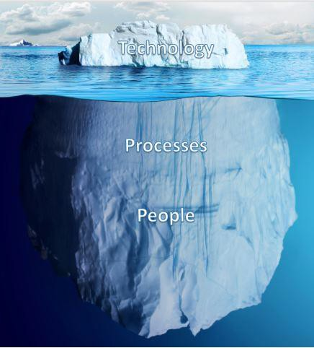
Figure 2: Technology, people, process nexus in design

In so doing, the consultant is expected to:

- Develop/adapt a web-based management information system with appropriate security arrangements (e.g., for data backup, data security, and allocation of access rights etc.). The MIS should;
  - Be open access for GW4R Counties and not attract recurrent license (or other) fees.
  - Respond to (1) ongoing digital asset inventorying needs of Counties, and (2) sector performance monitoring and reporting objectives, and build on already existing efforts and successes for efficiency and avoidance of duplication.
  - Be implemented using modular system development approaches, which will include piloting, beta testing, customization of each module, and user acceptance testing.

- Develop/adapt a mobile application for collecting and visualization of data, with offline data collection and access capability. The mobile app should be accessible to County-identified operators and field government officers and facilitate regular and remote reporting on individual RWSS performance for a given period based on indicators/templates to be developed with users.
- Integrate a GIS / mapping feature in the MIS system and mobile App to provide spatial perspective to diverse project status data
- Design an online dashboard with maps, charts, tables, graphs, etc. for ‘real-time’ data visualizations in order to ensure that the parameters tracked are captured,

conveyed, stored, processed, aggregated, visualized, and reported in an adequate and timely manner to support RWSS performance review and adaptive decision-making. The dashboard designs must be validated with WASREB, Counties, their WASH stakeholders, and should be customized and respond to individual Counties monitoring and reporting requirements and obligations.
- Integrate a reporting module in the MIS to enable publishing and sharing of reports (and bulk data if needed) in various standard formats by the users.
- Develop a user manual and integrate it as a module in the MIS, and provide the system documentation and guarantee availability technical expertise in future to support maintain/improve MIS as part of business continuity planning.
- The Consultant shall provide the detailed MIS system architecture diagrams and any other technical material that may be required for effective implementation of the MIS.
- Provide specifications of the necessary hardware the counties are expected to purchase to operationalize the MIS and support the county towards preparation of procurement documents. The consultant shall provide their technical opinion to the county during the procurement process particularly in the technical evaluation of submitted bids/offers.

Task 3: Implementation support and Technical backstopping to the CWD for operationalizing the MIS and DSS for RWSS

Under this task, the Consultant is expected to:
- Facilitate/supervise installations and testing of the functionality and operation of the proposed MIS and DSS, and address any key issues resulting from the testing period
- Conduct system training of users on system functionalities, including data extraction, analysis, aggregation, visualization, reporting/transfer, and management. The training should clarify/define system roles and responsibilities and access rights for users, including the administrators.
- Guarantee a 24-months defects liability period and warranty, for technical support to the counties to address emerging issues on the installed MIS. The WaterFund shall hold a proportion of the consultant remuneration to be paid only after the defects liability period has successfully ended.

DELIVERABLES

- A comprehensive inception report clearly specifying how tasks will be carried out including the proposed MIS platform, methodology, the work plan and tentative delivery date as part of the application
- Software requirements specification (SRS) document
- A web-based management information system

81 | P a g e

- A mobile application for collecting data and visualization of data.
- An inbuilt GIS / mapping system with spatial perspective of the project status data
- User testing and acceptance, and Training report
- User manual, source code and system administrators training report
- 24 months warranty (hand holding period) that shall include system maintenance such as fixing bugs and system maintenance.
- It is envisioned that a 24-36 months maintenance contract may be required after the defects liability period (hand holding)
- A comprehensive final report with delivery of all system documentation, the source code for official handing over.

CONSULTANTS QUALIFICATIONS AND EXPERIENCE

This assignment will require an experienced ICT services provider with requisite staff that have sound academic and professional training, as well as solid experience in ICT, Water Sector monitoring at scale preferably in sub-Saharan Africa, and RWSS operations and maintenance.

In order to fulfil the assignment, the firm must have the requisite expertise to plan the projects’ implementation, manage the overall assignment, manage the developers, and undertake the quality control of the final products and advice the WaterFund on any inherent project risks and mitigation measures.

Profile of the Consultant Firm and Developers Experience of the Firm
The Consultant firm must have at least 10 years’ experience in undertaking similar projects. Previous proven experience of similar work is essential. The consultant firm must meet the following minimum criteria:
- At least 10 years in the development, rollout and management of ICT projects
- At least 5 similar projects undertaken in the water sector
- Meet all the statutory requirements for a service provider of ICT services (specified under preliminary criteria)
- Have a local representation in the team.

The successful bidder/firm will be required to provide information on the Beneficial Ownership using the Beneficiary Ownership Disclosure Form to be provided, to be published as part of the Contract Award Notice.

Technical Expertise of the firm
It is essential that the Consultant firm should have the necessary personnel undertaking this assignment with academic and professional qualifications and extensive experience in ICT systems development and management, with a profile meeting or exceeding the scope detailed in these terms of reference. It is important that their profiles should include verifiable and operational reference MIS systems or projects with which the WaterFund can benchmark. The firm should be able to identify bottlenecks and challenges in the project implementation, if any, and make appropriate recommendations.

Qualifications and Skills of the firm’s Key experts

Key Personnel | Qualification and Experience
Project Lead | Academic:  - Must have a Master’s degree in either Computer Science, ICT, project management, Business Administration or any other related field.  - A university degree in either ICT / IT, software engineering, or any related degree course.  Experience:  - Minimum of 10 years’ experience in ICT systems development, Engineering, Water services monitoring  - Experience in development of management information systems or Project Management Information Systems of comparable scope  - Experience in development and implementation of mobile applications and other user interfaces  - Experience in development / application of geo-information systems
Software developer | Academic:  - A university degree in either Computer Science, ICT / IT, Software Engineering, Technology or other related field.  Experience  - Software Development Certification or equivalent  - Minimum of 10 years’ experience in ICT systems development  - Demonstrated experience in development of 5 or more systems of comparable scope  - Experience in full stack mobile application development

83 | P a g e

Key Personnel | Qualification and Experience
GIS Specialist | Academic:  - A University degree in either ICT / IT, geo-engineering or related field.  - GIS certification or equivalent  Experience:  - Minimum of 5 years’ experience in development of GIS systems  - Demonstrated experience in development / application of 5 or more GIS systems  - Experience in development of management information systems of comparable scope
Water Specialist/Engineer | Academic qualifications;  - Degree in either Civil, Water Engineering, Natural Resources Management, Business Administration or related field  Professional experience;  - At least 10 years’ experience in water infrastructure operation and maintenance, O&M performance monitoring, or water utility management in technical or commercial roles.  - Should have experience in implementation of projects funded by the World Bank or other multilateral agencies.  - Demonstrated experience in structuring O&M services for water supply systems and implementation of water supply systems.  - Registered with a professional body, where applicable, and in good standing.

OBLIGATION OF THE CONSULTANT

The Consultant will be responsible for the payment of local taxes and duties for all goods and services including levies during execution of the project. The Consultant is, therefore, expected to liaise with tax authorities, and other relevant government agencies.

In addition, The Consultant shall be responsible for the provision of all the necessary resources to carry out the tasks outlined above, and where necessary shall make arrangements for office space, supporting office equipment and furniture, vehicles, accommodation, utilities, communications, and any other required resources when carrying out the assignment. This includes security costs/arrangement needed during field activities within the Counties.

The Client and CWDs/Sub-PIUs will also provide free of charge to the Consultant all available existing project information, data, reports and maps as far as available and will assist the Consultant in obtaining other relevant information and materials from government institutions where possible. However, it is the duty of the Consultant to check availability, quality, and suitability of this information.

OBLIGATION OF THE CLIENT

The Client will be responsible for providing the Consultant with the necessary information or data which are available and relevant to the assignment. In addition, the Client will provide linkage between IMS Consultant and other Consultants working in the project.

DURATION

The Consultant is expected to deliver on the assignment, including final reporting, within 12 calendar months from the start date, excluding the 12 months (hand holding period) for system maintenance. An additional 24 months maintenance contract will be required after the hand- holding period.
The time per expert input is as stipulated in the table below

No. | Expertise description | Placement | Remarks | Duration in Months
1 | Project Lead | 1 |  | 48
2 | Software developer | 5 | One per County | 120
3 | GIS Specialist | 5 | One per County | 90
4 | Water Specialist/Engineer | 5 | One per County | 90
 |  |  |  | 348

REPORTING FORMAT

All the reports should be submitted to the WSTF in electronic format and in two coloured hard copies.

METHOD OF SELECTION

The Consultant will be selected based on the Quality Cost Based Selection (QCBS) method as per the World Bank’s Procurement Regulations for IPF Borrowers July, 2016, revised Fifth Edition September 2023 (available on www.worldbank.org).

85 | P a g e

