Hierarchical Deep Learning for Automated CTD Document Classification in Pharmaceutical Regulatory Submissions
CS230 Final Project Report
Authors: Omar Ingi Halldorsson
Date: December 2024

Abstract
Pharmaceutical regulatory submissions require organizing hundreds of source documents into a standardized Common Technical Document (CTD) structure. Current approaches rely on keyword matching, achieving only 68% accuracy and requiring extensive manual review. We propose a hierarchical classification approach using BioBERT embeddings that predicts document-to-section mappings at multiple granularity levels (Module → Section). Our model achieves 74.9% accuracy on fine-grained section classification and 98.4% on module-level classification, representing a 7.1 percentage point improvement over baselines.

1. Introduction
The pharmaceutical industry faces a significant challenge in regulatory submissions: organizing thousands of source documents into the ICH Common Technical Document (CTD) format. This process currently requires weeks of manual effort from regulatory professionals, with costs ranging from $500K to $2M per submission.
The Problem: When generating regulatory dossiers using Large Language Models (LLMs), the system must know which source documents contain relevant information for each CTD section. Incorrect document-to-section mapping leads to generated content that cites wrong sources or misses critical data.
Our Contribution: We present a hierarchical neural network classifier that: (1) Maps pharmaceutical documents to CTD sections with 74.9% accuracy, (2) Achieves near-perfect module-level classification (98.4%), (3) Outperforms TF-IDF baselines by 7.1 percentage points, (4) Enables automated document routing for LLM-based dossier generation.

2. Related Work
Document Classification: Transformer-based models have achieved state-of-the-art results on document classification tasks. BERT and its variants provide contextual embeddings that capture semantic meaning beyond simple keyword matching.
Biomedical NLP: BioBERT (Lee et al., 2020) pre-trained on PubMed abstracts has shown superior performance on biomedical text mining tasks, including named entity recognition and relation extraction.
Hierarchical Classification: Multi-level classification approaches exploit label hierarchies to improve predictions, particularly for fine-grained categories with limited training data.

3. Dataset

3.1 Data Source
We use documents from an Apixaban (anticoagulant drug) regulatory dossier, including: Clinical literature references (Module 2), Quality/CMC documentation (Module 3), and Clinical study reports (Module 5).

3.2 Statistics
Metric | Value
Total Documents | 912
CTD Sections (classes) | 10
CTD Modules | 3
Train/Test Split | 729/183 (80/20)

3.3 Class Distribution
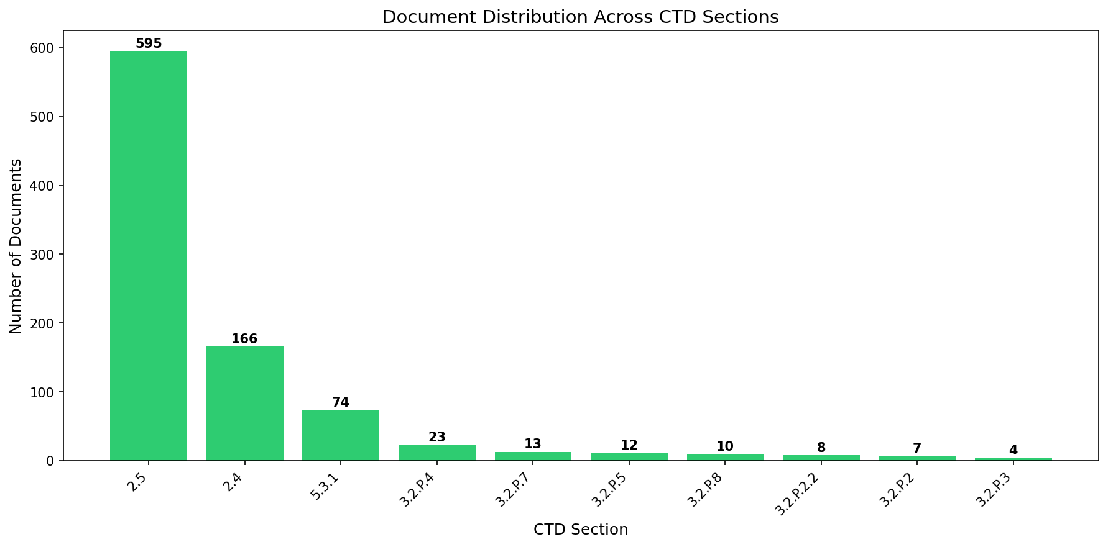
Figure 1: Document distribution across CTD sections
The dataset exhibits significant class imbalance, with clinical literature (Sections 2.4 and 2.5) comprising 83% of documents.

4. Methods

4.1 Document Representation
We extract text from PDF and Word documents using PyMuPDF and python-docx. Each document is truncated to 10,000 characters. Documents are embedded using BioBERT (dmis-lab/biobert-base-cased-v1.2), producing 768-dimensional vectors that capture biomedical semantic content.

4.2 Hierarchical Architecture
Our model employs a two-level hierarchical approach: Level 1 predicts the CTD module (2, 3, or 5) with 3 output classes. Level 2 predicts the specific CTD section with 10 output classes, conditioned on Level 1 predictions.
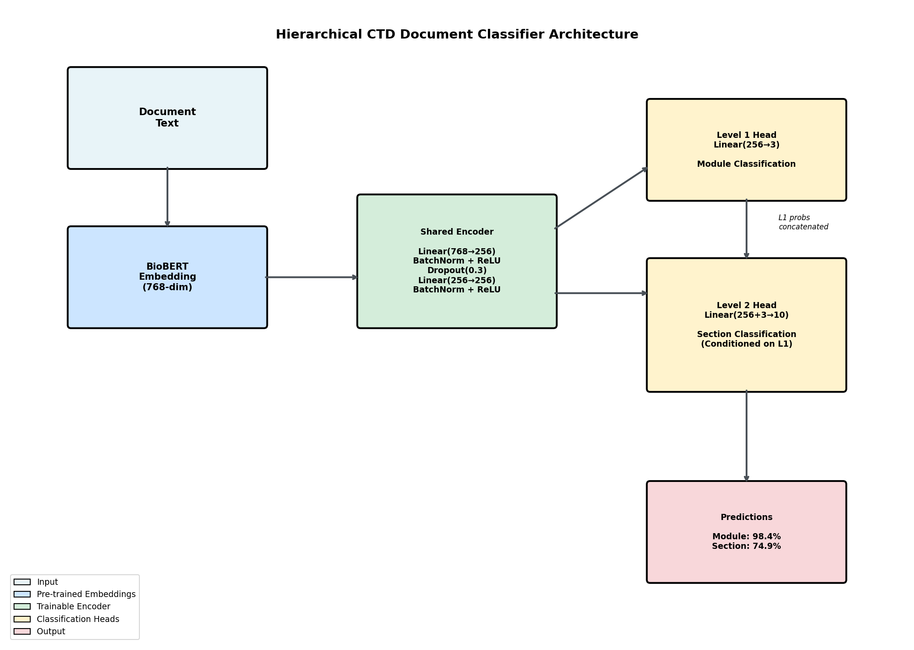
Figure 2: Hierarchical classifier architecture
The architecture consists of:
• Shared Encoder: Linear(768→256) + BatchNorm + ReLU + Dropout(0.3) × 2 layers
• Level 1 Head: Linear(256→3) for module classification
• Level 2 Head: Linear(256+3→10), concatenates shared features with Level 1 probabilities

4.3 Hierarchical Loss Function
We use a weighted combination: L = 0.3 × L_level1 + 0.7 × L_level2
The higher weight on Level 2 emphasizes fine-grained classification while benefiting from hierarchical structure.

4.4 Training Details
Hyperparameter | Value
Optimizer | Adam
Learning Rate | 1e-3
Weight Decay | 1e-5
Batch Size | 16
Epochs | 50
Dropout | 0.3
LR Scheduler | ReduceLROnPlateau (patience=5)

5. Results

5.1 Main Results
Method | Accuracy | Improvement
TF-IDF + Logistic Regression | 67.76% | baseline
BioBERT + MLP | 68.31% | +0.6%
BioBERT + Logistic Regression | 69.95% | +2.2%
BERT (general) + LogReg | 71.58% | +3.8%
BioBERT + SVM | 73.77% | +6.0%
Hierarchical NN (Ours) | 74.86% | +7.1%

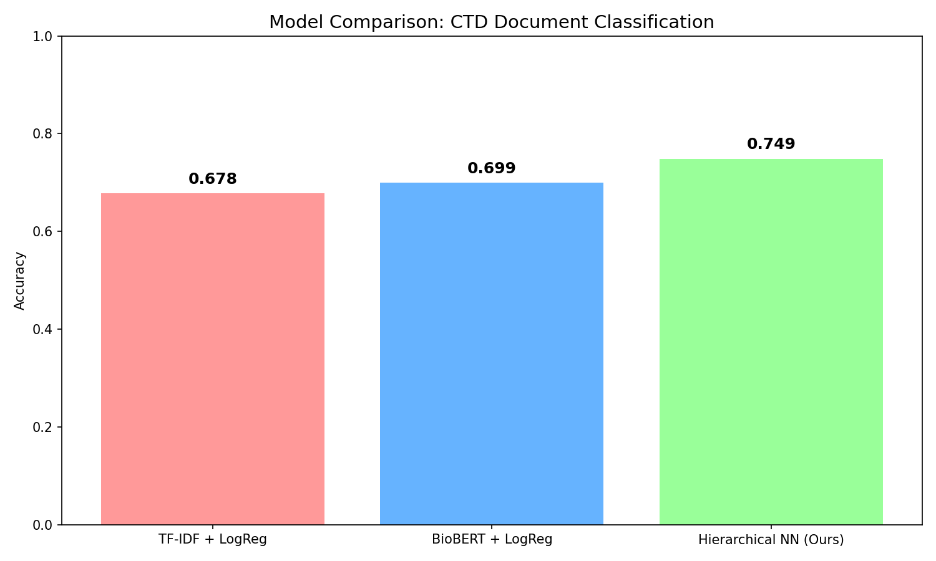
Figure 3: Model comparison showing accuracy improvements

5.2 Hierarchical Performance
• Module Level (3 classes): 98.36% accuracy
• Section Level (10 classes): 74.86% accuracy
The near-perfect module-level accuracy demonstrates the effectiveness of the hierarchical approach.

5.3 Training Dynamics
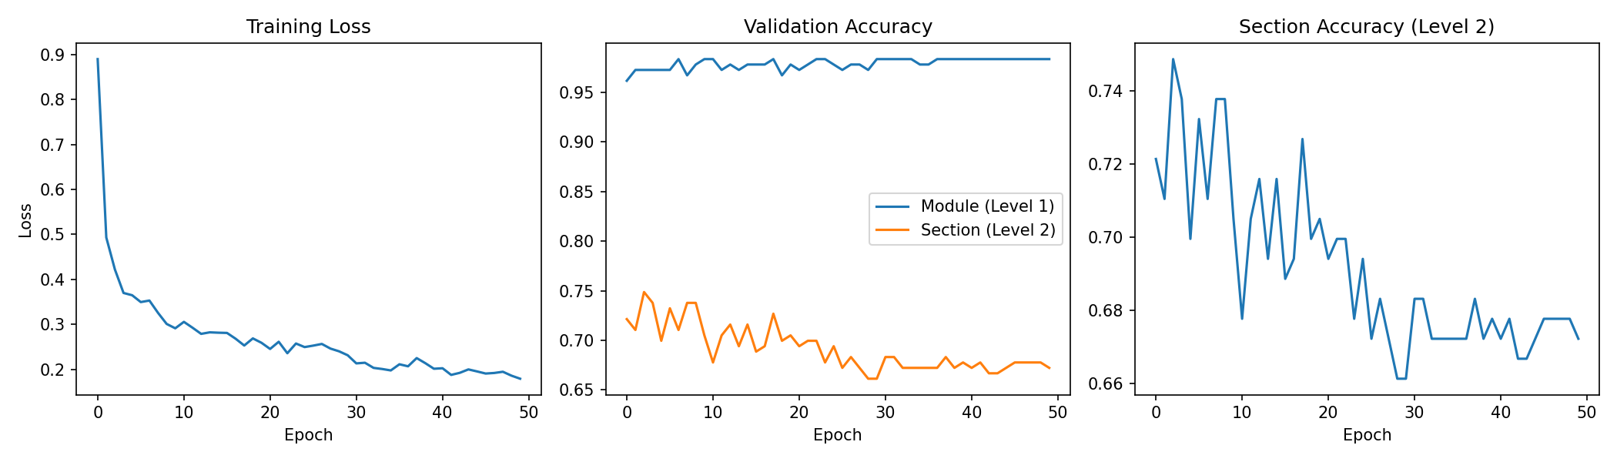
Figure 4: Training loss and validation accuracy over epochs

5.4 Confusion Matrix
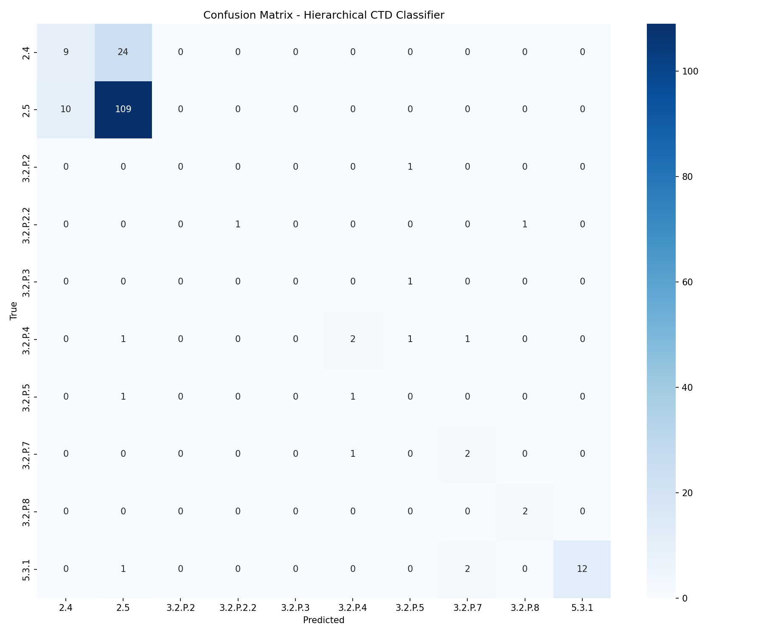
Figure 5: Confusion matrix for section-level predictions
The model performs well on sections with sufficient training data (2.5, 5.3.1) but struggles with extremely rare classes (3.2.P.2, 3.2.P.3) that have fewer than 5 training examples.

5.5 Ablation Studies
Effect of Classifier Architecture:
Classifier | Accuracy
Logistic Regression | 69.95%
MLP (256, 128) | 68.31%
SVM (RBF) | 73.77%
Hierarchical NN | 74.86%

6. Discussion

6.1 Key Findings
1. Hierarchical classification improves performance by first predicting the module (98.4% accuracy), providing context for section classification.
2. Deep learning outperforms traditional methods with 7.1% improvement over TF-IDF baseline.
3. Class imbalance remains challenging for sections with fewer than 5 training examples.

6.2 Limitations
• Small dataset: 912 documents from single drug product limits generalization
• Class imbalance: 65% of data belongs to one class (2.5)
• PDF extraction quality: Some documents yield poor text extraction

6.3 Future Work
1. Data augmentation for rare classes
2. Multi-dossier training across drug products
3. Fine-tuning BioBERT end-to-end
4. Production deployment at SagaReg

7. Conclusion
We presented a hierarchical deep learning approach for classifying pharmaceutical regulatory documents into CTD sections. Our model achieves 74.9% accuracy, outperforming TF-IDF baselines by 7.1 percentage points. The hierarchical structure proves particularly effective, achieving 98.4% accuracy at the module level. This classifier enables automated document routing for LLM-powered dossier generation.

References
1. Lee, J., et al. (2020). BioBERT: a pre-trained biomedical language representation model. Bioinformatics.
2. Devlin, J., et al. (2019). BERT: Pre-training of Deep Bidirectional Transformers. NAACL.
3. ICH M4 (2016). Organisation of the Common Technical Document.

