Module20-Week3/Deliverable 3
After Deliverable2, I started working on my own project which was the business case for the Fast-Food Industry.
ISSUES:
- Is Fast Food Industry a good investment or a poor investment idea?
- The workers are clamoring for more pay, can the franchise owners yield to them and maintain profitability?
- US population growth is at 0.1 percent, almost stagnant, where will the new customers come from?
- Unhealthy Food Practices abound the industry, there is too much salt, which causes high blood pressure and is starchy which may be the cause of artery clogging and other cardiac diseases.
RESEARCH:
Only secondary research was done, no primary research was done. Through secondary research, searching the databases both private and government a reasonable conclusion was arrived. The GDP graph came from the US Government data base and the machine learning curves came from google. The research question was:
Is Fast Food Industry a good investment in the future?
ANALYSIS:
In any market research, the primary emphasis is on the customer. Who is the customer and why does he buy the product?
According to Philip Kotler, Professor of Marketing at North-Western University, America is divided into six social classes. These classes are as follows:
- The Rich Class, who inherited wealth. They include the Rockefellers, Carnegie etc. These are the reference group for other classes.
- Newly Rich Class, who just became wealthy and want to show off their wealth to impress others below them. This would include Silicon Valley Millionaires like Jerry Sanders etc.
- Upper Middle Class- Professional and Career Oriented individuals, who want to climb the corporate ladder, they are constantly improving their skills and want the best education for their children.
- Middle -Middle Class: Middle Management and some independent businessmen.
- Lower Middle Class: Blue Collar workers, who work for the Union. Some highly skilled blue -collar workers may be in the Middle Class.
- Lower Class, who are generally on government handouts and have no steady job.
Who is the customer?
It becomes apparent that the middle classes are the customers. The main advantage of the Fast- Food Industry is affordability and fast service (people should be able to drive-in). Is the customer base going to grow or shrink in the future?
The customer bases are directly dependent on economic well- being of the middle classes. If the GDP grows, there will be customers, and on the other hand, if it shrinks, there would be dearth of customers. In the past, both political parties have endorsed economic growth. The only difference is in the distribution of wealth. The Democrats favor the growth of middle class, while the Republicans favor “top-down distribution or trickle-down economics”. They favor the investment community, while the democrats favor the labor. These were traditional roles, but there are cross party affiliations. For this purpose, we would need to see if GDP growth will occur in the future? To do that, we went into the past and used regression analysis, but this analysis could not solve the problem, as there was too much variance in the future prediction.
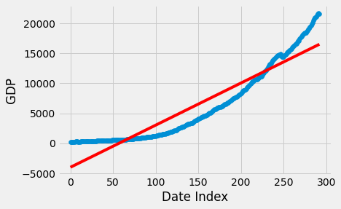
GDP and Regression Analysis Line
Key:
RED LINE: Regression Analysis Line
BLUE LINE: GDP Line
We had no option, but to discover other predictive methods. The first method was a simple moving averages method using Excel.
Below is the graph:
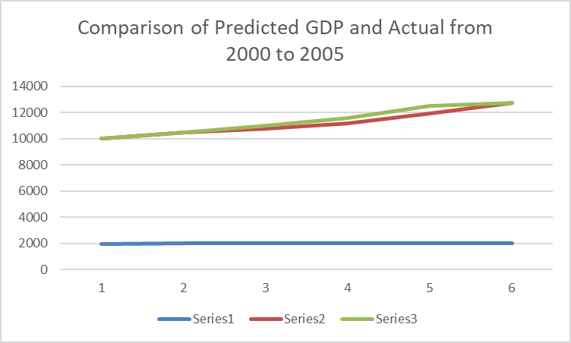
Red Line: Predicted
Green Line: Actual
This could have been done in Python Notebook, the graph would be the same.
 | Actual | Predicted
2000 | 10002.86 | 10002.86
2001 | 10472.88 | 10503
2002 | 10788.95 | 11028.15
2003 | 11183 | 11579.55
2004 | 11920 | 12518.52
2005 | 12761.34 | 12766.45
AVERAGE INCREASE IN PERCENT: |  |  | 0.050070688
This graph gave us a glimmer of hope:
we can predict the GDP.

Since we were to predict the GDP growth from 2021 or 2019 to 2024, the data from the last five years was taken and the same procedure followed.
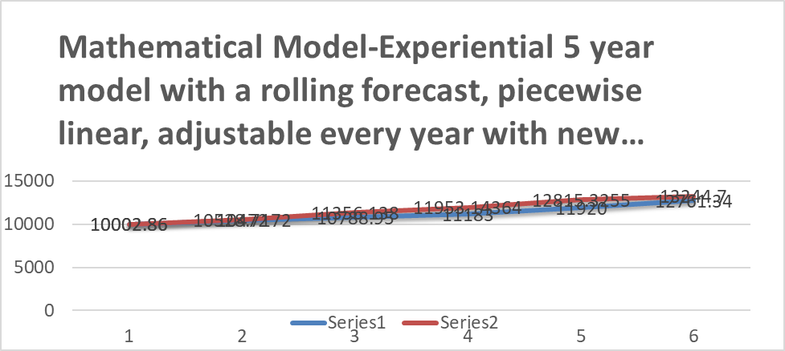

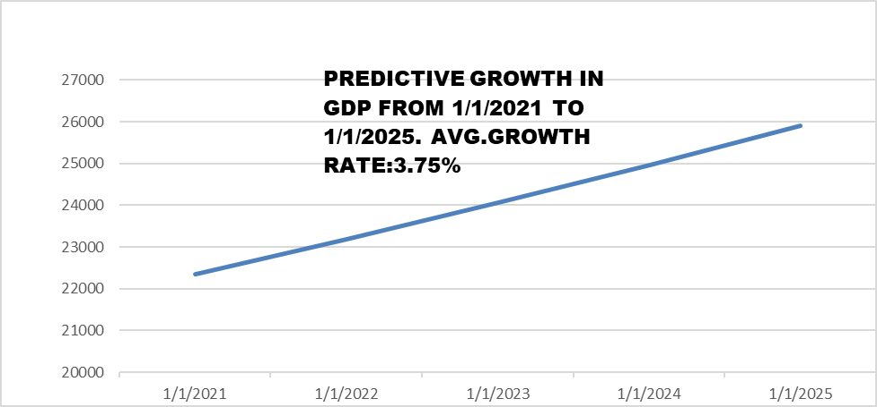

In the 4th Week, another new method came to light: The Time Series, which has been submitted with Week4.
Great progress was made in Modelling the GDP which was a result of literature search on the web and on government databases. In the business case the issue was: Who is the customer and is the investment in Fast Food Industry viable?
The American Middle Classes are the customers, and their numbers will increase despite slow population growth. The investment in Fast Food industry is a strong buy.

