Deliverable3-Pyber Analysis
Overview:
The purpose of this analysis is to study ride-sharing data by city type and how those differences can be used by decision makers at PyBer. Total Fare by City Type is graphed by value and time. For the purpose of this study a time period of January 2019 to April 2019 is studied.
Results:
The results of total rides indicate the following:
Type | Total Rides | Percentage
Rural | 125 | 5.26%
Suburban | 625 | 26.32%
Urban | 1625 | 68.42%

A vast majority of the rides occurred in the urban areas and very few in rural areas. Suburban areas which are a little more spread out, the number of rides decrease dramatically.
Type | Total Fares | Total Drivers | Total Fares Percentage | Average Fare per Ride | Average Fare per Driver
Rural | $4327.93 | 78 | 6.8% | $34.62 | $55.486
Suburban | $19356.33 | 490 | 30.46% | $30.97 | $39.503
Urban | $39854.38 | 2405 | 62.72% | $24.53 | $16.57

As you can see from the above table, the majority of the revenue is coming from the Urban Areas, although the average price is the per ride and per Driver is the lowest.
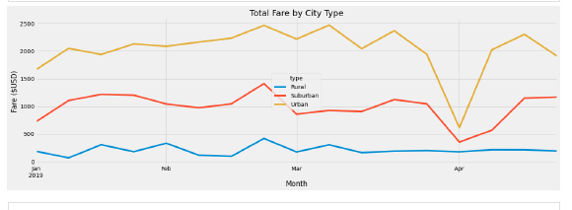
The above graph is very proportional then it shows a dip in April, which may indicate a loss of service.
Summary:
Recommendations to the CEO:
- All three types of service have their advantages and disadvantages, but from a return on investment point of view, the Urban Service is more profitable and is the main source of revenue. As distance between points increase, revenues drop. So, based on ROI, the urban and suburban services would be more profitable and the rural service may be dropped.
- We need to investigate the sudden drop Urban Fare in April, while in the rural areas there was no drop. Perhaps it could be due to Pandemic or some other area specific reason, which is only hitting populated areas. Sparsely populated areas are untouched.
Short Rides are preferred by the consumer, so perhaps electric cars can be used more efficiently in this role. It will keep the city clean, and can also be more response. They are smaller cars. So, investment in clean technology may be appropriate at this time. It will show social responsibility and forward loo
As you can see from the above table, the majority of the revenue is coming from the Urban Areas, although the average price is the low per ride and per Driver is the lowest.

