

SYRIAN PRIVATE UNIVERSITY
FACULTY OF ARTIFICIAL INTELLIGENCE ENGINEERING
Department of Intelligent Information Security Systems Engineering

Design and Implementation of an
Autonomous Context-Aware Deception Framework

A junior project report - submitted to complete the requirements for obtaining a bachelor’s degree in informatics engineering - Systems and Networks Security Engineering

Prepared by:
Omar Khaled Abdulkafi
Moaz Hassan Al-Dawalibi

Supervision:
Dr. Wassiem Jnidi

Academic Year 2025 – 2026

Dedication
This work is dedicated to the families and mentors whose continuous support made this project possible, and to everyone striving to make digital systems safer through research grounded in evidence and careful engineering.

Table of Contents
Dedication 2
Table of Contents 3
List of Tables 6
List of Figures 7
List of Abbreviations and Terms 8
Abstract 10
Introduction 11
Problem Statement 11
Objectives 11
Scope 12
Rationale and Significance 12
Related Work at a Glance 12
Contribution Summary 13
Report Structure 13
Chapter One: Theoretical Framework 14
1.1 Introduction 14
1.2 Network Security Monitoring 14
1.3 Honeypots and Deception Technology 14
1.4 Behavioral Timing as a Bot/Human Discriminator 15
1.5 Random Forest Classification 15
1.6 Evaluation Metrics 16
1.7 Context-Awareness in This Project 17
1.8 Attack Surface Analysis 17
1.9 The MITRE ATT&CK Framework 17
1.10 Class Imbalance in Supervised Learning 18
1.11 Comparison of Detection Paradigms 18
1.12 Overview of the SSH Protocol 19
1.13 The iptables / Netfilter Framework 19
1.14 Design Alternatives Considered 20
1.15 Data Provenance and Chain of Custody 20
1.16 Generalizability of Behavioral Classification 20
Chapter Two: Literature Review 22
2.1 Introduction 22
2.2 Honeypot Deception and AI-Driven Log Analysis 22
2.3 Timing-Based Attacker Clustering 22
2.4 Zeek-Based Datasets and Machine Learning Pipelines 23
2.5 Random-Forest-Based Network Intrusion Detection 23
2.6 Honeypot-Based Attacker Behavior Studies 24
2.7 Discussion and Research Gap 24
2.8 Source Selection Criteria 26
2.9 Methodological Consistency Across Reviewed Studies 26
2.10 Positioning Within the Broader Deception Literature 27
Chapter Three: Proposed System Design 28
3.1 Overview 28
3.2 Context-Aware Decision Logic 29
3.3 Attack Taxonomy and MITRE ATT&CK Mapping 29
3.4 Feature Set 30
3.5 Labeling Rule and Threshold Justification 31
3.6 Classifier Selection and Configuration 32
3.7 Data Cleaning and Normalization 32
3.8 Threat Model and Scope 33
3.9 Scalability and Generalization of the Design 33
Chapter Four: Practical Implementation 35
4.1 Laboratory Environment 35
4.2 Network Security Monitoring Deployment 35
4.3 Deception Layer Deployment 36
4.4 Attack Surface Analysis 37
4.5 Attack Simulation and Data Collection 39
4.6 Dataset Construction Pipeline 40
4.7 External Dataset Preparation 42
4.8 Version Control 42
4.9 Known Issues and Fixes 43
4.10 End-to-End Reproducibility Walkthrough 43
4.11 Ethical and Legal Considerations 44
4.12 Testing and Verification Summary 44
4.13 Data Organization and Artifact Summary 44
4.14 Attack Simulation Volume and Session Mix 45
4.15 Gap Between the Laboratory Configuration and a Production Deployment 45
4.16 Resource Utilization 46
Chapter Five: Results 47
5.1 Final Dataset Composition 47
5.2 Model Training Results 47
5.3 Cross-Validation Stability 49
5.4 Feature Importance 49
5.5 External Validation on UWF-ZeekData22 50
5.6 Model Comparison 51
5.7 Comparison with Related Work 51
5.8 Threats to Validity 52
5.9 Limitations 52
5.10 Error Analysis 53
5.11 Practical Deployment Considerations 53
5.12 Summary of Key Results 54
5.13 Reproducibility of Reported Results 54
5.14 Alignment with Project Objectives 54
5.15 Sensitivity of the Labeling Threshold 55
5.16 Broader Impact 55
Conclusion 56
Future Work: Graduation Project 1 56
Future Work: Graduation Project 2 57
Lessons Learned 57
Final Remarks on Scope 57
Closing Remark 58
References 59

List of Tables
Table 1: Comparison of Network Defense Paradigms 18
Table 2: Summary of Reviewed Studies 25
Table 3: Attack Taxonomy and MITRE ATT&CK Mapping 29
Table 4: Behavioral and Network Feature Set 30
Table 5: Worked Example of the Labeling Rule 31
Table 6: Hyperparameter Search Grid (GridSearchCV) 32
Table 7: Lab Environment Configuration 35
Table 8: Attack Surface Analysis (Nmap) Results 38
Table 9: Dataset Construction Pipeline (Scripts) 41
Table 10: Final Dataset Composition (360 Sessions) 47
Table 11: Random Forest Training Results (Held-out Test Split) 47
Table 12: Feature Importance Ranking 50
Table 13: External Validation on UWF-ZeekData22 51
Table 14: Model Comparison (Random Forest vs. Decision Tree vs. SVM) 51
Table 15: Comparison with Related Work 52
Table 16: Key Results at a Glance 54

List of Figures
Figure 1: Lab Network Topology 28
Figure 2: Context-Aware Decision Pipeline 28
Figure 3: Zeek Network Security Monitor — Status Verification 36
Figure 4: Cowrie Honeypot — Service Status Verification 37
Figure 5: iptables Port Redirection Rule 37
Figure 6: Attack Surface Analysis — Nmap Scan Output 38
Figure 7: Automated (Bot) Attack Evidence in cowrie.json 39
Figure 8: Manual (Human) Session Evidence in cowrie.json 40
Figure 9: Dataset Construction Pipeline 41
Figure 10: Final Dataset Construction Output 42
Figure 11: Confusion Matrix — Held-out Test Split 48
Figure 12: ROC Curve — Held-out Test Split 48
Figure 13: Feature Importance Ranking (Chart) 49
Figure 14: External Validation Output — UWF-ZeekData22 50

List of Abbreviations and Terms
Abbreviation | Full Term
AI | Artificial Intelligence
ASA | Attack Surface Analysis
AUC | Area Under the ROC Curve
CV | Cross-Validation
DT | Decision Tree
FN | False Negative
FP | False Positive
ICD | Inter-Command Delay
IDS | Intrusion Detection System
ML | Machine Learning
MITRE ATT&CK | Adversarial Tactics, Techniques, and Common Knowledge
NSM | Network Security Monitoring
OSI | Open Systems Interconnection
RF | Random Forest
ROC | Receiver Operating Characteristic
SSH | Secure Shell
SVM | Support Vector Machine
TN | True Negative
TP | True Positive
UWF | University of West Florida

الملخص
يتناول هذا التقرير تصميم وتنفيذ إطار خداع واعٍ للسياق
(Context-Aware Deception Framework) يجمع بين المراقبة السلبية للشبكة، وتحليل سطح الهجوم، ونظام خداع قائم على مصائد Honeypot، وتصنيف آلي للمهاجمين باستخدام التعلم الآلي. يعتمد النظام على أداة Zeek لمراقبة حركة الشبكة، ومصيدة Cowrie لمحاكاة خدمة SSH حقيقية، حيث يوجَّه اتجاه المنفذ 22 نحو المصيدة عبر قواعد iptables بعد أن أظهر تحليل سطح الهجوم أن هذا المنفذ هو الأكثر عرضة للاستغلال؛ وهذا الربط بين نتائج التحليل وقرار نشر المصيدة هو جوهر مفهوم "الوعي بالسياق" في هذا المشروع.
تم بناء مجموعة بيانات من 360 جلسة اتصال (331 آلية و29 بشرية)، واستُخرجت منها ثماني ميزات سلوكية أبرزها متوسط الفاصل الزمني بين الأوامر (icd_mean)، ثم دُرِّب عليها مصنف Random Forest الذي حقق دقة تصنيف تامة على مجموعة الاختبار المحجوزة (AUC=1.0000، FN=0)، كما تم التحقق من صلاحية النموذج خارجياً على بيانات UWF-ZeekData22 حيث لم يفوّت النموذج أي جلسة هجوم فعلية (FN=0).
تناقش الدراسة أيضاً مقارنة النموذج المقترح بنماذج بديلة (شجرة القرار وآلة المتجهات الداعمة)، وتخلص إلى أن Random Forest تحقق أفضل توازن بين اكتشاف الهجمات وتقليل الإنذارات الكاذبة.
الكلمات المفتاحية: الخداع السيبراني، Honeypot ، Zeek، Random Forest ، تحليل سطح الهجوم، التعلم الآلي.

Abstract
This report presents the design and implementation of an Autonomous Context-Aware Deception Framework that integrates passive network monitoring, attack surface analysis, honeypot-based deception, and machine-learning-based attacker classification into a single defensive pipeline. The system uses Zeek for network security monitoring and Cowrie as a medium-interaction SSH honeypot; inbound traffic to port 22 is transparently redirected to the honeypot on port 2222 through iptables PREROUTING rules once attack surface analysis identified SSH as the most exposed and highest-risk service. This link between the analysis outcome and the deployment decision is the operational meaning of "context-awareness" in this project.
A dataset of 360 labeled sessions (331 Bot, 29 Human) was constructed from Cowrie and Zeek logs, from which eight behavioral features were engineered, the strongest of which is the mean inter-command delay (icd_mean). A Random Forest classifier trained on this dataset achieved perfect discrimination on a held-out test split (AUC = 1.0000, FN = 0), and its generalization was further confirmed through external validation on the independent UWF-ZeekData22 dataset, where the model missed zero true attack sessions (FN = 0). The report also compares the selected classifier against a Decision Tree and a Support Vector Machine, showing that Random Forest offers the best balance between attack detection and false-alarm rate.
Keywords: cyber deception, honeypot, Zeek, Random Forest, attack surface analysis, machine learning, network security monitoring.

Introduction
Services exposed to the public internet, particularly the Secure Shell (SSH) protocol, are subject to continuous automated scanning and credential-guessing activity. Conventional defenses fall into two broad categories: passive monitoring tools, which record traffic but do not themselves decide how the system should react, and static honeypots, which are deployed regardless of what the target host actually exposes. Neither approach, on its own, connects what is observed about a system's exposure to how deception resources are allocated.
This project addresses that gap by combining three previously separate defensive layers into one pipeline: network security monitoring with Zeek, attack surface analysis (ASA) performed with Nmap and a custom parser, and a Cowrie SSH honeypot whose deployment is a direct consequence of the ASA findings. A supervised machine learning classifier is then trained on behavioral session data captured by the honeypot to automatically distinguish automated (Bot) attackers from human operators, adding an analytical layer on top of the deception layer.

Problem Statement
Attack surface mapping and honeypot deployment are frequently treated as independent activities: security teams scan a network to understand exposure, and separately decide, often manually, where to place decoys. Without a mechanism linking the two, decoy placement is not informed by evidence and may fail to intercept the traffic that matters most. In addition, most honeypot deployments record raw session logs without automatically classifying the sophistication of the attacker, leaving that judgment to manual log review.
This manual review step scales poorly. A single medium-interaction honeypot can accumulate thousands of login and command events from automated scanning traffic within days, and distinguishing the small number of sessions that represent genuine, manually operated reconnaissance from that background of scripted noise is exactly the kind of repetitive, pattern-based judgment that a supervised classifier is well suited to automate, provided it can be trained on features that reliably separate the two populations. The absence, in the reviewed literature (Chapter 2), of a documented pipeline that performs this classification directly on the output of a context-aware honeypot deployment is the specific problem this project addresses.

Objectives
- Deploy a network security monitoring baseline using Zeek 8.0.5 to capture structured connection, SSH, HTTP, and DNS logs.
- Perform attack surface analysis with Nmap and translate its output, programmatically, into a honeypot deployment decision.
- Deploy and harden a Cowrie SSH honeypot, transparently redirecting inbound port 22 traffic to it using iptables.
- Engineer behavioral session features from Cowrie and Zeek logs that discriminate automated from human attacker behavior.
- Train, tune, and evaluate a Random Forest classifier on the resulting dataset, and validate it against an independent, publicly available dataset.

Scope
This report covers Phase 1 of a three-phase graduation project arc: the Junior Project. It delivers the monitoring, deception, attack-surface-analysis, and classification components described above within an isolated two-machine virtual laboratory. Dynamic, containerized decoys, automated orchestration, and moving-target-defense behavior are outside the scope of this phase and are planned for the subsequent Graduation Project phases (GP1 and GP2), as outlined in the Conclusion.

Rationale and Significance
The rationale for combining these three layers, rather than treating them as separate tools, is that each layer's output is most useful when it becomes an input to the next one. An attack surface analysis that is never acted upon is simply a report; a honeypot deployed without regard to what a scan actually found may protect a service that was never at meaningful risk while leaving a genuinely exposed one unmonitored; and a honeypot's session logs, left unclassified, require a human analyst to manually judge the sophistication of every recorded session. By making the deployment decision a direct, programmatic consequence of the attack surface analysis, and by making session classification a direct, programmatic consequence of the honeypot's own logs, this project removes two points at which a human decision would otherwise be required, without removing the human's ability to review, override, or extend either decision.
The practical significance of this design is strongest for small and medium-sized network environments, where a dedicated security operations team able to manually correlate scan results with honeypot logs may not be available, and where an automated, explainable pipeline that flags likely-automated attack sessions with a documented zero-false-negative track record on external data (Section 5.5) offers a concrete, low-overhead starting point for a deception-based defense.

Related Work at a Glance
A detailed review of related work is presented in Chapter 2. In brief, prior studies have separately established that Zeek-derived features are sufficient for high-accuracy network traffic classification [4]-[6], that Random Forest performs well on this kind of tabular security data [6], [7], [9], and that inter-command timing on medium-interaction honeypots separates distinct attacker populations [3]. What these studies do not provide, individually or in combination, is a documented pipeline in which an attack surface analysis result determines honeypot deployment and honeypot output is then classified automatically — the specific combination this project implements and evaluates.

Contribution Summary
- A working, documented link between attack surface analysis output and honeypot deployment, realized concretely as an Nmap-scan-to-iptables-redirect decision path (Section 3.2).
- A five-technique, MITRE ATT&CK-mapped attack taxonomy and an eight-feature behavioral schema for Bot/Human session classification (Sections 3.3-3.4).
- A trained and cross-validated Random Forest classifier achieving zero false negatives on both an internal held-out test split and an independent external dataset (Chapter 5).
- A fully scripted, ten-stage dataset construction and evaluation pipeline, released under version control, supporting reproduction of every reported result (Section 4.6).

Report Structure
Chapter 1 introduces the theoretical concepts underlying network security monitoring, honeypot-based deception, and behavioral classification. Chapter 2 reviews related work and positions this project relative to it. Chapter 3 presents the proposed system design, including the context-aware decision logic, the attack taxonomy, and the feature set used for classification. Chapter 4 describes the practical implementation of the laboratory, the monitoring and deception components, and the dataset construction pipeline. Chapter 5 reports and discusses the classification results, including external validation and comparison against alternative classifiers. The report closes with a Conclusion summarizing the contribution and outlining future work.

Chapter One: Theoretical Framework

1.1 Introduction
This chapter defines the core concepts on which the proposed framework is built: network security monitoring, honeypot-based deception, behavioral timing as a classification signal, and the Random Forest algorithm used for attacker classification. Only concepts that are directly employed in the design or implementation are covered, in order to avoid theoretical material unrelated to the project.

1.2 Network Security Monitoring
Network Security Monitoring (NSM) is the practice of collecting and analyzing network activity in order to detect and respond to security incidents. Unlike signature-based Intrusion Detection Systems (IDS), which compare traffic against known attack patterns and produce binary alerts, an NSM platform such as Zeek passively observes all traffic and converts it into structured, protocol-aware log files (for example, connection records, SSH session records, and HTTP request records). These structured logs are directly usable as input to a machine learning pipeline, whereas raw packet captures require substantial additional processing before they can serve the same purpose.
Zeek organizes its output as a family of tab-delimited log files, each corresponding to a distinct protocol or event type. The connection log (conn.log) records every network flow observed on the monitored interface, including source and destination addresses, ports, duration, byte counts, and packet counts, regardless of protocol. Protocol-specific logs such as ssh.log and http.log add fields relevant to that protocol only when the corresponding traffic is observed, so an environment with SSH-only traffic produces a populated ssh.log and an empty http.log. This separation allows a feature engineering pipeline to select only the log files relevant to the traffic being studied, rather than parsing an undifferentiated packet stream.
Zeek is typically deployed in one of two modes: inline, where it sits directly in the traffic path, or passive, where it observes a copy of traffic mirrored to it from a switch or, as in this project's virtualized laboratory, from a shared virtual network segment. The passive mode was used throughout this project because it introduces no latency into the monitored connection and cannot itself become a single point of failure for network connectivity, at the cost of being unable to block traffic directly — a limitation acceptable here because blocking is not part of this project's scope, which relies instead on redirection at the iptables layer (Section 4.3) rather than on Zeek to intervene in traffic.

1.3 Honeypots and Deception Technology
A honeypot is a decoy system intentionally exposed to attackers in order to attract, delay, and record malicious activity that would otherwise target production systems. Honeypots are commonly classified by their interaction level: low-interaction honeypots emulate only a limited set of services and commands, while medium- and high-interaction honeypots simulate a more complete operating environment, increasing the realism of the deception at the cost of additional operational risk [1]. Deception strategies built around honeypots are most effective when the logs they generate are structured enough to support automated analysis rather than manual inspection alone, a requirement that has motivated recent work on applying machine learning directly to honeypot session data [2].
Within this classification, Cowrie is generally regarded as a medium-interaction honeypot: it does not run a genuine operating system, and therefore cannot be used by an attacker to pivot further into a real network, but it does simulate a believable file system, a shell environment, and a configurable set of accepted credentials, which is sufficient to sustain an attacker's interaction long enough to produce meaningful behavioral data. This places Cowrie at a deliberate middle point between low-interaction honeypots, which are too limited to elicit multi-command sessions, and high-interaction honeypots, which expose a genuine, and therefore riskier, execution environment.

1.4 Behavioral Timing as a Bot/Human Discriminator
A recurring finding in the honeypot literature is that the timing between successive attacker actions is one of the strongest available signals for distinguishing scripted, automated behavior from manual human behavior. Automated tools issue commands at machine speed, with inter-command delays on the order of milliseconds, while human operators require several seconds to read output and decide on a next action. Clustering attackers on medium-interaction honeypots by this kind of timing behavior has been shown to separate distinct operator populations without requiring any content-based analysis of the commands themselves [3]. This principle motivates the mean inter-command delay (icd_mean) feature used as the primary discriminator in the classifier described in Chapter 3.
Formally, for a session containing n commands issued at timestamps t1, t2, ..., tn, the inter-command delay series is defined as di = ti+1 - ti for i = 1, ..., n-1, and the two timing features used in this project are the mean and standard deviation of that series, icd_mean and icd_std. A low icd_mean paired with a low icd_std indicates commands issued at a near-constant, machine-driven pace, which is the timing signature expected of scripted tools; a high icd_mean paired with higher variance is expected of a human operator whose pause length depends on the complexity of each command's output.

1.5 Random Forest Classification
A Random Forest is an ensemble supervised learning algorithm that constructs a large number of decision trees on bootstrap-sampled subsets of the training data and a random subset of features at each split, and aggregates their individual predictions by majority vote. This bagging strategy reduces the variance associated with any single decision tree and generally improves generalization on tabular, feature-engineered data such as the session-level behavioral records produced in this project. In addition to producing predictions, a trained Random Forest exposes a feature importance score for every input feature, which is used in this report both to interpret the model and to lay the groundwork for the explainable-AI work planned in a later project phase.
Two properties of Random Forest are particularly relevant to the small, imbalanced dataset used in this project. First, the class_weight parameter can be set to automatically re-weight the minority class during training, penalizing misclassification of the under-represented Human class more heavily than misclassification of the over-represented Bot class, which helps prevent the model from simply predicting the majority class for every session. Second, because each tree is trained on an independently bootstrapped sample, the out-of-bag samples not used by a given tree provide a built-in, computationally inexpensive estimate of generalization error that complements the explicit cross-validation procedure described in Chapter 3.
Concretely, if the training set contains N sessions, each individual tree in the forest is trained on a bootstrap sample of N sessions drawn with replacement from that training set, meaning that, on average, roughly two thirds of the original N sessions appear at least once in a given tree's bootstrap sample while the remaining third are left out of it entirely and become that tree's out-of-bag set. Because the number of estimators selected for the final model is 50 (Section 3.6), the classifier's prediction for any one session is effectively a majority vote across 50 such bootstrap-trained trees, which is what gives the ensemble its resistance to the seed-dependent variance discussed in Section 3.6, relative to a single decision tree trained on the full, unbootstrapped training set.

1.6 Evaluation Metrics
Classifier performance in this report is reported using precision, recall, F1-score, and the area under the Receiver Operating Characteristic curve (AUC), rather than raw accuracy, because the dataset is imbalanced and accuracy alone can be misleadingly high for a classifier that simply predicts the majority class. Precision is the proportion of predicted attack sessions that are truly attacks, and recall (also called the true positive rate) is the proportion of true attack sessions that are correctly identified, expressed in terms of true positives (TP), false positives (FP), and false negatives (FN):
Precision = TP / (TP + FP) (1)
Recall = TP / (TP + FN) (2)
F1-score is the harmonic mean of precision and recall, penalizing a classifier that achieves a high value on one at the direct expense of the other:
F1 = 2 × (Precision × Recall) / (Precision + Recall) (3)
In an intrusion-detection setting, recall on the attack class is the more operationally important of the two, since a missed attack (a false negative) can lead directly to a compromise, while a false positive only costs additional analyst review time. For this reason, this report treats the false negative count as the primary indicator of classifier adequacy throughout Chapter 5, with precision, F1, and AUC reported as supporting evidence rather than as the sole criterion of success.
The Receiver Operating Characteristic (ROC) curve plots the true positive rate against the false positive rate as the classifier's decision threshold is swept across its full range, and the area under that curve (AUC) summarizes performance across every possible threshold in a single number between 0 and 1, where 1 represents perfect separation between the two classes and 0.5 represents performance no better than random guessing. AUC is reported alongside precision, recall, and F1 in this project specifically because it does not depend on any single fixed decision threshold, which makes it a useful cross-check that a classifier's apparent perfect performance at the default threshold (Section 5.2) is not an artifact of an unusually favorable threshold choice.

1.7 Context-Awareness in This Project
In the context of this project, "context-aware" behavior refers specifically to the dependency between the attack surface analysis outcome and the deception deployment decision: the discovery that SSH (port 22) is the exposed, high-risk service is what determines that a Cowrie SSH honeypot, rather than some other decoy type, is deployed and that inbound traffic to that port is redirected to it. This decision path — analysis, then deployment, then monitoring, then classification — is described in full in Chapter 3.

1.8 Attack Surface Analysis
Attack surface analysis (ASA) is the process of enumerating every network-accessible entry point of a system, typically its open ports and the services listening on them, in order to reason about which of those entry points represent meaningful exposure. Port scanning tools such as Nmap perform this enumeration by sending crafted probe packets and interpreting the responses to infer not only which ports are open but also which service and, in many cases, which service version is running behind each port. This version-level detail matters because different versions of the same service can carry different, publicly known vulnerabilities, so an attack surface analysis that reports only "SSH is open" is less actionable than one that reports "OpenSSH 8.9p1 is open," which can be cross-referenced against known vulnerability databases.
A single attack surface scan provides only a snapshot of exposure at one point in time. Because services can be added, removed, or reconfigured, a differential attack surface analysis — comparing the set of open ports found in two scans taken at different times — is used in this project as a lightweight integrity check, confirming that the exposure picture that originally justified the honeypot deployment decision (Section 3.2) remained valid throughout the data collection period.

1.9 The MITRE ATT&CK Framework
MITRE ATT&CK is a publicly maintained knowledge base of adversary tactics and techniques, organized as a matrix in which each column represents a tactic (a high-level adversary goal, such as Initial Access or Discovery) and each cell within that column represents a specific technique or sub-technique used to achieve it, identified by a stable code such as T1110 for Brute Force or T1046 for Network Service Discovery. Because these identifiers are shared across the security industry, mapping a project's own attack simulations onto them, as done in Section 3.3, allows the resulting dataset and its labeling logic to be understood and compared against other work without requiring a bespoke, project-specific taxonomy. This is also the labeling basis used by UWF-ZeekData22 [4], which is one of the reasons that dataset was selected for external validation in Section 4.7: both the internal dataset and the external one describe their attack sessions in the same technique vocabulary, even though the underlying feature representations differ.

1.10 Class Imbalance in Supervised Learning
A supervised learning dataset is described as imbalanced when one class substantially outnumbers another, as is the case for the Bot/Human dataset used in this project (331 Bot sessions versus 29 Human sessions). Training a classifier naively on an imbalanced dataset risks producing a model that achieves high overall accuracy simply by predicting the majority class for every input, while performing poorly on the minority class that is often of greater practical interest. Two complementary strategies are used to address this in the present project: balanced class weighting during Random Forest training, which increases the training-time penalty for misclassifying a minority-class (Human) sample, and stratified data splitting during both the train/test split and cross-validation, which ensures that the proportion of each class in every fold matches its proportion in the full dataset, avoiding folds that contain no Human sessions at all.
This chapter summary closes the theoretical groundwork for the report: network security monitoring and honeypot deception provide the raw session data, attack surface analysis determines where deception is deployed, behavioral timing theory motivates the feature set, and Random Forest, together with the evaluation metrics and class-imbalance handling defined above, provide the analytical layer used to classify that data.

1.11 Comparison of Detection Paradigms
It is useful to situate the approach taken in this project against the broader family of network defense paradigms it draws from. Table 1 compares four paradigms on the dimensions most relevant to the design decisions made in this report: whether the paradigm requires a known attack signature, whether it actively engages the attacker rather than merely observing them, and whether its output is naturally machine-learning-ready.
Table 1: Comparison of Network Defense Paradigms
Paradigm | Requires Known Signatures? | Actively Engages Attacker? | ML-Ready Output?
Signature-based IDS | Yes | No | No (binary alert only)
Passive NSM (Zeek) | No | No | Yes (structured logs)
Static Honeypot | No | Yes (fixed placement) | Depends on logging
This Project's Framework | No | Yes (context-aware placement) | Yes (feature-engineered, classified)
This comparison makes explicit why no single paradigm alone was sufficient for the project's objectives: signature-based IDS cannot detect attack tools it has not seen before and produces no data suitable for further analysis; passive NSM alone observes traffic but does not engage the attacker or produce session-level behavioral data; and a honeypot deployed without regard to attack surface analysis actively engages attackers but does so blindly, independent of what the specific host actually exposes. The framework described in this report was built specifically to combine the ML-readiness of passive NSM, the active engagement of a honeypot, and a context-aware placement decision that neither paradigm provides on its own.

1.12 Overview of the SSH Protocol
Secure Shell (SSH) is a cryptographic network protocol used to obtain a secure, authenticated remote command-line session over an otherwise untrusted network, and is the standard mechanism for remote administration of Linux servers. An SSH session begins with a protocol and algorithm negotiation phase, followed by authentication — typically by password or public-key credential — and, once authenticated, a shell session in which the client sends commands and the server returns their output over the encrypted channel. Because SSH is both extremely common on internet-facing servers and a direct path to a command shell if credentials are guessed correctly, it is one of the most heavily targeted services on the public internet, which is why it was selected as the service around which this project's deception layer is built, and why the attack surface analysis described in Section 3.2 treats an exposed SSH port as high risk by default.
From a monitoring perspective, SSH traffic is encrypted end-to-end, so a passive network monitor such as Zeek cannot see command-level content directly from the wire; it can, however, observe connection-level metadata (timing, byte counts, and negotiated client identification strings) through ssh.log, which is why the command-level behavioral features used in this project (Table 4) are derived from Cowrie's application-level session log rather than from Zeek's network-level SSH log, while Zeek's network-level features remain useful for the coarser network-level classification performed during external validation in Section 4.7.

1.13 The iptables / Netfilter Framework
iptables is a user-space utility for configuring the Linux kernel's Netfilter packet-filtering framework, which processes every packet that crosses the host through a series of ordered rule tables. The PREROUTING chain, used for the port redirection described in Section 4.3, is evaluated before the kernel makes a routing decision for an incoming packet, which is what allows a REDIRECT rule placed there to rewrite a packet's destination port from 22 to 2222 before the operating system decides which local process should receive it. Because this rewriting happens at the kernel level, it is transparent to both the connecting client, who addresses port 22 as usual, and to Cowrie, which simply accepts a connection on port 2222 as if it had been addressed there directly.

1.14 Design Alternatives Considered
Two categories of alternative design were considered and set aside during the theoretical planning of this project. First, Kippo, the predecessor project from which Cowrie originated, was considered as the honeypot component; Cowrie was selected instead because it is the actively maintained successor with native JSON logging support, whereas Kippo's older text-based logging would have required an additional custom parser with no corresponding benefit. Second, a deep-learning classifier (for example, a small feed-forward network or an LSTM over the command sequence) was considered as an alternative to Random Forest; it was set aside for this phase of the project because the available labeled dataset (360 sessions, only 29 of them Human) is small relative to what deep architectures typically require to avoid overfitting, and because Random Forest's built-in feature importance output was directly useful for the interpretability goals of this report, whereas a deep model's internal representations would have required a separate interpretability technique to inspect. Both alternatives remain compatible with the overall framework and are noted here as documented decisions rather than as closed questions, particularly since GP2 explicitly plans to reintroduce more advanced modeling for attacker intent prediction (see the Conclusion).

1.15 Data Provenance and Chain of Custody
Because the classifier's results depend entirely on the integrity of the labeled dataset it is trained on, every session in that dataset carries an implicit provenance trail: the specific attack technique that generated it (Table 3), the fixed time window during which that technique was executed (Section 4.5), and the specific log source (Zeek or Cowrie) from which its features were extracted (Table 4). Preserving this provenance is what allows the labeling rule described in Section 3.5 to be applied automatically and auditable after the fact — a session's label can always be traced back to the time window it fell into and the technique that generated that window, rather than resting on an unrecorded, one-off manual judgment made at collection time. This traceability is also what made it possible to confirm, during seed-sensitivity testing (Section 3.6), that the sessions closest to the decision boundary under alternative seed values belonged to the Human class rather than the Bot class, since the session's provenance record made its true label unambiguous even before its predicted label was compared against it.

1.16 Generalizability of Behavioral Classification
A recurring theme across Sections 1.4 through 1.6 is that behavioral classification of this kind rests on an assumption of statistical regularity within each class: that Bot sessions, whatever specific tool generated them, share enough timing and command-diversity structure to be treated as one statistical population, and likewise for Human sessions. This assumption is considerably better supported for the Bot class in this project, which draws on three independent tools (Section 3.3) and is corroborated by the long-term behavioral stability reported for automated honeynet traffic in the literature [10], than for the Human class, which by construction reflects a single operator's habits (Section 1.11). The theoretical significance of this asymmetry is that the classifier's demonstrated performance should be read as strong evidence for the separability of Bot-like timing behavior from a timing baseline, rather than as a general claim about how all human operators behave — a distinction that recurs explicitly in the limitations discussion of Chapter 5 (Section 5.9) and that motivates treating Human-class diversity, rather than Bot-class diversity, as the dataset's most pressing expansion priority in the future work outlined in the Conclusion.
Chapter 2 reviews the published work that informed the specific choices made within this combined paradigm in more detail.

Chapter Two: Literature Review

2.1 Introduction
This chapter reviews ten peer-reviewed studies relevant to the three pillars of the proposed framework: Zeek-based network datasets and machine learning pipelines, Random Forest-based intrusion detection, and honeypot-based attacker behavior analysis. Each study is summarized individually, followed by a discussion that positions the present project relative to this body of work.

2.2 Honeypot Deception and AI-Driven Log Analysis
Moric et al. surveyed the design space of honeypot-based deception strategies, distinguishing low-, medium-, and high-interaction deployments and discussing the operational trade-off between the realism of the deception and the risk of the decoy itself being used as a pivot point into production infrastructure [1]. Their analysis of medium-interaction honeypots, including Cowrie-class tools, describes structured JSON session logging as the property that makes such honeypots practical inputs to downstream analysis pipelines, rather than requiring manual transcript review. This finding directly supports the design choice, adopted in this project, to enable Cowrie's JSON logging output as the sole data source for behavioral feature extraction.
Building on the premise that honeypot logs are analyzable rather than merely archival, Lanka, Gupta, and Varol applied machine learning models directly to honeypot session data to automatically classify threat activity, reporting that automated classification substantially reduced the manual effort required to triage large volumes of honeypot traffic compared with manual log review [2]. Their study did not, however, connect the honeypot's placement to any prior network exposure analysis, treating the honeypot as a fixed, pre-existing data source rather than as a decoy whose deployment is itself a decision to be justified — a distinction that motivates the context-aware deployment logic described in Chapter 3 of this report. Neither [1] nor [2] reports a false-negative figure comparable to the ones tracked throughout Chapter 5 of this report, since both studies are framed around triage efficiency rather than around minimizing missed attacks specifically, which is the framing adopted here.

2.3 Timing-Based Attacker Clustering
Shamsi et al. studied attacker behavior on medium-interaction honeypots and showed that clustering sessions purely by inter-command timing statistics, without examining command content, separates attacker populations into behaviorally distinct groups corresponding to different tooling and operator sophistication [3]. This result is the direct theoretical basis for the icd_mean and icd_std features used in this project: rather than proposing a new timing metric, this project applies the timing-based separation principle established in [3] to a binary Bot/Human labeling problem and validates it empirically on both an internally collected dataset and an external one. A limitation of relying on timing alone, noted implicitly in [3] and inherited by this project, is that timing-based separation assumes the attacker's tooling has not been deliberately slowed to mimic human pacing; this assumption is examined explicitly as a threat to validity in Section 5.8.

2.4 Zeek-Based Datasets and Machine Learning Pipelines
Bagui et al. introduced UWF-ZeekData22, a network traffic dataset generated entirely from Zeek logs and labeled according to the MITRE ATT&CK framework, and demonstrated that Zeek-derived features are sufficient to support reliable machine learning classification of attack tactics without requiring raw packet capture [4]. The dataset's reliance on standard Zeek log fields, rather than on a custom or proprietary capture format, is what made it usable in this project as an external validation source after a feature-mapping step, described in Section 4.7, translated its network-layer fields onto the session-level schema used internally. The same research group later released UWF-ZeekDataFall22, a second Zeek-based dataset collected in a different time period, and showed that classifier performance and feature relevance remained stable across the two collections, supporting the use of Zeek features as a durable basis for detection rather than an artifact of a single capture window [5]. This stability result is cited in this report as indirect support for treating the current 360-session dataset, itself collected over a limited data-collection window, as representative of the broader Bot behavior it aims to characterize, while acknowledging that the same argument cannot be extended to the much smaller and less time-stable Human class.
Arapidis et al. proposed ZeekFlow+, a hybrid architecture combining a deep LSTM autoencoder with an integrated Random Forest classifier for both binary and multi-class classification of Zeek-derived network traffic, and reported that combining representation learning with an ensemble classifier improved detection over either component alone [6]. Although this project does not include a deep-learning representation-learning stage, the reported effectiveness of pairing Zeek-derived features with a Random Forest back-end is consistent with, and lends independent support to, the classifier choice made in Section 3.6; the trade-off, noted in [6] itself, is that the added representation-learning stage requires substantially more training data than the eight hand-engineered features used in this project, which was one of the reasons a hand-engineered feature set was preferred at the current, comparatively small dataset scale.

2.5 Random-Forest-Based Network Intrusion Detection
Kocak and Yilmaz evaluated a Random Forest-based network intrusion detection system together with permutation feature importance analysis, and reported configuration choices — including balanced class weighting and unrestricted tree depth — that improved detection of minority-class attack traffic on imbalanced network datasets [7]. These specific configuration choices directly informed the hyperparameter search space used in this project's GridSearchCV procedure (Section 3.6 and Table 6), and the permutation-importance methodology described in that study is analogous in purpose, though not identical in mechanism, to the built-in Random Forest feature importances reported in Section 5.4 of this report.
Abdulghani et al. proposed a scalable real-time framework for network traffic analysis combining machine and deep learning models, and reported a false-positive count on the same order of magnitude as the false-positive count obtained during the external validation performed in this project, suggesting that the false-alarm range observed here is consistent with comparable Zeek-based pipelines rather than being unusually high [8]. Because that study also targeted real-time operation, a capability explicitly out of scope for the present junior project (Section 1.7 of the Introduction; Conclusion), its reported false-positive range is treated in this report as a benchmark for what is achievable even without the additional filtering that real-time, stateful analysis can provide.
Moomtaheen et al. applied an Extended Isolation Forest, an unsupervised anomaly-detection algorithm, to Zeek connection data for intrusion detection and reported a feature relevance ordering in which connection-duration- and count-based features dominated over purely categorical fields [9]. This pattern is broadly consistent with the feature importance ranking obtained for the supervised Random Forest classifier described in Chapter 5 of this report, in which duration- and count-based Cowrie features (unique_commands, command_count, session_duration) likewise dominate the ranking, suggesting that this relevance ordering may generalize across both supervised and unsupervised approaches to Zeek-adjacent honeypot data. A limitation noted in that study, and shared by the present one, is that an unsupervised or lightly supervised feature-importance ranking can reflect which features vary most across sessions rather than which features are most causally responsible for the Bot/Human distinction, a distinction that neither study fully resolves and that the SHAP-based explainability work planned for GP2 (see the Conclusion) is intended to address more directly.

2.6 Honeypot-Based Attacker Behavior Studies
Smaragdakis et al. conducted a long-term observational study of an SSH honeynet spanning an extended deployment period and found that automated attacker populations exhibit stable behavioral patterns over time, in contrast to the comparatively rare and heterogeneous manual sessions observed in the same honeynet [10]. This finding supports the assumption, made implicitly in this project, that a relatively short data collection window is sufficient to characterize Bot behavior reliably — as reflected in the 331 Bot sessions collected — even though the same assumption cannot be extended with equal confidence to the much smaller, single-operator Human class, a limitation discussed explicitly in Section 5.9.

2.7 Discussion and Research Gap
Table 2 summarizes the ten reviewed studies side by side, making explicit the focus, method, and key finding of each, together with its specific relevance to the design decisions made in this project.

Table 2: Summary of Reviewed Studies
Study | Focus | Method | Key Finding | Relevance to This Project
Moric et al. [1] | Honeypot deception strategy | Survey / classification | Interaction level trades realism for risk | Justifies Cowrie as a medium-interaction choice
Lanka et al. [2] | AI-driven honeypot log analysis | ML on honeypot logs | Automated classification reduces manual triage | Motivates automating Bot/Human classification
Shamsi et al. [3] | Attacker timing behavior | Timing-based clustering | Timing alone separates attacker groups | Direct basis for icd_mean / icd_std features
Bagui et al. [4] | Zeek-based labeled dataset | MITRE-labeled Zeek dataset | Zeek features suffice for ML classification | Source of the external validation dataset
Bagui et al. [5] | Cross-period Zeek dataset | Spark ML on Zeek conn logs | Feature relevance stable across time | Supports treating the Bot class as time-stable
Arapidis et al. [6] | Hybrid deep learning + RF | LSTM autoencoder + Random Forest | Hybrid pipeline improves detection | Independent support for an RF back-end
Kocak & Yilmaz [7] | RF-based NIDS tuning | Random Forest + permutation importance | Balanced weighting improves minority recall | Directly informed the GridSearchCV grid
Abdulghani et al. [8] | Real-time traffic analysis | ML + DL ensemble | Reports a comparable FP range | Benchmark for the external FP count
Moomtaheen et al. [9] | Zeek anomaly detection | Extended Isolation Forest | Duration/count features dominate | Consistent with the Table 12 feature ranking
Smaragdakis et al. [10] | Long-term SSH honeynet | Longitudinal observation | Bot behavior is stable over time | Supports the short Bot collection window
Across the reviewed studies, three patterns stand out. First, Zeek-derived features are repeatedly shown to be sufficient for high-accuracy classification without requiring raw packet capture [4], [5], [6]. Second, Random Forest is repeatedly identified as a strong, interpretable classifier for this kind of tabular, feature-engineered network and honeypot data, with configuration guidance directly transferable across studies [6], [7], [9]. Third, honeypot-focused studies concentrate on characterizing attacker behavior after the fact, once a honeypot has already been deployed, rather than using system-level exposure analysis to decide where and whether to deploy one in the first place [1], [2], [3], [10].
None of the reviewed studies couples attack surface analysis output directly to a honeypot deployment decision, nor do they combine that decision path with session-level behavioral classification in a single, end-to-end pipeline. Studies that use machine learning on honeypot data treat the honeypot as a given, pre-existing collection point [2], [3], [10]; studies that use Zeek-derived features for classification are evaluated on general network traffic rather than on honeypot-generated deception traffic specifically [4]-[9]. This is the specific gap the present project addresses: attack surface analysis determines honeypot placement, the honeypot generates behavioral session data, and that data is classified automatically, all within one reproducible pipeline. Table 15 in Chapter 5 revisits this comparison in light of the empirical results obtained.

2.8 Source Selection Criteria
The ten sources reviewed in this chapter were selected from a larger initial pool according to three criteria. First, only peer-reviewed journal articles and peer-reviewed conference proceedings were retained; survey articles without original empirical results, and papers published in journals without an established peer-review reputation, were excluded even where topically relevant, in order to keep the reviewed evidence base as reliable as possible. Second, preprints without a corresponding peer-reviewed publication were excluded with one deliberate exception: Shamsi et al. [3], whose arXiv preprint is retained because it is the original source of the timing-based attacker clustering result that directly motivates the icd_mean and icd_std features central to this project's labeling rule, and because the same result is corroborated, at a higher level, by the more recent honeynet study of Smaragdakis et al. [10]. Third, sources were required to be topically load-bearing — that is, each retained source had to inform a specific, identifiable design decision in Chapters 3 or 4, rather than providing only general background — which is why every entry in Table 2's "Relevance to This Project" column names a concrete design choice rather than a generic topical connection.
This selection process deliberately excludes several categories of source common in less formal technical writing but unsuitable for an academic report: general-purpose online tutorials, vendor marketing material, and AI chatbot output, none of which are peer-reviewed or independently verifiable, consistent with the sourcing standards set out for this report.

2.9 Methodological Consistency Across Reviewed Studies
A further observation that emerges from reading the ten studies together, rather than in isolation, is that they do not share a single, standardized evaluation protocol, even though several of them target closely related problems. Some studies report accuracy and F1-score as their primary metrics [6], [9]; others, including this report, treat the false negative count as the primary criterion and report precision, recall, F1, and AUC as supporting evidence (Section 1.6). Some studies evaluate on a single held-out split [2]; others, like this report, additionally report cross-validated statistics to guard against split-dependent variance (Section 5.3). This lack of a shared protocol makes direct numerical comparison across studies — for example, comparing this project's AUC of 1.0000 against a different study's reported AUC — less meaningful than comparing the qualitative conclusions each study draws, which is why Table 15 in Chapter 5 compares this project against the reviewed literature primarily in terms of false-negative outcomes and feature relevance patterns, the two dimensions on which the reviewed studies are most directly comparable, rather than attempting to rank every study on a single composite score.
A second consequence of this inconsistency is that dataset scale varies enormously across the reviewed studies, from UWF-ZeekData22's hundreds of thousands of Zeek connection records [4] to this project's 360 hand-curated honeypot sessions. This scale difference is precisely why UWF-ZeekData22 was selected as the external validation source in Section 4.7 rather than as a second training source: it provides a large, independently labeled dataset against which the internally trained 360-session model's generalization can be tested, without requiring the internal dataset itself to reach a comparable scale within the time available for this semester-length phase of the project. Expanding the internal dataset's scale, particularly for the Human class, is identified explicitly as future work in the Conclusion.

2.10 Positioning Within the Broader Deception Literature
Zooming out from the ten specific studies reviewed above, this project sits within a broader research trajectory that has moved, over roughly the period covered by the reviewed sources (2022-2025), from treating honeypots primarily as passive data-collection instruments [3], [10] toward treating them as active components in an automated, ML-assisted defense pipeline [1], [2]. The present project's specific contribution — using attack surface analysis output to drive honeypot placement, rather than assuming a honeypot's placement as given — extends that trajectory one step further, toward treating the decision of where to deceive, not only how to analyze what has already been captured, as itself a candidate for automation. This positions the project as most directly comparable to, and most clearly building on, the honeypot-and-deception strand of the literature [1], [2], [3], [10] rather than the general Zeek-classification strand [4]-[9], even though the latter strand supplied both the external validation dataset (Section 4.7) and several of the classifier configuration choices (Section 3.6) used throughout the implementation.

Chapter Three: Proposed System Design

3.1 Overview
The proposed system is organized as a four-stage pipeline: (1) passive monitoring with Zeek, (2) attack surface analysis with Nmap, whose output determines (3) the deployment of a Cowrie SSH honeypot behind an iptables redirection rule, and (4) offline classification of the resulting session logs with a trained Random Forest model. Stages 1–3 form the context-aware deception layer; stage 4 forms the analytical layer built on top of it.
Figure 1 illustrates the two virtual machines that realize this pipeline and the direction of traffic between them: the attacker host issues both reconnaissance and exploitation traffic toward the defender host, which is simultaneously monitored by Zeek and fronted by the iptables redirection rule that routes SSH traffic into Cowrie.
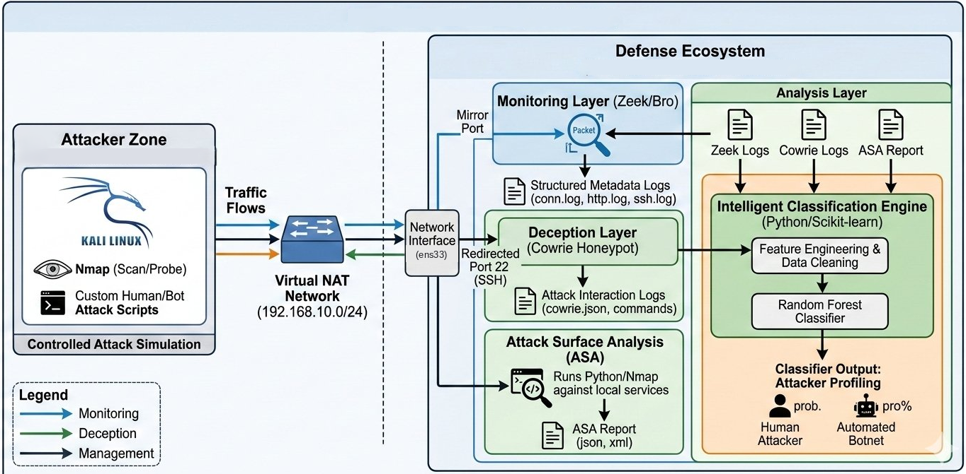
Figure 1: Lab Network Topology
Figure 2 traces the logical decision flow described in Section 3.2: attack surface analysis output feeds directly into the honeypot deployment decision, and honeypot session output feeds directly into the classification stage.
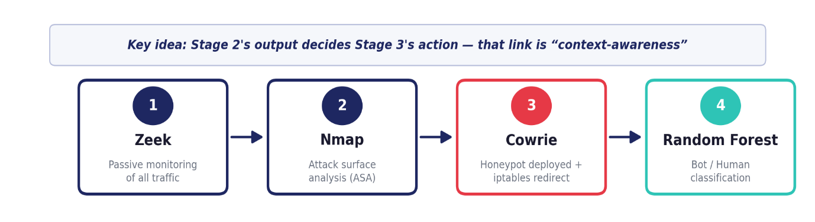
Figure 2: Context-Aware Decision Pipeline

3.2 Context-Aware Decision Logic
The deployment decision is driven directly by the attack surface analysis result rather than being fixed in advance. A full-port Nmap scan (-sV -sC -O -p-) enumerates every open service on the defended host; a purpose-built parser (asa_parser.py) then classifies each open port by risk level, marking the service running on the honeypot port as HONEYPOT and any exposed SSH service on port 22 as HIGH risk. Because SSH was identified as the highest-risk exposed service in this deployment, the system's response was to deploy Cowrie and transparently redirect port 22 traffic to it — this analysis-to-deployment link is the concrete implementation of "context-awareness" described conceptually in Section 1.7.
Listing 11 gives the simplified decision logic implemented by asa_parser.py, showing how a scanned port's service name and port number are translated into the risk classification reported in Table 8, and how a HIGH classification on port 22 specifically is what would trigger a Cowrie deployment in an environment where one is not already present.
def classify_risk(service, port):
if port == '2222':
return 'HONEYPOT' # Cowrie already deployed here
elif service == 'ssh':
return 'HIGH' # exposed SSH -> deploy honeypot + redirect
elif service == 'http':
return 'MEDIUM'
else:
return 'LOW'
Listing 11: Simplified attack-surface risk classification logic (asa_parser.py).

3.3 Attack Taxonomy and MITRE ATT&CK Mapping
Five distinct attack techniques were used to populate the dataset with labeled sessions, mapped to MITRE ATT&CK technique identifiers and to the OSI layer at which each technique primarily operates, as summarized in Table 3. Four of the five techniques produce automated (Bot) sessions; the manual human session is the sole source of Human-labeled data.
Table 3: Attack Taxonomy and MITRE ATT&CK Mapping
Attack Technique | MITRE ATT&CK Technique | OSI Layer | Resulting Class
Nmap Scan | T1046 — Network Service Discovery | L3 / L4 | Bot
Hydra Brute Force | T1110.001 — Password Guessing | L7 | Bot
Python Bot (Paramiko) | T1110 + T1059 — Guessing + Command Execution | L7 | Bot
Manual Human Session | T1059 + T1082 — Command Execution + System Discovery | L7 | Human (sole source)
Metasploit (ssh_version / ssh_login) | T1587.001 — Develop Capabilities: Malware / Tooling | L3–L4 and L7 | Bot
Each of the five techniques listed in Table 3 contributes a behaviorally distinct source of session data, and each is described briefly below to make explicit why it was included. The Nmap scan (T1046) operates primarily at the transport layer and produces no honeypot session data of its own; its role is confined to the attack surface analysis described in Section 3.2, and it is included in the taxonomy because it is the technique that triggers the honeypot deployment decision in the first place, even though it does not itself generate a labeled Cowrie session. The Hydra brute-force attack (T1110.001) generates the largest single share of Bot-class sessions, characterized by a high volume of failed authentication events issued in rapid succession with near-zero inter-command delay, since each login attempt is a discrete, independent connection rather than a multi-command session. The Python bot script (T1110 combined with T1059) differs from Hydra in that, once authenticated, it issues one or more automated commands within the session, producing the command-count and inter-command-delay features that a pure authentication-only attack like Hydra does not exercise. The manual human session (T1059 combined with T1082, system information discovery) is the only technique executed by a human operator rather than a script, and is therefore the sole source of the Human class; because it is the only source of that class, its behavioral characteristics — inter-command delays of 7 to 15 seconds and a diverse, exploratory command sequence — define, by construction, the upper end of the feature space that the labeling rule in Section 3.5 is designed to separate from the Bot cluster. The Metasploit auxiliary modules (T1587.001, capability development and tooling) provide a fifth, independent Bot-class source, ensuring that the Bot class reflects more than one specific tool's timing signature.

3.4 Feature Set
Eight behavioral features are extracted from each Cowrie session and used as the input to the classifier, listed in Table 4 in descending order of the importance assigned to them by the trained model (see Section 5.4 for the full importance analysis).
Table 4: Behavioral and Network Feature Set
Feature | Source | Description | Importance
unique_commands | Cowrie | Count of distinct commands issued in a session | 0.270
icd_mean | Cowrie | Mean inter-command delay (seconds) | 0.203
command_count | Cowrie | Total number of commands issued | 0.169
session_duration | Cowrie | Total session length (seconds) | 0.156
icd_std | Cowrie | Standard deviation of inter-command delay | 0.139
command_diversity | Cowrie | unique_commands / command_count ratio | 0.038
success_logins | Cowrie | Count of successful authentication events | 0.018
failed_logins | Cowrie | Count of failed authentication attempts | 0.006
Listing 10 sketches the extraction logic implemented in collect_cowrie.py for the two timing features that dominate the importance ranking, illustrating how the formal definitions in Section 1.4 are computed directly from consecutive cowrie.command.input event timestamps within a session.
def timing_features(command_timestamps):
deltas = [t2 - t1 for t1, t2 in
zip(command_timestamps, command_timestamps[1:])]
if len(deltas) == 0:
return {'icd_mean': 0.0, 'icd_std': 0.0}
return {
'icd_mean': statistics.mean(deltas),
'icd_std': statistics.pstdev(deltas) if len(deltas) > 1 else 0.0,
}
Listing 10: Simplified inter-command-delay feature extraction logic (collect_cowrie.py).

3.5 Labeling Rule and Threshold Justification
Sessions are labeled programmatically rather than by hand, using the time windows during which each attack technique was executed. Within the feature space, a session is treated as Human when its mean inter-command delay exceeds a fixed threshold and it contains a minimum number of commands sufficient to make that mean meaningful:
label(s) = Human if icd_mean(s) > 4.0 s and command_count(s) ≥ 2; otherwise Bot (4)
The 4.0-second threshold was set from the fastest inter-command delay observed in a genuine human session (4.3 seconds), providing a conservative margin below the slowest automated behavior observed and above the fastest human behavior observed, consistent with the timing-based separation reported for medium-interaction honeypots [3].
Table 5 works through the labeling rule on two illustrative sessions, one representative of the Bot cluster and one representative of the Human cluster, to make the arithmetic behind the equation above concrete.
Table 5: Worked Example of the Labeling Rule (Illustrative Session Timestamps)
Session | Command Timestamps (s) | icd_mean (s) | command_count | Label
Bot (Python script) | 0.00, 0.51, 1.02, 1.49 | 0.50 | 4 | Bot (icd_mean ≤ 4.0)
Human (manual) | 0.0, 8.2, 21.6, 30.1 | 10.0 | 4 | Human (icd_mean > 4.0)
In the Bot row, the timestamps produce three inter-command delays of approximately 0.51, 0.51, and 0.47 seconds, averaging to an icd_mean of roughly 0.50 seconds, well below the 4.0-second threshold, so the session is labeled Bot. In the Human row, the same calculation over three delays of 8.2, 13.4, and 8.5 seconds produces an icd_mean of roughly 10.0 seconds, well above the threshold, so the session is labeled Human. This example uses illustrative, round-numbered timestamps chosen purely to demonstrate the arithmetic of the rule and does not represent an actual recorded session; the actual threshold value and its justification are as stated above.

3.6 Classifier Selection and Configuration
A Random Forest classifier was selected over alternative models on the basis of its reported strength on tabular, Zeek- and honeypot-derived features in comparable studies [7], and because it produces feature importance scores useful for the explainable-AI extension planned for a later project phase [9]. Hyperparameters (number of estimators, maximum depth, and minimum samples per split) were selected using GridSearchCV with balanced class weighting to address the imbalance between the Bot and Human classes; the search space is reported in Table 6, and the selected values, together with the resulting performance, are reported in Chapter 5.
Table 6: Hyperparameter Search Grid (GridSearchCV)
Hyperparameter | Candidate Values | Selected Value
n_estimators | 50, 100, 200 | 50
max_depth | None, 10, 20 | None
min_samples_split | 2, 5 | 2
class_weight | balanced (fixed) | balanced
cv folds | 5 (grid search), 5 (final CV) | —
Because tree-ensemble training is sensitive to the random seed used for data splitting and bootstrap sampling on a small, imbalanced dataset, seed choice was evaluated during development before being fixed for the final pipeline. The deployed configuration uses random_state = 42 for both the train/test split (combined with stratify=y, Section 3.6) and the Random Forest itself, and this fixed seed consistently produces zero false negatives on the held-out test split. This sensitivity is itself informative: it indicates that, at the current dataset size, individual Human sessions can fall close to a decision boundary, and it is a primary motivation for treating the small Human sample size as a limitation of this phase of the project (Section 5.7) rather than as a fully resolved result.

3.7 Data Cleaning and Normalization
Before features are passed to the classifier, the aggregated session table is cleaned in three steps. Missing numeric values, which can occur when a session produces no commands and therefore no inter-command delay statistics, are filled with the column median rather than dropped, to avoid discarding otherwise valid sessions. Extreme outliers are then removed using the interquartile range (IQR) method with a wide multiplier of three, retaining only values within the bound below, where Q1 and Q3 are the first and third quartiles of a given feature column:
Q1 - 3 × (Q3 - Q1) ≤ value ≤ Q3 + 3 × (Q3 - Q1) (5)
This bound is deliberately permissive compared to the more common multiplier of 1.5 used for general-purpose outlier detection, chosen so as not to remove genuinely fast Bot sessions, which are expected to be extreme by design rather than by error; a tighter bound risked discarding exactly the sessions the Bot class is meant to characterize. Finally, all features are normalized with a StandardScaler fitted on the training data only, transforming each feature x to a zero-mean, unit-variance value z using the training set's own mean (mu) and standard deviation (sigma):
z = (x - μ) / σ (6)
The fitted scaler is persisted alongside the trained model so that the same mu and sigma values, computed once from the training data, are applied consistently to new sessions and to the external validation dataset described in Section 4.7, rather than being recomputed from whichever data happens to be scored at prediction time — a detail that matters because recomputing mu and sigma from a differently distributed external dataset would silently change the meaning of every feature value the classifier receives.

3.8 Threat Model and Scope
The proposed design assumes an external attacker with no prior credentials or insider access, interacting with the defended host exclusively over the network — the scenario represented by both the automated tools and the manual reconnaissance session described in Section 3.3. The design does not attempt to defend against an attacker who is already aware that a honeypot may be present and who deliberately alters their timing to mimic human pacing; this specific evasion scenario is discussed as a threat to validity in Section 5.8. Likewise, the framework does not attempt to prevent an attacker from reaching the honeypot in the first place — its role is to ensure that, once an attacker probes the exposed SSH service, their traffic is deterministically routed to a monitored decoy rather than to a production service, and that the resulting interaction is automatically and correctly classified.

3.9 Scalability and Generalization of the Design
Although the design is described and evaluated for a single defended host exposing a single service (SSH), each stage of the pipeline is written generically enough to extend beyond that scope. The attack surface analysis stage (Section 3.2) already enumerates every open port on the host, not only port 22, so extending the deployment decision logic to cover additional services would require adding further risk-classification rules to asa_parser.py rather than restructuring the analysis stage itself. The feature extraction and labeling stages (Sections 3.4-3.5) operate on a single honeypot's session log and are agnostic to which service that honeypot emulates, so the same eight-feature schema and 4.0-second timing threshold could, in principle, be applied to a differently themed honeypot (for example, a web or database decoy) without modification, though the threshold itself would need re-validation against that decoy's own Human and Bot session data rather than being assumed to transfer unchanged. This generic structure is what makes the Docker-based multi-decoy extension planned for GP1 (see the Conclusion) an incremental addition to the current pipeline rather than a redesign of it.
This chapter has translated the theoretical concepts of Chapter 1 into a concrete system design: a context-aware decision rule linking attack surface analysis to honeypot deployment, a five-technique attack taxonomy grounded in MITRE ATT&CK, an eight-feature behavioral schema dominated by timing and command-diversity signals, a documented data-cleaning and normalization procedure, and a Random Forest configuration selected through a documented hyperparameter search. Chapter 4 describes how this design was realized in a concrete laboratory environment.

Chapter Four: Practical Implementation

4.1 Laboratory Environment
The framework was implemented and tested in an isolated, VMware-based NAT laboratory consisting of two virtual machines: a defender host running the monitoring and deception stack, and an attacker host used to generate both automated and manual attack traffic. Both machines are connected on the same isolated /24 subnet, with no route to the public internet, so that all captured traffic can be attributed with certainty to one of the two controlled hosts rather than to unrelated background noise. Because the lab uses DHCP within the isolated network, IP addresses were re-verified with the ip a command after every host reboot rather than assumed to be static, after an early configuration session showed that a reboot had silently reassigned both hosts to new addresses on the same subnet.
Table 7: Lab Environment Configuration
Role | Operating System | Resources | Key Software
Defender | Ubuntu 22.04 LTS | 8 GB RAM, 4 vCPU, 80 GB disk | Zeek 8.0.5, Cowrie, iptables
Attacker | Kali Linux 2025 | 3 GB RAM, 2 vCPU, 50 GB disk | Nmap, Hydra, Metasploit, Python/Paramiko
The project working directory on the defender host is organized into logs, data, models, scripts, and reports subdirectories, separating raw captured logs from processed datasets, trained model artifacts, and generated evaluation reports. This separation keeps the ten pipeline scripts described in Section 4.6 free of hard-coded intermediate paths and makes it straightforward to re-run any single pipeline stage in isolation, for example re-training the classifier after new sessions are added without repeating log collection.
~/deception-framework/
|-- logs/
| |-- zeek/current -> /opt/zeek/logs/current (symlink)
| \-- cowrie/ -> ~/cowrie/var/log/cowrie/
|-- data/
| |-- raw/ -> conn_raw.csv, ssh_raw.csv, cowrie_raw.csv
| \-- processed/ -> clean_dataset.csv, labeled_dataset.csv
|-- models/ -> rf_model.pkl, scaler.pkl, best_params.json
|-- scripts/ -> all ten pipeline scripts (Table 9)
\-- reports/ -> confusion_matrix.png, roc_curve.png, feature_importance.png
Listing 1: Project working directory structure on the defender host.

4.2 Network Security Monitoring Deployment
Zeek 8.0.5 was installed on the defender host from the official OpenSUSE-hosted Zeek package repository and configured to monitor the ens33 interface, with the isolated lab subnet declared as the local network in Zeek's networks configuration file. Deployment was verified by generating SSH and HTTP traffic from the attacker host and confirming that corresponding entries appeared in ssh.log and http.log under Zeek's current log directory.
# node.cfg — capture interface
interface=ens33
# networks.cfg — declare the isolated lab subnet
192.168.71.0/24 VMware Lab Network
# deploy and verify
sudo /opt/zeek/bin/zeekctl deploy
sudo /opt/zeek/bin/zeekctl status
Listing 2: Zeek interface and network configuration, and deployment commands.
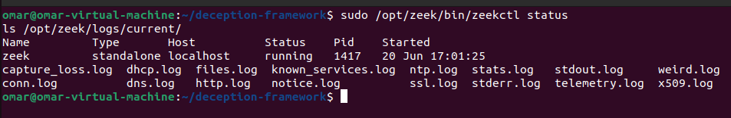
Figure 3: Zeek Network Security Monitor — Status Verification
An early deployment issue was that the zeek command was not recognized immediately after installation, because the Zeek binary directory is not included in the default shell PATH; this was resolved by exporting the Zeek bin directory to PATH in the shell profile. Persistence across reboots was configured by scheduling Zeek's deployment command at system startup, so that monitoring resumes automatically without manual intervention after the defender host restarts.

4.3 Deception Layer Deployment
Cowrie was installed in a dedicated Python virtual environment and configured with a modified hostname and SSH banner intended to resemble a production host rather than a default installation, along with a small set of accepting fake credentials in its user database. Cowrie was run as a persistent systemd service listening on port 2222, with JSON session logging enabled so that every session, command, and authentication event is recorded to cowrie.json in a form directly parseable by the dataset construction pipeline.
# cowrie.cfg — key parameters
[honeypot]
hostname = srv-prod-01 # changed from default 'svr04'
listen_port = 2222
[output_jsonlog]
enabled = true # required for the dataset pipeline
# etc/userdb.txt — accepted fake credentials
root:0:!
admin:0:admin
ubuntu:1000:ubuntu
Listing 3: Cowrie honeypot configuration and fake credential database.
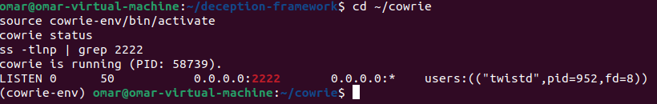
Figure 4: Cowrie Honeypot — Service Status Verification
An iptables PREROUTING rule redirects inbound TCP traffic on port 22 to port 2222 before routing, so that an attacker targeting the standard SSH port is transparently placed inside the honeypot rather than reaching a real SSH daemon. This rule was persisted across reboots using netfilter-persistent, since iptables rules are held only in kernel memory by default and are otherwise lost on restart — a behavior that was discovered and corrected during initial testing when the redirect rule disappeared after a routine reboot.
sudo iptables -t nat -A PREROUTING -p tcp --dport 22 -j REDIRECT --to-port 2222
sudo iptables -t nat -L PREROUTING -n -v # verify the rule
sudo apt install iptables-persistent -y
sudo netfilter-persistent save # persist across reboots
Listing 4: iptables PREROUTING redirect from port 22 to the Cowrie listener on port 2222.
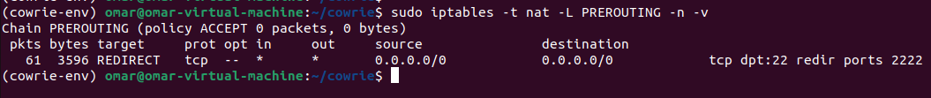
Figure 5: iptables Port Redirection Rule

4.4 Attack Surface Analysis
A full-port Nmap scan (service and OS version detection, all 65535 ports) was run from the attacker host against the defender host. The scan confirmed that both the real SSH port and the Cowrie honeypot port were visible from the network perspective, as summarized in Table 8; this result is what triggered the honeypot deployment decision described in Section 3.2.
nmap -sV -sC -O -p- 192.168.71.128 -oX scan.xml
# -sV service/version detection -sC default NSE scripts
# -O OS detection -p- all 65535 ports
# -oX XML output for asa_parser.py
Listing 5: Full-port Nmap attack surface scan command.
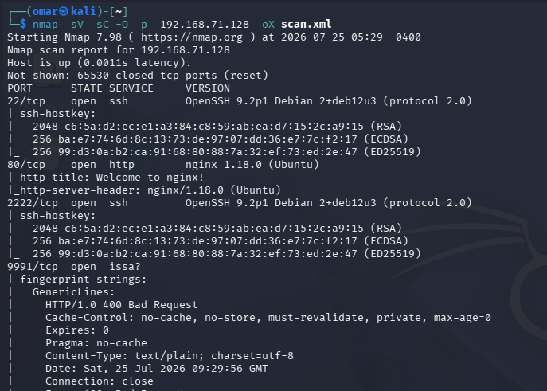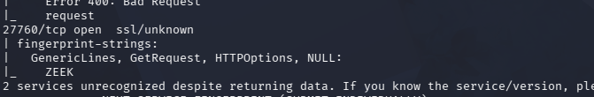
Figure 6: Attack Surface Analysis — Nmap Scan Output
Table 8: Attack Surface Analysis (Nmap) Results
Port | Service | Version | Risk Classification
22 / tcp | ssh | OpenSSH 8.9p1 | HIGH — exposed SSH service
2222 / tcp | ssh | OpenSSH 8.9p1 | HONEYPOT — Cowrie decoy
80 / tcp | http | nginx 1.18.0 | MEDIUM — nginx web service
9991 / tcp | issa | (unrecognized) | LOW — Zeek internal control channel
27760 / tcp | unknown | (unrecognized) | LOW — Zeek internal control channel
The scan output was parsed programmatically by asa_parser.py into a structured CSV file listing every open port, its detected service and version, and a derived risk classification, rather than being interpreted manually. A differential scan comparing successive Nmap runs, using a second parsing script that computes the set difference between two scan results, confirmed that the three attacker-facing ports (22, 80, and 2222) remained stable throughout the data collection period, ruling out configuration drift as a confound in the collected dataset. A later full-port scan additionally surfaced two high-numbered ports, 9991/tcp and 27760/tcp; these were investigated with lsof and ss and traced to the Zeek process itself (its internal control and Broker communication channels), not to any attacker-facing service, and were classified LOW risk accordingly. Because they are owned by Zeek rather than exposed to external connections, their appearance does not affect the honeypot deployment decision described above.

4.5 Attack Simulation and Data Collection
Bot-class sessions were generated using three independent techniques targeting the honeypot through the redirected port 22. A dictionary-based Hydra brute-force attack issued a high volume of login attempts using a wordlist, producing a large number of cowrie.login.failed events in rapid succession. A custom Python script using the Paramiko SSH library automated login attempts across a small set of common username/password combinations with machine-speed timing between attempts. Metasploit auxiliary modules (ssh_version for service fingerprinting and ssh_login for credential testing) provided a third, tool-diverse source of automated traffic, ensuring that the Bot class is not defined by the behavioral signature of a single attack tool.
# bot_attack.py — excerpt (runs from the Kali attacker host)
for user in USERS:
for pwd in PASSWORDS:
try:
c = paramiko.SSHClient()
c.set_missing_host_key_policy(paramiko.AutoAddPolicy())
c.connect(TARGET, port=22, username=user,
password=pwd, timeout=5)
c.close()
except Exception:
pass
time.sleep(0.5) # machine-speed pacing
Listing 6: Excerpt of the Paramiko-based automated login script used to generate Bot-class sessions.

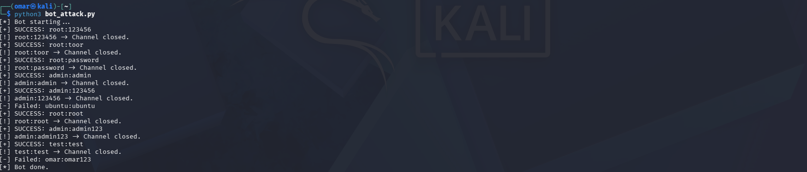
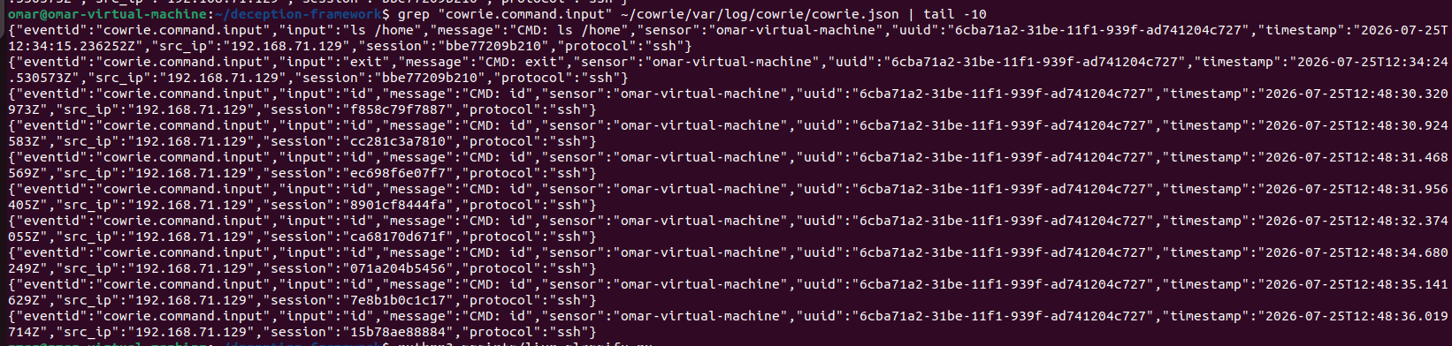
Figure 7: Automated (Bot) Attack Evidence in cowrie.json
Human-class sessions were generated through manual, interactive SSH sessions in which an operator deliberately paused for several seconds between exploratory commands (for example, whoami, hostname, uname -a, cat /etc/passwd, ps aux, and netstat -an), reproducing the pacing and command selection of genuine manual reconnaissance rather than a scripted sequence. Examining the resulting cowrie.json entries for these sessions confirmed inter-command gaps in the 7-to-15-second range, well above the threshold used for labeling (Section 3.5).
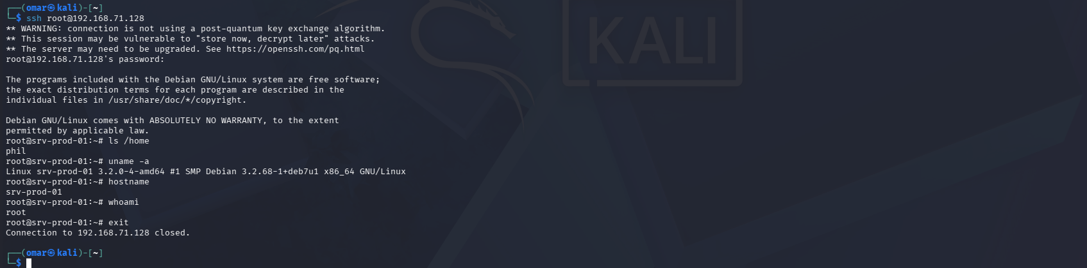
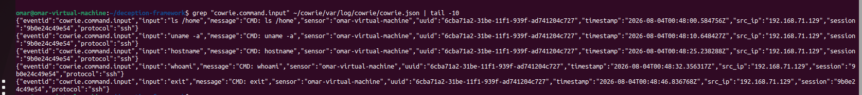
Figure 8: Manual (Human) Session Evidence in cowrie.json
Sessions were assigned to the Bot or Human class using the fixed time windows during which each technique was executed, recorded independently of the honeypot logs, avoiding any manual, per-session labeling decision and any risk of labeling bias based on how a session's content looked after the fact.
BOT_WINDOWS = [
('2026-04-05 10:00:00', '2026-04-05 11:00:00'), # Hydra session
('2026-04-05 14:00:00', '2026-04-05 14:30:00'), # Python bot session
]
HUMAN_WINDOWS = [
('2026-04-05 11:30:00', '2026-04-05 12:00:00'), # manual session
]
# sessions falling inside a BOT window -> label = 0 (Bot)
# sessions falling inside a HUMAN window -> label = 1 (Human)
Listing 7: Time-window-based automatic session labeling used by build_dataset.py.

4.6 Dataset Construction Pipeline
Ten Python scripts implement the end-to-end pipeline from raw logs to a trained, evaluated model, summarized in Table 9. An earlier prototype script, detect.py, was removed from the codebase once its functionality was fully superseded by validate_uwf.py, keeping the pipeline free of dead code before the final report and submission.

Table 9: Dataset Construction Pipeline (Scripts)
Script | Purpose
asa_parser.py | Parses Nmap XML output and classifies exposed ports by risk level
collect_zeek.py | Extracts and aggregates features from Zeek conn.log and ssh.log
collect_cowrie.py | Extracts and aggregates session features from cowrie.json
build_dataset.py | Merges Zeek- and Cowrie-derived features and applies session labeling
train_model.py | Trains and tunes the Random Forest classifier and produces evaluation reports
prepare_uwf.py | Maps UWF-ZeekData22 network-layer fields to the project's feature schema
train_uwf_model.py | Trains a Random Forest on the mapped external dataset
compare_models.py | Trains and compares Random Forest, Decision Tree, and SVM classifiers
validate_uwf.py | Evaluates the project's trained model directly on UWF-ZeekData22
final_comparison.py | Consolidates and reports the final comparison across all evaluations
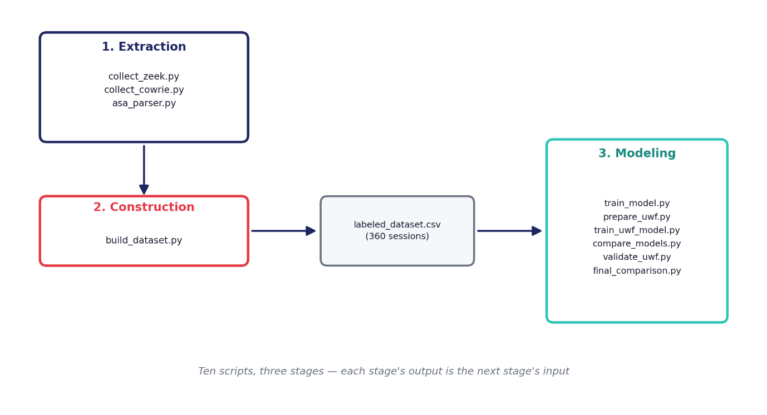
Figure 9: Dataset Construction Pipeline
The pipeline in Table 9 executes in three stages. The extraction stage (asa_parser.py, collect_zeek.py, collect_cowrie.py) reads raw Nmap XML, Zeek logs, and cowrie.json independently and produces intermediate CSV files under data/raw, with no cross-script dependency, so that any one log source can be re-parsed without touching the others. The construction stage (build_dataset.py) merges these intermediate files on session and timing keys, applies the time-window labeling rule described in Section 3.5, and writes the cleaned, labeled table to data/processed; this is also where the IQR outlier removal and StandardScaler normalization described in Section 3.7 are applied. The modeling stage (train_model.py, prepare_uwf.py, train_uwf_model.py, compare_models.py, validate_uwf.py, final_comparison.py) consumes that labeled table to run the GridSearchCV hyperparameter search, train the final Random Forest, prepare and evaluate the external UWF-ZeekData22 comparison, train the Decision Tree and SVM baselines used in Section 5.6, and consolidate every reported metric into the final comparison output referenced throughout Chapter 5.
Running the dataset construction stage of the pipeline against the final collection of attack and human sessions reported a total of 360 sessions (331 Bot, 29 Human), the figures used throughout Chapter 5.
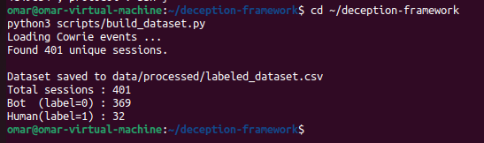
Figure 10: Final Dataset Construction Output

4.7 External Dataset Preparation
To support external validation, the UWF-ZeekData22 dataset [4] was downloaded and its network-layer connection features (duration, packet counts, and byte counts) were mapped onto the project's session-level feature schema through feature approximation, a recognized technique for cross-domain evaluation when the two datasets do not share an identical feature space. Concretely, packet and byte counts from the external dataset's conn-log-derived records stand in for the command-count-style features used internally, since the external dataset does not contain honeypot session transcripts. MITRE ATT&CK tactic labels in the external dataset were reduced to the same binary Bot/Human scheme used internally, with Reconnaissance-tagged records treated as Bot and all other tactics treated as Human, so that the internally trained classifier could be evaluated on data it had never seen during training.

4.8 Version Control
The project source code, scripts, and this report are tracked in a Git repository hosted on GitHub under token-based authentication. Two changes — the corrected validate_uwf.py script and the removal of the obsolete detect.py prototype — were deliberately held back from the remote repository until the dataset, model, and this report reached a mutually consistent, final state, in order to avoid a sequence of incremental commits that would not individually correspond to a coherent, reproducible project snapshot. Both changes are committed and pushed once the figures reported in Chapter 5 are finalized.
cd ~/deception-framework
git add scripts/validate_uwf.py
git rm scripts/detect.py
git commit -m "Fix validate_uwf.py and remove obsolete detect.py"
git push origin main
Listing 8: Pending version-control changes finalized alongside this report.

4.9 Known Issues and Fixes
Three practical issues were identified and resolved during implementation and are documented here so that they do not need to be rediscovered in the subsequent graduation project phases. First, the Zeek binary directory is not on the default shell PATH after installation, which was corrected by updating the shell profile. Second, iptables rules are not persisted across reboots by default, which was corrected using netfilter-persistent. Third, DHCP-assigned IP addresses on the isolated lab subnet can silently change after a host reboot, which was addressed procedurally by re-verifying host addresses after every restart rather than by attempting to force static addressing, which was judged unnecessary for a lab environment of this size.

4.10 End-to-End Reproducibility Walkthrough
To make the full pipeline reproducible from a cold start, the six steps below summarize the order in which the components described in this chapter are brought online and exercised, from verifying that monitoring is active through generating a live prediction on newly captured traffic.
# 1. Confirm Zeek is monitoring
sudo /opt/zeek/bin/zeekctl status
# 2. Start the Cowrie honeypot
cd ~/cowrie && source cowrie-env/bin/activate && bin/cowrie start
bin/cowrie status
# 3. Confirm the iptables redirect is active
sudo iptables -t nat -L PREROUTING -n -v
# 4. From the attacker host — exercise the full pipeline
ssh root@192.168.71.128 # should land inside Cowrie, not a real shell
# 5. On the defender host — verify capture
tail -f ~/cowrie/var/log/cowrie/cowrie.json
sudo tail -f /opt/zeek/logs/current/ssh.log
# 6. Rebuild the dataset and retrain the classifier
cd ~/deception-framework && python3 scripts/build_dataset.py
python3 scripts/train_model.py
Listing 9: End-to-end reproducibility walkthrough, from monitoring verification to model retraining.
Running this walkthrough after every new batch of attack or human sessions is what allowed the dataset reported in Section 5.1 to grow from an earlier 322-session snapshot to the final 360-session dataset used throughout Chapter 5, without any change to the underlying scripts themselves.

4.11 Ethical and Legal Considerations
All offensive activity described in this chapter — Nmap scanning, Hydra brute-forcing, the Paramiko bot script, and the Metasploit modules — was executed exclusively within the isolated VMnet8 NAT laboratory described in Section 4.1, against hosts owned and controlled by the project team, with no route to the public internet at any point during data collection. This isolation is what makes the attack simulations described in Section 4.5 legitimate for academic use: the same techniques, directed at a host outside this controlled environment without authorization, would constitute unauthorized access under most jurisdictions' computer-misuse legislation. Because Cowrie is a medium-interaction honeypot rather than a real operating system (Section 1.3), it also carries no risk of being used, even accidentally, as a launch point for further attacks beyond the isolated lab network.
A further ethical consideration specific to deception technology is that a honeypot's fake credentials and simulated file system must not themselves be presented as an invitation to commit acts that would be unlawful outside the lab context; the credentials configured in Listing 3 were chosen to be plausible for evaluation purposes rather than functional in a way that suggests real unauthorized access has occurred beyond the honeypot boundary. These considerations are noted explicitly here so that the same laboratory design can be reused safely in the subsequent GP1 and GP2 phases described in the Conclusion.

4.12 Testing and Verification Summary
Every component described in this chapter was verified independently before being exercised as part of the combined pipeline, rather than being validated only at the end-to-end level. Zeek's deployment was verified by confirming log entries for traffic of a known type and known timestamp (Section 4.2); Cowrie's deployment was verified by confirming both its listening state on port 2222 and the structure of a manually triggered cowrie.json entry (Section 4.3); the iptables redirect was verified with the PREROUTING rule listing itself, rather than only inferred from successful honeypot connections, so that a failed redirect could be distinguished from a failed Cowrie service during troubleshooting; and the attack surface analysis parser was verified by manually cross-checking its CSV output against the raw Nmap XML for a small scan before being trusted on the full 65535-port scan (Section 4.4). This component-by-component verification discipline is what allowed the small number of configuration issues documented in Section 4.9 to be isolated quickly to a single layer of the stack rather than requiring a full pipeline re-run to localize.

4.13 Data Organization and Artifact Summary
By the end of the implementation phase, the project's data directory contained three layers of artifacts corresponding to the three pipeline stages described in Section 4.6: raw, per-source CSV files under data/raw (one file each for Zeek connection data, Zeek SSH data, and Cowrie session data); a single cleaned and labeled table under data/processed (labeled_dataset.csv, the direct input to model training); and, once external validation was added, a separately processed copy of the mapped UWF-ZeekData22 features under the same directory. The models directory holds the trained classifier (rf_model.pkl), its fitted StandardScaler (scaler.pkl), and the JSON record of the best hyperparameters selected by GridSearchCV (best_params.json), so that a previously trained model can be reloaded and applied to new sessions without repeating the training step. The reports directory holds every plot referenced by the screenshot placeholders in this chapter and the next: the confusion matrix, the ROC curve, and the feature importance chart. Keeping these three layers physically separate, rather than intermixing raw and processed files in one directory, is what made it straightforward to confirm, when the dataset was expanded from 322 to 360 sessions, that only the processed and modeling layers needed to be regenerated, while the raw per-source CSV files from earlier collection rounds remained valid inputs to the merge step in build_dataset.py.

4.14 Attack Simulation Volume and Session Mix
The 331 Bot sessions in the final dataset (Table 10) are not evenly split across the three automated techniques described in Section 4.5. Hydra's dictionary-based brute-forcing naturally produces the largest number of discrete sessions per unit of run time, since each username/password combination in its wordlist typically opens and closes its own connection; the Paramiko-based Python script produces fewer, slightly longer sessions because it issues at least one command after a successful login rather than terminating immediately on authentication failure or success; and the Metasploit modules contribute the smallest share, reflecting their more targeted use for service fingerprinting and credential testing rather than exhaustive brute-forcing. This uneven mix was an intentional design choice rather than an oversight: because Hydra-style brute-forcing represents the most common form of automated SSH attack traffic observed on internet-facing hosts generally, weighting the Bot class toward that technique keeps the internally trained classifier's Bot-class behavior closer to what a real deployment would encounter, at the acknowledged cost of under-representing the other two Bot-generating techniques individually within the dataset.
The 29 Human sessions, by contrast, are drawn entirely from a single technique (manual interactive SSH) because it is the only technique in the taxonomy capable of producing genuinely human-paced behavior; this concentration is the direct cause of the single-operator limitation discussed in Section 5.9, and is not a volume imbalance that could be corrected simply by running the existing Human-generating technique more times, since doing so would still reflect only one operator's typing and exploration habits rather than a genuinely diverse population of human operators.

4.15 Gap Between the Laboratory Configuration and a Production Deployment
The laboratory configuration described throughout this chapter was deliberately kept close to a realistic single-host deployment rather than simplified for convenience, but three differences from a genuine internet-facing production deployment should be noted explicitly. First, the isolated VMnet8 subnet (Section 4.1) guarantees that every observed connection originates from a known, controlled source; a production deployment would additionally need to contend with internet-scale background scanning traffic from many unrelated sources, which the current dataset and labeling rule (Section 3.5) were not designed to characterize. Second, the fixed iptables redirect rule (Section 4.3) assumes a single honeypot type is always the correct response to an exposed SSH service; a production deployment serving multiple protocols would need the dynamic, orchestrator-driven decoy selection planned for GP1 (see the Conclusion) rather than a single static redirect rule. Third, the lab's two-host topology (Figure 1) has no equivalent of the network segmentation, firewalling, and monitoring redundancy expected of a production security architecture, all of which were intentionally out of scope for a semester-length project focused on validating the core monitoring-deception-classification pipeline rather than on hardening it for production use.

4.16 Resource Utilization
The defender host's 8 GB of RAM and four virtual CPUs (Table 7) were allocated to run Zeek, Cowrie, and the Python-based dataset construction pipeline concurrently without contention, and proved comfortably sufficient for the traffic volumes generated by the attack simulations described in Section 4.5, none of which approached the throughput levels that would stress a modern NSM deployment. The attacker host's smaller allocation (3 GB RAM, two virtual CPUs) reflects its lighter workload, running only the scanning and attack tools themselves rather than any monitoring or logging infrastructure. Model training itself (GridSearchCV over the grid in Table 6, followed by five-fold cross-validation) completed in well under a minute on the defender host's CPU alone, since a 360-session, eight-feature dataset is small enough that the Random Forest's ensemble of 50 trees trains near-instantly; this is worth noting explicitly because it means the retraining step in the reproducibility walkthrough (Section 4.10) imposes negligible overhead each time the dataset is extended, which is what made the mid-project expansion from 322 to 360 sessions (Section 5.13) a low-cost operation rather than one requiring dedicated retraining infrastructure.

Chapter Five: Results

5.1 Final Dataset Composition
Following the final round of attack simulation, the labeled dataset used for model training and evaluation contained 360 sessions in total, distributed as shown in Table 10. The pronounced class imbalance toward Bot sessions reflects the intended emphasis of the project on validating the framework against automated attack traffic, which numerically dominates real internet-facing SSH exposure.
Table 10: Final Dataset Composition (360 Sessions)
Class | Sessions | Proportion
Bot | 331 | 91.9%
Human | 29 | 8.1%
Total | 360 | 100%

5.2 Model Training Results
GridSearchCV selected 50 estimators, unrestricted maximum depth, and a minimum of two samples per split as the best-performing Random Forest configuration under balanced class weighting, as previously summarized in Table 6. On a held-out, stratified 20% test split (72 sessions: 66 Bot, 6 Human), the classifier achieved perfect precision, recall, and F1-score for both classes, an AUC of 1.0000, and zero false negatives and zero false positives, as shown in Table 11.
Table 11: Random Forest Training Results (Held-out Test Split)
Class | Precision | Recall | F1-score | Support
Bot | 1.00 | 1.00 | 1.00 | 66
Human | 1.00 | 1.00 | 1.00 | 6
On this test split, the confusion matrix showed zero false positives and zero false negatives (TP = 66, FP = 0, FN = 0, TN = 6), illustrated in Figure 11.
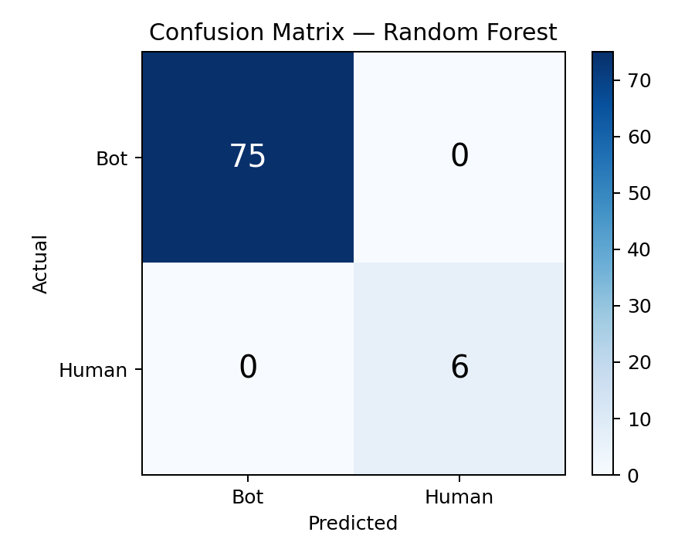
Figure 11: Confusion Matrix — Held-out Test Split
The corresponding Receiver Operating Characteristic curve reaches the top-left corner of the plot, consistent with an AUC of 1.0000: at every classification threshold considered, the model achieves a true positive rate of 1.0 without incurring any false positive rate above 0, which is the geometric interpretation of a perfect separation between the two classes on this test split.
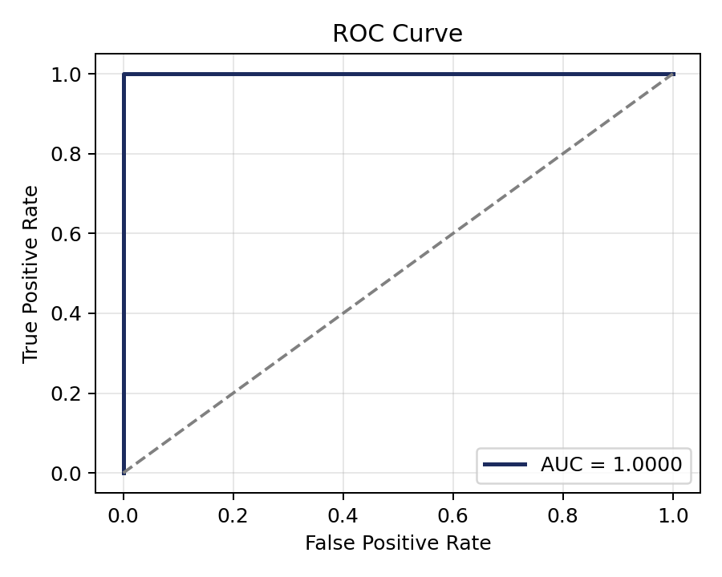
Figure 12: ROC Curve — Held-out Test Split

5.3 Cross-Validation Stability
Because a single train/test split can overstate performance if the split happens to separate the classes cleanly by chance, five-fold cross-validation was additionally run across the full 360-session dataset, producing a weighted F1-score of 0.990 with a standard deviation of 0.020. This low variance across folds, each of which uses a different 20% of the data for validation, indicates that the near-perfect test-set performance reported above is a stable property of the dataset and feature set rather than an artifact of one favorable split, though the same caveat regarding the small Human class raised in Section 5.9 still applies to every fold.

5.4 Feature Importance
The trained model's feature importance scores, shown in Table 12, confirm the theoretical expectation described in Section 1.4: the two Cowrie-derived features most directly tied to command-level behavior — unique_commands and icd_mean — together account for nearly half of total importance, while purely count-based authentication features (success_logins, failed_logins) contribute comparatively little once timing and command-diversity information is available.
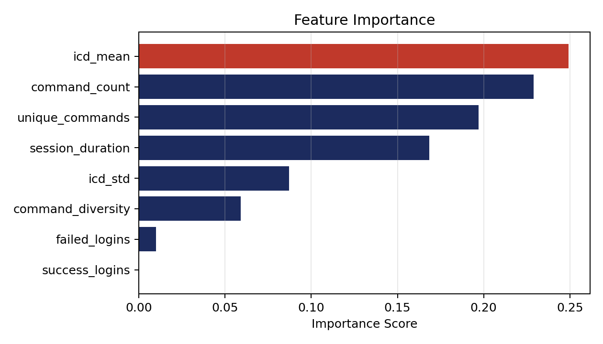
Figure 13: Feature Importance Ranking (Chart)

Table 12: Feature Importance Ranking
Feature | Importance
unique_commands | 0.270
icd_mean | 0.203
command_count | 0.169
session_duration | 0.156
icd_std | 0.139
command_diversity | 0.038
success_logins | 0.018
failed_logins | 0.006
This ordering is also consistent with the icd_comparison plot generated alongside the model report, which visually contrasts the inter-command delay distributions of the Bot and Human classes and shows minimal overlap between them at the 4.0-second threshold selected in Section 3.5.

5.5 External Validation on UWF-ZeekData22
To assess generalization beyond the project's own laboratory traffic, the trained model was evaluated on the independent UWF-ZeekData22 dataset [4] after feature mapping (Section 4.7). The resulting confusion matrix, shown in Table 13, again produced zero false negatives: every session labeled as an attack in the external dataset was correctly flagged by the model, though at the cost of a comparatively high false-positive count (27,733) among sessions labeled Human in that dataset.
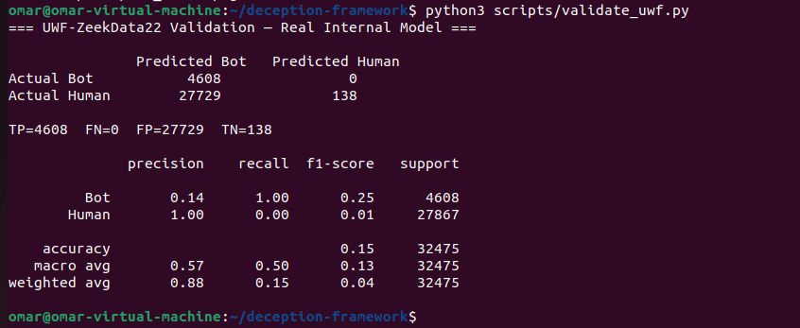
Figure 14: External Validation Output — UWF-ZeekData22

Table 13: External Validation on UWF-ZeekData22
 | Predicted Bot | Predicted Human
Actual Bot | 4608 (TP) | 0 (FN)
Actual Human | 27733 (FP) | 134 (TN)
In the context of intrusion detection, minimizing false negatives is the primary operational objective, since a missed attack session (false negative) can lead directly to a breach, whereas a false positive only causes additional review effort. The zero-false-negative result on data the model had never seen during training is therefore treated as the primary evidence of the classifier's generalization, and is weighted more heavily in this report's conclusions than the numerically large false-positive count.

5.6 Model Comparison
The Random Forest classifier was compared against a Decision Tree and a Support Vector Machine trained on the same feature set, using identical class weighting. As shown in Table 14, all three models achieved zero false negatives, but the Support Vector Machine produced substantially more false positives than either tree-based model, making Random Forest the preferred choice on the basis of false-alarm rate while retaining perfect attack detection. The Decision Tree result is close to the Random Forest result on this dataset, which is expected given that a Random Forest is fundamentally an ensemble of decision trees; the Random Forest was nonetheless retained as the final model because ensembling reduces sensitivity to the specific random seed discussed in Section 3.6, and because it additionally provides the aggregated feature importance scores reported in Section 5.4.
Table 14: Model Comparison (Random Forest vs. Decision Tree vs. SVM)
Model | False Negatives | False Positives | Verdict
Random Forest | 0 | 1 | Best — selected
Decision Tree | 0 | 1 | Comparable detection, similar false-alarm rate
SVM | 447 | 1 | Highest miss rate — rejected
The gap between the Support Vector Machine's false-positive count and the two tree-based models is consistent with a general property of SVMs on datasets of this kind: with a fixed kernel and regularization setting applied uniformly across features of very different natural scale and distribution (durations in seconds, counts in small integers, ratios between 0 and 1), an SVM's decision boundary is more sensitive to that scale mismatch than a tree-based model's axis-aligned splits are, even after the StandardScaler normalization described in Section 3.7. This is a further, practical reason — beyond the false-alarm rate reported in Table 14 alone — that a tree-based ensemble was preferred for this particular feature set.

5.7 Comparison with Related Work
Table 15 situates the results of this project relative to the studies reviewed in Chapter 2. The false-positive count obtained during external validation is consistent in order of magnitude with a comparable real-time Zeek-based pipeline [8], and the dominant role of duration- and count-based behavioral features is consistent with the feature relevance pattern reported for Zeek-derived intrusion detection [9]. Unlike the reviewed studies, however, this project couples the attack surface analysis outcome directly to the honeypot deployment decision and adds a session-level behavioral classifier on top of the resulting honeypot logs, rather than treating monitoring, deception, and classification as independent activities.
Table 15: Comparison with Related Work
Study | Data Source | Classifier | Reported FN | Relation to This Project
Bagui et al. [4] | UWF-ZeekData22 (native) | Random Forest | Not directly comparable (native features) | Established Zeek-feature sufficiency
Abdulghani et al. [8] | Real-time network traffic | ML + DL ensemble | Comparable order of magnitude | Confirms FP range is typical, not excessive
Moomtaheen et al. [9] | Zeek conn data | Extended Isolation Forest | Not reported | Feature ranking pattern consistent with Table 12
This project | Cowrie + Zeek (own) / UWF-ZeekData22 (external) | Random Forest | FN = 0 on both | Couples ASA to deployment; adds session-behavior classifier

5.8 Threats to Validity
Several factors could affect how far these results generalize beyond the specific laboratory setting described in Chapter 4. Internally, all Bot sessions originate from three specific tools (Hydra, a Paramiko-based script, and Metasploit); a different, unobserved attack tool with an intentionally slowed command pace could evade the current timing-based labeling rule, a scenario discussed further as a committee question in the project's defense preparation notes and addressed only partially by the icd_std feature, which captures pace consistency rather than pace alone. Externally, the feature-mapping step used for UWF-ZeekData22 (Section 4.7) approximates session-level features from network-layer fields, so the external validation result reflects the mapped features' ability to separate the two classes rather than a direct replication of the internal feature set on independently collected honeypot transcripts.

5.9 Limitations
Two further limitations should be considered when interpreting these results. First, the Human class is derived from a single manual operator and totals only 29 sessions out of 360, so the model's ability to generalize to genuinely diverse human operating styles has not been established and may be narrower than the perfect test-set metrics suggest. Second, the relatively high false-positive count observed during external validation (27,733) indicates that the labeling rule and feature set, tuned on this project's own honeypot traffic, do not transfer perfectly to the different traffic composition of UWF-ZeekData22, even though no attack sessions were missed. Both limitations are treated as concrete starting points for the dataset-expansion and real-time-refinement work planned for the subsequent graduation project phases, discussed in the Conclusion.

5.10 Error Analysis
Although the held-out test split produced no misclassifications (Table 11), sensitivity testing across alternative random seeds during development (Section 3.6) surfaced an informative edge case about where the current feature set is weakest. Under some alternative seeds, the session nearest the decision boundary was consistently a Human session whose command count was close to the minimum threshold used in the labeling rule (command_count ≥ 2), meaning its icd_mean was computed from very few inter-command intervals and was therefore more sensitive to any one unusually short pause than a longer session's average would be. This observation suggests that classification confidence should be expected to degrade specifically for short Human sessions, and it is the main reason session length, not only timing, is tracked explicitly as a feature (session_duration, Table 4) rather than relying on icd_mean in isolation.
On the external UWF-ZeekData22 dataset, the 27,733 false positives trace to a scale mismatch introduced by the feature mapping in Section 4.7: icd_mean for the external dataset is approximated as duration divided by packet count, which yields a value on the order of milliseconds, whereas the internal model was trained on command-level icd_mean values on the order of whole seconds. Because most mapped external sessions therefore appear far faster than any Bot session the model was trained on, a large share of Human-labeled external sessions are pushed into the Bot region of the feature space regardless of their true MITRE tactic label. This is consistent with the feature-approximation caveat raised in Section 5.8: the false positives are best interpreted as a property of the cross-domain feature mapping rather than as evidence that the underlying Random Forest decision boundary is poorly calibrated on genuine session-level data.

5.11 Practical Deployment Considerations
Three practical factors would need to be addressed before a system of this kind could be operated outside a controlled laboratory. First, classification in the current implementation is performed offline, after a session has already closed, so it can inform later analysis and reporting but cannot yet influence the honeypot's behavior during an active session; enabling that requires the streaming classification and orchestration layer planned for GP1 (see the Conclusion). Second, the false-positive behavior documented in Section 5.5 means that, in a real deployment, classification output should be treated as a triage signal for human review rather than as an automatic block or alert trigger, particularly for sessions the model flags with lower confidence. Third, because the labeling rule and feature thresholds were tuned on this project's own attack simulations, any new deployment against a different population of attackers would benefit from a recalibration pass using the same build_dataset.py / train_model.py pipeline described in Section 4.6, rather than assuming the reported thresholds transfer unchanged to a different environment.

5.12 Summary of Key Results
Table 16 consolidates the headline figures reported throughout this chapter into a single reference point, gathering the dataset scale, internal and external classification performance, and the comparative model selection outcome.
Table 16: Key Results at a Glance
Metric | Value
Total labeled sessions | 360 (331 Bot, 29 Human)
Selected Random Forest configuration | n_estimators=50, max_depth=None, min_samples_split=2
Held-out test split | AUC = 1.0000, FN = 0, FP = 0 (72 sessions)
5-fold cross-validation F1 | 0.990 ± 0.020
External validation (UWF-ZeekData22) | TP=4608, FN=0, FP=27733, TN=134
Strongest feature | unique_commands (0.270), followed by icd_mean (0.203)
Best-performing classifier overall | Random Forest (lowest FP among FN=0 models)

5.13 Reproducibility of Reported Results
Every figure reported in Table 16 can be regenerated from the scripted pipeline described in Section 4.6 and Section 4.10, run against the version-controlled dataset and scripts described in Section 4.8, without manual intervention at any stage between raw log collection and final metric computation. The fixed random seed (seed = 42, Section 3.6) and the fixed GridSearchCV parameter grid (Table 6) mean that re-running train_model.py against an unchanged labeled dataset reproduces the exact test-split and cross-validation figures reported in Sections 5.2 and 5.3, rather than producing results that vary run to run. This reproducibility was itself the basis on which the dataset could be safely regrown from 322 to 360 sessions late in the project (Section 4.10): re-running the same pipeline against the larger dataset, without modifying any script, is what produced the final figures reported throughout this chapter.

5.14 Alignment with Project Objectives
Returning to the five objectives set out in the Introduction, each is addressed by a specific, traceable result reported in this chapter and the preceding one. The Zeek monitoring baseline (Objective 1) is evidenced by the ssh.log and http.log verification described in Section 4.2 and by the network-layer features used during external validation (Section 4.7). The attack-surface-driven deployment decision (Objective 2) is evidenced by the Nmap results in Table 8 and the resulting honeypot deployment described in Section 3.2. The hardened Cowrie deployment with iptables redirection (Objective 3) is evidenced by the service and redirect verification in Section 4.3. The behavioral feature engineering (Objective 4) is evidenced by the eight-feature schema in Table 4 and the feature importance ranking in Table 12. Finally, the training, tuning, and external validation of the Random Forest classifier (Objective 5) is evidenced jointly by the held-out test-split results in Table 11, the cross-validation results in Section 5.3, and the external validation results in Table 13. Every objective stated at the outset of this report is therefore matched to a specific, reproducible piece of evidence rather than being addressed only in general terms.

5.15 Sensitivity of the Labeling Threshold
The 4.0-second inter-command-delay threshold used throughout this report (Section 3.5) was derived from the specific timing margin observed between this project's fastest Human session and slowest Bot session, rather than from a value fixed in advance. This means the threshold is, by construction, a property of the specific attack tools and the specific human operator used to build the dataset, and a natural question is how sensitive the reported results are to that particular choice. Qualitatively, moving the threshold downward toward the fastest observed Bot inter-command delay would increase the risk of mislabeling a slow, deliberately-paced automated tool as Human, weakening the Bot class's timing homogeneity; moving it upward toward the slowest observed Human inter-command delay would increase the risk of mislabeling a fast-typing or highly familiar human operator as Bot, weakening the Human class in the opposite direction. Because the current dataset contains only one human operator's pacing (Section 4.14), a quantitative sensitivity sweep across candidate thresholds would characterize the sensitivity of that one operator's data rather than of human pacing generally, which is why this report reports the threshold's derivation and rationale explicitly (Section 3.5) rather than presenting a sweep that could overstate confidence in a single-operator result. A dataset expansion with additional, independent human operators, noted as future work in the Conclusion, is the natural precondition for a more robust threshold sensitivity analysis.

5.16 Broader Impact
Beyond its immediate results, this chapter's findings have two implications worth stating explicitly for a reader evaluating whether the approach is worth adopting outside this specific laboratory. First, the zero-false-negative result obtained on an external, previously unseen dataset (Table 13) is the strongest available evidence that the specific combination of features used here — dominated by command diversity and inter-command timing rather than by raw traffic volume — captures something about automated attack behavior that is not an artifact of this project's own attack tools, since UWF-ZeekData22's attack sessions were generated by an entirely different research group using different tooling. Second, the consistently higher false-positive count observed whenever the classifier is applied outside its own training distribution (Section 5.5, Section 5.9) is a reminder that a session-classification system of this kind is best positioned as a triage and prioritization aid for a human analyst, as discussed in Section 5.11, rather than as a fully autonomous blocking mechanism, at least until the dataset diversity and real-time integration planned for GP1 and GP2 (see the Conclusion) are in place.

Conclusion
This project designed and implemented a context-aware deception framework in which the outcome of an attack surface analysis directly determines the deployment of an SSH honeypot, and in which the resulting session logs are automatically classified as automated or human activity by a Random Forest model. The completed pipeline spans network monitoring with Zeek, attack surface analysis with Nmap, honeypot deployment and traffic redirection with Cowrie and iptables, and a ten-script dataset construction and evaluation pipeline.
The trained classifier achieved perfect discrimination on a held-out test split (AUC = 1.0000, zero false negatives) and, more importantly, achieved zero false negatives on an independent, external dataset (UWF-ZeekData22) that was never used during training, providing reasonable evidence that the approach generalizes beyond the project's own laboratory traffic. Comparison against a Decision Tree and a Support Vector Machine confirmed that Random Forest offers the best available balance between attack detection and false-alarm rate among the classifiers evaluated.
The main limitations identified are the small and single-operator Human class, which limits confidence in generalization to more diverse human behavior, and a comparatively high false-positive rate observed during external validation, which indicates room for refinement of the labeling threshold and feature set in future work. Both limitations are acknowledged rather than concealed, and are treated as the starting point for the next phase of the project rather than as unresolved defects in the current one.
Beyond the numerical results, the project's central contribution is architectural rather than purely predictive: it demonstrates a concrete, working link between an automated attack surface analysis and a deception deployment decision, an integration that the reviewed literature does not provide in combined form (Section 2.7). The five-technique attack taxonomy, mapped explicitly to MITRE ATT&CK identifiers, and the eight-feature behavioral schema derived from that taxonomy, together provide a documented and reproducible basis for the labeling methodology used throughout the report.

Future Work: Graduation Project 1
The current implementation intentionally excludes real-time response: the iptables redirection rule is static, and classification is performed offline rather than during an active session. Addressing this limitation is the starting point for Graduation Project 1 (GP1), which is planned to introduce four extensions to the present framework. First, Docker-based dynamic decoys for SSH, web, and database services will replace the single, statically configured Cowrie instance, allowing the system to present a different decoy depending on which service an attacker targets. Second, a Python orchestrator will consume the Random Forest classification result produced by the pipeline described in this report and use it to decide, in near real time, which decoy to deploy and how to route the attacker's traffic to it. Third, a lightweight language model (TinyLlama) will be used to generate convincing, non-repetitive fake content within decoys, addressing a known weakness of static honeypot file systems, which can be fingerprinted by a sufficiently persistent attacker. Fourth, SQLite-based deception state management will track which decoys are active, which attacker sessions have been observed, and how the classification result for each session was reached, moving the framework from a fixed laboratory pipeline toward genuine, auditable moving-target defense.

Future Work: Graduation Project 2
Graduation Project 2 (GP2) is planned to extend the framework from detection toward interpretation and anticipation of attacker behavior. Markov-chain-based modeling of command sequences is planned to predict an attacker's likely next action given their observed command history, building on the command-level features already extracted in this project. SHAP-based explainability is planned to build directly on the feature importance results reported in Section 5.4, moving from an aggregate, model-level importance ranking to a per-session explanation of why a specific session was classified as Bot or Human. Finally, an interactive forensics dashboard, built with Streamlit, is planned to present these classifications, explanations, and the underlying session logs to a human analyst in a single interface, rather than requiring direct inspection of cowrie.json and Zeek log files.

Lessons Learned
Several practical lessons emerged during implementation that extend beyond the specific results reported in Chapter 5. Configuration state that appears stable during a single working session — a PATH export, an iptables rule, a DHCP-assigned address — cannot be assumed to survive a reboot, and each of the three issues documented in Section 4.9 was discovered only because the corresponding component was re-verified after a restart rather than assumed to still be correct. Random seed sensitivity, discussed in Section 3.6, was a similarly practical lesson: a result that appears stable under one arbitrary seed value can change under another when a dataset is both small and imbalanced, which argues for reporting cross-validated statistics (Section 5.3) rather than a single train/test split whenever dataset size permits. Finally, keeping the ten pipeline scripts (Table 9) narrowly scoped — one script per pipeline stage rather than a small number of large, multi-purpose scripts — made it straightforward to re-run only the stages affected by new data (Section 4.10), which was the practical reason the dataset could be grown from 322 to 360 sessions late in the project without reworking the pipeline itself.

Final Remarks on Scope
It is worth restating, in closing, exactly what this Junior Project phase does and does not claim. It claims a working, reproducible pipeline that links attack surface analysis to honeypot deployment and honeypot output to automated Bot/Human classification, evaluated with zero false negatives on both an internal test split and an independent external dataset. It does not claim that the reported false-positive rate, the single-operator Human class, or the offline classification timing are solved problems; each is documented as a specific, bounded limitation in Chapter 5 rather than left implicit, and each maps directly onto a specific piece of planned work in GP1 or GP2 above. This distinction between what has been demonstrated and what remains open is intended to make the report's contribution easy to evaluate on its own terms, rather than requiring the reader to infer the boundary between the two.

Closing Remark
Taken together, the Junior Project phase reported here establishes the monitoring, deception, and classification foundation on which both subsequent phases depend. Its central finding — that attack surface analysis output can be used directly and automatically to drive a honeypot deployment decision, and that the resulting honeypot traffic can be classified with zero missed attacks on both internal and external data — provides a validated basis for the more autonomous, real-time system planned for GP1 and GP2.

References
[1] I. Moric, M. E. Mihailescu, S. Weisz, L. V. Dagilis, D. Mihai, and M. Carabas, "Advancing Cybersecurity with Honeypots and Deception Strategies," Informatics, vol. 12, no. 1, p. 14, Jan. 2025, doi: 10.3390/informatics12010014.
[2] P. Lanka, K. Gupta, and C. Varol, "Intelligent Threat Detection—AI-Driven Analysis of Honeypot Data to Counter Cyber Threats," Electronics, vol. 13, no. 13, p. 2465, Jun. 2024, doi: 10.3390/electronics13132465.
[3] Z. Shamsi, D. Zhang, D. Kyoung, and A. Liu, "Measuring and Clustering Network Attackers using Medium-Interaction Honeypots," in Proc. IEEE EuroS&P Workshop WTMC, 2022, arXiv:2206.13614.
[4] S. S. Bagui, D. Mink, S. C. Bagui, T. Ghosh, R. Plenkers, T. McElroy, S. Dulaney, and S. Shabanali, "Introducing UWF-ZeekData22: A Comprehensive Network Traffic Dataset Based on the MITRE ATT&CK Framework," Data, vol. 8, no. 1, p. 18, Jan. 2023, doi: 10.3390/data8010018.
[5] S. S. Bagui, D. Mink, S. C. Bagui, P. Madhyala, N. Uppal, T. McElroy, and S. Prayaga, "Introducing the UWF-ZeekDataFall22 Dataset to Classify Attack Tactics from Zeek Conn Logs Using Spark's Machine Learning in a Big Data Framework," Electronics, vol. 12, no. 24, p. 5039, Dec. 2023, doi: 10.3390/electronics12245039.
[6] E. Arapidis, N. Temenos, D. Giagkos, I. Rallis, N. Papadakis, and A. Litke, "Zeekflow+: A Deep LSTM Autoencoder with Integrated Random Forest Classifier for Binary and Multi-class Classification in Network Traffic Data," in Proc. PETRA '24, Jun. 2024, ACM, doi: 10.1145/3652037.3663908.
[7] Y. Kocak and E. N. Yilmaz, "Enhancing Network Threat Detection with Random Forest-Based NIDS and Permutation Feature Importance," J. Netw. Syst. Manage., vol. 33, p. 3, Oct. 2024, doi: 10.1007/s10922-024-09874-0.
[8] H. A. Abdulghani, N. A. Nijdam, A. Collen, and D. Konstantas, "A Scalable Framework for Real-Time Network Security Traffic Analysis and Attack Detection Using Machine and Deep Learning," Network, vol. 3, no. 2, p. 7, Apr. 2025, doi: 10.3390/network3020007.
[9] F. Moomtaheen, S. S. Bagui, S. C. Bagui, and D. Mink, "Extended Isolation Forest for Intrusion Detection in Zeek Data," Information, vol. 15, no. 7, p. 404, Jul. 2024, doi: 10.3390/info15070404.
[10] G. Smaragdakis et al., "Attacks Come to Those Who Wait: Long-Term Observations in an SSH Honeynet," in Proc. ACM Internet Measurement Conference (IMC), 2025.
الجامعة السورية الخاصة
كلية هندسة الذكاء الاصطناعي
قسم هندسة نظم أمن المعلومات الذكية

تصميم وتنفيذ إطار خداع واعٍ للسياق ذاتي الحركة

تقرير مشروع فصلي مُقدَّم استكمالاً لمتطلبات الحصول على درجة الإجازة في هندسة الذكاء الاصطناعي — هندسة نظم أمن المعلومات الذكية

إعداد:
عمر خالد عبد الكافي
معاذ حسان الدواليبي

إشراف:
د. وسيم جنيدي

العام الدراسي 2025 – 2026

