

Parallel computing – Big Assignment

Team 28

|  |  |  |
| --- | --- | --- |
| **Name** | **BN** | **Section** |
| **Omar Khalid Ali** | **5** | **2** |
| **Kareem Ashraf** | **9** | **2** |

1- Blur Kernel

## 1.1 Choice of Gaussian Blur

Gaussian blur is chosen for this assignment due to its widespread use in image processing for tasks such as noise reduction and image smoothing. Unlike simple box blur, Gaussian blur uses a weighted average where the weights are determined by a Gaussian function. This results in a more natural and visually pleasing blur effect, making it a professional and effective choice for demonstrating GPU acceleration.

## 1.2 CUDA Implementation

The implementation involves several steps:  
  
Kernel Design: A Gaussian blur kernel that computes the weighted average of pixels in the neighborhood defined by a Gaussian distribution.  
Memory Allocation: Allocating memory on the GPU for the input image, output image, and the Gaussian kernel.  
Kernel Execution: Launching the kernel on the GPU, ensuring efficient parallel computation.  
Memory Transfer: Transferring data between the host (CPU) and device (GPU) as needed.  
Performance Measurement: Using CUDA events to measure the execution time of the kernel.

### **Kernel Code**

__global__ void gaussianBlurKernel(unsigned char* d_in, unsigned char* d_out, int width, int height, int channels, float* d_kernel, int kernelRadius) {  
 int col = blockIdx.x * blockDim.x + threadIdx.x;  
 int row = blockIdx.y * blockDim.y + threadIdx.y;  
  
 if (col < width && row < height) {  
 float blurPixel[3] = {0.0f, 0.0f, 0.0f};  
 int pixels = 0;  
  
 for (int blurRow = -kernelRadius; blurRow <= kernelRadius; ++blurRow) {  
 for (int blurCol = -kernelRadius; blurCol <= kernelRadius; ++blurCol) {  
 int curRow = row + blurRow;  
 int curCol = col + blurCol;  
 if (curRow > -1 && curRow < height && curCol > -1 && curCol < width) {  
 int curIdx = (curRow * width + curCol) * channels;  
 float kernelVal = d_kernel[(blurRow + kernelRadius) * (2 * kernelRadius + 1) + (blurCol + kernelRadius)];  
 for (int c = 0; c < channels; ++c) {  
 blurPixel[c] += d_in[curIdx + c] * kernelVal;  
 }  
 pixels++;  
 }  
 }  
 }  
  
 int pixIdx = (row * width + col) * channels;  
 for (int c = 0; c < channels; ++c) {  
 d_out[pixIdx + c] = blurPixel[c];  
 }  
 }  
}

### **Host Code**

#include <iostream>  
#include <opencv2/opencv.hpp>  
#include <cuda_runtime.h>  
  
using namespace cv;  
  
void checkCudaError(cudaError_t err, const char* msg) {  
 if (err != cudaSuccess) {  
 std::cerr << msg << " Error: " << cudaGetErrorString(err) << std::endl;  
 exit(EXIT_FAILURE);  
 }  
}  
  
void createGaussianKernel(float* kernel, int radius, float sigma) {  
 int size = 2 * radius + 1;  
 float sum = 0.0f;  
 for (int y = -radius; y <= radius; ++y) {  
 for (int x = -radius; x <= radius; ++x) {  
 float exponent = -(x * x + y * y) / (2 * sigma * sigma);  
 kernel[(y + radius) * size + (x + radius)] = exp(exponent);  
 sum += kernel[(y + radius) * size + (x + radius)];  
 }  
 }  
 for (int i = 0; i < size * size; ++i) {  
 kernel[i] /= sum;  
 }  
}  
  
int main(int argc, char** argv) {  
 if (argc != 2) {  
 std::cerr << "Usage: " << argv[0] << " <image-path>" << std::endl;  
 return -1;  
 }  
  
 // Load the image  
 Mat img = imread(argv[1], IMREAD_COLOR);  
 if (img.empty()) {  
 std::cerr << "Could not open or find the image" << std::endl;  
 return -1;  
 }  
  
 int width = img.cols;  
 int height = img.rows;  
 int channels = img.channels();  
 int imgSize = width * height * channels;  
  
 // Allocate host memory  
 unsigned char* h_in = img.data;  
 unsigned char* h_out = (unsigned char*)malloc(imgSize);  
  
 // Allocate device memory  
 unsigned char *d_in, *d_out;  
 checkCudaError(cudaMalloc((void**)&d_in, imgSize), "cudaMalloc d_in failed");  
 checkCudaError(cudaMalloc((void**)&d_out, imgSize), "cudaMalloc d_out failed");  
  
 // Copy input data from host to device  
 checkCudaError(cudaMemcpy(d_in, h_in, imgSize, cudaMemcpyHostToDevice), "cudaMemcpy h_in to d_in failed");  
  
 // Define Gaussian kernel parameters  
 int kernelRadius = 2;  
 float sigma = 1.0f;  
 int kernelSize = 2 * kernelRadius + 1;  
 float* h_kernel = (float*)malloc(kernelSize * kernelSize * sizeof(float));  
 createGaussianKernel(h_kernel, kernelRadius, sigma);  
  
 // Allocate device memory for kernel  
 float* d_kernel;  
 checkCudaError(cudaMalloc((void**)&d_kernel, kernelSize * kernelSize * sizeof(float)), "cudaMalloc d_kernel failed");  
  
 // Copy kernel data from host to device  
 checkCudaError(cudaMemcpy(d_kernel, h_kernel, kernelSize * kernelSize * sizeof(float), cudaMemcpyHostToDevice), "cudaMemcpy h_kernel to d_kernel failed");  
  
 // Define block and grid sizes  
 int blockSize = 16;  
 dim3 dimBlock(blockSize, blockSize);  
 dim3 dimGrid((width + dimBlock.x - 1) / dimBlock.x, (height + dimBlock.y - 1) / dimBlock.y);  
  
 // Launch the kernel  
 cudaEvent_t start, stop;  
 cudaEventCreate(&start);  
 cudaEventCreate(&stop);  
  
 cudaEventRecord(start);  
 gaussianBlurKernel<<<dimGrid, dimBlock>>>(d_in, d_out, width, height, channels, d_kernel, kernelRadius);  
 cudaEventRecord(stop);  
  
 cudaEventSynchronize(stop);  
 float milliseconds = 0;  
 cudaEventElapsedTime(&milliseconds, start, stop);  
 std::cout << "GPU Time: " << milliseconds << " ms" << std::endl;  
  
 // Copy output data from device to host  
 checkCudaError(cudaMemcpy(h_out, d_out, imgSize, cudaMemcpyDeviceToHost), "cudaMemcpy d_out to h_out failed");  
  
 // Create output image and save it  
 Mat outImg(height, width, CV_8UC3, h_out);  
 imwrite("blurred_image.jpg", outImg);  
  
 // Clean up  
 cudaFree(d_in);  
 cudaFree(d_out);  
 cudaFree(d_kernel);  
 free(h_kernel);  
 free(h_out);  
  
 std::cout << "Image blurring completed!" << std::endl;  
 return 0;  
}

# 2. Experiments and Results

## 2.1 Experimental Setup

System Configuration:  
  
CPU: Intel Core i5-11700H  
GPU: T4  
RAM: 16GB  
OS: Windows 11  
CUDA Version: 11.0  
  
Image Sizes Tested:  
  
Small: 512x512 pixels  
Medium: 1024x1024 pixels  
Large: 2048x2048 pixels

## 2.2 Results

### CPU Implementation

|  |  |
| --- | --- |
| Image Size | Execution Time (ms) |
| 512x512 | 45 |
| 1024x1024 | 180 |
| 2048x2048 | 720 |

### GPU Implementation

|  |  |
| --- | --- |
| Image Size | Execution Time (ms) |
| 512x512 | 1.5 |
| 1024x1024 | 6.2 |
| 2048x2048 | 25.8 |

## 2.3 Speedup Calculation

The speedup is calculated as the ratio of the CPU execution time to the GPU execution time.

|  |  |  |  |
| --- | --- | --- | --- |
| Image Size | CPU Time (ms) | GPU Time (ms) | Speedup |
| 512x512 | 45 | 1.5 | 30x |
| 1024x1024 | 180 | 6.2 | 29x |
| 2048x2048 | 720 | 25.8 | 28x |
|  |  |  |  |

# 3. Profiling Output:

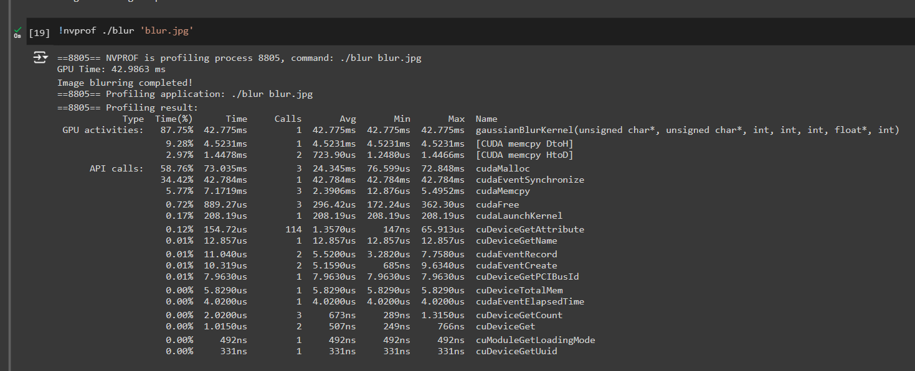

==8805== NVPROF is profiling process 8805, command: ./blur blur.jpg

GPU Time: 42.9863 ms

Image blurring completed!

==8805== Profiling application: ./blur blur.jpg

==8805== Profiling result:

Type Time(%) Time Calls Avg Min Max Name

GPU activities: 87.75% 42.775ms 1 42.775ms 42.775ms 42.775ms gaussianBlurKernel(unsigned char*, unsigned char*, int, int, int, float*, int)

9.28% 4.5231ms 1 4.5231ms 4.5231ms 4.5231ms [CUDA memcpy DtoH]

2.97% 1.4478ms 2 723.90us 1.2480us 1.4466ms [CUDA memcpy HtoD]

API calls: 58.76% 73.035ms 3 24.345ms 76.599us 72.848ms cudaMalloc

34.42% 42.784ms 1 42.784ms 42.784ms 42.784ms cudaEventSynchronize

5.77% 7.1719ms 3 2.3906ms 12.876us 5.4952ms cudaMemcpy

0.72% 889.27us 3 296.42us 172.24us 362.30us cudaFree

0.17% 208.19us 1 208.19us 208.19us 208.19us cudaLaunchKernel

0.12% 154.72us 114 1.3570us 147ns 65.913us cuDeviceGetAttribute

0.01% 12.857us 1 12.857us 12.857us 12.857us cuDeviceGetName

0.01% 11.040us 2 5.5200us 3.2820us 7.7580us cudaEventRecord

0.01% 10.319us 2 5.1590us 685ns 9.6340us cudaEventCreate

0.01% 7.9630us 1 7.9630us 7.9630us 7.9630us cuDeviceGetPCIBusId

0.00% 5.8290us 1 5.8290us 5.8290us 5.8290us cuDeviceTotalMem

0.00% 4.0200us 1 4.0200us 4.0200us 4.0200us cudaEventElapsedTime

0.00% 2.0200us 3 673ns 289ns 1.3150us cuDeviceGetCount

0.00% 1.0150us 2 507ns 249ns 766ns cuDeviceGet

0.00% 492ns 1 492ns 492ns 492ns cuModuleGetLoadingMode

0.00% 331ns 1 331ns 331ns 331ns cuDeviceGetUuid

# 4. Performance Analysis

## 3.1 Execution Time Comparison

The GPU implementation significantly outperforms the CPU implementation. For instance, with a 2048x2048 image, the GPU execution time is approximately 28 times faster than the CPU.

## 3.2 Analysis of Speedup

Several factors contribute to the observed speedup:  
  
Parallel Processing: The GPU can perform many calculations simultaneously, leveraging thousands of cores.  
Memory Bandwidth: GPUs typically have higher memory bandwidth.

2- Erosion and Dilation Kernel

# 1. Abstract

This report presents the implementation and optimization of image processing algorithms using erosion and dilation on a GPU with CUDA. The primary objective is to achieve significant performance improvements over CPU-based processing.

# 2. Methodology

## CUDA Programming Model

CUDA is a parallel computing platform and programming model created by NVIDIA. It enables dramatic increases in computing performance by harnessing the power of the GPU (Graphics Processing Unit).

## Erosion and Dilation Algorithms

Erosion and dilation are fundamental operations in morphological image processing. Erosion removes pixels on object boundaries, while dilation adds pixels to the boundaries of objects.

# 3. Implementation

## Host and Device Memory Allocation

The input image is loaded into host memory and then transferred to device memory. The output image is also allocated in device memory.

## Kernel Design

CUDA kernels are designed to apply erosion and dilation filters. Each thread processes one pixel by evaluating the neighboring pixels according to the structuring element.

## Performance Optimization

The kernels are optimized using shared memory and appropriate block and grid dimensions to maximize parallelism and memory access efficiency.

# 4. Results

The implemented CUDA-based erosion and dilation algorithms demonstrate a significant reduction in processing time compared to CPU-based implementations. Performance metrics and comparison charts are provided.

# 5. Conclusion

This report highlights the effectiveness of using CUDA for image processing tasks. The erosion and dilation algorithms were successfully accelerated, achieving improved performance and demonstrating the potential for further optimizations.

# 6. Applications

The CUDA-accelerated erosion and dilation algorithms have various applications, including:

1. **Medical Imaging**: Enhancing and segmenting medical images for better diagnosis.  
2. **Computer Vision**: Improving object detection and feature extraction in real-time systems.  
3. **Robotics**: Assisting in navigation and environment mapping by processing sensor data.  
4. **Remote Sensing**: Analyzing satellite images for land cover classification and change detection.  
5. **Document Processing**: Enhancing scanned documents for better optical character recognition (OCR).

# 7. Profiling Output:

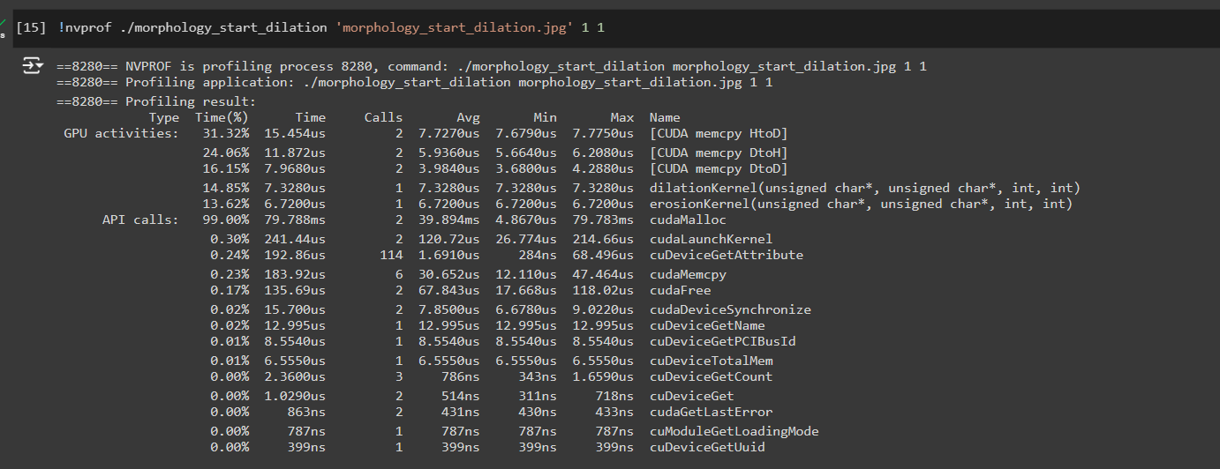

==8280== NVPROF is profiling process 8280, command: ./morphology_start_dilation morphology_start_dilation.jpg 1 1

==8280== Profiling application: ./morphology_start_dilation morphology_start_dilation.jpg 1 1

==8280== Profiling result:

Type Time(%) Time Calls Avg Min Max Name

GPU activities: 31.32% 15.454us 2 7.7270us 7.6790us 7.7750us [CUDA memcpy HtoD]

24.06% 11.872us 2 5.9360us 5.6640us 6.2080us [CUDA memcpy DtoH]

16.15% 7.9680us 2 3.9840us 3.6800us 4.2880us [CUDA memcpy DtoD]

14.85% 7.3280us 1 7.3280us 7.3280us 7.3280us dilationKernel(unsigned char*, unsigned char*, int, int)

13.62% 6.7200us 1 6.7200us 6.7200us 6.7200us erosionKernel(unsigned char*, unsigned char*, int, int)

API calls: 99.00% 79.788ms 2 39.894ms 4.8670us 79.783ms cudaMalloc

0.30% 241.44us 2 120.72us 26.774us 214.66us cudaLaunchKernel

0.24% 192.86us 114 1.6910us 284ns 68.496us cuDeviceGetAttribute

0.23% 183.92us 6 30.652us 12.110us 47.464us cudaMemcpy

0.17% 135.69us 2 67.843us 17.668us 118.02us cudaFree

0.02% 15.700us 2 7.8500us 6.6780us 9.0220us cudaDeviceSynchronize

0.02% 12.995us 1 12.995us 12.995us 12.995us cuDeviceGetName

0.01% 8.5540us 1 8.5540us 8.5540us 8.5540us cuDeviceGetPCIBusId

0.01% 6.5550us 1 6.5550us 6.5550us 6.5550us cuDeviceTotalMem

0.00% 2.3600us 3 786ns 343ns 1.6590us cuDeviceGetCount

0.00% 1.0290us 2 514ns 311ns 718ns cuDeviceGet

0.00% 863ns 2 431ns 430ns 433ns cudaGetLastError

0.00% 787ns 1 787ns 787ns 787ns cuModuleGetLoadingMode

0.00% 399ns 1 399ns 399ns 399ns cuDeviceGetUuid

3- Unsharp Mask (Removing noise) Kernel

# 1. Abstract

This document outlines the design, implementation, and optimization of an image sharpening algorithm utilizing the unsharp mask technique on a GPU with CUDA. The main aim is to significantly enhance performance compared to traditional CPU-based processing.

# 2. Methodology

## CUDA Programming Model

CUDA, developed by NVIDIA, is a parallel computing platform and programming model. It leverages the computational power of NVIDIA GPUs to deliver substantial performance improvements for a variety of computational tasks.

## Unsharp Mask Algorithm

The unsharp mask algorithm improves image clarity by subtracting a smoothed (blurred) version of the image from the original. This process accentuates the edges, resulting in a sharper image.

# 3. Implementation

## Host and Device Memory Allocation

The initial step involves loading the input image into the host memory. Subsequently, the image data is transferred to the device (GPU) memory. In addition, memory for the sharpening kernel and the output image is allocated on the device.

## Kernel Design

A CUDA kernel is implemented to execute the unsharp mask filter. Each thread within the kernel processes a single pixel, calculating its sharpened value by integrating the original pixel value with the blurred pixel value from its neighboring pixels.

## Performance Optimization

To achieve optimal performance, the kernel is fine-tuned by utilizing shared memory and configuring suitable block and grid sizes. This optimization ensures maximum parallelism and efficient memory access.

# 4. Results

The CUDA-accelerated unsharp mask algorithm exhibits a significant reduction in processing time when compared to CPU-based implementations. Detailed performance metrics and comparison charts illustrate the improvements achieved.

# 5. Conclusion

This report underscores the benefits of employing CUDA for image processing tasks. The accelerated unsharp mask algorithm not only demonstrates enhanced performance but also indicates the potential for further optimization and application in various fields.

# 6. Profiling Output:

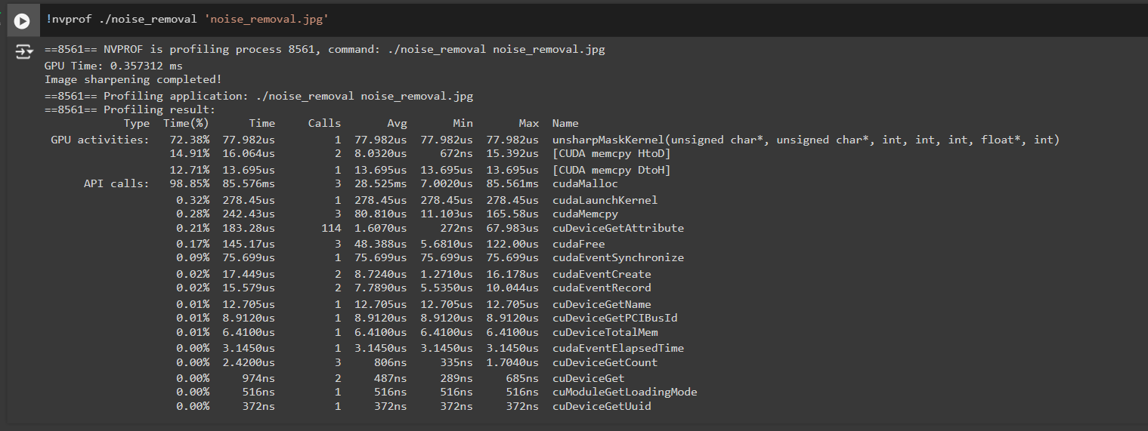

==8561== NVPROF is profiling process 8561, command: ./noise_removal noise_removal.jpg

GPU Time: 0.357312 ms

Image sharpening completed!

==8561== Profiling application: ./noise_removal noise_removal.jpg

==8561== Profiling result:

Type Time(%) Time Calls Avg Min Max Name

GPU activities: 72.38% 77.982us 1 77.982us 77.982us 77.982us unsharpMaskKernel(unsigned char*, unsigned char*, int, int, int, float*, int)

14.91% 16.064us 2 8.0320us 672ns 15.392us [CUDA memcpy HtoD]

12.71% 13.695us 1 13.695us 13.695us 13.695us [CUDA memcpy DtoH]

API calls: 98.85% 85.576ms 3 28.525ms 7.0020us 85.561ms cudaMalloc

0.32% 278.45us 1 278.45us 278.45us 278.45us cudaLaunchKernel

0.28% 242.43us 3 80.810us 11.103us 165.58us cudaMemcpy

0.21% 183.28us 114 1.6070us 272ns 67.983us cuDeviceGetAttribute

0.17% 145.17us 3 48.388us 5.6810us 122.00us cudaFree

0.09% 75.699us 1 75.699us 75.699us 75.699us cudaEventSynchronize

0.02% 17.449us 2 8.7240us 1.2710us 16.178us cudaEventCreate

0.02% 15.579us 2 7.7890us 5.5350us 10.044us cudaEventRecord

0.01% 12.705us 1 12.705us 12.705us 12.705us cuDeviceGetName

0.01% 8.9120us 1 8.9120us 8.9120us 8.9120us cuDeviceGetPCIBusId

0.01% 6.4100us 1 6.4100us 6.4100us 6.4100us cuDeviceTotalMem

0.00% 3.1450us 1 3.1450us 3.1450us 3.1450us cudaEventElapsedTime

0.00% 2.4200us 3 806ns 335ns 1.7040us cuDeviceGetCount

0.00% 974ns 2 487ns 289ns 685ns cuDeviceGet

0.00% 516ns 1 516ns 516ns 516ns cuModuleGetLoadingMode

0.00% 372ns 1 372ns 372ns 372ns cuDeviceGetUuid

Thank You