Admin

1. Authentication & Access Control
- Admin Login / Logout
- Two-Factor Authentication (2FA)
- Role-Based Access Control (RBAC)
- Multi-role system (Super Admin, Operations Admin, Compliance Admin, Finance Admin)
- Session management and IP restriction
- Audit logs and activity tracking

2. Dashboard Overview (Analytics Home)
- Total Users, Active Users
- Total Applications (Pending, Approved, Rejected)
- Revenue & Commission Summary
- Agent Performance Metrics
- Conversion Rate Tracking
- Charts (Monthly enrollments, Revenue trends)
- Recent Activity Feed

3. User Management
- View, Search, Filter Users
- Edit user profiles
- Suspend / Activate accounts
- Delete accounts
- View user applications
- Reset passwords
- View login history

4. Agent Management
- Add / Edit / Remove agents
- Assign licensing & regional access
- Activate / Deactivate agents
- Monitor agent performance
- Commission tracking per agent
- Assign applications manually

5. Application Management
- View all applications
- Filter by status
- Approve / Reject applications
- Request additional documents
- Assign to agent
- Resubmit to carrier
- Export applications (Excel/PDF)

6. Insurance Plan Management
- Add / Edit / Delete plans
- Enable / Disable plan visibility
- Set pricing & coverage benefits
- ZIP code-based visibility rules
- Upload plan documents
- Sync plans with Carrier API
- Bulk import via CSV

7. Recommendation Engine Control
- Configure recommendation scoring logic
- Set premium weight importance
- Set doctor network weight
- Set prescription coverage weight
- Enable / Disable AI recommendation
- View recommendation logs

8. Commission & Finance Management
- Set commission rates per carrier
- Set commission rates per agent
- Track earned commissions
- Generate payout reports
- Export financial reports
- Payment integration tracking

9. CMS (Content Management System)
- Create & Edit blog articles
- Manage FAQ pages
- Manage landing pages
- SEO metadata control
- Media library management
- Content approval workflow

10. Analytics & Reporting
- User acquisition reports
- Conversion funnel analysis
- Application approval rates
- Revenue reports
- Custom report builder
- Geographic analytics

11. Notifications & Communication
- Email template management
- SMS template management
- Automated notifications
- Broadcast messaging to users & agents

12. API & Integration Management
- Manage Carrier API credentials
- API error logs
- Webhook configuration
- CRM integrations
- Analytics integrations

13. Security & Compliance
- HIPAA compliance configuration
- GDPR data deletion tools
- Audit trail access
- Data encryption control
- Data retention policies

14. System Settings
- General configuration settings
- Feature enable / disable control
- Maintenance mode
- Localization & timezone management
- Backup & restore tools
- Database monitoring
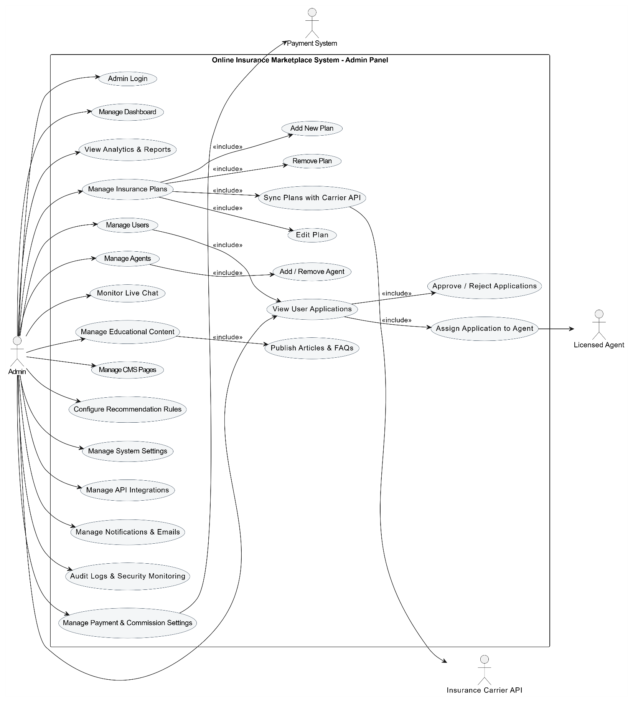

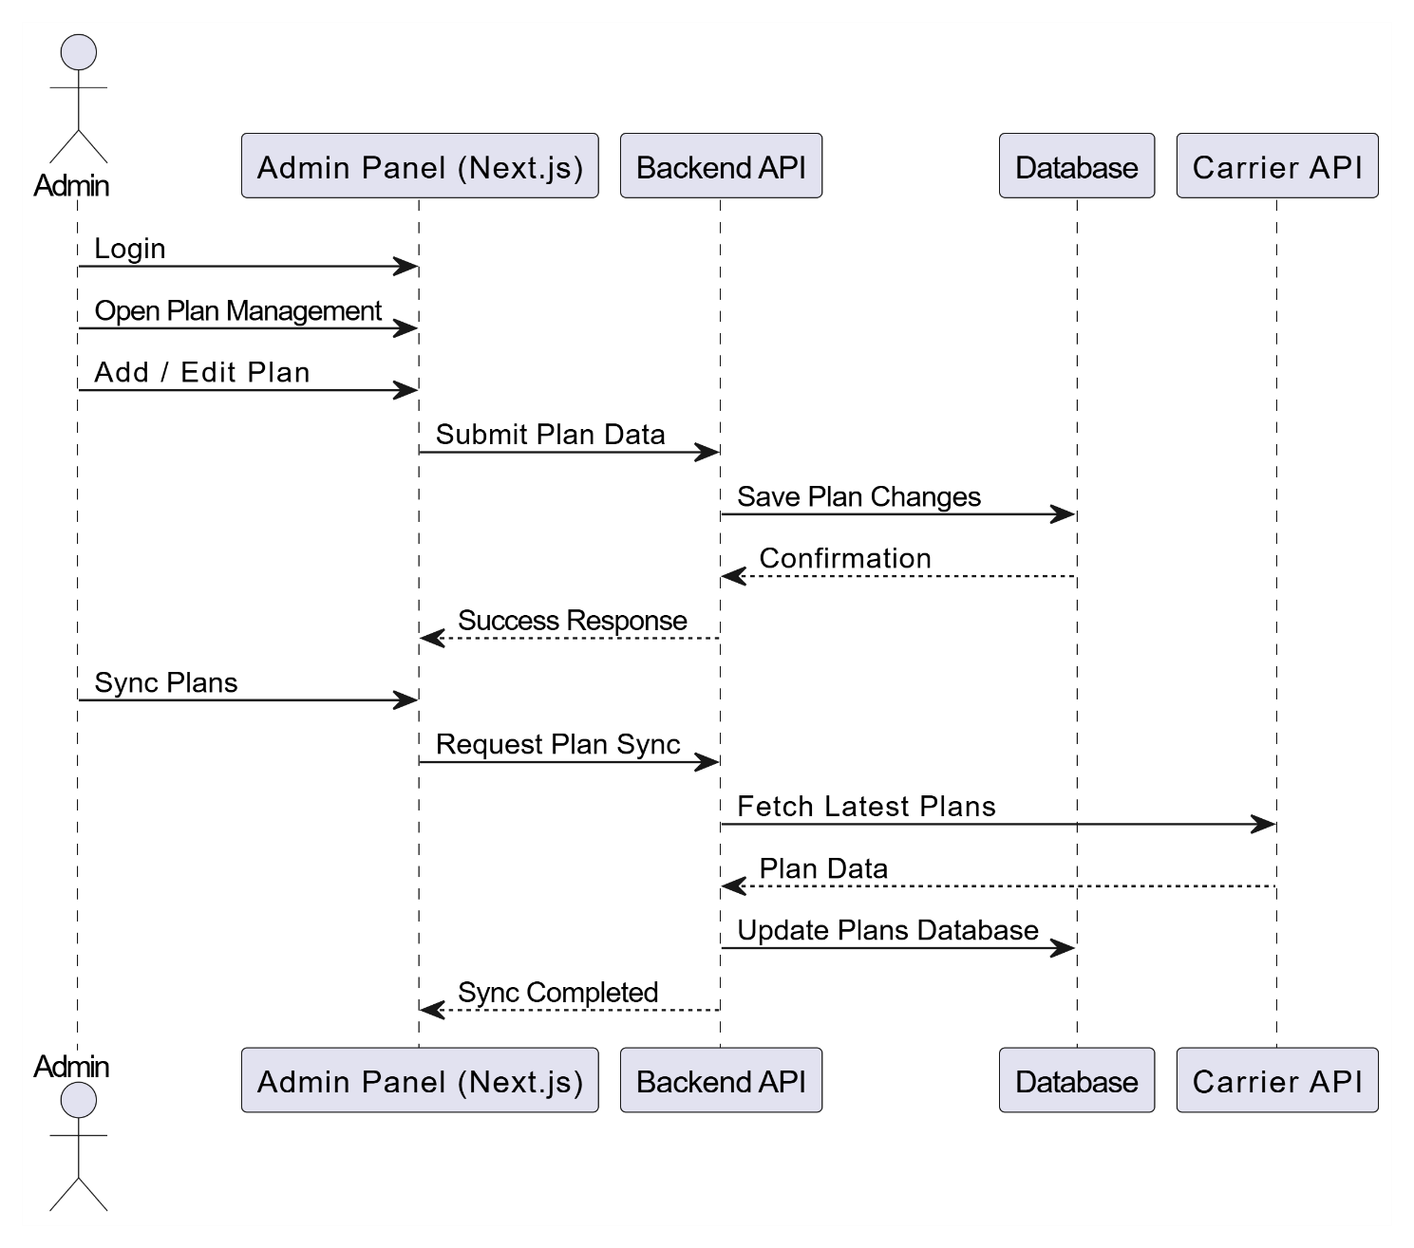

Agents

1. Authentication & Access
- Agent Login / Logout
- Two-Factor Authentication (2FA)
- Role-based access control
- Session management and security logs

2. Dashboard Overview
- Assigned applications summary
- Pending / Submitted / Approved / Rejected counts
- Recent activity feed
- Notifications / alerts

3. Application Management
- View assigned applications
- Review applicant details
- Check submitted documents
- Update application status (Pending / Submitted / Approved / Rejected)
- Assist user with enrollment process
- Submit application to Carrier API
- Track carrier responses
- Download application PDFs
- Export application data

4. User Interaction
- Call applicant
- Send email to applicant
- Live chat with applicant
- Schedule consultation or follow-up
- Request additional information / documents

5. Agent Performance & Commission
- View earned commissions
- Track commission history
- Download performance reports
- Analytics dashboard for agent metrics

6. Notifications & Alerts
- Receive notifications when new applications are assigned
- Track updates from users or carrier responses
- Email / SMS / in-dashboard alerts

7. Settings & Preferences
- Manage availability schedule
- Set communication preferences
- Update profile information
- Change password / security settings
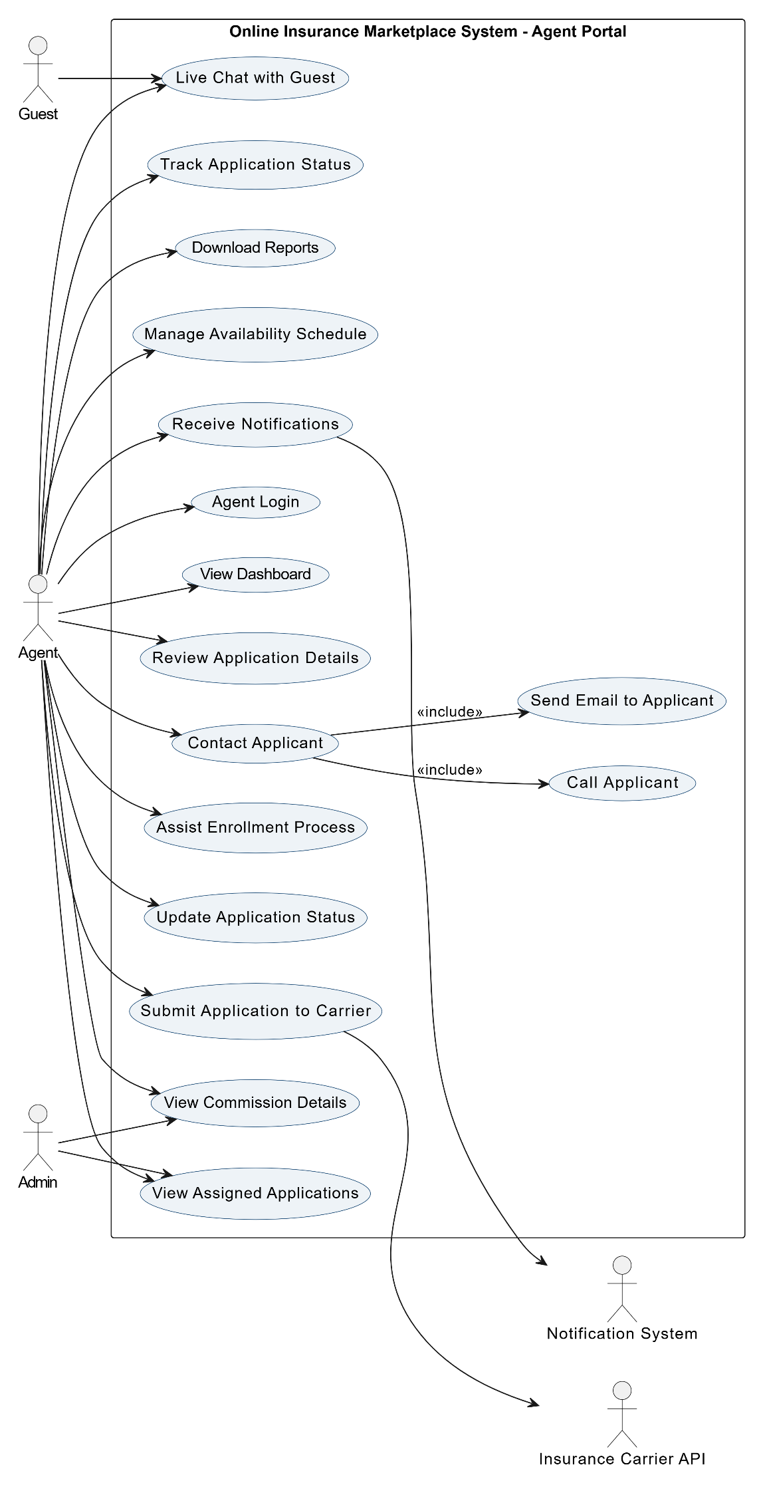
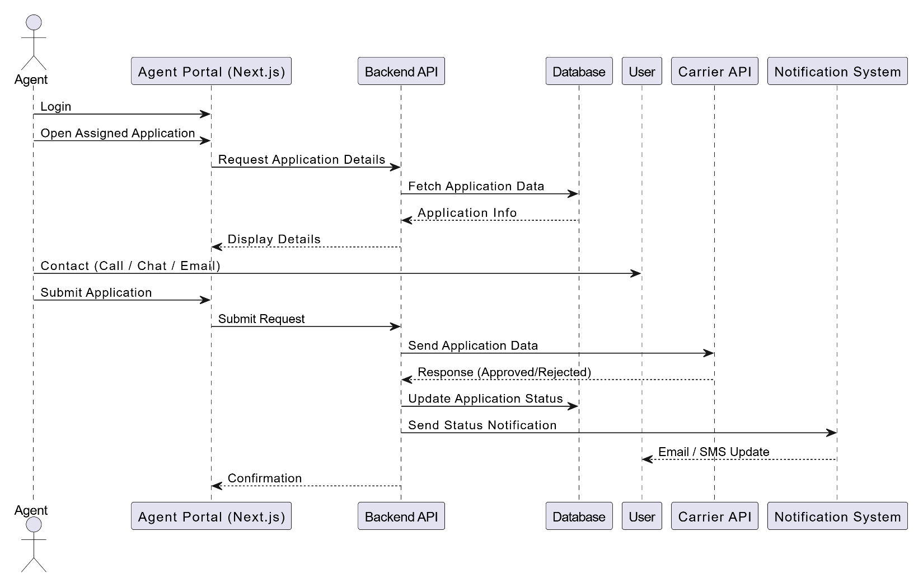

Registered User Features

1. Account Management
- Register a new account
- Login / Logout
- Edit personal profile
- Change password
- Delete account
- Manage security settings (2FA if enabled)

2. Personalization
- Save favorite insurance plans
- Add doctors and prescriptions
- Set personal preferences (coverage priorities, price sensitivity)
- View personalized plan recommendations

3. Plan Search & Comparison
- Enter ZIP code to view available plans
- Filter plans by cost, coverage, network, or prescription drugs
- Compare multiple plans side-by-side
- View detailed plan benefits and cost breakdown
- Use AI-powered recommendation tool

4. Enrollment
- Start multi-step enrollment process
- Fill personal and health-related details
- Upload required documents
- Submit application to insurance carrier
- Track application status (pending, approved, rejected)
- Download final policy documents

5. Communication & Support
- Chat with licensed agents
- Schedule appointments or consultations
- Receive notifications about applications, documents, and approvals
- Contact support or agent for assistance

6. History & Records
- View past applications and submission history
- Track saved plans and recommendations
- Download historical policy documents
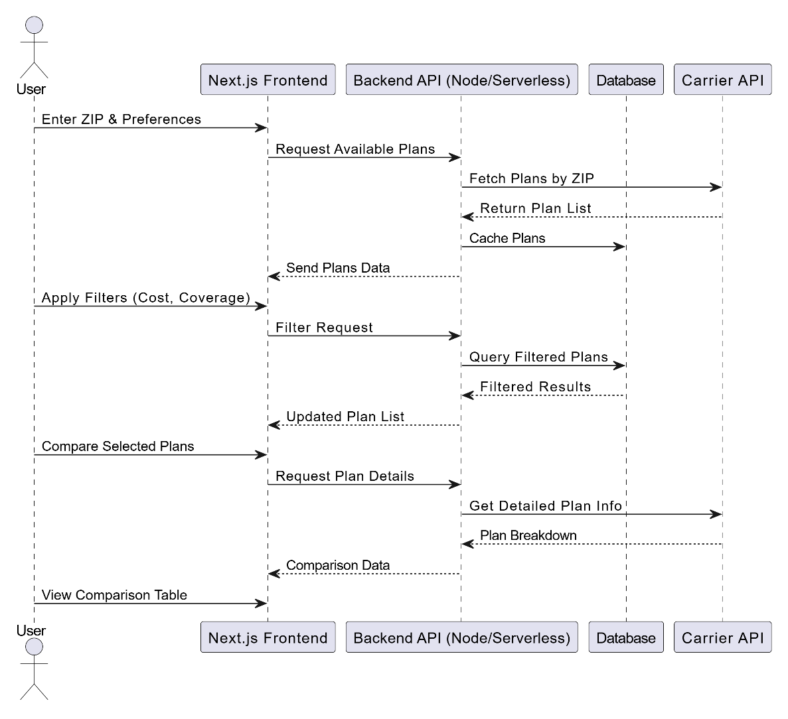
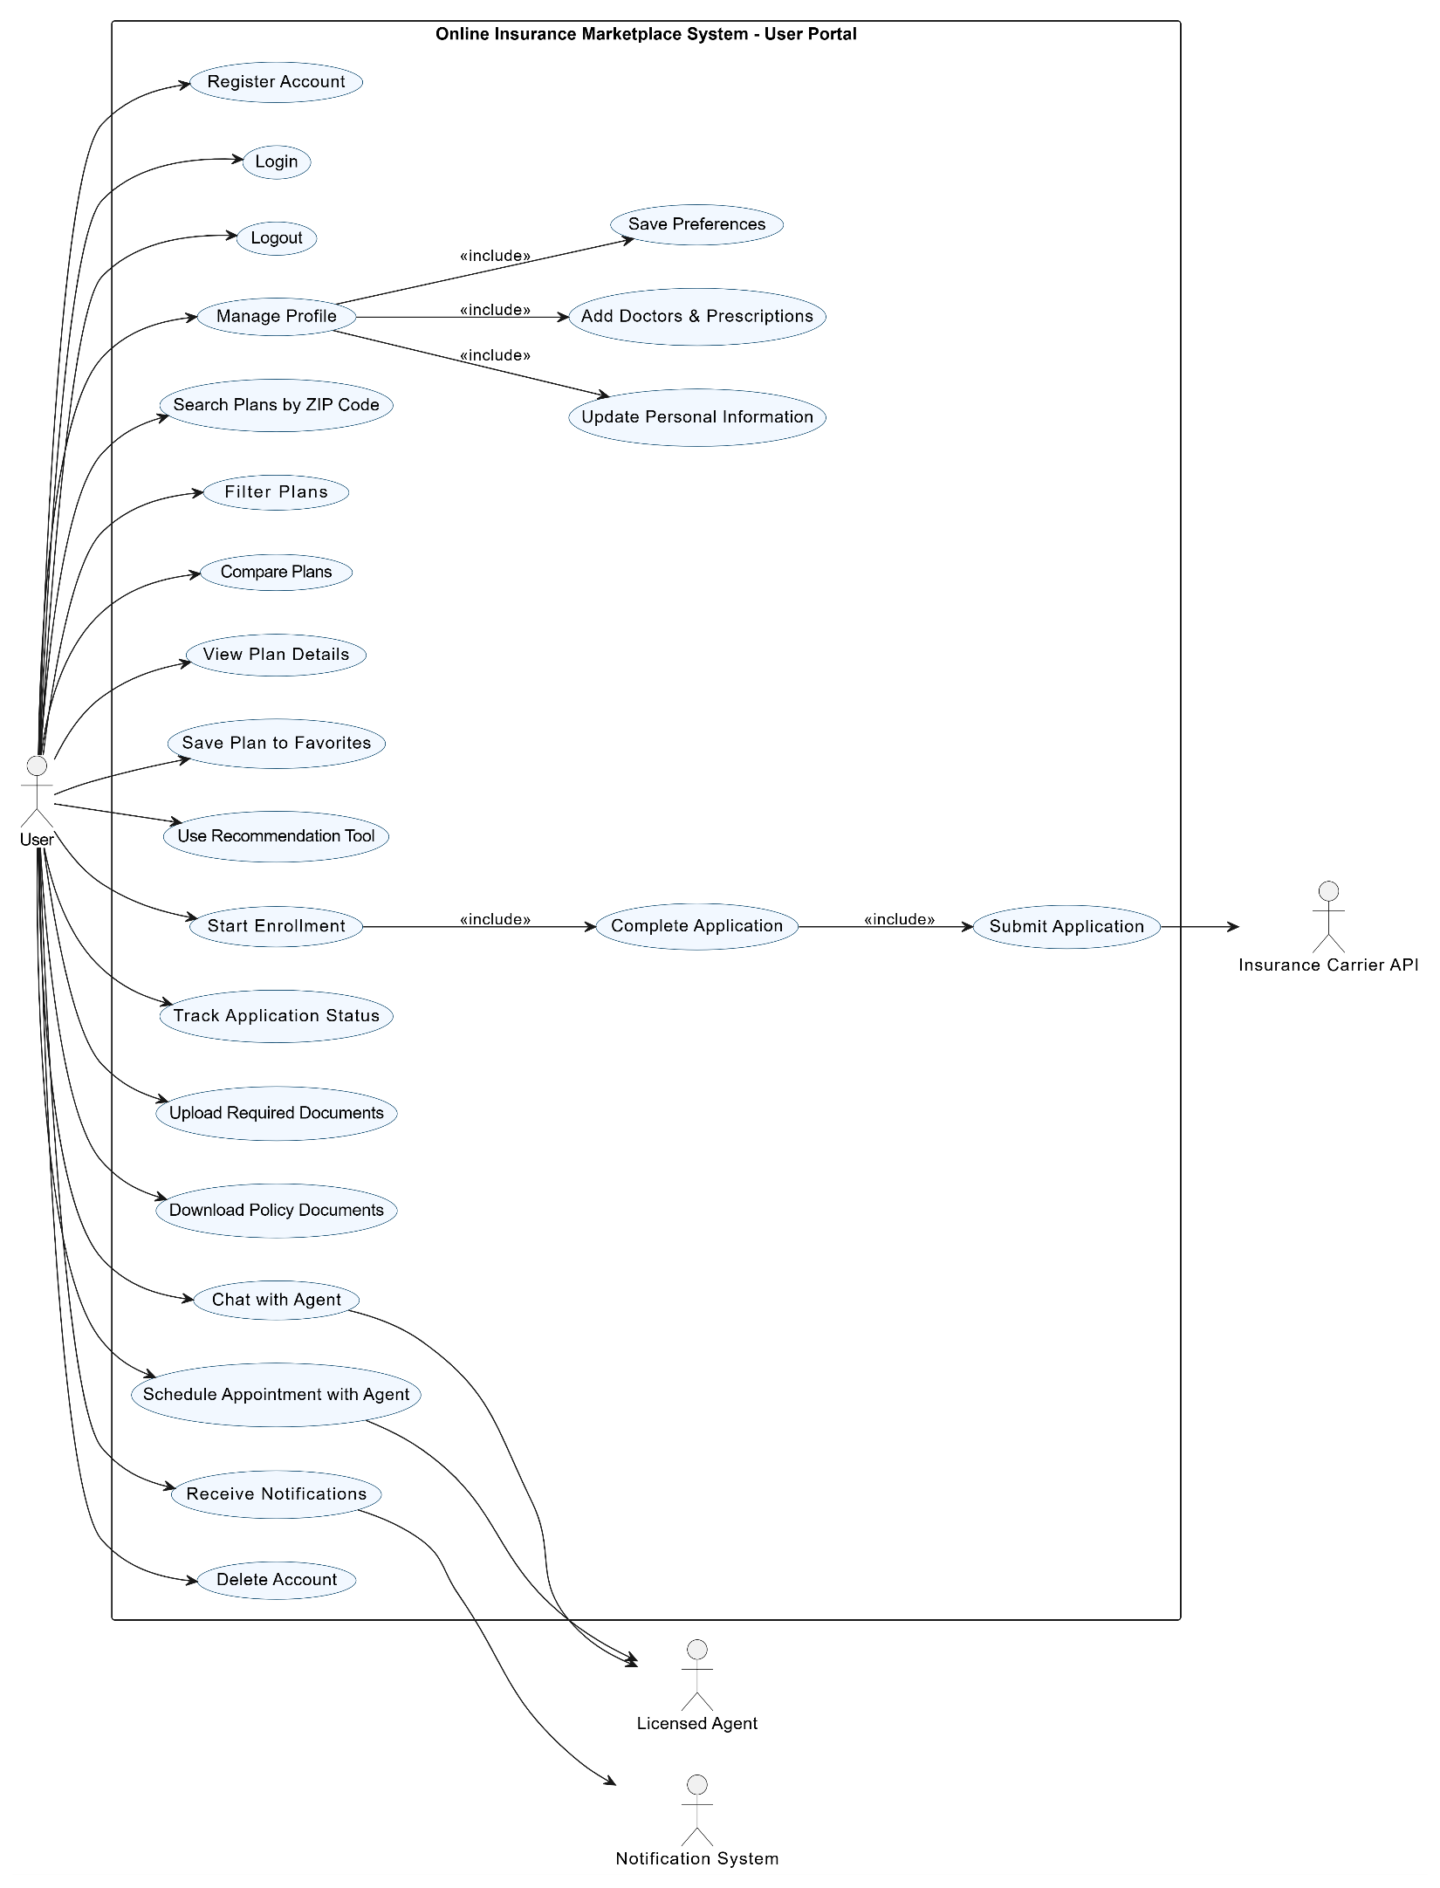

Guest User Features (No Sign-In)

1. Browsing & Searching
- Access homepage without login
- Enter ZIP code to see available insurance plans
- Browse plans by type, cost, or coverage
- Filter and sort plans based on price, network, or benefits
- Compare multiple plans side-by-side

2. Plan Information
- View detailed plan benefits
- Check doctor network coverage
- Check prescription drug coverage
- View cost breakdown (monthly premium, deductibles, copays)
- Download plan brochures

3. Recommendations & Tools
- Use “Plan Recommendation” or “Plan Finder” tool (basic guidance)
- View suggestions based on ZIP code and general criteria

4. Educational Resources
- Read articles, FAQs, and guides
- Access general insurance information and tutorials

5. Contact & Support
- Contact licensed agents (via form, email, or call request)
- Access live chat for questions
- Schedule a call or consultation with an agent

6. Enrollment Initiation
- Start enrollment process (limited, may require registration)
- Fill initial application form (saved temporarily)
- Receive instructions to register for full submission

Development
1. Frontend Development
Stack: Next.js (App Router), TypeScript, Tailwind CSS / Material UI
2. Backend Development
Stack: Node.js / Express / Fastify, TypeScript
Focus Areas:
- RESTful or GraphQL API design
- Authentication & role-based authorization (JWT / OAuth2)
- Multi-step workflows & state management
- Integration with external APIs (insurance carriers, CMS.gov)
- Secure document storage & retrieval (S3 / GCP)
- Notifications system (email/SMS)
- Logging, monitoring, and audit trails

3. Database & Caching
Stack: PostgreSQL (primary), Redis (caching & sessions)
Focus Areas:
- Relational schema design for users, applications, plans, agents, admin
- Referential integrity & indexing for fast queries
- Redis caching for high-frequency reads (plan listings, temporary sessions)
- Backup & restore strategy

4. Third-Party API Integration
- Carrier APIs for plan info & enrollment
- CMS.gov Medicare Plan Finder API
- NPPES API (doctor network lookup)
- Twilio / SendGrid for notifications
- Stripe / PayPal (optional for payments/commissions)
- USPS / SmartyStreets for ZIP validation
5. Security & Compliance
- HTTPS/TLS everywhere
- Role-based access control for all APIs
- Encryption at rest and in transit
- HIPAA-compliant storage & audit logging
- Input validation and XSS/SQL injection prevention

