**­­Project 02**

**CS2803 – WDB**

**Spring 2015**

For this project you are to create the six layouts illustrated below using HTML and CSS as discussed in class. Turn in your assignment by submitting the URL for each page. Your pages need only contain the black boxes; white boxes and Lorem Ipsum text as shown in the examples below. The menu items are not expected to work. The purpose of this assignment is to get you comfortable with placing elements on the page and creating the desired spacing on your page. All of these layouts along with a brief discussion of when to use them and “In the Wild” examples can be found at http://designshack.net/articles/layouts/10-rock-solid-website-layout-examples/.

Three Box Layout **DONE**

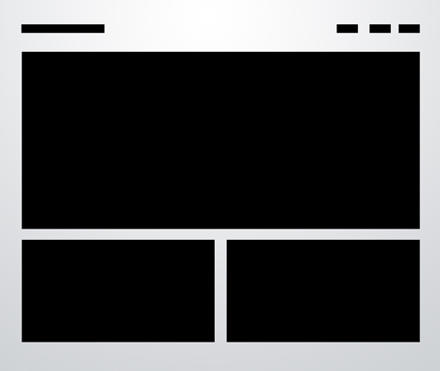

Five Box Layout **DONE**

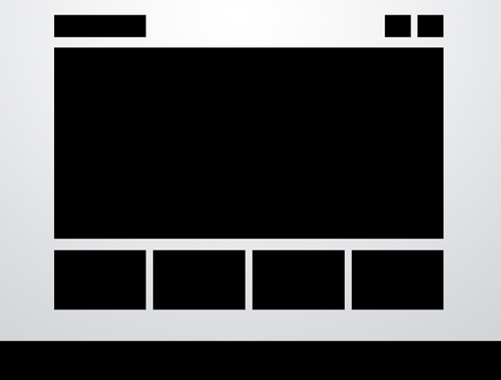

Advanced Grid Layout

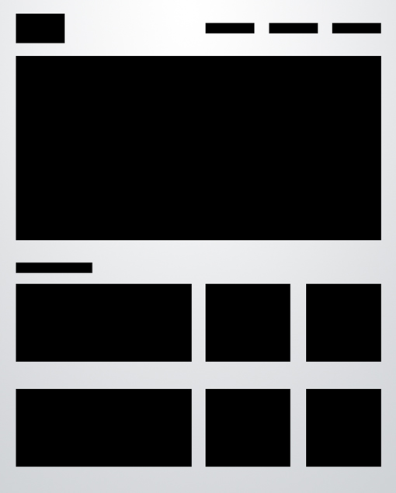

Power Grid Layout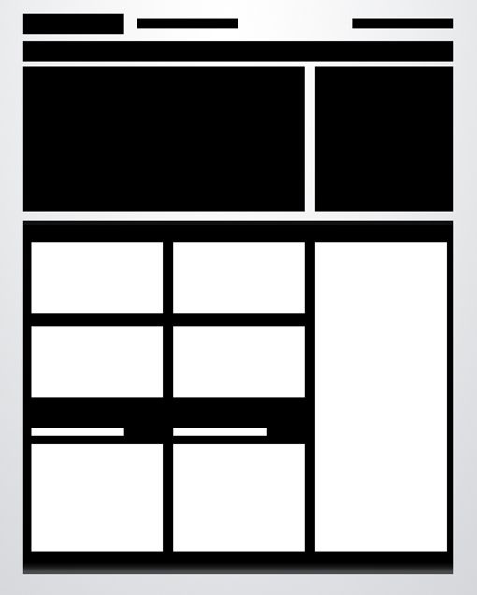

Fixed Sidebar

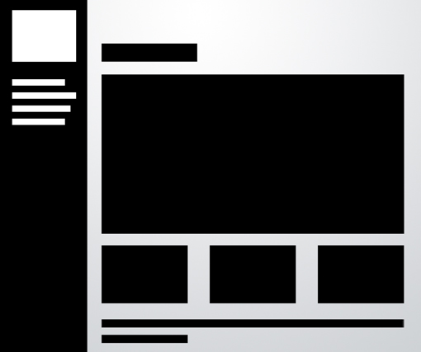

Headline& Gallery

