CoP

Clown of Plates

Omar Emam 44

Ahmed Waleed 9

Mohamed Zidan 57

Abd-Elrahman Adel 37

**Report Content:**

1. Program Specifications
2. User Guide
3. UML Diagrams
4. Design Patterns



Program Specifications:

-Program has interactive GUI which will help the user change the setting (size, quality, sound …),the level (easy,medium,hard)and inside the game the user will be able to pause , un/mute sound and see his time and score all in very friendly GUI.

-The user will have variety in plates shapes and speeds in each level

-A logging file is created each game to save the logger output in side it

-After one is over the user will be able to exit or return to start frame where he will be able to change the setting or start a new game

User Guide:

-To play the game:

1. Choose your preferred setting
2. Click Start
3. Choose your preferred level
4. Click play button
5. Use arrows to move your clown right and left
6. Each 3 plates give you a point
7. Collect as much points as you can before time is up

UML Diagrams & Design Patterns:

* MVC :

The Model View Controller (MVC) design pattern specifies that an application consist of a data model, presentation information, and control information.



* Singleton :

It’s used in all view elements that will allow us to have only one frame at once with no duplicates

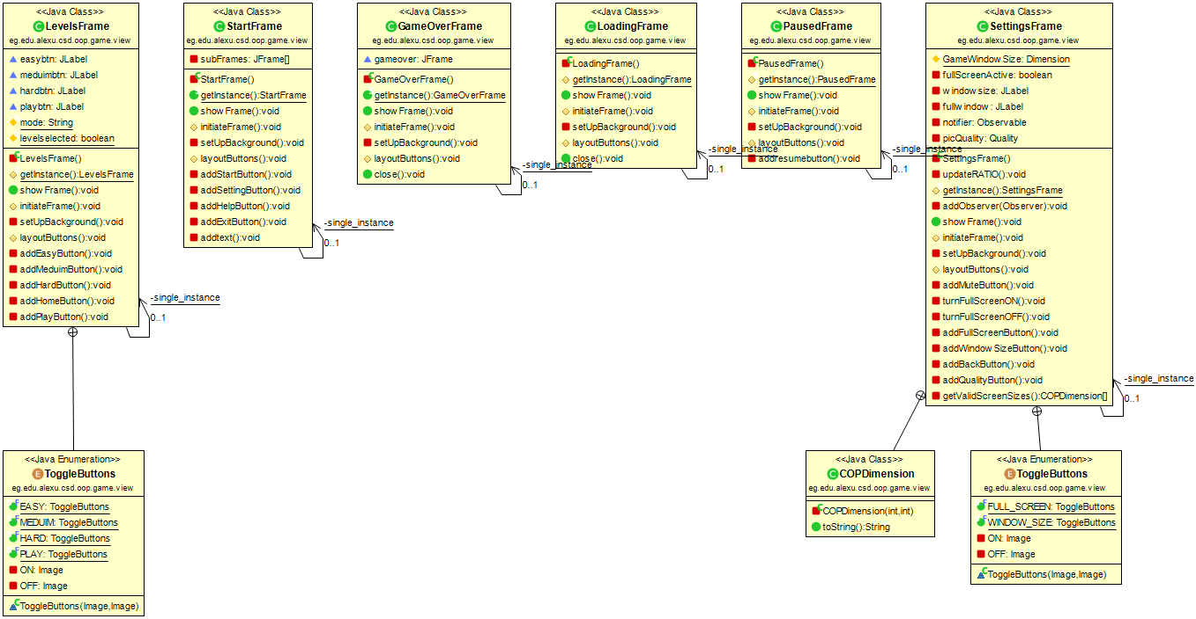

* Factory :

In Factory pattern, we create object without exposing the creation logic to the client and refer to newly created object using a common interface.

We used this pattern generating the plates

* Iretrator:

The iterator pattern is a design pattern in which an iterator is used to traverse a container and access the container's elements

We used this pattern looping over game elements

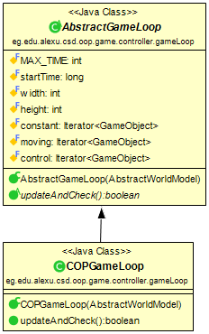

* Dynamic Linkage:

We used this pattern for the function of all plates

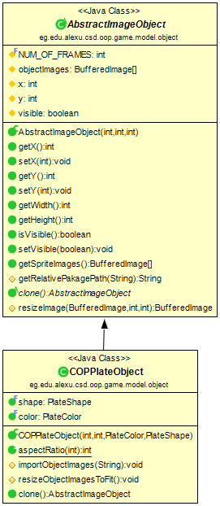

* Snapshots:

Memento pattern is used to restore state of an object to a previous state. It is also known as snapshot pattern. A memento is like a restore point during the life cycle on the object, which the client application can use to restore the object state to its state.

We used this pattern to overcome the pause issue in the engine

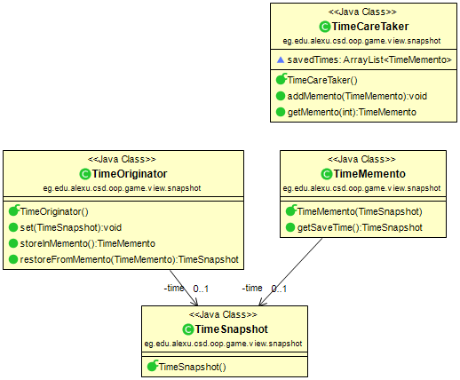

* Strategy:

The strategy pattern (also known as the policy pattern) is a behavioral software design pattern that enables selecting an algorithm at runtime. Instead of implementing a single algorithm directly, code receives run-time instructions as to which in a family of algorithms to use.

We used this pattern to distribute the logic of the world among various components

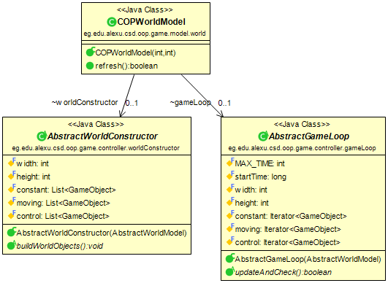

* State:

The state pattern is a behavioral software design pattern that allows an object to alter its behavior when its internal state changes.

We used this pattern to control the pictures quality

* Flyweight:

Flyweight is a structural design pattern that lets you fit more objects into the available amount of RAM by sharing common parts of state between multiple objects instead of keeping all of the data in each object.

We used this pattern to avoid loading the pictures more than once

* Observer:

The observer pattern is a software design pattern in which an object, called the subject, maintains a list of its dependents, called observers, and notifies them automatically of any state changes, usually by calling one of their methods.

We used this pattern to notify the image manager with quality needed

* Visitor:

The visitor design pattern is a way of separating an algorithm from an object structure on which it operates

We used this pattern to allow the image manager to give each element its image

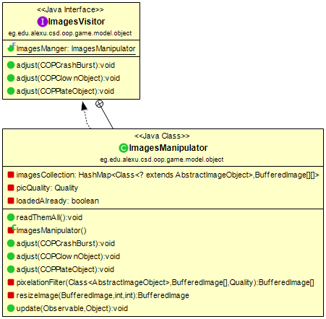

* Sequence Diagram :

