DBMS

Data Base Manager System.

BY:

* Omar Mohamed Emam 44
* Islam Yousry 14
* Islam Mohamed 12
* Bahaa Khlaf 21

Report

DBMS

Report

**Report Content:**

1. Program Specifications
2. User Guide
3. UML Diagram
4. Program Description
5. Design Patterns
6. Sample Runs

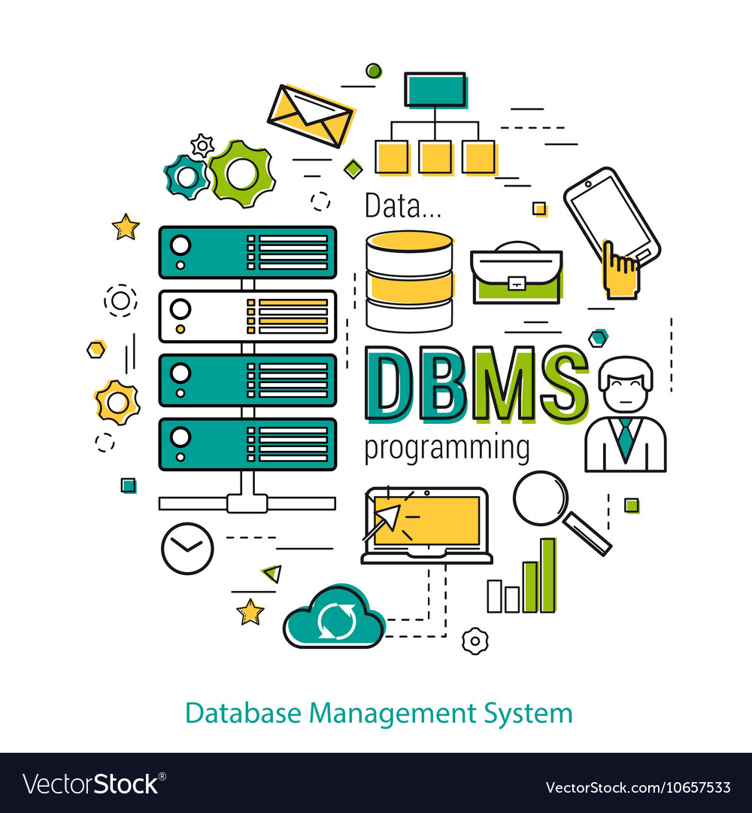

Program Specifications:

-The Program specify all SQL queries (Create, drop, insert, update, select, delete)

- Program uses dynamic loading for all of your databases, so you can edit them whenever you want

- Program is able to re-load your data no matter where you stored it

- Program is able to understand your SQL query in uppercase or lowercase and with spaces or not

- Program will keep running even if you entered in wrong syntax, you will be able to retry till you want to stop

- Program runs through self-runnable Cmd app

User Guide:

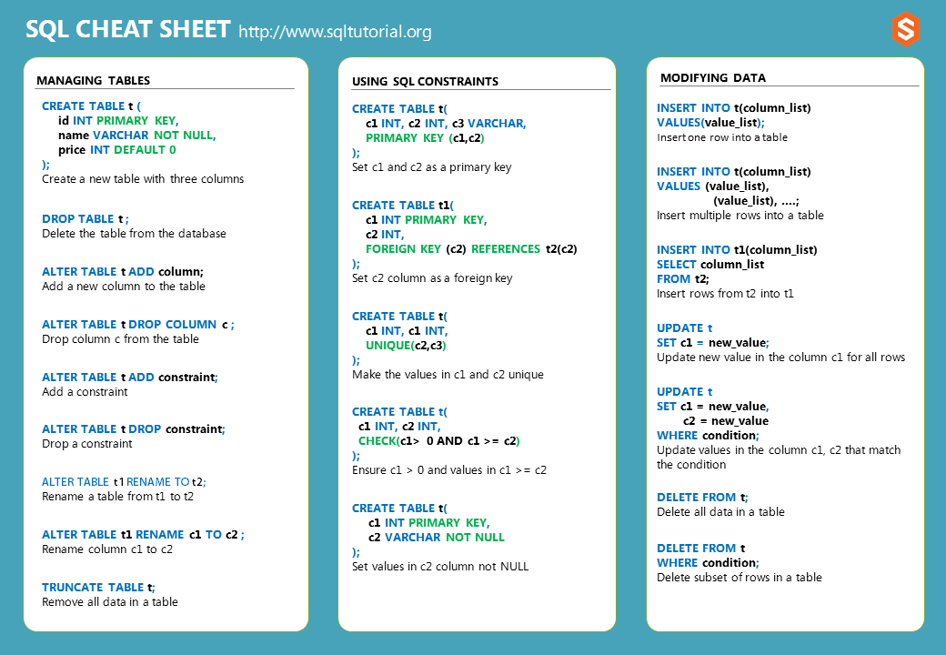Run “excucation.bat” and enter your SQL query in right syntax and then you can do more queries or exit by typing “end”.

UML Diagram:

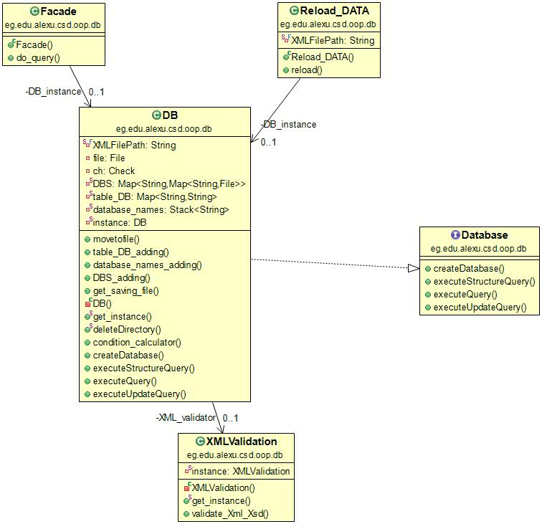

Program Description:

After entering your sql query , it will be check by the regex through :

Check:  
The check class is responsible for check if the input that token is in a correct syntax or not.

The check class has 6 function and these functions are : createcheck , updatecheck ,insertcheck , deletcheck ,selectcheck and dropcheck.

And these functions are called by the DB class.

Createcheck:

This function applied on any input start with the word (create) and this function check if the input is (create database database_name) , (create database (path)) , (create table table_name (column_name dataType)) by three regex and then it takes the wanted information by (split and regex ) and return it in array and if the input was wrong syntax it returns null.

updatecheck:

This function applied on any input start with the word (update) and this function check if the input is (UPDATE *table_name* SET *column1* = *value1*, *column2* = *value2*, ... WHERE *condition*) or (UPDATE *table_name* SET *column1* = *value1*, *column2* = *value2*, ...) by two regex and then it takes the wanted information by (split and regex ) and return it in array and if the input was wrong syntax it returns null.

insertcheck:

This function applied on any input start with the word (insert ) and this function check if the input is (INSERT INTO *table_name* (*column1*, *column2*, *column3*, ...) VALUES (*value1*, *value2*, *value3*, ...)) or(INSERT INTO *table_name* VALUES (*value1*, *value2*, *value3*, ...)) by two regex and then it takes the wanted information by (split and regex ) and return it in array and if the input was wrong syntax it returns null.

deletcheck:

This function applied on any input start with the word (delet) and this function check if the input is (DELETE FROM *table_name* WHERE *condition*) or (DELETE FROM *table_name*) by two regex and then it takes the wanted information by (split and regex ) and return it in array and if the input was wrong syntax it returns null.

selectcheck:

This function applied on any input start with the word (select) and this function check if the input is (SELECT *column1*, *column2, ...*  
FROM *table_name*) or (SELECT *column1*, *column2, ...* FROM *table_name where condition*) or (SELECT * FROM *table_name*) or (SELECT * FROM *table_name where condition*) by four regex and then it takes the wanted information by (split and regex ) and return it in array and if the input was wrong syntax it returns null.

dropcheck:

This function applied on any input start with the word (drop) and this function check if the input is (DROP DATABASE *databasename*) or (DROP TABLE *table_name*) by two regex and then it takes the wanted information by (split and regex ) and return it in String and if the input was wrong syntax it returns null.

After Checking The Query:

We use Java DOM(Document Object Model) to create and parse XML files by representing the document in tree  structure.

We use Java XSD (XML Schema Definition) to describe the structure of the xml file(data types of each element and the sequence of elements of each row)

The class XMLValidation is used to determine whatever the xml file is good structured or not

Design Patterns:

1. **Facade design pattern**: used to decide which method in the interface execute dependent on the input query.
2. **Singleton design pattern**: to make one instance of object.

Sample Runs:

First run & generated xml

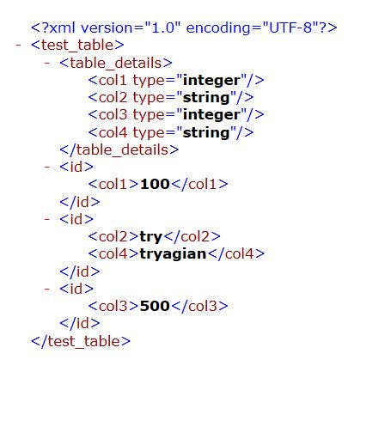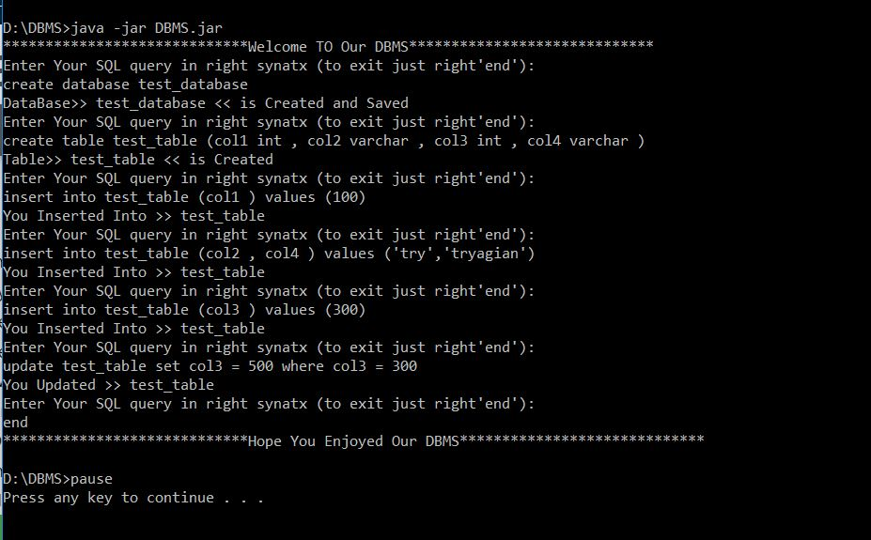

After Reloading and editing

