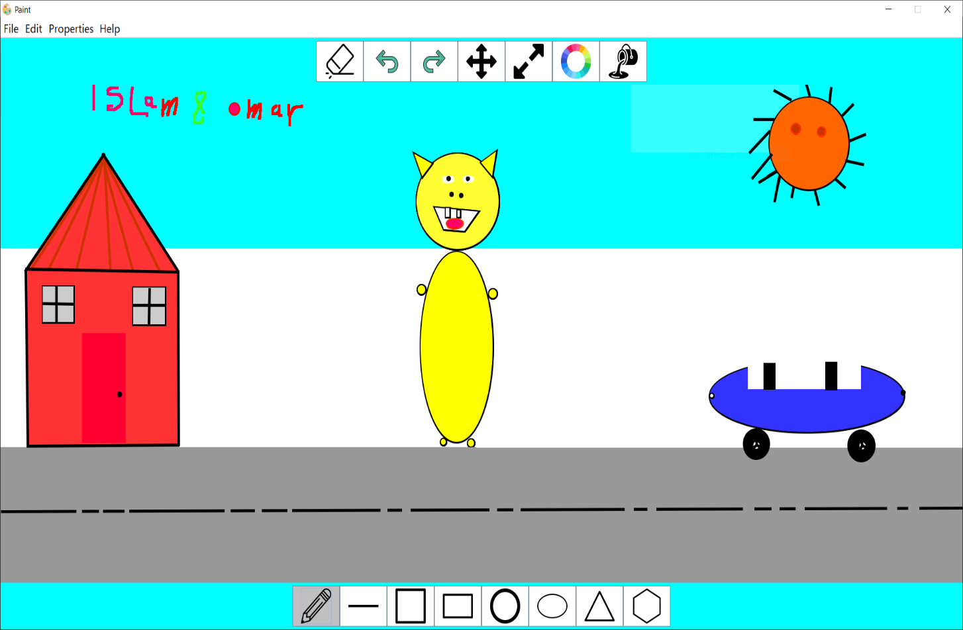Paint Program

By:

-Islam Yousry Abdelwahid (no.14)

-Omar Mohamed Emam (no.44)

Report Contents:

1. UML Diagram …………………………….. 3

2. Design Description ………………………. 4

3. GUI Snapshots …………………………….. 5

4. User Guide …………………………………. 8



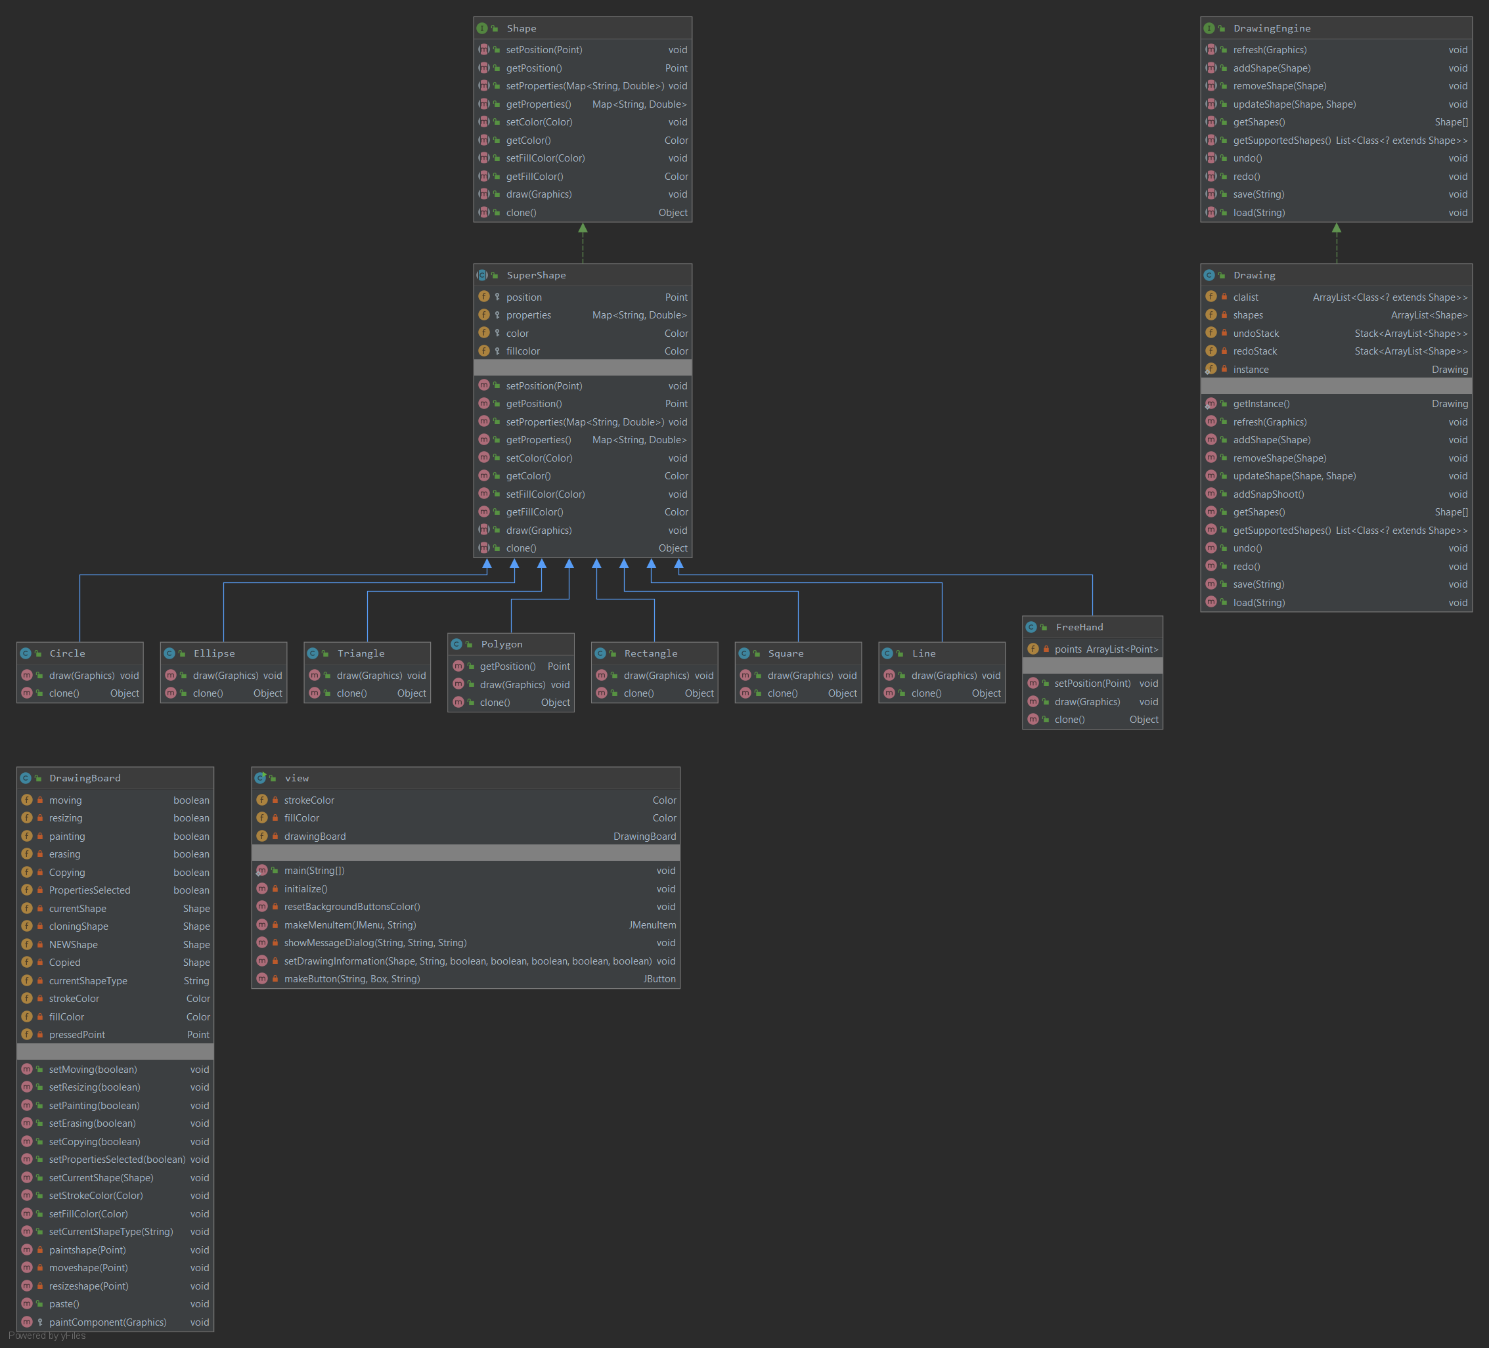UML Diagram:

Design Description:

* The program consists of three main parts:

1. **view Class**: this class is a subclass of JFrame class which controls the interface style (e.g. buttons icons, pop ups …etc.) and has the buttons actions.
2. **DrawingBoard** **Class:** this class is a subclass of JPanel that has mouse Actions for painting.
3. **Shape Interface and its classes :** this part have the implementation for every shape in its own way

**-**here we set the parameters for every shape, draw it, color it, fill it and clone it.

**-**other buttons which don’t have a specific function is implemented in gui class

1. **Drawing Engine and Drawing Class:** this class implements the drawing engine interface which controls the whole flow in program and has the main required functions.

* All functions work in the flow showed in the UML
* The program is able to show the user everything required to finish operation in user friendly way
* Program handles all expected errors.

GUI Snapshots:

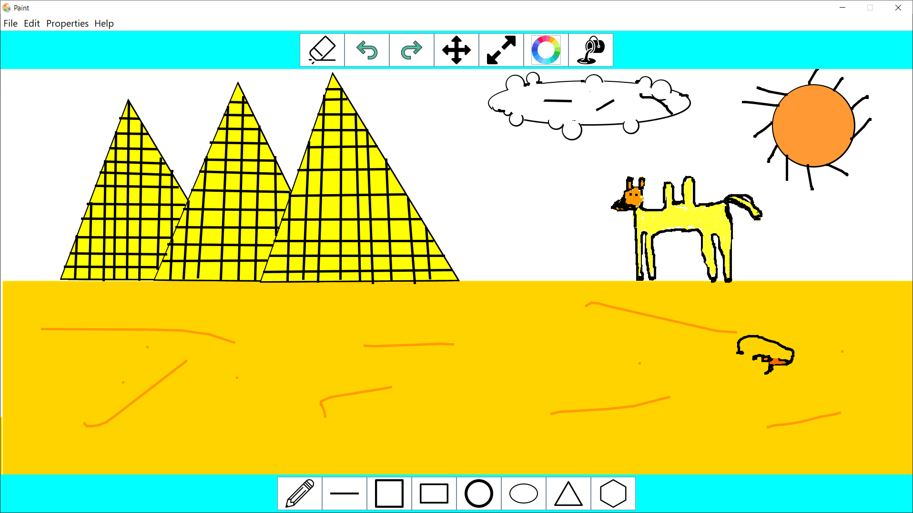

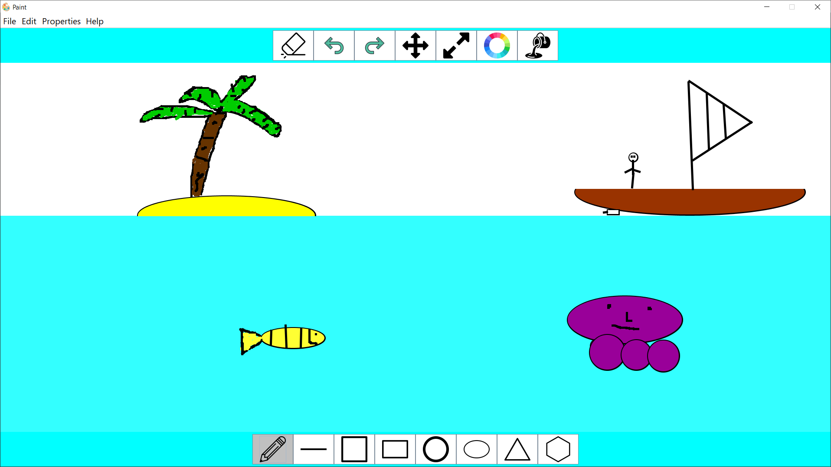

User Guide:

|  |  |
| --- | --- |
| Task | Method |
| Draw | Click on shape button then click and drag on the canvas |
| move | Click on move button, select the shape the move it |
| resize | Click on resize button, select shape, move up to increase size or down to decrease size |
| Change fill color | Click fill button, choose color from pallet as last pic shows |
| Change stroke color | Click button, choose color from pallet as last pic shows |
| Delete | Click erase button, select the shape |
| Undo & Redo | Just click on the button |
| Copy | Edit menu > copy  > select shape |
| paste | Edit menu > paste |
| Show Properties | Properties menu > show properties > select shape |
| Save | File menu > save > choose location > save |
| Load | File menu > load > choose location > open |
| Add Shape | File menu > Add Shape > choose location of Jar file > open |

Program Designed By:

Islam Yousry Abdelwahid No.14

Omar Mohamed Emam No.44

