mask recognition

LOGIC AND ARTIFICIAL INTELLIGENCE

MADE BY:

MAZEN HUSSAM 182069

FARIS DARWISH 184232

OMAR MOHSEN 179771

|  |  |  |
| --- | --- | --- |
| Student Name | ID | Each student’s responsibility in the project |
| Faris Darwish | 184232 | Database, Cascade Files |
| Mazen Hussam | 182069 | GUI, Analyzing Datasets |
| Omar Mohsen | 179771 | Creating Functions |

Table of Contributions:

Project Summary:

COVID-19 pandemic has rapidly affected our day-to-day life disrupting the world trade and movements. Wearing a protective face mask has become a new normal. In the near future, many public service providers will ask the customers to wear masks correctly to avail of their services. Therefore, face mask detection has become a crucial task to help global society.

This project presents a simplified approach to achieve this purpose using some basic Machine Learning packages like TensorFlow, Keras, OpenCV, Tkinter and Numpy. The proposed method detects the face from the image correctly and then identifies if it has a mask on it or not. Face mask detection involves in detecting the location of the face and then determining whether it has a mask on it or not.

As a surveillance task performer, it can also detect a face along with a mask in motion. The method attains accuracy up to 97.77% and 95.58% respectively on two different datasets.

Problem Description and Background:

* Finding Datasets: We may encounter some difficulties finding a suitable dataset for the project due to insufficient cascade file.
* Detection Accuracy Level: The accuracy may not be high due to insufficient data in datasets.
* Database: A full employee database is needed for implementation and this may result in consuming more time with table user and have columns username , password, userid, Attendance.

Problem Solution:

* We found 2 efficient datasets from the web.
* Open web cam on python tkinter library and linking opencv to tkinter window
* Linking mysql database with python we solve it by mysql.connector library
* Reading the train and test images we solve it by using argparse.ArgumentParser()

|  |  |  |  |
| --- | --- | --- | --- |
| **Performance Measure** | **Environment** | **Actuators** | **Sensors** |
| Limited accessibility, fast, accurate | Workplace,  HQs,  Companies,  Co-working places | Database | Touch Screen, Camera |

|  |  |  |  |
| --- | --- | --- | --- |
| **Preceptors** | **Actions** | **Goals** | **Environment** |
| Perceive the login credentials | If the credentials are approved, the recognition is granted, if not the system will restart and ask for the username and password again | Only employees goes through recognition process | Workplace,  HQs,  Companies,  Co-working places |
| Perceive whether the employee is wearing a mask or not | If employee is wearing a mask, attendance is given and recorded in the database and a welcome message will appear to the employee. If not, access is denied, and the system has to restart the process in both cases | Only employees wearing masks are granted the attendance | Workplace,  HQs,  Companies,  Co-working places |

Type of Agent: Simple Reflex Agent

The agent perceives how the world is now then acts on it based on condition action rules. In our case the employee stands on front of the camera and the system will perceives if the employee is wearing a mask or not. If the employee is wearing a mask, then the system will take the attendance and the employee will proceed to his day. If the employee is not wearing a mask, then the attendance will not be taken, and the employee will have to leave.

Results:

The system can efficiently detect partially occluded faces either with a mask or hair or hand. It considers the occlusion degree of four regions – nose, mouth, chin and eye to differentiate between annotated mask or face covered by hand. Therefore, a mask covering the face fully including nose and chin will only be treated as “with mask”.

Tools Used:

* PyCharm
* MySQL

Scenario:

* First the employee enters and asked for his login credentials.

* If the credentials are met, then he will proceed to the test.

* The agent will check if the employee is wearing a mask or not.

* If the employee is wearing the mask the system will take the attendance.

* If the employee is not wearing a mask no attendance will be taken.

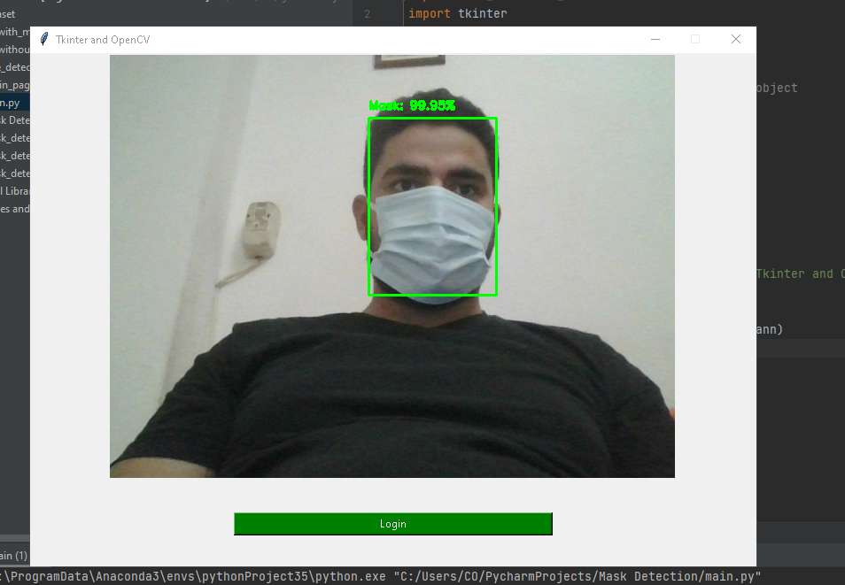

Conclusion:

We briefly explained the motivation of the work at first. Then, we illustrated the learning and performance task of the model. Using basic Machine learning tools and simplified techniques the method has achieved reasonably high accuracy. It can be used for a variety of applications. Wearing a mask may be obligatory in the near future, considering the Covid-19 crisis. Many public service providers will ask the customers to wear masks correctly to avail of their services.