Troubleshooting and Fixing Connection Errors
Connectivity inspection, fault identification, and verification
Date: September 29, 2026
Issue | One device was found to be disconnected or not working.
Investigation | The working devices were checked through their wired connection settings.
Resolution | The affected device was reconnected and verified with repeated ping tests.

1. Objective
The objective of this activity was to identify the source of a connectivity problem, correct the affected device connection, and confirm that the network was operating correctly.

2. Network Topology
The environment included an Internet connection, a wireless router, multiple PCs, and laptops. The attached image shows the Packet Tracer-style network layout used during the troubleshooting activity.

3. Troubleshooting Procedure

1. Inspecting all devices
Checked all devices in the network environment and began searching for the source of the connectivity problem.

2. Identifying the faulty device
Found that one device was the only device that was not working or was not connected properly.

3. Comparing working devices
Opened the devices that were working and reviewed their wired connection settings for comparison.

4. Reviewing the user information
Checked the configured username. The username was recorded as Cisco123.

5. Reconnecting the affected device
Returned to the affected device and re-established its connection using the appropriate settings.

6. Confirming the connection
Verified that the device successfully connected to the network after the settings were corrected.

7. Running repeated ping tests
Used the ping command multiple times to confirm reachability and verify that the connection remained operational.

4. Verification Results
• One non-working device was successfully isolated during the inspection.
• The wired connection settings of working devices were used as a reference.
• The username Cisco123 was reviewed during the configuration check.
• The affected device was reconnected successfully.
• Multiple ping attempts confirmed that the device could communicate across the network.

5. Conclusion
The connectivity error was identified by checking all devices and comparing the working wired connection settings. After the affected device was reconnected, repeated ping tests confirmed that the connection was functioning correctly.

6. Evidence Image
The following image documents the network layout and the connected devices used during the troubleshooting activity.
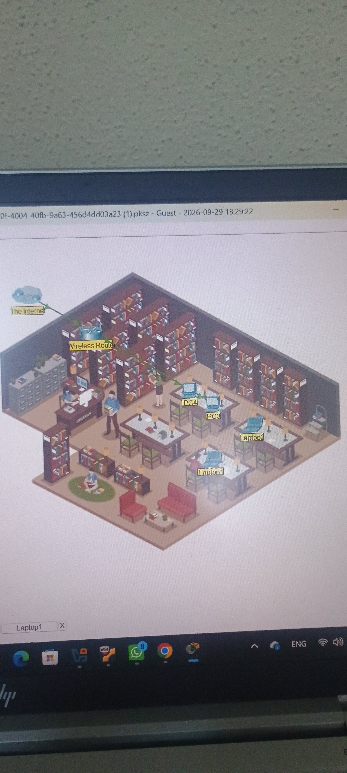
Figure 1. Network topology showing the Internet, wireless router, PCs, and laptops.

