AegisScan
Smart Web Vulnerability Scanner
Software Engineering Final Project Report

Course | Software Engineering
Teaching Assistant | Eng. Rawan El Gendy
Team Members | Omar Nabil, Youssef Ashraf, Mazen Mohamed,  Abdelrahman Mohamed, Abdelrahman Shaheen
Project Type | Security-focused web application
Containerization | Docker-ready deployment included
GitHub Repository | https://github.com/omarnabilgaafar/aegisscan-cloud

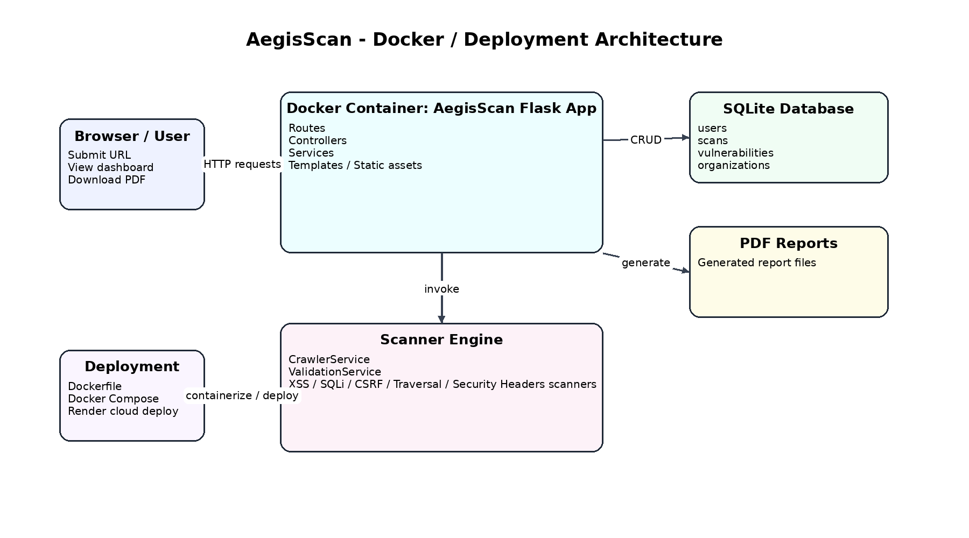
Figure 1. High-level Docker/deployment view of AegisScan.

Executive Summary
AegisScan is a web vulnerability scanning platform designed to help users analyze target web applications, identify common security weaknesses, store findings, and generate downloadable PDF reports. The system combines a Flask-based web interface, modular scanning services, database persistence, and Docker-ready deployment to provide a practical software engineering case study.
The project follows the Software Development Life Cycle (SDLC) requested in the course brief: requirements, design, implementation, testing, and maintenance. The report also includes the required UML diagrams: Use Case, Sequence, Activity, Class, and State Machine.
1. Introduction and Project Scope
1.1 Problem Statement
Manual security checking is slow, repetitive, and error-prone. Students, developers, and small teams often need a lightweight way to inspect a web target for common issues such as cross-site scripting, SQL injection, CSRF weaknesses, directory traversal, and missing security headers.
1.2 Objectives
• Provide a simple interface for entering a target URL and starting a scan.
• Validate the target before execution to keep the educational build controlled and safe.
• Run several security checks and aggregate the results in one scan summary.
• Store scans and vulnerabilities for later viewing in the dashboard.
• Generate printable PDF reports for documentation and review.
1.3 System Scope
In scope: user registration and login, launching scans, viewing scan results, dashboard visualization, report generation, and admin/workspace views. Out of scope: production-grade internet-wide scanning, distributed scan agents, and unrestricted scanning of arbitrary public hosts.
1.4 User Interface Snapshot
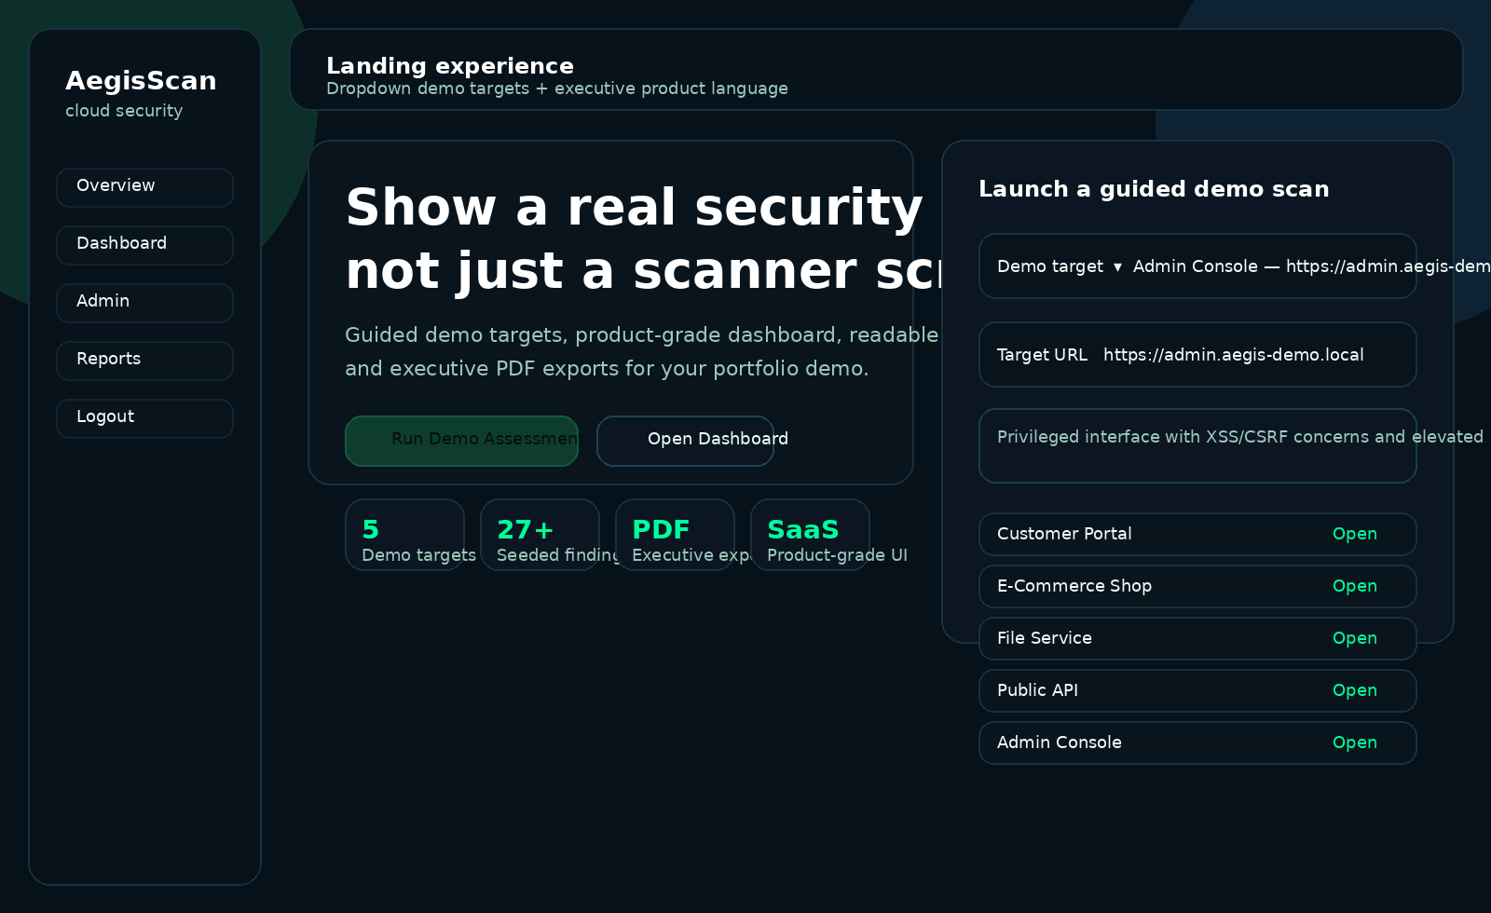
Figure 2. Landing page of the AegisScan application.
2. Requirements Phase
2.1 Functional Requirements
ID | Requirement
FR1 | The system shall allow a visitor to register an account and log in.
FR2 | The system shall allow a user to submit a target URL for scanning.
FR3 | The system shall validate the submitted URL before running the scan.
FR4 | The system shall crawl links and forms from the target where applicable.
FR5 | The system shall execute security checks for XSS, SQL injection, CSRF, directory traversal, and security headers.
FR6 | The system shall aggregate findings, calculate severity counts, and summarize scan risk.
FR7 | The system shall save scans and vulnerabilities in the database.
FR8 | The system shall display scan results and support PDF report download.
FR9 | The dashboard shall show recent scans, findings, severity distribution, and workspace usage.
FR10 | The admin view shall expose organization and user overview data for administrators.
2.2 Non-Functional Requirements
Attribute | Requirement
Security | Only allowed hosts are scanned in the educational build, and the request must include a CSRF token.
Performance | The system should present a completed result page within an acceptable time for the selected target and show clear feedback in case of limited coverage.
Usability | The web interface should be straightforward for students to use without advanced security knowledge.
Reliability | Scan results and vulnerabilities must be persisted correctly in the database once the scan is completed.
Maintainability | The project uses separated routes, controllers, services, scanners, and models to keep the codebase modular.
Deployability | The application must be container-ready using Docker and support simple cloud deployment.
3. Design Phase
3.1 Architectural Design
The system adopts a layered web architecture. Routes receive HTTP requests, controllers coordinate the request flow, services perform validation, crawling, scanning, and reporting logic, and models represent persisted entities such as users, scans, vulnerabilities, and reports. SQLite is used as the project database in the current build.
Containerization is part of the design. The project includes a Dockerfile, docker-compose configuration, and a Render deployment file. This makes the system easier to demonstrate, deploy, and reproduce on another machine.

Figure 3. Docker and deployment architecture included in the implementation.
3.2 Design Decisions
• Flask was selected because it is lightweight, clear for academic projects, and fits a modular MVC-like organization.
• Scanning logic was separated into dedicated modules so each vulnerability type can evolve independently.
• Validation was isolated in its own service to enforce safe target rules before scanning.
• PDF report generation was kept as a dedicated reporting module to separate presentation from scan execution.
3.3 Use Case Diagram
Shows the primary actors and high-level system services such as registration, login, scanning, viewing results, downloading reports, dashboard access, and admin management.
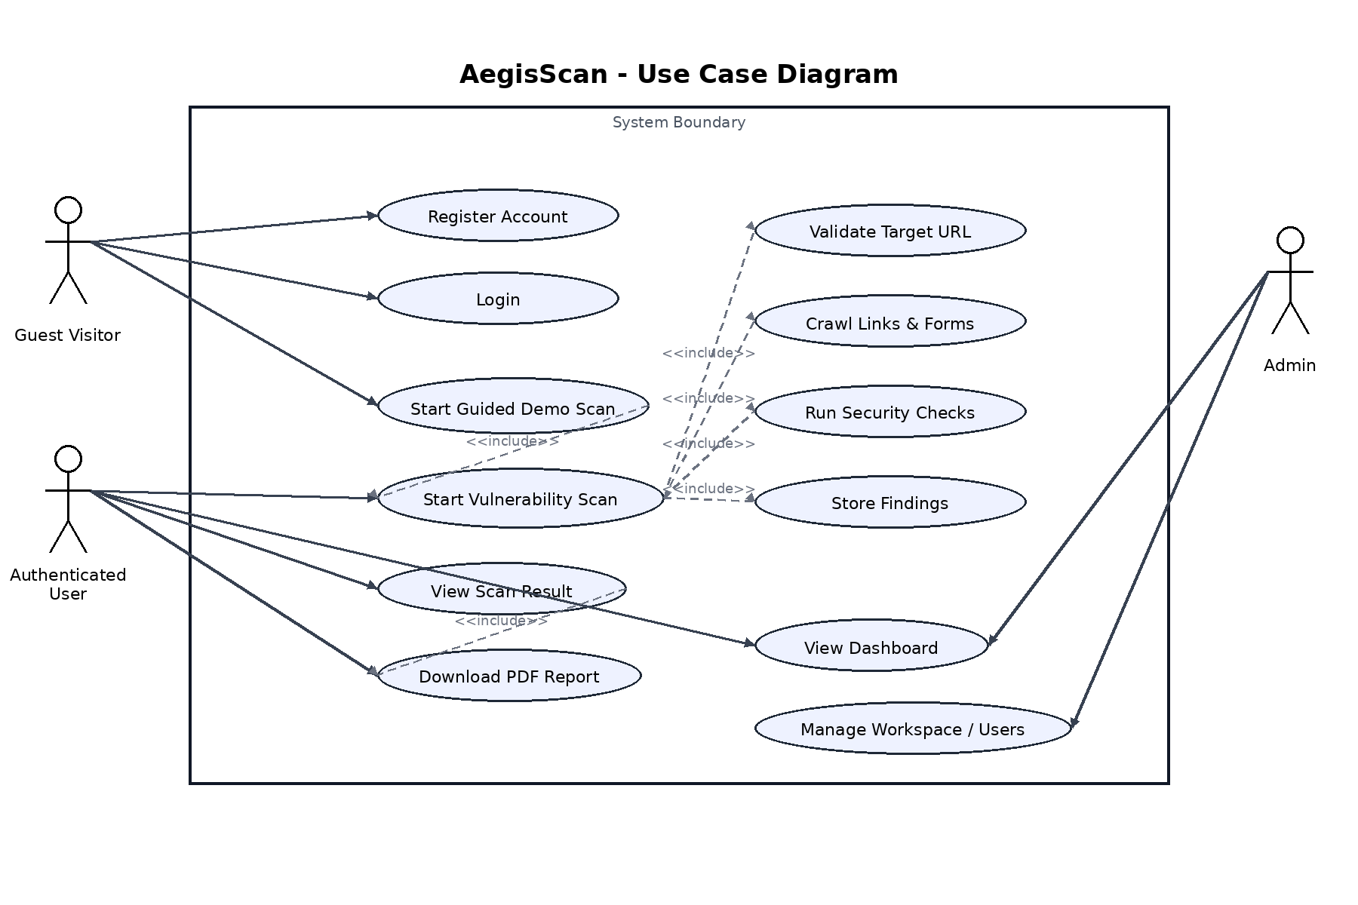
Figure 4. Use Case Diagram for AegisScan.
3.4 Sequence Diagram
Explains the interaction order when a user submits a scan request and the system validates, runs, stores, and returns the result.
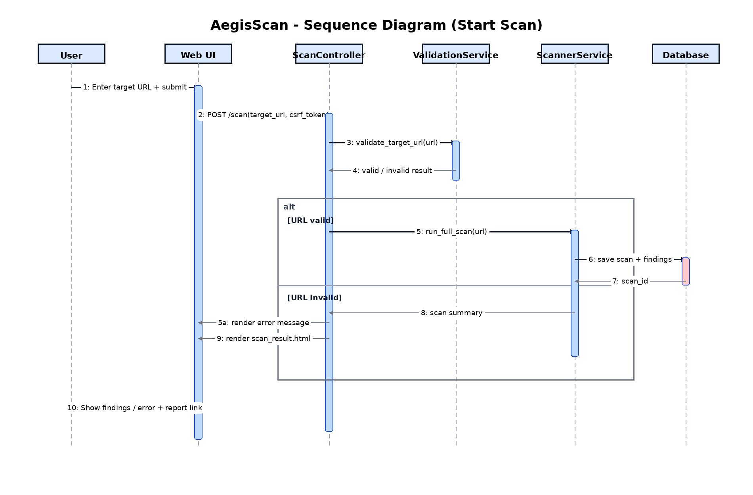
Figure 5. Sequence Diagram for AegisScan.
3.5 Activity Diagram
Represents the workflow from launching the application to validating the URL, running the scan, handling invalid input, and displaying the result.
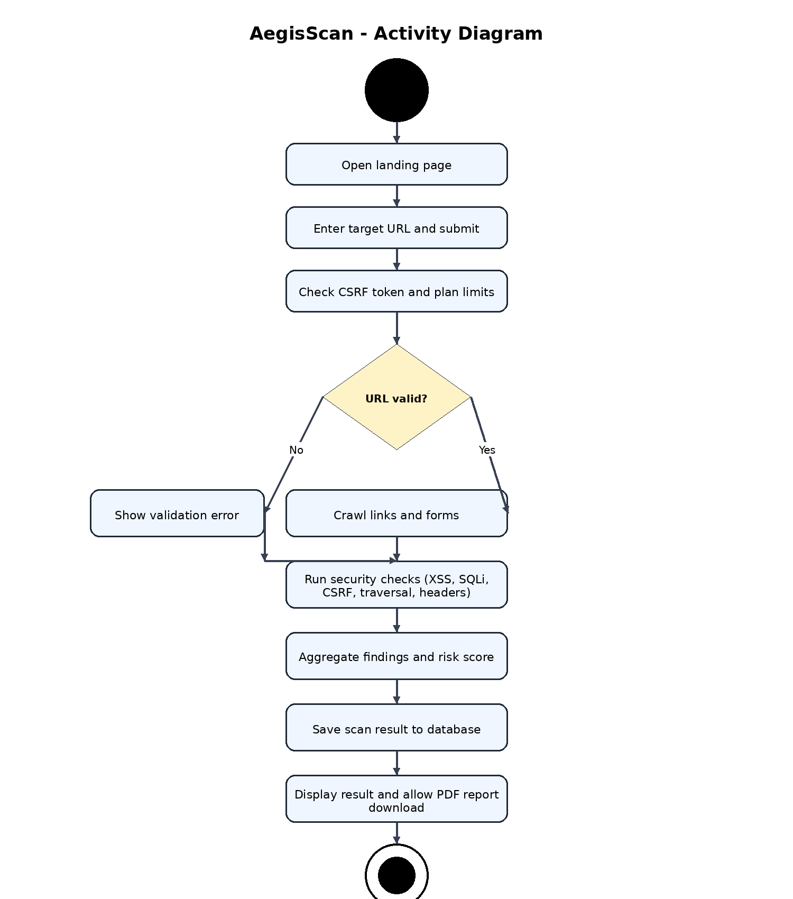
Figure 6. Activity Diagram for AegisScan.
3.6 Class Diagram
Illustrates the core domain objects and service classes used by the project.
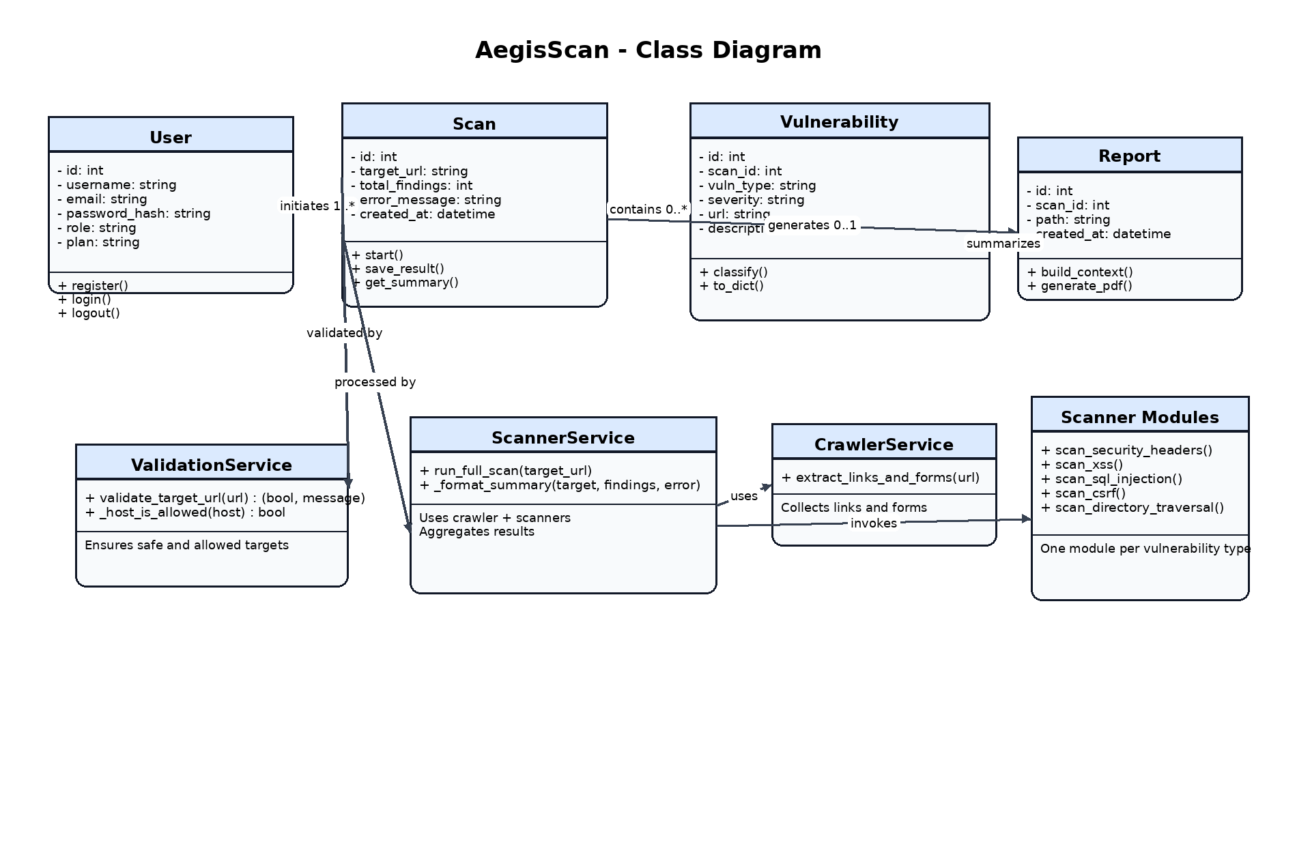
Figure 7. Class Diagram for AegisScan.
3.7 State Machine Diagram
Shows how the scan process changes state from idle to validation, scanning, saving, completion, or failure.
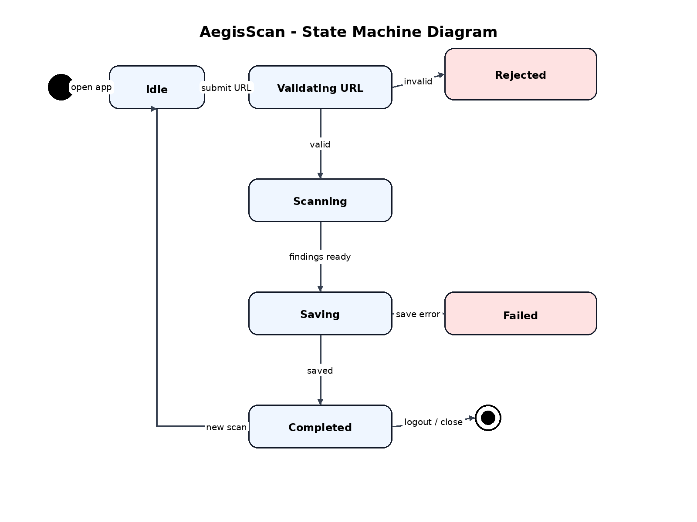
Figure 8. State Machine Diagram for AegisScan.
4. Implementation Phase
4.1 Technologies and Tools
Technology | Purpose
Python + Flask | Web application framework and request handling
SQLite | Local persistence for users, scans, findings, organizations, and keys
HTML/CSS/JS | User interface templates and dashboard behavior
Docker / Docker Compose | Containerization and local deployment
Render configuration | Cloud deployment support
Report generation | Downloadable PDF report output
4.2 Major Modules
• Authentication module: registration, login, logout, workspace/session setup.
• Scan module: target submission, validation, scanning pipeline, and result rendering.
• Scanner modules: specialized checks for XSS, SQL injection, CSRF, directory traversal, and headers.
• Report module: report page generation and PDF export.
• Dashboard and admin module: statistics, recent scans, findings, organizations, and users.
4.3 Project Resources
GitHub Repository (provided by the team): github.com/omarnabilgaafar/aegisscan-cloud
Docker support: The project contains a Dockerfile and docker-compose.yml, which makes it valid to include a deployment/container diagram inside the report.
Docker execution evidence: the team successfully built Docker images for the project, including the final image 'aegisscan:latest', and executed the container with host-to-container port mapping. At runtime, Flask started correctly inside the container and exposed the application on localhost:5000, confirming that the system is portable and deployable through containerization.
This practical run validates the deployment setup beyond configuration files alone because it demonstrates that the provided Docker assets can launch the application successfully in a reproducible environment.
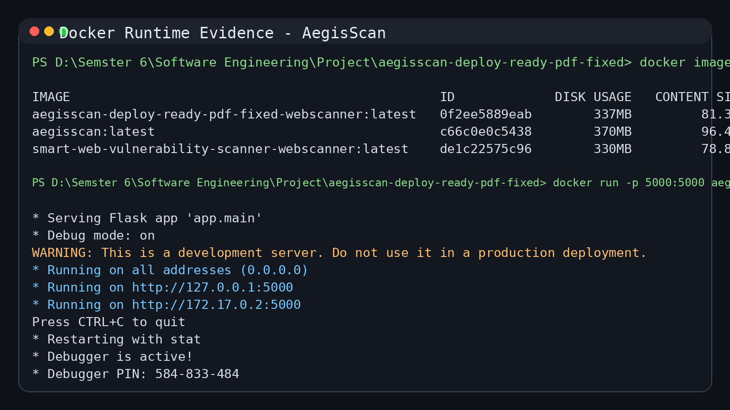
Figure 4. Docker runtime evidence: built image and successful container execution on localhost:5000.
4.4 Interface Screenshots
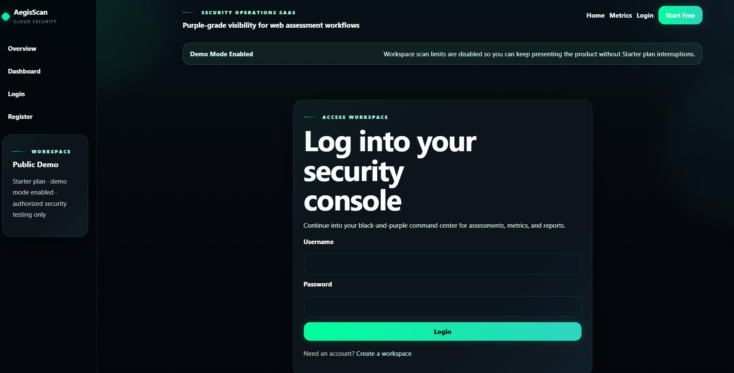
Figure 9. Login page.
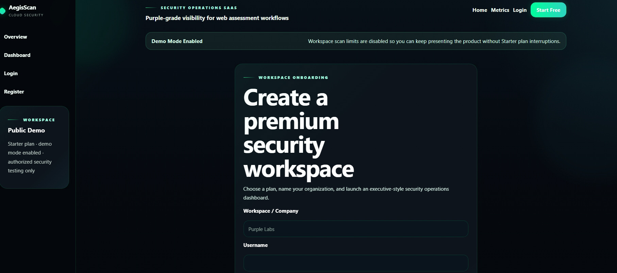
Figure 10. Registration page.
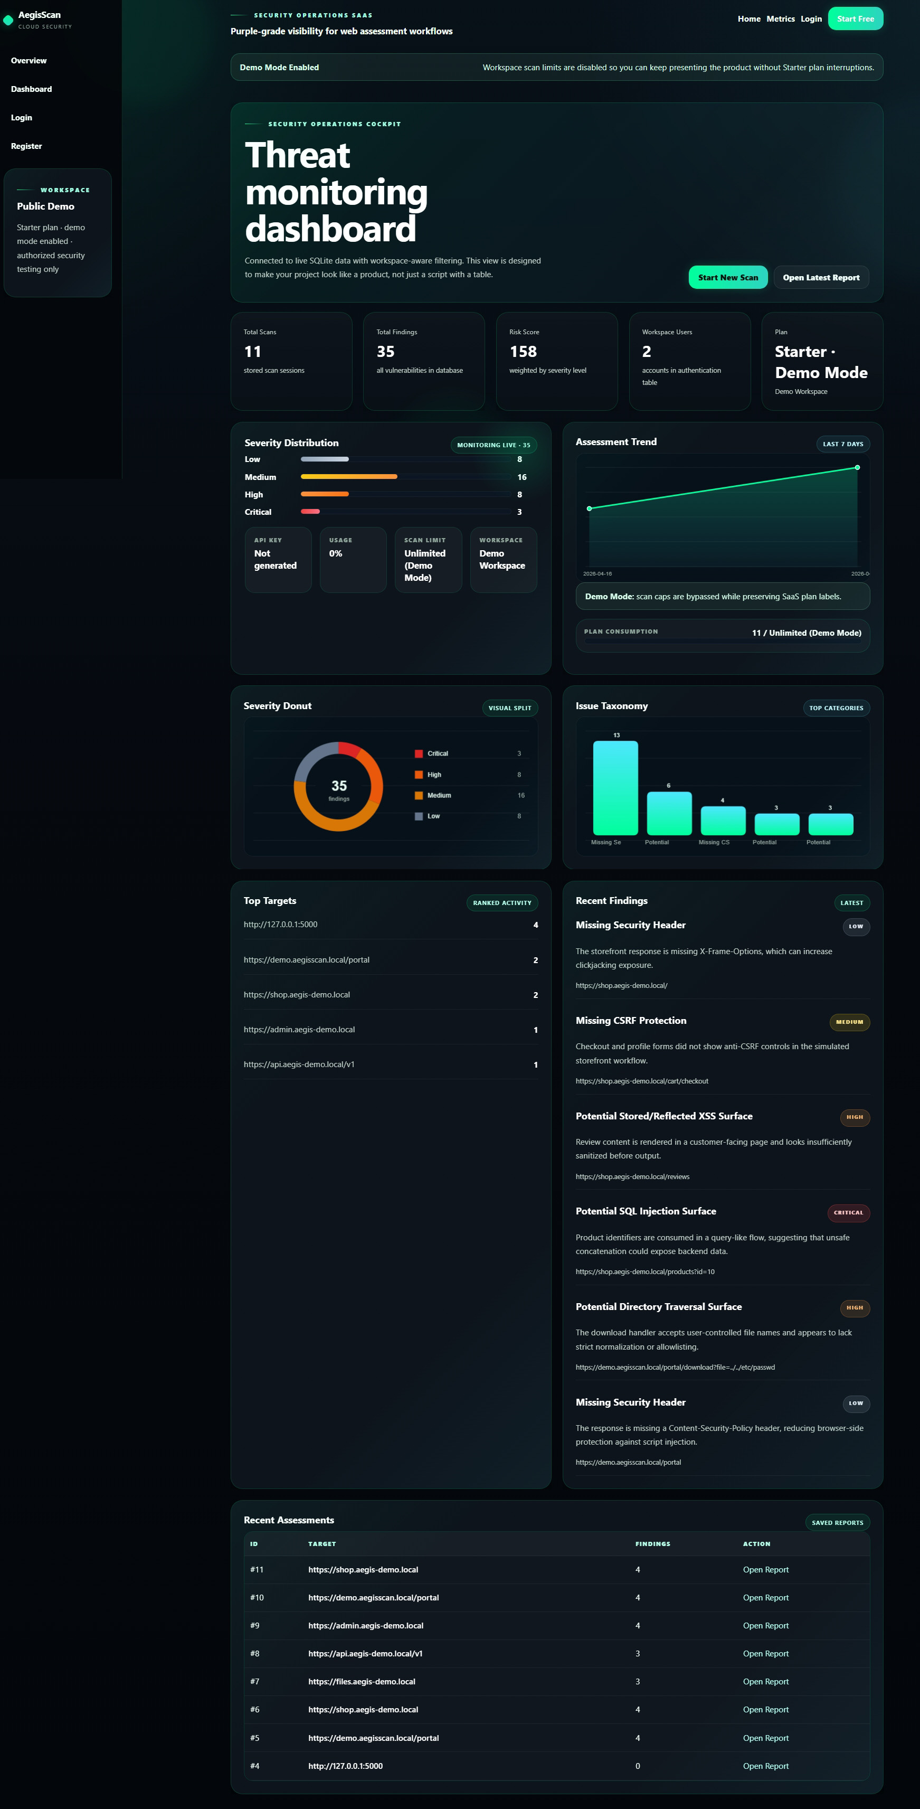
Figure 11. Dashboard.
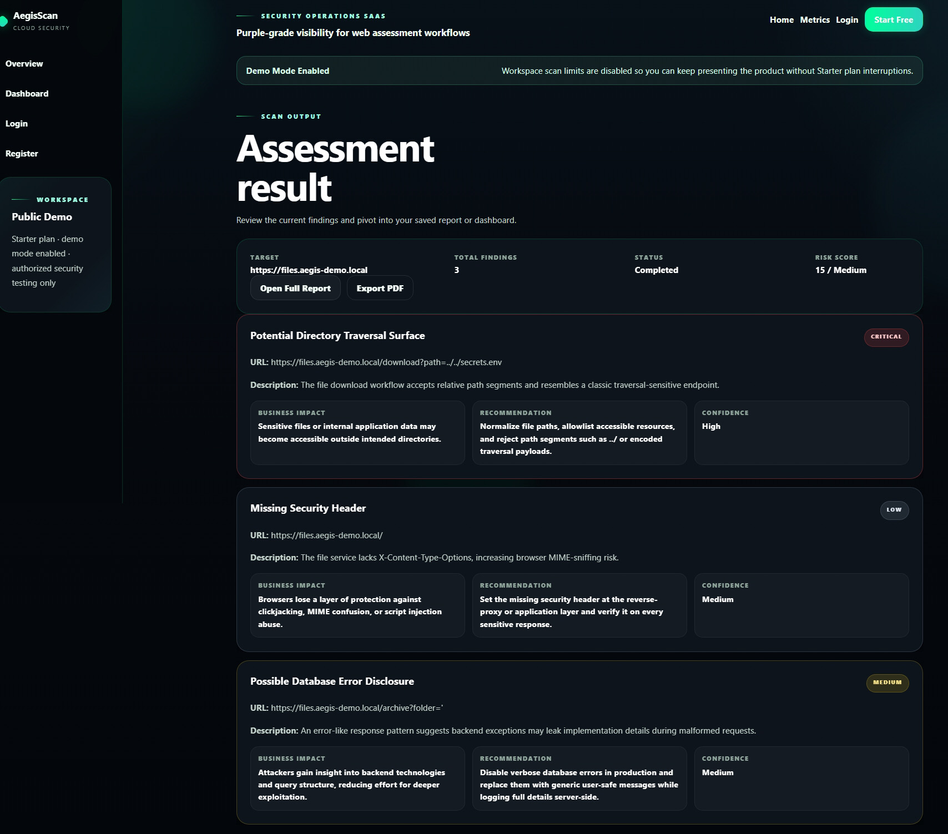
Figure 12. Scan result page.
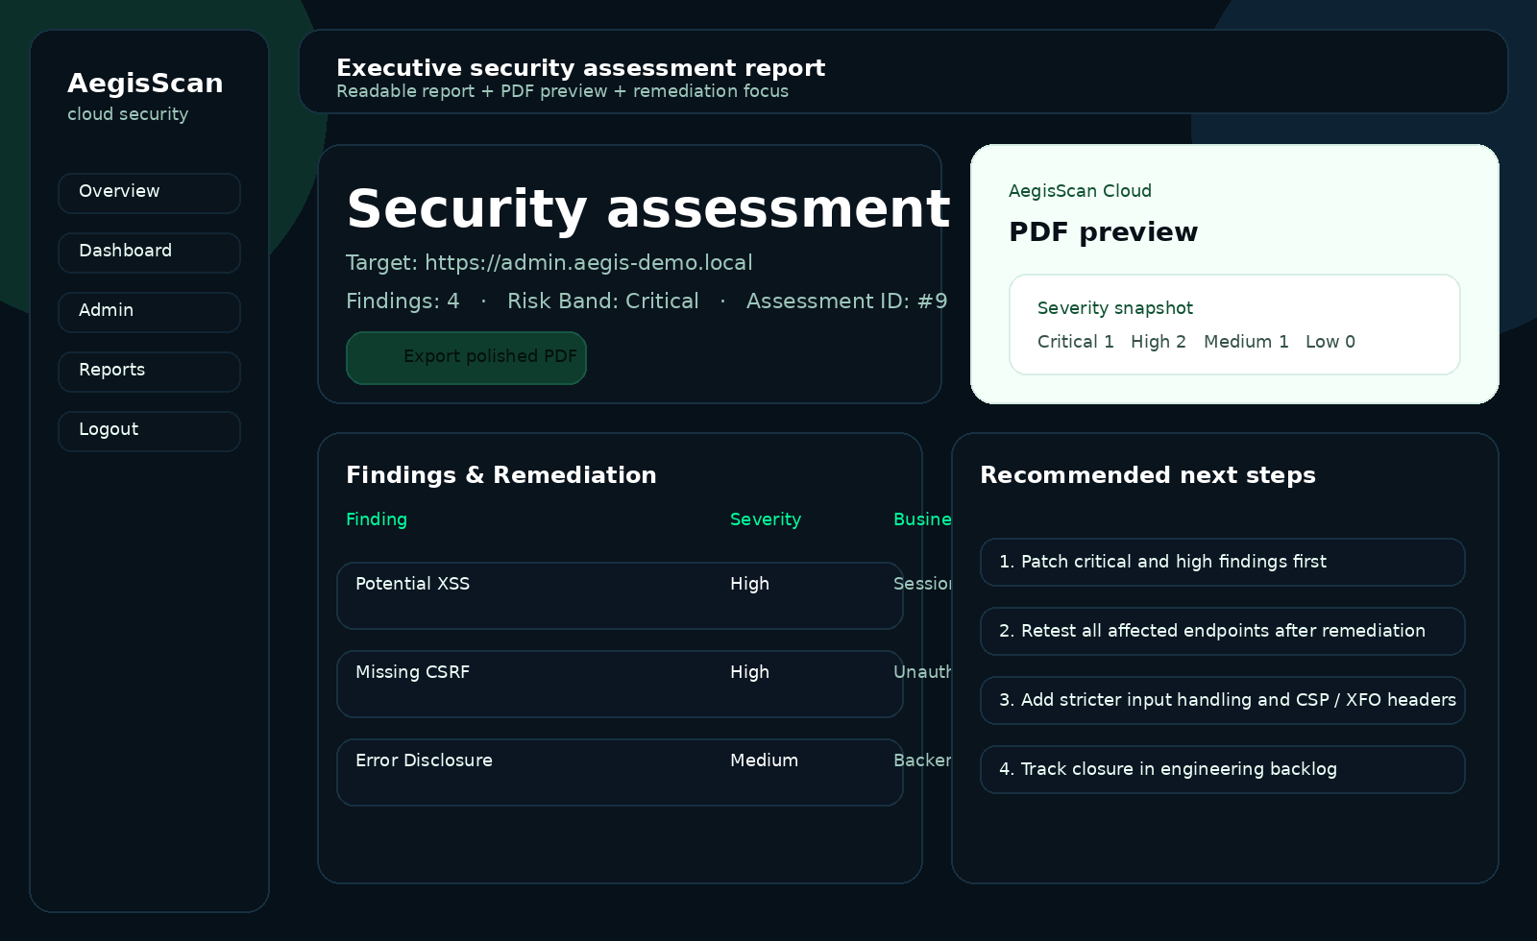
Figure 13. Report page.
5. Testing Phase
The project includes a tests directory with code-level tests that target validation, route behavior, scanner outputs, and report persistence. In this report, the testing phase is documented as a combination of unit testing, integration testing, and functional verification of the main user flow.
5.1 Testing Strategy
• Unit testing for isolated functions such as URL validation and individual scanner return structures.
• Integration testing for saving scan results and loading the home route.
• System testing for the full user flow: submit URL -> scan -> view result -> open report -> download PDF.
5.2 Sample Test Cases
ID | Test Case | Expected Result | Status
TC1 | Submit empty target URL | Validation error is shown | Pass by design
TC2 | Submit invalid host | Scan is rejected with safe-host message | Pass by design
TC3 | Submit valid target URL | Scan result page is rendered | Pass by flow
TC4 | Save scan findings | A numeric scan ID is returned | Covered by test file
TC5 | Open home page | HTTP 200 response | Covered by test file
TC6 | Generate report page | Findings are displayed and PDF link is available | Functional verification
6. Maintenance Phase
The modular structure makes the project maintainable. New scanners can be added as new modules, dashboard indicators can be extended, and the deployment method can be upgraded without redesigning the whole system.
6.1 Future Improvements
• Add authentication hardening, rate limiting, and audit logging.
• Add asynchronous task execution for longer scans.
• Support more vulnerability plugins and richer evidence capture.
• Use PostgreSQL or another production database for a cloud-scale version.
• Add CI/CD automation for testing and deployment.
7. Conclusion
AegisScan demonstrates the application of software engineering concepts in a real security-focused web system. The final solution includes functional requirements, design artifacts, implementation details, testing evidence, maintenance planning, UML modeling, screenshots, Docker support, and a GitHub reference suitable for project submission.

