* **Requirements Collection and Analysis: -**

The pharmacy database stores details about the drugs and employees who work in the pharmacy that sells the drugs. Keep in mind that the pharmacy has only one main branch.

Requirements of this database are as follows: -

- The employees in the pharmacy sells some **drugs**, and each drug has attributes: Barcode (primary key), trade name, generic name, the total number in the pharmacy, the drug usage, type of each drug, and its price.

- Each **employee** has an EID (primary key), name (composite: first_ and last_), age, work hours, phone number(multivalued), and salary.

- The pharmaceutical **company** has a CID (primary key), address, telephone number, its name indeed, the time to deliver the orders of the drug, and the representative who will be responsible for providing the order.

- Each **order (exportation)** must contain the barcode of the required drug, in addition to its quantity, price, and the date of Exportation.

- Each **sell** operation must contain the barcode of the required drug, in addition to its quantity and basic price, in addition to its price after applying the 20% discount and the date of the purchase.

**ER diagram: -**

**Relational model :-**

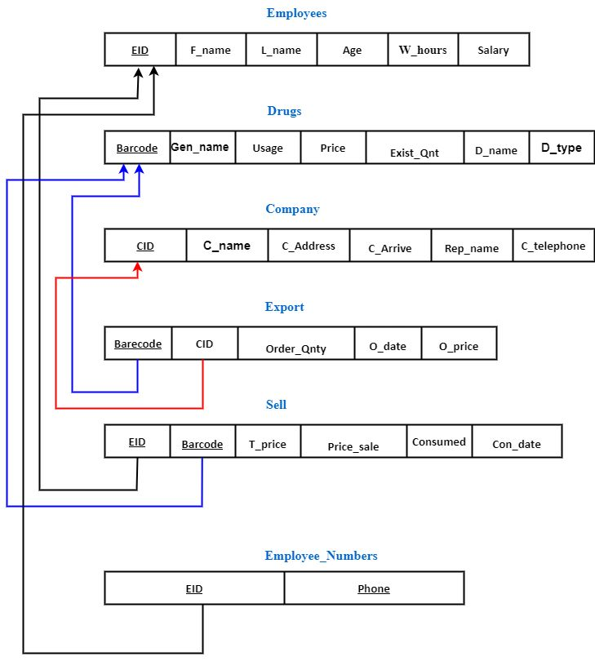

**Company**

|  |  |  |  |  |  |
| --- | --- | --- | --- | --- | --- |
| CID | C_name | C_Address | C_Arrive | Rep_name | C_telephone |
| 1 | Ibnsina pharma | EL Mahala | 1 | Ahmed Alaa | 1552345341 |
| 2 | Degla pharm | Alexandria | 7 | Ali Farag | 1227472055 |
| 3 | Pharco | El Mansora | 2 | Mona Ahmed | 0502331030 |
| 4 | Promise Pharma | Kafrelsheikh | 2 | Ali Salem | 1014449490 |
| 5 | Pharma Plus | Tanta | 1 | Michael Hamdy | 1025689357 |
| 6 | Ramacin | El Mansora | 2 | Doha Abdullah | 1141601065 |
| 7 | Elixir pharma Delta office | Tanta | 1 | Hassan Sabry | 4035774102 |
| 8 | Beta Pharm | Cairo | 4 | Adel Seleem | 3412050101 |
| 9 | Adwia SAE | Cairo | 4 | Maged Sobhy | 3330222135 |
| 10 | Amecath | Cairo | 4 | Yara Saied | 3033122231 |

**Drugs**

|  |  |  |  |  |  |  |
| --- | --- | --- | --- | --- | --- | --- |
| Barcode | D_name | Gen_name | Usage | D_type | Price | Exist_Qnt |
| 1000 | OLFEN | diclofenace | treat mild to moderate pain | ampoule | 26.5 | 10 |
| 1001 | OLFEN | diclofenace | treat mild to moderate pain | tablet | 24 | 10 |
| 1002 | PREX | Pregabalin | management of neuropathic | capsoul | 92 | 10 |
| 1003 | Claritine | Loratadine | antihistamine | tablet | 43 | 10 |
| 1004 | Claritine | Loratadine | antihistamine | syroup | 21 | 10 |
| 1005 | lorine | Loratadine | antihistamine | tablet | 16.8 | 10 |
| 1006 | lorine | Loratadine | antihistamine | syroup | 16.8 | 10 |
| 1007 | epifenac | diclofenac sodium | Analgesic and antipyretic | drop | 9 | 10 |
| 1008 | epifenac | diclofenac sodium | Analgesic and antipyretic | tablet | 12 | 10 |
| 1009 | epifenac | diclofenac sodium | Analgesic and antipyretic | Supp | 8 | 10 |
| 1010 | epifenac | diclofenac sodium | Analgesic and antipyretic | ampoule | 18 | 10 |
| 1011 | voltaren | diclofenac sodium | Analgesic and antipyretic | tablet | 45 | 10 |
| 1012 | voltaren | diclofenac sodium | Analgesic and antipyretic | sup | 9 | 10 |
| 1013 | voltaren | diclofenac sodium | Analgesic and antipyretic | Amp | 58 | 10 |
| 1014 | voltaren | diclofenac sodium | Analgesic and antipyretic | drop | 23.6 | 10 |
| 1015 | antodine | Famotidine | Ulcers | tablet | 58.5 | 10 |
| 1016 | antodine | Famotidine | Ulcers | ampoule | 27 | 10 |
| 1017 | omez | omeprazole | Ulcers | capsoul | 73 | 10 |
| 1018 | pantoloc | pantoprazole | Ulcers | tablet | 21 | 10 |
| 1019 | hibiotic | amoxicillin+clavulanic | antibiotic | tablet | 91 | 10 |

|  |  |
| --- | --- |
| EID | Phone_num |
| 10 | 1035667866 |
| 10 | 1156357989 |
| 11 | 1025896217 |
| 12 | 1135678953 |
| 12 | 1235798567 |
| 12 | 1535795216 |
| 13 | 1056479823 |
| 14 | 1154879536 |
| 14 | 1235676535 |

**Emloyees E_numbers**

|  |  |  |  |  |  |
| --- | --- | --- | --- | --- | --- |
| EID | F_name | L_name | W_hours | Age | Salary |
| 10 | Vishal | Verma | 5 | 24 | 2500 |
| 11 | Vivek | Diwan | 5 | 23 | 2500 |
| 12 | Ahmed | Samy | 7 | 35 | 2520 |
| 13 | Maged | Keshk | 7 | 31 | 2520 |
| 14 | Yasser | Ali | 8 | 37 | 2530 |

**Export**

|  |  |  |  |  |
| --- | --- | --- | --- | --- |
| Barcode | CID | Order_Qnty | O_date | O_price |
| 1000 | 5 | 100 | 2018-02-12 10:25:25.000 | 1500 |
| 1009 | 7 | 1000 | 2021-10-05 12:05:01.000 | 5000 |
| 1010 | 3 | 300 | 2022-01-25 03:10:18.000 | 2500 |
| 1012 | 5 | 2000 | 2020-02-05 05:16:00.000 | 15000 |
| 1015 | 7 | 125 | 2019-12-15 07:57:51.000 | 5000 |
| 1015 | 7 | 125 | 2020-06-17 05:36:01.000 | 5000 |

**Sell**

|  |  |  |  |  |  |
| --- | --- | --- | --- | --- | --- |
| EID | Barcode | T_price | Price_sale | Consumed | Con_date |
| 10 | 1000 | 79 | 63 | 3 | 2022-12-03 05:35:24.000 |
| 10 | 1000 | 79 | 63 | 3 | 2022-12-04 04:22:12.000 |
| 11 | 1003 | 258 | 206 | 6 | 2022-08-20 11:43:50.000 |
| 12 | 1009 | 8 | 6 | 5 | 2022-12-21 04:22:12.000 |
| 12 | 1009 | 8 | 6 | 3 | 2023-01-05 04:22:12.000 |
| 13 | 1008 | 48 | 38 | 4 | 2022-05-01 06:20:29.000 |
| 14 | 1004 | 21 | 16 | 3 | 2022-10-11 04:22:12.000 |
| 14 | 1018 | 42 | 33 | 2 | 2022-10-15 09:15:00.000 |