The title page

**Content**

**Introduction** 3

**1 THEORETICAL BASES OF CREATING METHODOLOGICAL SUPPORT FOR FUTURE TEACHERS OF MATHEMATICS** 4

**1.1 Methodology of support of independent educational and professional work of future teachers of mathematics** 4

**1.2 Development of methodological skills of future teachers of mathematics in the course of mastering mathematical subjects** 5

**1.3 Specificity of development of teaching material on mathematical subjects in pedagogical higher education institutions** 6

**2 PRACTICAL COMPILATION OF METHODOLOGICAL SUPPORT OF THE DISCIPLINE "PROBABILITY THEORY AND MATHEMATICAL STATISTICS" FOR STUDENTS OF THE SPECIALTY "MATHEMATICS"** 7

**2.1 Modern tendencies and the role of teaching Probability Theory and Mathematical Statistics to future teachers of mathematics** 7

**2.2 Program and methodological support of the discipline "Probability Theory and Mathematical Statistics" for students of the specialty "Mathematics"** 8

**2.2.1 Purpose and objectives, as well as the place of the discipline in the structure of the educational program** 9

**2.2.2 List of expected results of the discipline training** 10

**2.2.3 Structure and content of the discipline** 11

**2.2.4 Methodical and evaluation resources for the organization of current and final control of students' knowledge on the discipline** 12

**2.2.5 Methodical recommendations for students to study the discipline** 13

**2.2.6 List of basic and additional teaching materials necessary for the study of the discipline** 14

**Conclusion** 15

**List of used literature** 16

**Appendix** 17

# **Introduction**

Public education of the Republic of Kazakhstan is actively developing, and the key aspect is the transformation of public outlook. In modern society there is a need for updated socio-psychological norms of citizens' behavior, while maintaining and paying great attention to national identity, cultural context, strategy of personal growth and self-education, as well as the creation of successful creative individuality on the foundation of higher professionalism, qualification and education, efforts to increase the importance of family values.

In Kazakhstan, the key innovation in education is radically new methods, among which the main one is the revision of the content of the school program. Teachers are now required to have a higher level of professional competence due to the renewal of the curriculum. The teacher is becoming the central figure in the implementation of these innovations.

The success of the renewal of Kazakhstan's educational system is closely linked to teachers' understanding of the key ideas of innovation processes and their readiness to implement these changes. Under such conditions, the responsibility for training future teachers, especially in the field of mathematical sciences, increases. The importance of higher education institutions lies in their quick response to changes in the secondary education program. The problem of training future mathematicians in universities is solved by creating educational programs aimed at forming new generation teachers.

The issues of education and training of future teachers of mathematics are of great importance nowadays. The spread of digital educational technologies and scientific methods in all aspects of our life and professional spheres has caused the need to raise the level of school education, particularly in mathematics. This has led to the fact that universities of all directions set high requirements for the mathematical training of applicants, i.e. when entering the university candidates pass the UNT - Unified National Test, which necessarily includes the section "Mathematical Literacy". Only experienced teachers can provide quality mathematics education in secondary schools. Consequently, quality methodological training of future teachers of mathematics and teaching of mathematical disciplines in accordance with modern standards in the pedagogical university is a guarantee of a high level of training of schoolchildren and, accordingly, university students, who in the future will become professionals in such fields as construction, architecture, engineering, metallurgy and others.

For effective formation of qualified teachers of mathematics, their pre-university training plays a key role. Special attention is paid to those who after school choose the specialization "Mathematics". The knowledge acquired during school years and the ability for independent cognition significantly affect the success of their educational path in higher education institutions.

In studies devoted to the methodological training of future teachers, the importance of a systematic and methodical approach in training is emphasized. The central place is occupied by preparation to work with mathematical material (works of scientists Ivanov M.I., Petrov Y.M., Alekseeva A., Nikolaeva A., Sokolova S.M., etc.). Some researchers claim that the system-methodical approach in teaching mathematics contributes to the creative development of personality and professional growth of future teachers (works by Lebedev A.I., Kharitonov A.V., Kuznetsova B.R., Kalinin R.I.).

The topic of methodological training of future teachers of mathematics is extensively studied. In the monograph by Smirnova N.L. and Popova N.S. the theoretical aspects of the modern methodical system of mathematics education are considered. The concept of "methodical system of mathematics education" with components such as goals, content, methods and means was introduced into scientific circulation by Pavlov A.M. The dissertation by Smirnova V.I. is devoted to the development of criteria for the effectiveness of the methodical system. Alexeeva A.E. in her works focuses on the adaptation of mathematics education to modern requirements, emphasizing the importance of continuous study of mathematics and its integration with methodological disciplines to improve the quality of teacher training.

The problems of teacher training and the content of mathematical disciplines are covered in many domestic and foreign works, including studies by Titova M.T., Romanov M.S., Razin M., Sergeeva G.I., Fedorov L.M., Prokofiev M.V., Kuznetsova B.R., Alekseeva A.E., Kabanova A.K., Samsonova O.S., and others. In the textbook "Didactic Foundations of Teaching in Higher Education" Alexeeva A.E. emphasizes the role of the teacher as a key element in mathematics education, noting his/her need to possess fundamental knowledge, apply the latest technologies and strive for the success of his/her students.

The study of methods of teaching probability theory, mathematical statistics and combinatorics with an emphasis on the development of critical thinking is an important task in the educational sphere. This need is conditioned by the introduction of elements of these disciplines in the educational standard, which is emphasized in the Concept of modernization of education in Kazakhstan until 2015, where the emphasis is placed on the development of students, not only on their learning.

In scientific studies it is noted that the beginning of the implementation of this direction lies in the analysis and description of the features of statistical thinking. In the works of such authors as B.V. Gnedenkov, G.A. Georgiyan, M.E. Orlovsky, E.A. Burov, L.O. Belova, V.A. Dmitriev, D.S. Doroshenko, G.S. Efimova, A.N. Komarov, D. V. Maximov, A. Plotnikov, Y. V. Sokolov, V. D. Sergeev, L. V. Trofimov, M. V. Timofeeva, Y. N. Tarasov, V. V. Fedorov, A. Y. Kharitonov, S. V. Shiryaev, and others, the specificity of this style of thinking is revealed, unique techniques are discussed, and methodological approaches to enrich learning in school and university programs are proposed.

Probability theory and mathematical statistics play a key role in the training of future mathematics teachers. Effective teaching involves the application of real-world problems, the use of statistical programs, an interdisciplinary approach, and an emphasis on teaching methods. However, there are challenges such as the high complexity of the subject, lack of qualified teachers, and limited resources that need to be addressed to produce quality mathematics teachers.

It is important to realize that modern education requires teachers not only to have a deep knowledge of their discipline, but also the ability to apply that knowledge in a rapidly changing world. Teaching probability theory and statistics at teacher training institutions should focus on the development of critical thinking, the ability to analyze and interpret data, and include the development of relevant and interesting curricula. Training teachers who can integrate these elements into the educational process is critical to creating an educational environment that encourages curiosity and prepares students for successful lives and careers in today's world.

**Purpose of the study.** Development of methodological support for the course of Probability Theory and Mathematical Statistics in pedagogical university.

**Object of the study.** The object of the study is the process of teaching Probability Theory and Mathematical Statistics at a pedagogical university.

**Subject of the study.** Methodological approaches to teaching the course of Probability Theory and Mathematical Statistics to future teachers of mathematics.

Within the framework of this study, the following tasks were identified to improve the teaching process in pedagogical higher education institutions:

* to conduct a comprehensive analysis of the methodological system of teaching Probability Theory and Mathematical Statistics;
* to establish the importance and function of Probability Theory and Mathematical Statistics in the process of education of a future teacher;
* to investigate the applied methods and forms of teaching Probability Theory and Mathematical Statistics to students specializing in mathematics;
* to create an improved methodological system for the course of Probability Theory and Mathematical Statistics.

**The research methodology** includes a variety of approaches: study and analysis of scientific literature on the subject, analysis of curricula and methodological guidelines, evaluation of existing methodological systems, organization and conduct of training sessions, as well as experimental research to evaluate the effectiveness of the new methodological system.

**The distinctive feature of the study** is the development of an innovative methodological system for the course of Probability Theory and Mathematical Statistics in a pedagogical university. As part of this work:

1. Еhe teaching material on Probability Theory and Mathematical Statistics aimed at the education of future teachers of mathematics is defined.

2. The peculiarities of methods of teaching Probability Theory and Mathematical Statistics in the context of updating the school educational program are highlighted.

**The hypothesis of the research** consists in the assumption that the application of scientifically-based teaching methodology based on the system-methodological approach, taking into account innovative information technologies, will allow to achieve a high level of professional and methodological training of future teachers of mathematics. This, in turn, contributes to strengthening the methodological and mathematical base, especially in the field of stochasticity, and improving the quality of education in pedagogical universities.

**1 THEORETICAL BASES OF CREATING METHODOLOGICAL SUPPORT FOR FUTURE TEACHERS OF MATHEMATICS**

## **1.1 Methodology of support of independent educational and professional work of future teachers of mathematics**

It is known that in Kazakhstan the process of training teachers for schools will soon be fully implemented under a new system that includes two stages: bachelor's and master's degrees. In this system, great importance is attached to independent study of material by students, which is the key to determining the level of their education. However, such activities need to be carefully planned to achieve their goals.

In the past, students' independent learning often consisted of completing assignments in various subjects and writing term papers with general guidelines for their design. Assignments for independent work were usually related to the topics of lectures and served to assimilate the material discussed in class. Students' activities were controlled by the development of assignments, their sequencing, and the discussion of methods for solving them in class.

The efficiency indicators of students' independent work in the conditions of the existing organization of the educational process usually do not reach high values. This is due, first of all, to the lack of students' understanding of unified methods and approaches to academic work, which should be developed in the framework of professional education, according to some experts, together with basic knowledge. Moreover, under such conditions, students do not act as active participants in the learning process. They do not take part in formulating the goals of their activities (which affects motivation), do not always understand the importance of planning and analyzing the results of their work. Now, when the volume of independent work is increasing (with a decrease in the number of classroom lessons), most of the educational material should be mastered by students on their own.

The competency-based approach, which is being introduced into the system of higher professional education (including pedagogical education), is aimed at the formation of students' independent work, during which various competencies are developed. It follows that the structure of students' independent work, including future teachers of mathematics, should facilitate not only the performance of tasks, but also the management of their activities (directly or indirectly), in order to master common methods of work. Such management should ensure full involvement of students in the learning process.

Mastering a variety of methods of cognitive work is of particular importance for the future teacher, since in his professional activity he will develop these methods in his students. Therefore, in the process of university education it is necessary to allocate a special type of activity for future teachers of mathematics - educational-professional work, focused on obtaining professional knowledge and methods of teaching mathematics. This task is solved in the framework of studying such subjects as "Elementary Mathematics" and "Theory and Methods of Teaching Mathematics". It is clear that appropriate methodological approaches are needed to organize independent educational and professional activity. We define these approaches as methodological support. Further we will consider the concept of methodological support in the context of training and independent work of future teachers of mathematics as the most important part of their training. The term "support" was borrowed into pedagogy from the theory of management. Today it is actively used in documents regulating the educational process and can include such aspects as personnel, financial, material and technical, legal support. To this list is added methodological support of both training in general and individual work of students. Methodological support is understood not only as a set of tools, but also as a system that can be changed and supplemented in accordance with new educational goals. It is important to note that methodological support differs from educational and methodological and scientific-methodological support.

Teaching and learning support for the educational process is an integrated set of didactically adapted materials used in the course of training. It includes, for example, didactic materials, collections of exercises, programs of lectures and practical courses, as well as the structure of laboratory work. Scientific and methodological equipment of educational process is formed by a set of scientific concepts and theoretical conclusions determining its effective organization. In this connection we consider methodological equipment of educational process (professional training) as a set of tools and techniques aimed at achievement of educational goals. First of all, they contribute to regulation of activity of students and teachers. Such tools include methods coordinating the activity of teachers and students and ensuring effective interaction between them in the learning process. Among the coordinating tools there are educational programs, methods of various forms of assessment, plans of individual work of students, etc. The tools describing the methods of work of the participants of the educational process include: schemes of various educational activities, guidelines for the system of control of academic performance, plans for implementation of various forms of educational and cognitive work.

Special attention is paid to the fact that we analyze methodological tools designed not only for independent work of students, but also for their full-fledged active activity within the framework of the classical approach to education. The object of our research is the methodological support of independent educational and professional activity of future teachers of mathematics, since in this sphere there is an increased need for methodological support. The process of formation of methodological support for independent educational and professional work of students includes its perception and development as a holistic system. This approach allows us to consider methodological support as a rather multifunctional and adaptable complex. As key aspects it emphasizes different types and levels of educational and professional activities that students should master during their independent work. These aspects include: analyzing and formulating general techniques and approaches, providing and explaining information to students, organizing their activity, and evaluating the results achieved. The analysis and description of techniques and approaches are usually based on school mathematics and are related to the professional understanding of mathematical problem solving.

The process, which we define as "informational explanation", includes mastering techniques of effective presentation of new information, as well as explanation of methods of proof, approaches to finding solutions, potential errors and shortcomings in already formed answers, which is typical for the discipline of "mathematics". Student action planning involves creating a strategy for the activity, selecting tools and techniques for its implementation, arranging suitable conditions for its realization, and determining methods of evaluation (self-analysis). The process of assessing the results includes establishing a standard of achievement or a procedure for performing a task, formulating assessment criteria and implementing the assessment procedure.

The degrees of educational and professional activity that should be reflected in methodological materials are usually a traditional set: reproducing, reconstructing, producing, creative (research). Note that the methodological tools focusing on the reproducing level within teacher education in higher education should be present to a limited extent and used only as needed for some students.

The main levels of activity to which students should be directed using appropriate methodological tools cover reconstructive (adapting known forms of activity to new circumstances, often with new content) and productive (developing new forms of activity in new contexts). The upper stage is research activity. Conducting independent work at this level is necessary for future teachers of mathematics, as prescribed in the State Educational Standard. Thus, methodological support of independent educational and professional activity of future teachers of mathematics is a set of methodological solutions based on the relevant principles (see Table-1).

Table-1.

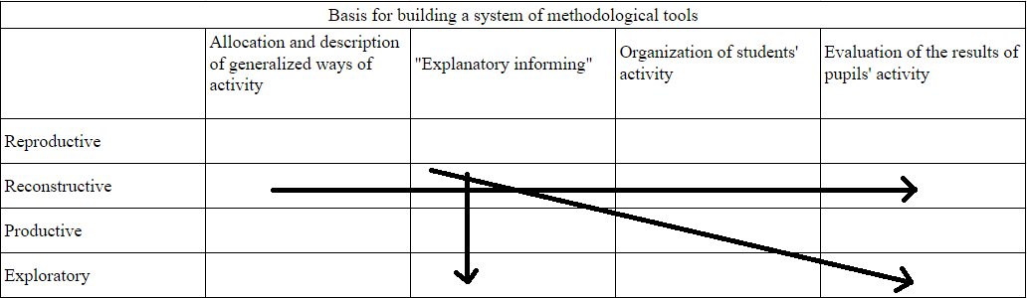

Formed in this way, methodological tools are based on the variety of content outlined in the curricula of relevant courses and can be applied in any logically justified sequence. In the table, some of these sequences are illustrated by special arrows. The key methodological tools relevant for the organization of students' independent educational and professional activity are self-execution tasks filled with flexible content. It is important that these tasks cover the full cycle of activity - from comprehension of the task to analyzing the achieved results. According to the competence approach, the tasks should include the determination of the significance (especially professional) of knowledge and skills acquired in the process of independent work.

For illustration, let us give an example of the development of the above-mentioned methodological tools used in the study of the course "Theory and Methodology of Teaching Mathematics". Each tool usually contains an assignment for independent work and recommendations for its implementation and evaluation.

Assignment: Develop a methodology for explaining the trapezoidal center line theorem that addresses a variety of learning objectives. The proposed self-performance task aims to realize "informational explanation" for students at the producing level of activity. This level requires the development of different approaches to the presentation of the teaching material (theorem about the midline of the trapezoid) in accordance with certain goals, which the student must independently identify. In the process of creating such tasks, it is allowed to change the mathematical data used to perform the corresponding work. Any element of the theory or a problem reflecting a specific type of mathematical problems can be chosen as such material.

When students begin to work independently on the assignment, they are provided with detailed guidelines for conducting the learning and professional development activity. These guidelines are divided into four main sections: strategic planning; recommendations for implementation; a list of materials needed; and criteria for evaluating the work completed. The first section emphasizes the objectives of the assignment and provides guidance for developing an action plan. The second section provides advice on how to complete and design the assignment, including examples of how to address the most challenging aspects. The third section specifies what resources (including print and electronic) will be needed to successfully complete the assignment. The fourth section assumes the student's self-analysis of the significance of the completed work from the point of view of his/her professional development and offers criteria for evaluation of the work by the instructor. Let us present a sample of instructions for the performance and evaluation of the considered assignment.

Strategic Planning

Consider that the assignment involves creating several (at least two) interpretations of the trapezoidal midline theorem, depending on the objectives set by the teacher. Identify the various objectives for learning this theorem, each with its own unique educational significance. Develop and present each variation of the explanation of the theorem that corresponds to each of these objectives. Prepare either a computer presentation or a written report demonstrating the different approaches to the explanation, and explain how each one corresponds to the objectives you have identified.

Implementation Recommendations

Consider the different categories of educational goals in mathematics when selecting potential objectives for studying this topic. Identify objectives for learning this theorem, connecting them to each of these categories.

Examples of goal statements:

* illustrate the possibilities of different methods of proving the mathematical statement contained in the theorem and identify the most comprehensible one - an educational goal;
* to stimulate the use of analogies and visualization to find the mathematical statement and its conclusions - developmental goal;
* to train attention and observation in the process of mastering a mathematical statement – educational goal;
* to develop the ability to apply mathematical knowledge in practical situations - educational goal.

Familiarize yourself with the different methods of proving the trapezoid midline theorem from the suggested sources. Evaluate whether it would be appropriate to use different methods of proof to achieve different goals, or whether one approach is sufficient.

Present the different ways of stating the theorem in the following order:

1) the stated purpose of studying the theorem;

2) the chosen method of stating the theorem;

3) methodological remarks on the application of this method.

Note: If a computerized presentation is prepared, it should be submitted to the instructor on an electronic medium and in printed form.

Additional questions for reflection:

What conclusions can be drawn from the statements of the midline theorem of a trapezoid?

What types of problems are commonly solved using this theorem?

What other theorems is the trapezoidal midline theorem associated with?

Which statement can be considered an extension of this theorem?

Which source first described the fact known today as the trapezoidal midline theorem?

What professional skills did you develop by completing this assignment?

What aspects that you have learned and mastered in the course of this assignment would you apply in teaching your students?

Required sources

It is recommended to use geometry textbooks that are part of the approved Federal List for general education institutions. In addition, it will be useful to familiarize yourself with additional educational materials on geometry, especially in the part concerning planimetry. As digital resources, it is suggested to pay attention to the website https://ocw.mit.edu/(https://ocw.mit.edu/) and its specialized section on algebraic geometry https://ocw.mit.edu/courses/18-726-algebraic-geometry-spring-2009/, as well as to the educational platform https://www.edx.org/, which is an integrated set of digital learning resources.

Criteria for assessing the work

An assignment is considered effectively completed if it meets the following criteria:

* at least two different methods of presenting the theorem are presented, each of which corresponds precisely to the specific objectives of its study;
* the assignment material is neatly and clearly organized, regardless of its format (whether printed or electronic);
* at least two-thirds of the supplementary questions in the final part of the paper are answered.

Examples of similarly structured tasks designed for the training of future elementary mathematics teachers are described in the study.

In the context of organizing students' independent work, two main methods stand out:

1) development of new individual assignments;

2) refining existing assignments by adding methodological guidelines and accompanying recommendations for their implementation.

The methodological resources discussed above are currently mostly in the form of traditional printed publications. However, a promising direction for further improvement and expansion of the system of methodological support of independent educational and professional activity of students can be the development and implementation of multimedia methodological materials.

## **1.2 Development of methodological skills of future teachers of mathematics in the course of mastering mathematical subjects**

The main goal in training future teachers of mathematics is to develop a wide range of pedagogical skills. According to A.S. Mikhailov, a well-known expert in the field of education, academician of the Russian Academy of Education, "In connection with the dynamics of methods of teaching mathematics, social transformations and the emergence of innovative approaches in education, the question of equipping future teachers with modern methods and techniques that they could not only use, but also develop becomes relevant". This task should be solved both in the process of teaching the theory and methodology of teaching mathematics and in the study of mathematics itself.

Research in the field of pedagogy identifies three categories of methodological skills of a mathematics teacher developed in students during courses on the theory and methodology of teaching mathematics and during pedagogical practice. In addition to these skills, it is also important to develop methodological skills closely related to subject knowledge. Let us examine them in more detail. In the context of the concept of learning, a skill is defined as a learned action, the level of mastery of which can be different. Learning activity includes special learning and cognitive actions, which, firstly, are predominantly intellectual; secondly, have a dual character. On the one hand, these are actions arising from the subject of study. For example, in mathematical analysis it can be calculation of the limit of a sequence or function, determination of the derivative of a function of one variable, integration of a function of two variables, analysis of a numerical (functional) series for convergence. These actions are usually called subject-specific. On the other hand, there are actions of general educational and cognitive nature, not directly linked to a specific discipline, but necessary for teaching various subjects. Such actions include analysis and synthesis, comparison and classification, justification and categorization, and others. These general learning and cognitive actions are also included in the number of methodological skills.

As Prof. V.A. Petrov said, in order to effectively form learning actions, it is necessary to bring them in line with the features of a particular educational subject. He also emphasized that learning skills should be developed on the basis of practical application of actions in the course of long-term study of specific "subject knowledge". This approach confirms the need to integrate methodological (learning and cognitive) skills with the study of mathematical disciplines in the process of education in pedagogical universities.

In the process of development of learning and cognitive abilities there are three main levels:

1) reproductive;

2) adaptive, where skills are used in similar contexts;

3) innovative, where skills are applied in unusual and innovative situations.

Let us look at examples of concepts and theorems from the field of mathematical analysis, the study of which contributes to the development of pedagogical skills (Tables 2 and 3).

Table-2.

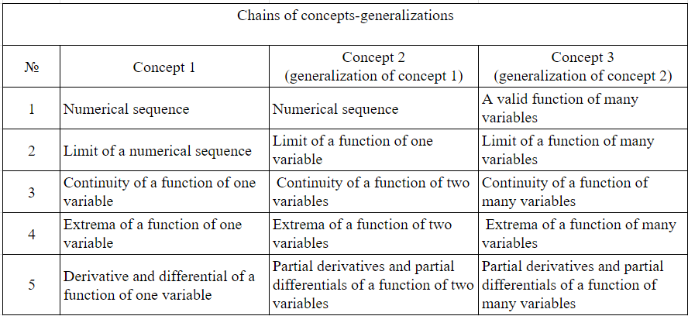

Table-3.

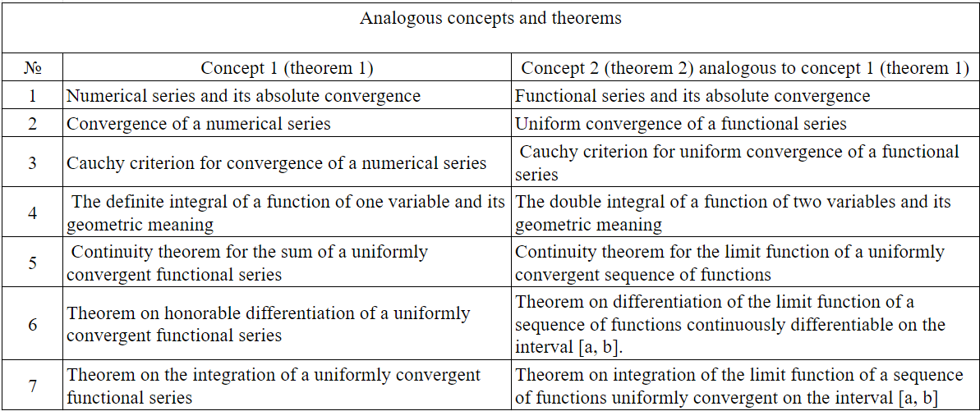

The task of developing pedagogical skills in future mathematics teachers in the course of mastering mathematical disciplines is becoming more and more urgent due to the fact that in modern school teaching there is a fusion of teaching methods with scientific approaches inherent in the subject. In an era when the amount of knowledge required for modern man is increasing rapidly, the task of providing students with in-depth knowledge and skills is complemented by the need to develop their broad intellectual potential, a key element of which is the ability to think creatively.

Therefore, teaching methods aimed not at simple provision of ready-made knowledge, but at independent research and assimilation of new knowledge acquire significance. As pointed out by V.S. Kuznetsov: "The important development of teaching methods in a particular academic discipline passes through the preparation of students to use approaches characteristic of this sphere of knowledge in combination with the assimilation of basic concepts, laws, theories, concepts and facts". In mathematics, such unique methods include, for example, axiomatic approach, algebraic and geometric methods, the method of mathematical modeling. The mastering of these methods is closely connected with the process of learning in pedagogical universities.

The coverage of the content of methodological training of mathematics teacher candidates, which takes place during lecture classes, practical exercises and during the period of independent study of mathematical analysis, a key subject in the mathematics teacher education program, deserves detailed consideration. In this context, it is useful to identify critical aspects of the teaching and individualized learning of this discipline.

1. The following points should be considered in the context of lecture classes:

1) The introduction of new concepts, theorems and techniques should be accompanied by increased motivation, which helps to activate student interest;

2) When defining concepts or theorems, it is recommended to offer students a multilingual approach: verbal, symbolic and geometric, the last of which includes geometric representation and explanation of concepts and theorems;

3) During theorem justification, students should be provided with tasks such as formulating and verifying inverse statements, analyzing the sufficiency and necessity of conditions with examples, demonstrating the structure of the proof of a theorem and highlighting its key idea; similar tasks can be offered for independent work;

4) When introducing new concepts and theorems, it is desirable to point out the similarity with what has been previously studied, asking students to form similar definitions or proofs on their own;

5) When introducing new methods of problem solving, it is necessary to emphasize the key steps of these methods or develop algorithms suitable for their implementation; it is also worthwhile to offer students similar tasks for individual work;

6) It is advisable to involve students in tasks aimed at deep analysis and concretization of the studied material, teach them to formulate appropriate examples;

7) Incorporating historical information and biographies of mathematicians into lectures can be useful, and students can actively participate by presenting short reports on the chosen topic;

8) The use of multimedia in the presentation of material is recommended where appropriate, showing students a model for later use in school practice.

2. Practical classes emphasize the consolidation of theoretical concepts learned by students in lecture courses, as well as practicing techniques and methods of solving certain types of problems. This process also includes additional deepening of the concepts presented in the lectures through:

* recognizing and identifying objects corresponding to a particular concept in different forms of representation, including analytic and geometric;
* extracting and analyzing the implications arising from the belonging of an object to a particular concept, especially when it is represented in geometric or analytical forms;
* realization of solutions to exercises and problems emphasizing the use of a given concept.

The stages of concept development during the study of mathematical disciplines at university contribute to the formation of a certain methodological approach in students, which they will later apply to the structuring of mathematical concepts in school teaching, although this approach may not be explicitly expressed. In the courses of theory and methodology of teaching mathematics in the third year, students get acquainted with this approach in detail, consolidate it and apply it in practice.

The second essential element of students' methodological training in mathematical analysis classes concerns the study of problem-solving techniques, in particular, mastering the sequence of steps for solving problems. The main criteria that students must meet when solving problems include the ability to:

1) conduct a comprehensive analysis of the problem at hand;

2) evaluate and choose the most logical of all the proposed solution methods;

3) argue each step of the solution based on the relevant theoretical provisions;

4) formulate the key conclusions obtained as a result of solving the problem;

5) develop problems similar to the one under discussion and solve them using the comparative method;

6) provide supporting or refuting examples for a specific statement;

7) identify and describe the components of a more complex problem;

8) show the relationship of the task under consideration with other tasks, etc.

In addition to traditional problems from textbooks and problem books, students should be engaged in solving test tasks. This will provide them with preparation for the use of tests in the school environment. It is known that in 2012-2013 the emphasis on knowledge testing in pedagogical higher education institutions increased. The introduction of the Unified National Testing (UNT) in mathematics in test format stimulated the expanded use of tests in school education. Test testing of schoolchildren began to be considered as a preparatory stage for the UNT. This necessitated the study of school tests at the university and the development of future teachers of mathematics competencies in creating and using different types of tests in mathematical disciplines.

At present, various Internet resources are actively used to assess knowledge, including online examinations and virtual Olympiads. In parallel, innovative educational methods are gaining popularity in higher education, such as the teaching system based on the block-module approach and the methodology of rating assessment of student activity, where testing plays the role of a key element of the evaluation system. It is important to note that mathematics education in pedagogical universities is characterized by its uniqueness. Unlike technical universities, it involves combining mathematical knowledge with students' methodological skills. In this regard, the process of developing the structure and content of test tasks in pedagogical universities has its own peculiarities. For example, at the initial stages of teaching, tests in mathematical analysis are classified into different categories.

The first category includes answer choice tasks, which are aimed at checking the mastery of definitions, terms and theorems. This category includes questions like, "Is the statement true...?" or similar, such as:

1. Is the statement "The product of a finite sequence by an infinitesimal sequence is equal to an infinitesimal sequence" true?

2. Is the statement "The difference of two infinitely large sequences is equal to an infinitely large sequence" true?

3. Can there exist a monotonically increasing unbounded sequence that is not infinitely large?

These questions can be used not only to test knowledge, but also for active discussion in practical classes, where students offer answers orally, arguing them or giving counterexamples. This approach helps students to develop the skill of clear and precise expression of mathematical thoughts, which is an important aspect of professional training of future teachers.

The second category of tasks requires students to give examples of mathematical objects that meet certain criteria:

1. Give an example of a bounded divergent sequence.

2. Name an example of a sequence increasing and tending to the number 2.

The third category focuses on tasks related to mastering mathematical symbolism, such as:

1. Formulate the definition of a sequence convergent to the number a using the symbols E (exists), A (any). Give an example of such a sequence.

2. Describe the definition of a bounded sequence using the symbols E, A. Give an example of a bounded sequence.

Students are also given tasks to relate concepts to their symbolic definitions.

The fourth category includes tasks to determine logical connections between statements, such as:

"Make logical connections ("follows") between the given statements. Justify each connection with a reference to a theorem or a proof:

(1) - the sequence is infinitely large;

(2) - the sequence has no limits;

(3) - the sequence diverges".

A separate group of assignments are those that include geometric elements or descriptions in geometric language. These tasks are divided into two types: some of them require to reveal the geometric meaning of a concept, theorem or formula; others require to define a geometrically depicted object by a formula or to check the validity of a statement using a graphical representation.

In general, all these tasks are aimed at understanding the studied definitions and theoretical statements, at the formation of skills to apply them in solving problems, to make reasonable inferences, to use analogies, generalizations, concretization, to give appropriate examples and counterexamples. The development of such skills is an integral part of the training of future teachers of mathematics.

3. There is an increase in the importance of individual work of students in pedagogical universities in recent times. When studying mathematics at the undergraduate level, independent work occupies a significant part of the learning process, reaching 38-45%. This form of learning is a continuation of the work started in lectures and practical classes. Preference is given to problem solving, which makes it advisable to use personalized and level-differentiated tasks with subsequent analysis. In the process of such analysis, not only the correctness of task fulfillment is evaluated, but also the student's ability to clearly present the solution on the basis of the studied concepts, theorems and methods.

At the initial stages of undergraduate studies, the performance of individual, check and test tasks promotes self-analysis and evaluation of the effectiveness of independent work, contributing to the development of students' skills of self-control, self-assessment, reflection and correction of their own actions. Over time, students master methods of independent learning, which will be useful to them in the future, contributing to the formation of independence as a significant personal quality.

"Week of Mathematical Creativity" in pedagogical universities provides a unique opportunity to combine mathematical and methodological skills of students. Within its framework various events can be held:

1) Olympiads in higher mathematics;

2) scientific conferences of students with reports on their research in the field of mathematics or methodology of its teaching;

3) thematic days devoted to the history of mathematics, including competitions of essays, presentations, speeches about famous mathematicians and quizzes;

4) intellectual games, such as math brainteasers;

5) days focusing on methods of teaching mathematics, including testing, defense of methodological projects and demonstrations of teaching sessions;

6) debriefing and award ceremonies.

Modern technologies, including multimedia tools and computer programs, greatly expand the possibilities for effective implementation of such events.

Preparation for the "Week of Mathematical Creativity" allows students to deepen their knowledge both in the field of mathematical disciplines and in aspects of the theory and methods of teaching mathematics. They also gain experience in organizing and conducting such events. Recently, more and more attention is paid to the integration of mathematical and methodological knowledge and skills of students of pedagogical universities at the All-International Olympiads in mathematics and methods of its teaching.

Thus, the process of studying mathematical disciplines in a pedagogical university contributes to the formation of students' methodological skills that meet modern requirements. Methodical approach to the study of mathematical courses and organization of independent and research work improves the quality of students' mathematical education and strengthens its professional orientation.

## **1.3 Specificity of development of teaching material on mathematical subjects in pedagogical higher education institutions**

The electronic database, including the list of educational programs of higher and postgraduate levels, developed by educational institutions of the Republic of Kazakhstan and successfully passed an objective external evaluation organized by the Center for the Bologna Process and Academic Mobility, is the main tool in the field of education. The examination often reveals various problems in the content of the programs, including inconsistencies in the list of disciplines, stated objectives and expected learning outcomes. Learning outcomes are often vague and difficult to measure. In addition, there is a gap between the duration of studies and the number of credits prescribed by the national standards of higher and postgraduate education in Kazakhstan.

The main task of educational reforms in Kazakhstan is to adapt the educational system to changing socio-economic realities. In accordance with the principles of the credit system of education and the program of updating the content of education, higher education institutions are faced with the task of cultivating independence among students, which allows educational institutions to create educational programs that take into account the individual characteristics of students. The modern approach to mathematics teacher training in pedagogical universities implies a complex combination of different directions: methodological, professional-pedagogical, focused on general academic and socio-political disciplines, professional-pedagogical, with an emphasis on psychological and pedagogical disciplines, mathematical and practical within the framework of methodological training.

The key aspect of professional and pedagogical work of a future teacher of mathematics is its equipping with the latest achievements in the field of pedagogical and the latest information and communication technologies. Education of pedagogical specialists in Kazakhstan is conducted in accordance with the criteria of state standards of higher pedagogical education (see table-4). According to experts, the revision of standards that took place in 2008, 2012 and 2020 in order to optimize the educational process and includes changes in the volume of credits for each academic discipline, has a negative impact on the methodological support of curricula. This leads to a decrease in the requirements for students' skills and competencies, their professional competencies and the quality of training focused on mastering the future profession.

Table-4.

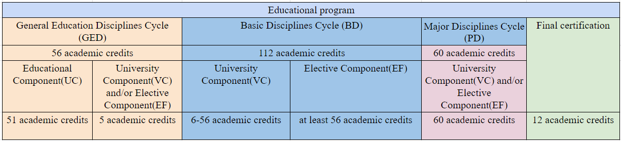

The creation of curricula for university and postgraduate studies is carried out within the framework of professional tasks and covers a range of subjects, the choice of which depends on the objectives, core competencies and intended outcomes of the educational process. These programs must meet the criteria of the National Education Standard (NES), including the requirements for the minimum amount of academic credits distributed in different academic units and modules, according to the direction and level of study.

The Professional Standard "Teacher" developed by the Kazakhstan Association of Entrepreneurs "Samruk" serves as a foundation for the formation of educational programs and modules for teachers, preparation of test materials for teacher certification and establishment of criteria for their qualification at various levels. The professional standard covers five key labor functions:

1) Teaching;

2) Educating;

3) Methodological;

4) Research and development;

5) General communicative.

The concept of professional standard is based on the model of a modern teacher, which is the basis for the development of training programs for the new generation of specialists. Professional training of a teacher of mathematics is considered as his/her readiness for pedagogical work, including knowledge, skills and abilities in the chosen specialty, personal qualities, ability to pedagogical activity and aspiration for continuous self-improvement. In this context, the order of the Ministry of Education and Science of the Republic of Kazakhstan "On the regulation of the educational process on the credit system of training" dated April 22, 2014 № 153, modifying the previous order dated October 21, 2019 № 564, which defines the basic educational program (Major) as the student's choice for the development of key competencies, was adopted.

The main indicator of the quality of future teachers' preparation for professional work is their professional competence, the achievement of which occurs through a purposeful educational process. The university should provide the future teacher with the necessary knowledge and skills for his/her professional career. To determine these requirements, it is important to understand what tasks the specialist will face and what skills he/she will need for successful work.

The formation of professional orientation in students occurs in the process of studying the disciplines of the educational program, through stimulating their interest in the material in the context of its importance for the future profession. The content aspect of professionalism emphasizes the need to integrate a specific course of mathematics with the corresponding school subject. Realization of this connection contributes to a holistic perception of the course, helps students to see the prospects of its study, which in turn contributes to a deep understanding of the learning process. This approach was described by A. O. Merdkivich as the principle of the leading idea.

The educational program "Mathematics" at the undergraduate level is based on six key academic disciplines that expand and deepen school knowledge in mathematics: elementary mathematics, mathematical analysis, algebra and number theory, analytical geometry, probability theory and mathematical statistics, and mathematics teaching methods.

In creating the mathematics curriculum at the Eurasian Scientific University, named after L.N. Gumilev, a wide range of content aspects have been taken into account. From the very beginning of the curriculum, the fundamentals of mathematics are closely intertwined with how it is taught at the university level. In the beginning semester, students are immersed in learning the key elements of basic mathematics, which is an integral part of more advanced mathematics courses. The integration of basic and advanced aspects of mathematics, proposed by scholars such as M.V. Pitutsky, A.G. Khemev, and Y.M. Kelyagon, promotes ease of learning and assimilation of new concepts, strengthening the link between the beginning and advanced levels of the discipline.

Throughout their studies, students systematically return to previously studied topics, analyzing and summarizing key ideas. Such a method not only maintains interest in mathematics, but also dispels misconceptions that higher mathematics is unnecessary for future school teachers.

The key idea approach creates a connection between school and university mathematics programs and between theory and practice in the mathematics teaching profession. This method enables students to see the connection between the topics they are learning and their practical applications, allowing them to compare different ways of presenting and understanding mathematical concepts.

The importance of repetition and propaedeutics in professional training in mathematical disciplines is key. Repetition of material at university helps to deepen understanding of mathematical structures, reinforcing what is already known and building new knowledge. During lectures and practical classes, special attention is paid to examples and theorems already familiar to students from the school curriculum, making it easier to master new mathematical concepts.

Propaedeutics in university mathematics courses requires careful and thoughtful work that students must master in practice. It fulfills a dual function: it helps in learning the discipline and teaches the methods of propaedeutic approach, which can be realized through lectures and intuitive use of terms before they are fully defined.

The main role in the training of future teachers of mathematics is assigned to elementary algebra and geometry. These disciplines not only continue the key topics, but also give students the opportunity to rethink the methods and ideas of mathematics at a new, higher level, taking into account school tasks. In addition, they lay the foundation for the methodological training of future teachers and are closely related to the discipline of teaching mathematics. The need for propaedeutics in basic mathematics courses is due to the insufficient mathematical preparation of freshmen and the gap between school and university programs.

The challenge of teaching these subjects is to create a link between school knowledge and university courses: it is necessary to refresh and systematize knowledge in arithmetic, elementary algebra and geometry, and the analytic section, and to stimulate interest in further study of university subjects. It is important to study number systems in the algebra and number theory course, including concepts of number groups, rings and fields, as well as the basics of divisibility of integers and polynomials. At the same time, the algebra and number theory course should not be reduced to the level of elementary algebra. From the very beginning, students should familiarize themselves with basic algebraic structures through practical examples. In addition to number groups, it is appropriate to study substitution groups. It is also important that the process of formation and development of concepts through mathematical structures corresponds to the actual historical process of the emergence of these concepts, an approach known as the genetic method or the principle of historicism proposed by many mathematicians.

Effective human intellectual development is achieved by going through the mental development of the whole of humanity, focusing on its key stages rather than on numerous small errors. Failure to adhere to this principle can lead to difficulty in learning math and misunderstanding of the material. In modern universities, students are immediately presented with complex and developed concepts of mathematical analysis without giving them the opportunity to see the evolution of these concepts and the process of their creation. This is one of the main reasons for difficulties in learning mathematics.

In the context of professional training of future teachers of mathematics, such disciplines as "algebraic numbers", "basics of geometry", "constructive geometry", "lattice theory", "abstract algebra" and others, rarely found in university programs, are significant. Some university courses in mathematics, important for application in other sciences but not related to the school program, are either not taught in teacher training institutions or are taught for other purposes. For future teachers it is important not only to study differential equations, but also to understand their connection with the need to deepen the already studied sections of mathematical analysis. Therefore, the program of the course "differential equations" should pay attention to questions based on the use of already studied sections of mathematical analysis.

Algebraic concepts such as vector spaces, groups, fields, rings and others are important for the teacher's mathematical education. The study of these aspects allows for effective repetition and reinforcement of knowledge in the discipline of algebra and number theory. This course combines basic algebraic, ordinal, and topological structures and provides a foundation for the professional work of the teacher in schools, where the study and application of numbers is central. In this course, students should view school mathematics from a new angle, assess its rigor, identify and address gaps in school knowledge, and transform intuitive understanding of various numbers into knowledge based on sound provable axioms.

Innovative teaching models include the technological aspect of mathematics teacher's professionalism, as noted in the works of Baspelko P.B. and Mynikhev V.t. This aspect is an integral part of mathematics training. As emphasized by S.G. Mardkevach, an important condition of professional and pedagogical orientation is the principle of binarity, combining scientific and methodical aspects of training. According to this principle, a set of mathematical disciplines in pedagogical university should provide not only a high level of mathematical culture and extensive knowledge of mathematics, but also familiarity with the ways of teaching the school course of mathematics.

The technological element in mathematics education requires the sequential inclusion of all mathematics courses in the process aimed at achieving students' qualification in pedagogy. This ensures the transition of students from the role of learners to the position of teachers, gives their mathematics training a strong creative component and motivates them to master individual elements of technology. The importance of studying mathematical disciplines for the development of mathematical thinking has been noted by many educators, including L.A. Vegetsky, A.U. Abelkisymova, A.U. Kegizbaeva, E.E. Smegulev, B. Beimekhanov, U.E. Deuletkelova, U.V. Bakbelganova. In this context, the individualized approach to learning is related to the principle of developmental learning, which requires that the complexity of the learning process corresponds to the "zone of nearest development" of the student's cognitive abilities, and also takes into account unique personality traits and psychological aspects related to the stages of intellectual development. As part of the research for the dissertation, the curriculum for the specialty "Mathematics" was analyzed in the universities of L.N. Gumilev Eurasian National University and Kazakh National Women's Pedagogical University. The authors of the study conducted a SWOT-analysis of the training program for future teachers of mathematics at L.N. Gumilev Eurasian National University.

The purpose of the SWOT-analysis was to identify and actively develop positive aspects of the curriculum, minimize its shortcomings and make optimal use of favorable conditions for improving the program, including methodological aspects of teaching. SWOT analysis combines both analytical and planning functions, taking into account uncertain factors. The factors considered in a SWOT analysis are categorized into four groups: advantages and disadvantages, opportunities and risks. The acronym SWOT is formed from the first letters of the English terms Strengths, Weaknesses, Opportunities, Threats and was introduced in 1965 by Professor Caenat Yendres of Harvard University. Strengths and weaknesses refer to the internal environment of an entity on which it can have a direct impact. Whereas opportunities and risks related to the external environment are often beyond the control of the object being analyzed. After the introduction of updated educational content in Kazakhstan, SWOT analysis started to be applied in the educational sphere as well. This analysis is conducted by filling in the relevant sections of the matrix and due to its simplicity and universality, it is used as a starting point for the development strategies of the analyzed objects, including educational institutions and specialists. Table 5 shows the results of SWOT-analysis of the educational program in the specialty "Mathematics".

The study of the updated mathematics course and modern teaching and learning materials used in current educational institutions makes it possible to identify certain competencies that meet the criteria of mathematical learning for students. In order to effectively transfer these competencies to students, the mathematics teacher must himself possess them at a high level. Graduate students aspiring to become mathematics teachers need to master a wide range of mathematical and methodological disciplines, where hands-on activities and individual student work play an important role in order to acquire the skills necessary for high school teaching. In the process of learning new concepts, topics, and units, it is important to provide sufficient hands-on exercises to repeat what has already been learned, to deepen understanding and organize the material, and to explore the relationships, similarities, and differences between old and new content.

Table-5.

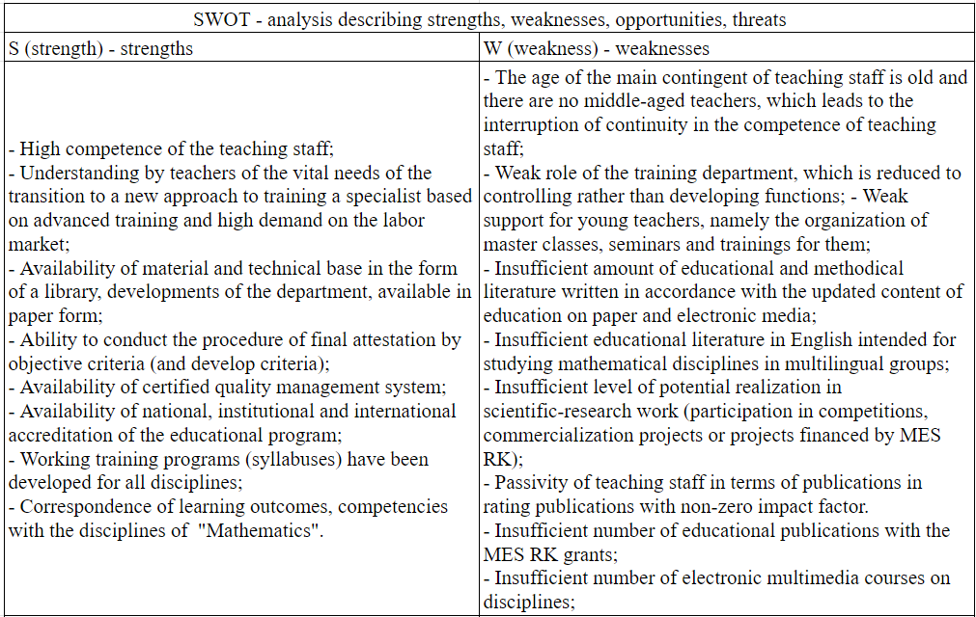

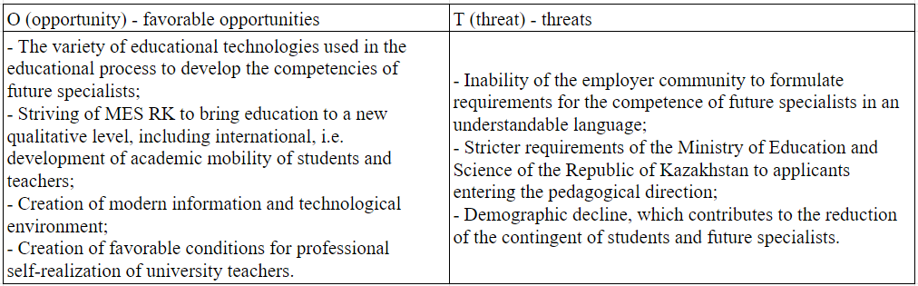

Incorporating secondary school content into the teaching of mathematics at a teacher education institution is a critical element of mathematics teacher education, as it provides students with the opportunity to demonstrate the level of skills needed to successfully interact with students. The perception of the profession of a mathematics teacher should include an understanding of both the history of the development of this specialty and its methodological issues, as well as its practical application.

Having analyzed the curriculum "Mathematics" (2019-2022) for the direction "Teacher Training in Natural Sciences" in L.N. Gumilev Eurasian National University, a significant decrease in the number of hours (credits) for mathematics and methodology courses was revealed. This is confirmed by the data presented in Table 6. For example, if earlier the course "Mathematical Analysis" lasted four semesters, now it was reduced to three semesters; the course "Algebra and Number Theory" was previously studied for two semesters, now – only one. Methodology courses such as Methods of Teaching Mathematics, Practical Mathematical Problem Solving, and Methodological Foundations of Mathematical Problem Solving were also reduced from two semesters to one. Such a reduction in the volume of both methodological and mathematical disciplines and corresponding credits leads to the deterioration of the quality of professional training of future teachers of mathematics.

Table-6.

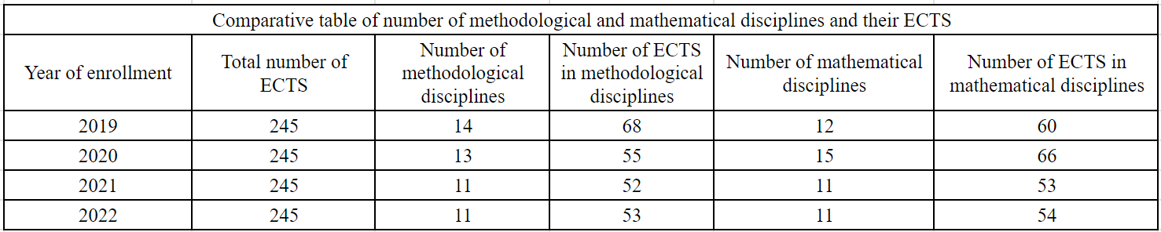

The educational program study investigated aspects of the mathematics and education sciences and identified key student skills and achievements. We developed a detailed description of each course, highlighted the skills developed and the learning outcomes, categorizing them into the following categories:

1. Increased pedagogical knowledge through the study of the mathematical sciences;

2. Expansion of pedagogical knowledge through the mastery of educational sciences;

3. Expansion of pedagogical knowledge through innovative methods.

In Table 7 we present examples of courses with their brief characteristics, skills developed and intended learning outcomes, according to the highlighted categories. All of these courses contribute to the professional development of future math teachers in the context of innovative methods.

For example, starting in 2019, the module "Novel Educational Content" was included in the curriculum of the Bachelor's degree program in Mathematics, which includes the following educational courses:

* Criterion-referenced assessment techniques;
* Methods of teaching mathematics in the framework of inclusive education;
* Fundamentals of teaching mathematics using different levels of programs;
* Improving students' functional literacy;
* Planning and delivery of math lessons;
* Innovative learning and teaching methods.

Table-7.

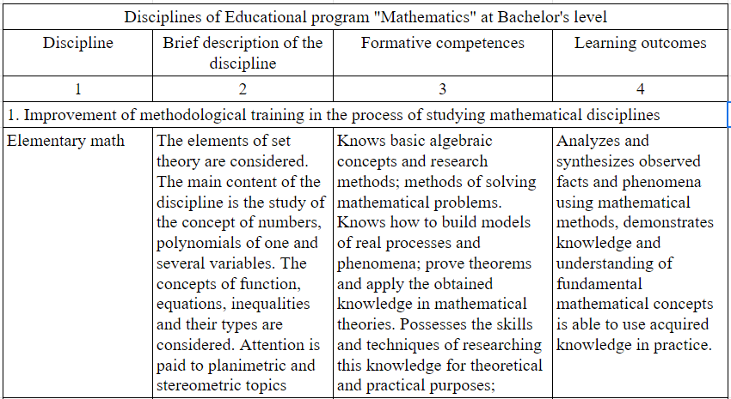

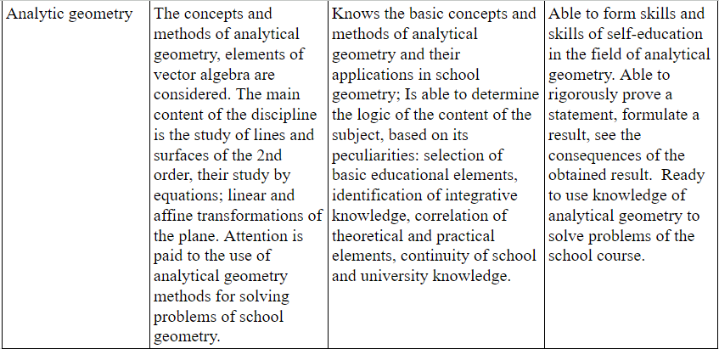

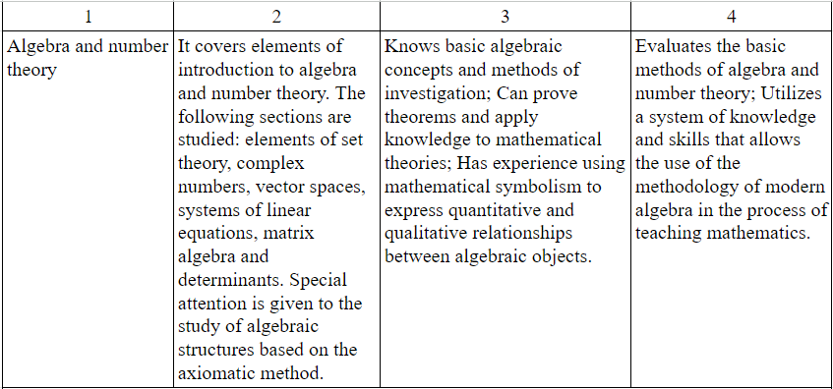

Continuation of Table-7.

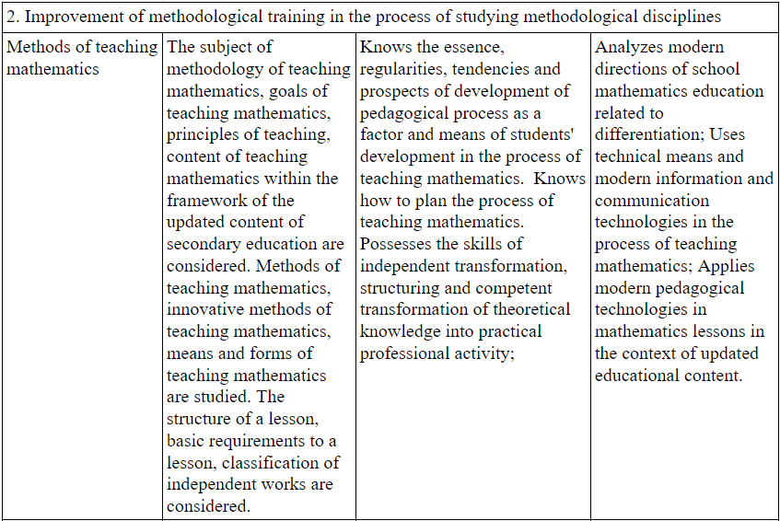

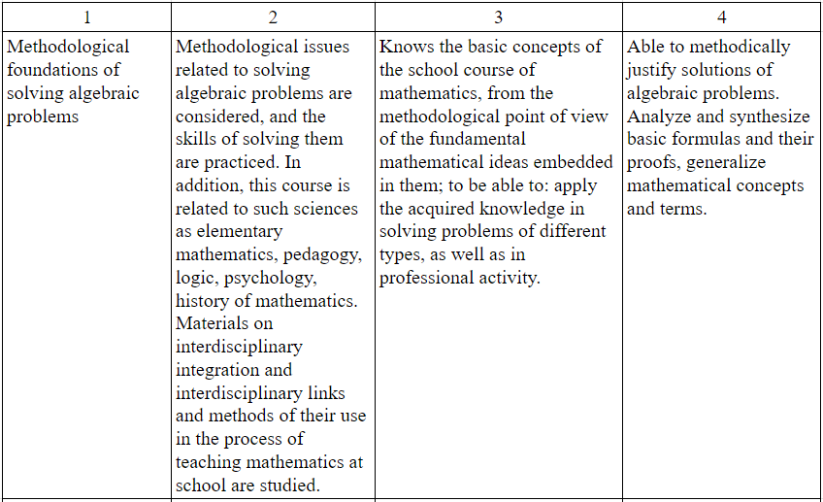

Continuation of Table-7.

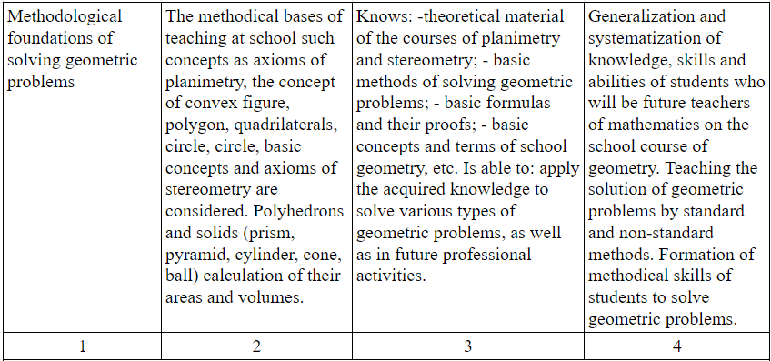

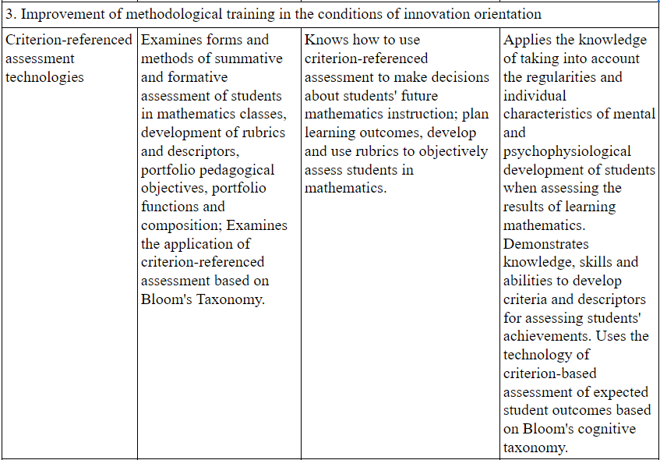

Continuation of Table-7.

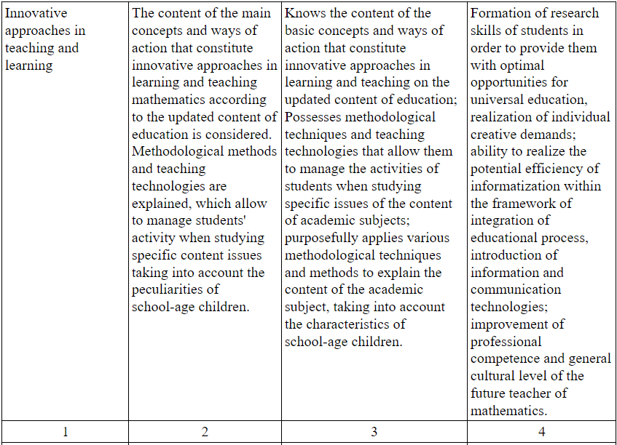

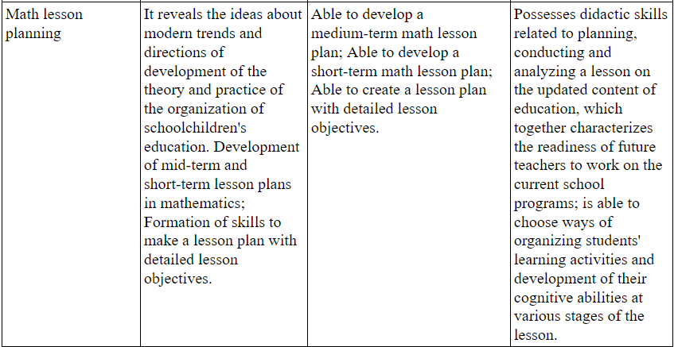

Continuation of Table-7.

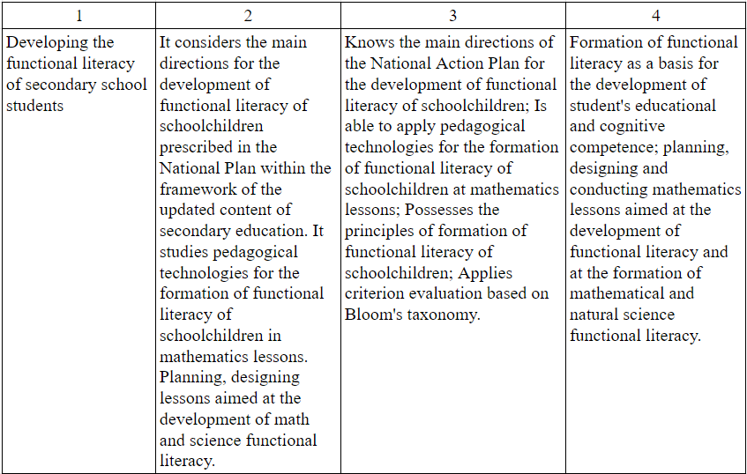

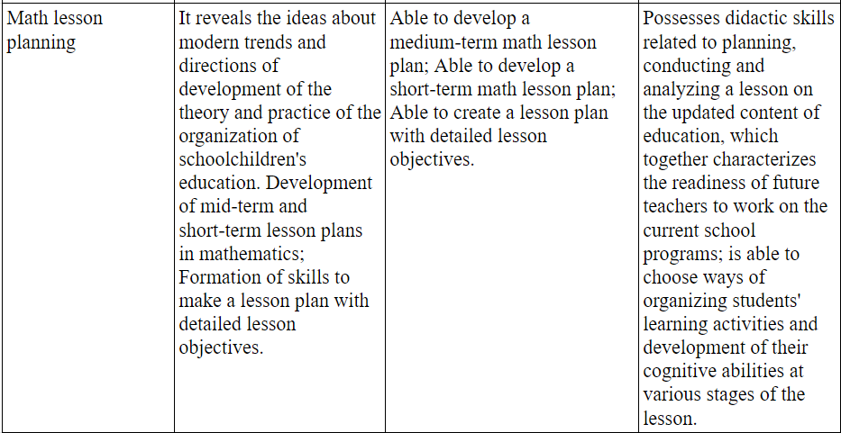

This module corresponds to the main parameters of modern educational content and is a key element of methodological training of future teachers of mathematics. Table 8 shows the scheme of "criteria of the latest educational content".

Mastering the above categories will give the future specialist the opportunity to:

* To teach and educate students, observing the basic principles of the latest educational content;
* Use mathematical knowledge for orientation in the world of modern information technologies;
* Master and actively apply methods of developing critical thinking and assessing intended learning outcomes based on Bloom's Taxonomy.

A math teacher must possess qualities such as impartiality, integrity, fairness, perseverance, critical thinking, responsibility, and passion for the work in order to pass these same qualities on to their students. Therefore, a math teacher has a special role in the moral and ethical education of the next generation. The importance of the pedagogical mission lies in combining mathematics education with the professional needs of the students and in bringing this connection to their awareness. The student must understand that each mathematics course is closely related to its practical application and to the solution of specific problems of school mathematics at a higher level.

The study of current curricula, advanced methods and achievements of mathematics teachers, taking into account the requirements of general education and professional standard "Teacher" lead to the conclusion that the requirements for the results of mastering educational programs in the specialty "Mathematics" should cover a universal set of competencies (mathematical, psychological, pedagogical, methodological) necessary for compliance with state educational standards and success in learning activities. It is especially relevant to deepen the principle of fundamentality in education in accordance with the concept of thorough approach to determine the content, structure and methodology of training of future teachers.

Table-8.

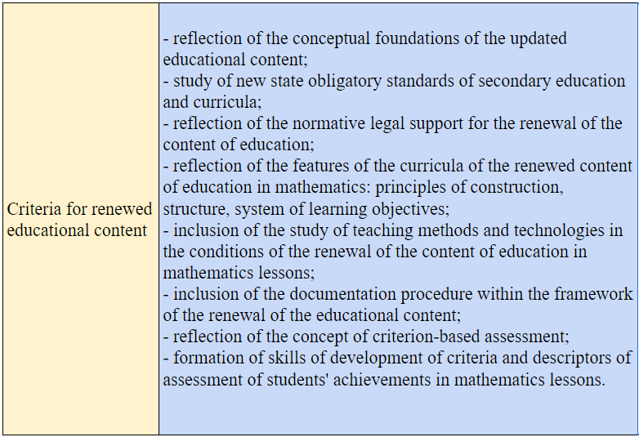

# **2 PRACTICAL COMPILATION OF METHODOLOGICAL SUPPORT OF THE DISCIPLINE "PROBABILITY THEORY AND MATHEMATICAL STATISTICS" FOR STUDENTS OF THE SPECIALTY "MATHEMATICS"**

## **2.1 Modern tendencies and the role of teaching Probability Theory and Mathematical Statistics to future teachers of mathematics**

*Сurrent directions in teaching the application of probability and statistics in practice*

The mathematics teacher of the future must have in-depth knowledge in their specialization. Quality teacher training implies not only an excellent command of the subject, but also an awareness of the latest scientific advances in the field and their necessity in modern society. While applied statistics and probability calculus stand at the forefront of the most exciting and important fields of science, they are also considered among the most difficult to master. As such, it is imperative when teaching it to develop an effective course structure within the context of the curriculum, and to demonstrate the relevance of the knowledge and skills being acquired, given the current trends in society.

For a thorough understanding of probability calculus, several key conditions need to be formed. First of all, a strong mathematical foundation in students is necessary. On the one hand, understanding mathematical concepts and the ability to apply them are critical for calculating probabilities of a variety of events, analyzing the characteristics of random variables, and the like. On the other hand, probability calculus is unique in that, as part of mathematics, it integrates virtually all of its sections, creating a kind of intellectual mosaic. This field provides a unique opportunity to understand the comprehensiveness of mathematics, the interrelationship of its various aspects, and its practical value in describing real-world phenomena.

Another important aspect is the creation of conditions for mastering terminology. It is advisable to explain each term not only using formal mathematical language, but also to illustrate it visually with real-life examples, emphasizing the conditions of application of each rule or method through problem solving. It is also useful to include in the training a discussion of various paradoxes of probability. Such examples are usually well-rehearsed and contribute to deeper learning of the material.

Additionally, it is useful to use modern technology and interactive teaching methods to enhance the learning process. Incorporating computer programs and applications that allow visualizing and simulating statistical processes and probability calculations can significantly improve the understanding of the material. Combining theoretical knowledge with practical skills through project work, group research and case methods also contributes to a deeper immersion in the subject and the development of analytical skills in students.

In conclusion, it is important to emphasize that teaching probability calculus and statistics requires an integrated approach that includes both traditional and innovative teaching methods. This will allow not only to form the necessary theoretical base for students, but also to develop their practical skills, critical thinking and the ability to apply the acquired knowledge in real life situations.

The third essential component ensuring the effectiveness of education in probability theory is emphasizing its relevance in the modern world. The rapid development of modern society requires professionals with deep mathematical knowledge in various life spheres. Therefore, it is crucial to include illustrative examples from a variety of professional fields related to the current topics being studied. For example, the growing demand for actuaries and insurance agents in our country emphasizes the importance of this discipline. This field has been underdeveloped for a long time and only the transition to a market economy has contributed to a revival of interest in training specialists. Although we are far behind Western and European countries, the increasing need for qualified specialists can accelerate the development of this area, contribute to the emergence of a competitive environment and increase interest in the study of probabilistic theory. Unfortunately, in our country there are still not enough educational institutions offering courses in the field of insurance. However, in order to change this situation, it is possible to expand educational programs on probabilistic theory, including the basics of actuarial science. This approach corresponds to the historical development of both disciplines and increases the practical value of the studied material for the future professional activity of graduates.

On the other hand, the problems of relevance of methods are especially noticeable in the process of studying mathematical statistics. Most training programs in this area are focused on methods developed in the middle of XX century, which do not always correspond to modern realities. Different directions in statistics have emerged in the scientific world, each of which has unique advantages and certain limitations, which makes it important to understand the context of their application. In this regard, along with classical mathematical statistics, it is advisable to introduce into the curricula the analysis of modern, alternative methods, as well as the practical application and testing of these methods on real examples and cases. This integrated approach will not only enrich the theoretical base of students, but will also allow them to master advanced methods of analysis, which will contribute to the formation of more competent specialists in the field of applied probability theory and mathematical statistics.

In addition, it is appropriate to incorporate elements of interdisciplinary learning, linking mathematical statistics and probability calculus with other sciences such as economics, sociology, biology and computer science. Such an approach will allow students to see the practical applicability of the disciplines studied in different fields, as well as help to develop their flexibility of thinking and ability to adapt to a variety of tasks. The introduction of project-based learning, where students can apply theoretical knowledge in solving real-world problems, will also have a significant impact on improving their professional competencies and motivation for further study.

*The importance of courses in mathematical statistics and probability theory in shaping the qualifications of future teachers of mathematics*

Numerous political, economic, socio-cultural changes have had a significant impact on the transformation of the educational system as a whole, especially emphasizing the development of mathematics education. The transformation of higher professional education has been particularly pushed by the Bologna Process. This process was officially launched on June 20, 1998, when representatives of higher education from 28 European states adopted the Bologna Declaration, which aimed to create a common European educational space by 2012, enriching traditional knowledge and skills with new competencies.

In the context of higher professional education, there is a shift from traditional approaches to competency-based approaches, which entails a change in the assessment of educational outcomes, as well as a shift from the concepts of "training" and "education" to the concepts of "competence" and "competency". A deeper study of the concept of "competence" reveals that it is interpreted differently in different literature. Researchers studying this topic emphasize its multidimensionality, diversity and systemic nature.

Let us consider some definitions of these terms in more detail. The Bologna Process glossary defines "competence" as a dynamic combination of various characteristics, including knowledge, its application, skills, abilities and personal qualities, which determine the learning outcomes of an educational program, implying the effectiveness of professional, social and personal activities. The TUNING project extends this notion by including in competence knowledge and understanding (theoretical knowledge in the academic field), ability to act (practical and operational application of knowledge) and value perception (a way of living and interacting with others in different social contexts).

N.K. Sulevkisk in her analysis offers two approaches to the interpretation of "competence". The first one considers competence as an educational resource expressed in the graduate's ability to master methods and tools of activity, as well as in his/her ability to cope with tasks. The second approach describes competence as a synthesis of knowledge, skills and abilities that allows setting and achieving goals, adapting to the environment. U.A. Zamnea describes competence as a multifaceted personal education, emphasizing such components as intellectual, emotional and narrative components.

J. Revney defines competence as a phenomenon consisting of various competencies, many of which are independent of each other and may include elements related to both cognitive and emotional spheres, complementing each other in the framework of effective behavior. N.V. Khuterskey sees competence as an individual's readiness to mobilize knowledge, skills and external resources for successful activity in specific life circumstances. He also specifies that competence combines the personal qualities of a student, such as value orientations, knowledge, skills, abilities and abilities necessary for action in a certain significant for the individual sphere.

These diverse approaches to the concept of competence and competency reflect a profound process of transformation in education, where the emphasis shifts to the development of a holistic, multifunctional professional capable of adapting to the changing conditions and requirements of the modern world. In this context, courses in mathematical statistics and probability theory play a key role in the training of future teachers of mathematics, providing them not only with the necessary theoretical knowledge, but also with the competencies required for successful professional and social activity.

Probability theory and mathematical statistics, as one of the most complex and faceted areas of mathematical science, have a significant impact on the professional development of future teachers of mathematics. This determines the uniqueness and diversity of methods of their teaching, as well as their application in modern educational practice. The main stages of inclusion of these disciplines in the educational process:

1. initial acquaintance of students with the basic concepts of probability theory begins in high school, where they learn about the concepts of random events and analyze problems with several trials.

2. Further immersion in the concept of a random variable and its distribution laws occurs at a deeper level during the study of probability theory in a university program.

3. Professional training emphasizes research methods that include the use of statistical criteria to evaluate the impact of teaching techniques and educational strategies.

Knowledge and application of statistical methods in the context of pedagogical experiment allows undergraduate and graduate students to actively participate in the professional process, ensuring their self-determination and self-realization in their future career. Research work is focused on solving actual professional tasks and problems. One of the key aspects in teaching statistical methods is to create an educational environment that focuses on practical research, including the development of real-world assignments and scenarios. This approach is challenging, but at the same time the most productive, as it combines theoretical knowledge with practical skills, making learning professional and preparing future specialists for competitive work in their field. The development of skills of modeling and analyzing problems in the learning process contributes to the effective use of knowledge in real practice.

The figure of the teacher-researcher represents the pinnacle of achievement in pedagogical activity aimed at obtaining results. Acmeology, as a discipline dealing with the study of factors and methods of self-development and improvement of a specialist's activity, forms the basis of the modern approach in university education, emphasizing the independent development and self-movement of a professional. In this system of education, undergraduate and graduate students are considered as future experts and teachers, who through their training acquire the necessary skills and knowledge for professional growth.

The acmeological concept is aimed at the theoretical justification of the effectiveness of the teacher's pedagogical influence on students through systematic and meaningful study of interrelated disciplines based on probability. The application of the acmeological approach in the development of stochastic competencies of the teacher contributes to the formation of complex professional and managerial skills, which in turn helps each student to achieve a high level of professionalism.

*Educational process of probability theory and mathematical statistics courses in educational institutions of pedagogical profile*

Probability theory, which is a unique mathematical model for analyzing probabilistic phenomena, occupies an important place in the scientific world as a discipline that studies mass random processes. In the context of training future teachers of mathematics, the study of this science contributes to the development of so-called probabilistic thinking. This process includes the application of methods of rigorous logical analysis under conditions of uncertainty and the formation of a clear understanding of concepts and terms.

Modern didactics of higher education defines six fundamental principles that form the basis of professional and pedagogical orientation of learning: depth, consistency, central concept, duality, integration of information technology and integrative approach. Let us consider how these principles are realized in the process of teaching probability theory, which is an integral part of the educational process in mathematics.

The principle of depth stipulates that during training, special attention should be paid to the practical connection of teaching material with real life phenomena. This allows students to revise their idea of probability theory, which they may have perceived as an abstract science, and realize its relevance in teacher training. Particularly important is flexibility in introducing the basic concepts of the course, including a variety of definitions of probability and methods of calculating it.

The principle of duality emphasizes the importance of students mastering not only theoretical knowledge and practical skills, but also their ability to apply them in a real professional environment.

The principle of central concept implies direct connection of classes on probability theory and mathematical statistics with school curricula, paying attention to the choice and methods of presenting the material for different types of classes.

The principle of consistency is based on the continuous development of students' professional skills in solving probability problems, learning new theoretical data and deep comprehension of already known material throughout their studies in higher education.

The principle of information technology integration implies the introduction of innovative teaching methods using computer technologies and modern information systems at all stages of the educational process.

The principle of integrative approach allows us to consider the professional-pedagogical orientation of training as a multilevel system that includes the development of skills related to pedagogical communication and personal growth. Harmonious and holistic application of these principles contributes to improving the quality of education and efficiency of students' preparation for future professional activity.

## **2.2 Program and methodological support of the discipline "Probability Theory and Mathematical Statistics" for students of the specialty "Mathematics"**

## **2.2.1 Purpose and objectives, as well as the place of the discipline in the structure of the educational program**

*The main purpose of teaching the discipline:*

The educational process is aimed at developing in students a deep understanding and practical skills in the construction and analysis of mathematical models that accurately reflect the features and relationships characteristic of real random events and processes.

The course also aims to teach students the basic aspects of probability theory and mathematical statistics, developing their ability to apply these methods in the analysis of complex economic and technical systems.

*Course Goals and Objectives:*

* To develop students' skills and abilities to work competently in their specialty with a variety of attributes of distributions of random variables, including mastery of limit theorems, elements of random process theory, analysis of variance, correlation and regression analysis, and model development for the financial marketplace.
* Immersion in key concepts related to various approaches to defining probability, learning the algebra of events and mastering basic theorems including addition theorems, multiplication of probabilities, and more.
* Study and analysis of discrete and continuous random variables, investigating their distributions and numerical characteristics.
* Consideration of complex systems of random variables, study of their distributions and numerical characteristics, as well as functions from random variables and their properties.
* In-depth study of the main types of distributions, including uniform, binomial, normal and Poisson distributions.
* Mastering the limit theorems of probability theory and their practical application.
* Studying techniques of information recovery on limited data (sample population) with a certain degree of reliability for estimating parameters of the general population, including estimation of unknown parameters and testing statistical hypotheses.
* Mastering practical skills of problem solving, building mathematical models of random experiments and their application in the context of the discipline under study.
* Development of independent work skills, research skills and organization of research activities.

In the context of the educational program of higher education, the discipline "Probability Theory and Mathematical Statistics" occupies a central place in the basic part of the state educational standard of higher education in the specialization "Mathematics". Teaching this subject, conducted in the first or second year of study, serves as a cornerstone in the formation of theoretical and practical foundations for all subsequent mathematics courses, preparing bachelors and future teachers of mathematics to use appropriate quantitative methods in their future professional activities.

### **2.2.2 List of expected results of the discipline training**

In mastering the course, students will:

*Expand their knowledge and understanding:*

* on the methods of identification and detailed study of regularities inherent in random phenomena and methods of developing theoretical and probabilistic models for these phenomena;
* the axiomatic method in defining the concept of probability, its significance and application in various spheres;
* about discrete and continuous random variables, including their systems, methods of defining these variables, and various approaches to calculating their numerical characteristics;
* key theorems in probability theory, including the laws of large numbers and their practical significance;
* the variety of distribution types of discrete and continuous random variables and their applications;
* on methods of investigating statistical regularities inherent in mass random events and their importance in various fields;
* theoretical aspects and methods for obtaining point and interval estimates of parameters of general populations;
* on statistical hypotheses, their testing and methods for estimating the probability of their plausibility;
* discrete, correlation and regression analysis, their role and importance in modern statistics;
* on the theory of random processes, its importance and applications in various fields of science.

*To master the knowledge:*

* about the concept of events, their various classification and importance in the context of probability theory;
* about the various operations on events, their characteristics and properties;
* a detailed understanding of probability, including methods of calculating it under different conditions;
* comprehensive methods of calculating probability, using the probability addition and multiplication theorems, the total probability and Bayes formulas, and the use of the general and partial recurrence theorems and the asymptotic formulas of Moivre-Laplace;
* on a comprehensive understanding of the concept of random variables and their classification;
* on laws of distribution of random variables, their numerical characteristics and practical applications;
* systems of random variables and functions of random arguments, methods of determining the laws of their distribution and methods of calculating their numerical characteristics;
* fundamental concepts of mathematical statistics, including general and sample populations, statistical distribution of samples, empirical distribution functions, polygons, histograms;
* about the concept of point estimation, its criteria of unbiasedness, efficiency, and consistency; about sample characteristics and their meaning;
* confidence probability and confidence intervals, the concepts of asymmetry and excess;
* correlation dependence, methods of determining sample regression equations and regression coefficients;
* the concept of statistical hypothesis, null and alternative hypotheses, errors of the first and second kind, critical areas and points and their importance in statistical analysis.

*As part of the course, students will learn the following skills:*

* Effectively calculate probabilities of a variety of random events, applying key theorems and basic formulas of probability theory;
* Accurately determine the laws of distribution of discrete and continuous random variables, including complex systems of random variables, functions depending on random arguments, and make accurate calculations of their numerical characteristics;
* To master the skills of proving the theorems of addition and multiplication of probabilities, and to develop the formula of total probability and Bayes formula;
* Comprehend in depth and prove both partial and general theorems about repeating experiments;
* Accurately compute numerical characteristics for distributions, including uniform, binomial, exponential, normal, and Poisson distributions;
* Systematically create statistical distributions of samples, determine the empirical distribution function and effectively visualize it through graphs;
* Develop polygons and histograms to visualize statistical data;
* Accurately calculate point estimates of the parameters of distributions;
* Apply sophisticated methods to test statistical hypotheses;
* Use the method of least squares to analyze and smooth experimental data.

*Develop practical skills in:*

* Calculating probabilities for events arising from experiments based on classical principles of probability theory;
* Determining and analyzing numerical characteristics and distribution parameters of discrete and continuous random variables and their complex systems;
* Working with random variables having different types of distributions, such as uniform, binomial, exponential, normal and Poisson distributions;
* Applying limit theorems of probability theory and the law of large numbers to analyze data;
* Handling sample populations, their graphical and analytical representation;
* Calculating exact and interval estimates for statistical data;
* Testing statistical hypotheses based on data collection and analysis;
* Evaluating the effects of a variety of variables on experimental results.

*Achieve a high level of competence in:*

* Constructing theoretical and probabilistic models to analyze random events, random variables and processes;
* Applying methods and techniques to construct and analyze distributions of discrete and continuous random variables;
* Using statistical methods to test hypotheses in the context of analyzing empirical data and handling experimental results;
* Theoretical and probabilistic comprehension of reality, application of probabilistic estimations for quantitative characteristics of mass random events and processes, acquired during the study of the course of probability theory and mathematical statistics.

### **2.2.3 Structure and content of the discipline**

The table-9-Structure of academic discipline delineates the curriculum's components, emphasizing on statistical probability and its applications. It segments the curriculum into varied themes, such as stochastic events, stochastic variables, and statistical analysis. Specific themes are assigned distinct durations, with an allocation for theoretical discussions, practical sessions, autonomous study, and evaluative tasks. The organization of this table offers a lucid view of the educational content, including the aggregate instructional time per term and the general method of assessment.

Table-9. Structure of academic discipline

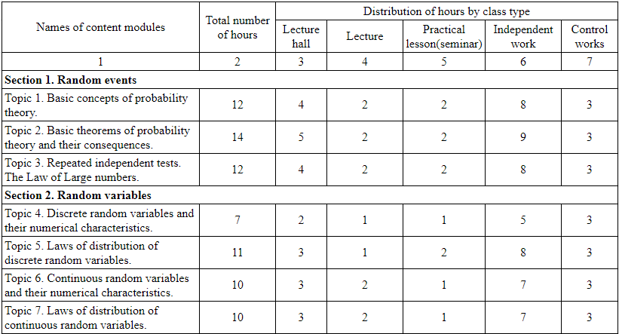

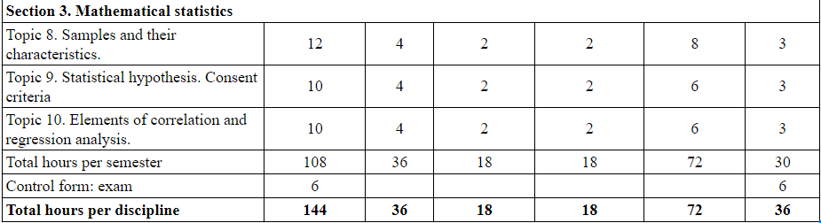

The table-10-Lecture content details the subject matter of each lecture. Arranged by subject titles and their respective durations, it encompasses fundamental probability concepts, statistical theorems, various tests, as well as discrete and continuous variable analysis. The arrangement links each subject to a certain segment of the study area, and provides exhaustive guidelines on lecture material, indicating specific textbook pages and problem sets for reinforcement, thereby promoting a deeper grasp and practical engagement with the subject matter.

Table-10. Lecture content

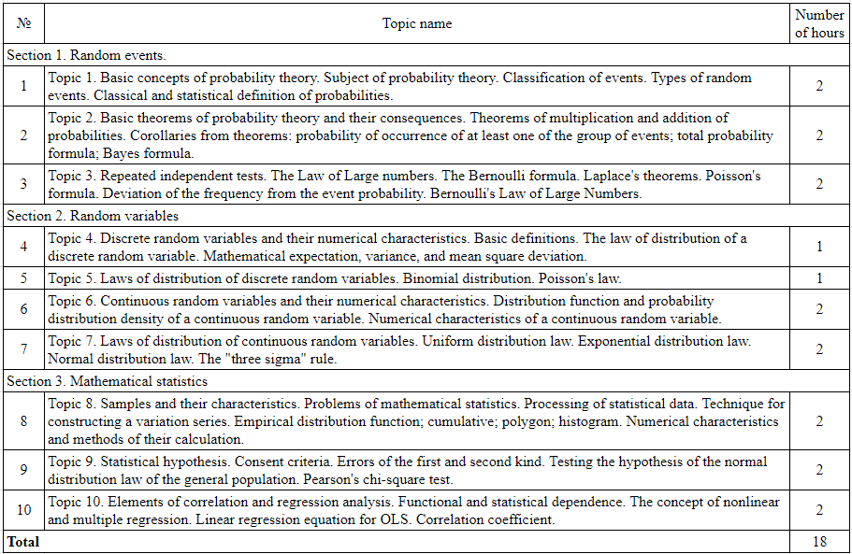

The table-11-Content and scope of student's independent work  outlines the self-guided tasks assigned to students within this field of study. It includes diverse activities such as responding to lecture-based queries, undertaking numerical problem-solving, and engaging with designated textbook sections. The table categorizes these activities by subject, mirroring the lecture syllabus, and specifies the nature of the independent tasks and the reference materials required, aiming for a comprehensive and applied understanding of the taught concepts.

Table-11. Content and scope of student's independent work

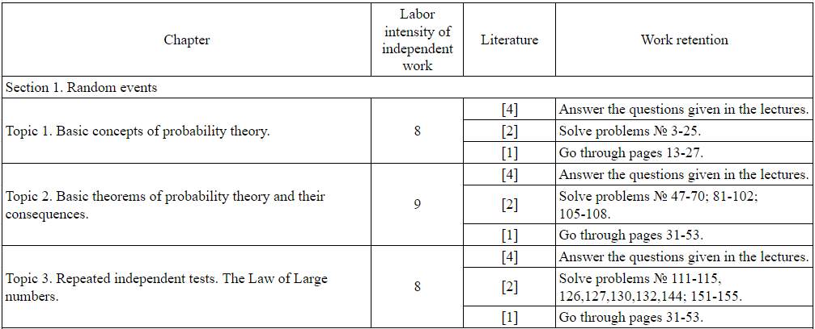

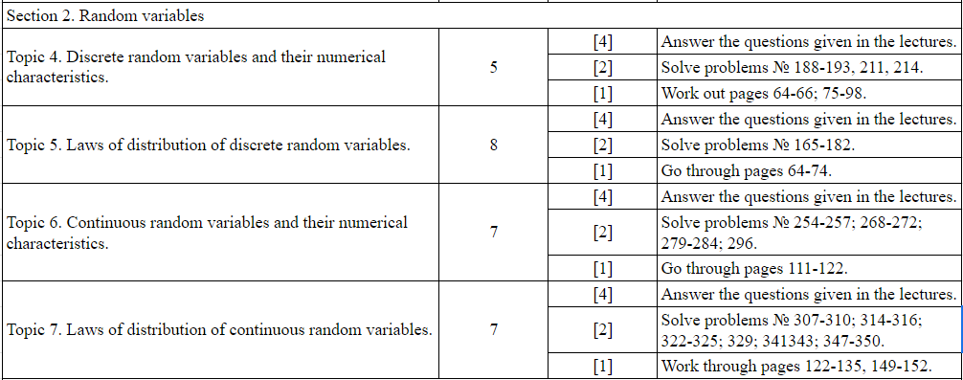

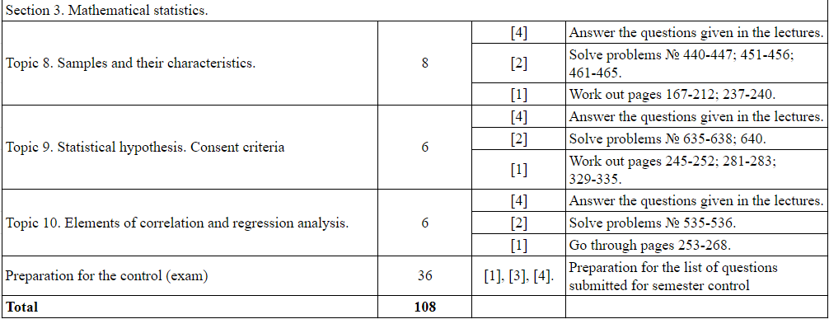

### **2.2.4 Methodical and evaluation resources for the organization of current and final control of students' knowledge on the discipline**

Methods of current assessment of knowledge in the discipline include:

1. Homework
2. Control work
3. Written exam

Students are given a homework containing from 6 to 9 different tasks. For each of them certain points are awarded. The allotted time for completing such an assignment is two weeks. Work will be submitted in a written format.

Examples of homework assignments:

Task 1. [maximum 1.5 points for a correct solution] Determine the probability distribution function for a random variable *X* characterized by the function *exp(-t^2)/3+2sin(t)/3t*.

Task 2. [maximum 1.5 points for a correctly completed solution] Calculate the mathematical expectation and variance of a random variable characterized by the function *(1-it)^(-p)(1+it)^(-q).*

Task 3. [maximum 2 points for a correctly completed solution] Determine the limit of the geometric mean for the first n independent random variables *X_1, X_2, ...,* uniformly distributed on the interval [0,1].

Task 4. [maximum 2 points for a correct solution] Estimate the distribution of the number of people *X* passing by the salesman while he is selling the first 100 newspapers, provided that the probability of purchase by each passerby is *1/3*. Use the central limit theorem for the estimation.

Task 5. [Prove that if random variables X and Y with finite mathematical expectations satisfy the conditions *E(X|Y)=Y and E(Y|X)=X* with probability approaching one, then *X=Y*.

Task 6. [Prove that if a sequence of 10 random variables *X(0), ..., X(n)* forms a Markov chain, then the inverse sequence Y(k)=X(n-k) also forms a Markov chain.

Task 7. [maximum 1.5 points for a correctly completed solution] Investigate to what limit the probability that the dice at the n-th throw will be on the edge "6", given the initial position on the same side. At the same time, the dice is moved to one of the four neighboring faces with equal probability, regardless of its previous position.

Table-12. Grading criteria and grading scale for the homework assignment 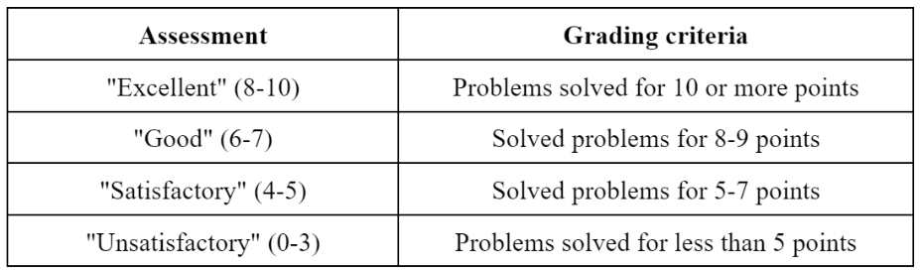

Students' progress in the discipline is monitored through various written assessment methods such as the Control Paper:

Students have 1.5 hours to complete the control paper, which is a set of five problems. A minimum of three of the five tasks must be completed to achieve a satisfactory score.

Examples of problems in the check paper are:

1. What is the number of ways to choose six people out of seven men and four women so that there are at least two women among those chosen?

2. Prove that any simple connected graph G, which is not complete and based on n>2 vertices, contains a subgraph in the form of an induced path P_3 of length 2.

3. Describe all trees built on the set of vertices {1,2,3,4,5,6,7} where vertices 2 and 3 have degree 3, vertex 5 has degree 2, and the rest have degree 1. Can the number of such trees be found using the Pruefer code?

4. Prove that a graph G is edge k-connected if and only if each of its blocks B_i is edge k-connected.

5. Prove the existence of a perfect pairing in any nonempty k-regular bipartite graph.

Table-13. Evaluation criteria and evaluation scale of the written test work

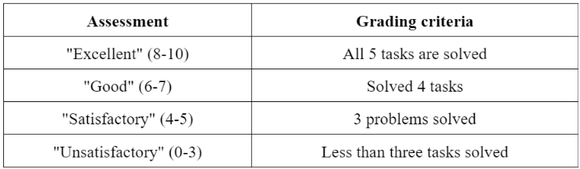

The written exam consists of answering two questions chosen from the exam paper. Students have 2.5 hours to prepare their answers.

Examples of questions for the exam:

1. Examine the probabilistic model of an experiment with random outcomes and analyze the similarities and differences between operations on events and operations on sets.

2. Describe a finite probability space, its properties, and the classical definition of probability.

3. Distinguish the concept of conditional probability, the full probability formula, and Bayes' theorem.

4. Define independent events, including their pairwise independence and independence in the aggregate.

5. Discuss Bernoulli's scheme and the polynomial scheme.

6. Analyze Erdősz's theorem representing probability estimation for Ramsey numbers.

7. Study Poisson's theorem and the estimate of the rate of convergence in this theorem.

8. Examine the local Moivre-Laplace theorem and its applications.

9. Discuss the integral theorem of Moivre-Laplace and an estimate of the rate of convergence in it.

10. Dissect the concept of probability space.

Table-14. Grading criteria and grading scale for the written exam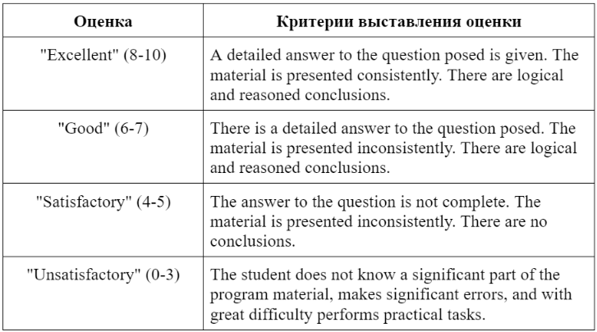

### **2.2.5 Methodical recommendations for students to study the discipline**

*Guidelines for taking notes during lecture classes:*

It is important to systematically record learning material while listening to lectures. Standard and effective methods for recording lectures include the following approaches:

* Creating lecture notes in a special notebook organized so that each page has margins for additional notes based on recommended literature. These notes should complement and deepen the main material of the lecture and highlight the most significant theoretical concepts.
* Carefully record the topic and structure of each lecture, as well as relevant recommended literature for further study. It is important to structure notes with clearly marked headings, subheadings and paragraphs. The use of colored pens or markers to highlight key sections, conclusions, definitions, and main ideas makes the notes easier to read and follow.
* Note in the margins of the notebook references to primary sources cited in the lecture to make it easier to locate and study these materials in detail during independent work.
* Carefully record all definitions, terminology, and basic laws presented in the lecture. All other information should be revised and put in your own words for better understanding and memorization.
* Develop customized abbreviation systems for frequently mentioned terms and concepts to speed up the writing process and make the notes more compact.
* Carefully record everything the instructor shows on the blackboard, including recommended charts, tables, diagrams, etc., as these materials often contain key points of the lecture.

*Recommendations for preparing for practical classes:*

The purpose of practical classes is not only to deepen, but also to consolidate the theoretical knowledge obtained by students during lectures and independent study of the subject. This contributes to the development and improvement of specific skills and abilities:

* In preparation for practical classes it is important to carefully study the lecture notes, study the recommended basic and additional literature, as well as to perform practical tasks proposed by the teacher.
* It is necessary to take into account all the instructions of the teacher and meet the requirements of the curriculum, finalizing and supplementing the lecture notes on the basis of the studied literature.
* It is recommended to use several sources of information to prepare for practical classes to ensure the fullest possible understanding and mastering of the studied issues. This will provide a deeper and more comprehensive understanding of the subject, as well as contribute to the development of critical thinking and analytical skills.

*Instructions for planning and conducting independent learning activities:*

This form of educational activity, defined by J.K. Dizl as "independent" - referring to a person with stable beliefs, is found in all types of learning, both full-time and part-time. Independent learning activity contributes not only to the acquisition of new knowledge, but also to the organization and deepening of existing knowledge, as well as in the formation and development of professional skills and abilities in students.

*Independent work fulfills a number of critical functions:*

* Promotes the development of individual learning abilities;
* Provides informational and educational support;
* Directs and stimulates learning interest;
* Educates and shapes a holistic personality;
* Promotes research activities.

*Various forms of independent work include:*

1. Compilation of notes from primary sources and additional academic literature;

2. Thorough study of the study material with the help of developed notes, educational and scientific texts;

3. Solving learning problems and performing exercises of varying degrees of difficulty;

4. Using test tasks and questions for self-checking of knowledge and skills;

5. Preparing for the final test paper for the course.

It is recommended that, from the very beginning of the course, students actively interact with the course material and assignments provided as preparation for future classes. This allows for repetition and reinforcement of what has already been learned, provides a foundation for mastering new topics and concepts, and leads to questions that students can get answers to in class.

It is worth noting that individual course assignments can have their own specific characteristics. In the process of studying the material, students have access to the extensive resource of the institution's library, which offers a wide range of relevant literature. In preparation for upcoming lectures and practical classes, an important role can be played by a brief lecture notes included in the educational and methodological complex. Such materials can be used not only to consolidate the information obtained in lectures, but also for deep understanding and analysis of the topics studied, as well as for preparation for practical classes and homework.

In addition, it is important to note that successful mastering of independent work requires planning and organization of time, as well as the development of critical thinking skills, analytical abilities and the ability to work with various sources of information. This includes the ability to identify key ideas and concepts, analyze and synthesize the data obtained, as well as the ability to apply theoretical knowledge in practice.

*Orientations for effective interaction with the range of learning materials:*

All learning resources can be categorized as textbooks and manuals, original research monographs, and scholarly articles published in periodicals. These resources are divided into core resources (recommended by the instructor), supplementary resources, and specialized resources for more in-depth study of the discipline.

It is optimal to begin the study of any discipline with a textbook, as it is a comprehensive publication that covers the main scientific concepts of the subject, according to the educational goals and objectives of the curriculum.

When working with educational materials, it is worth considering a variety of reading methods, each of which is applied at appropriate stages of learning the material:

* Initial reading is aimed at identifying and understanding unknown terms, which includes searching for them in reference materials for further analysis. It is especially important to carefully parse key concepts when reading academic literature.
* Sequential reading involves going through a text completely from beginning to end, which helps students develop a holistic understanding and mastery of the major concepts and concepts of the course.
* Selective reading focuses on locating and selecting specific portions of the text, and is key in preparing for practical activities related to specific course topics.
* Analytical reading involves in-depth critical analysis of what has been read, followed by the creation of an outline. Effective assimilation of material is achieved by actively formulating questions to the text during reading. Some of these questions may already be included in the list of interview questions within the framework of the FSF. It is important not only to get into the content of these questions, but also to master the methodology of studying the material through questions directed at the text.

Additionally, it should be emphasized that successful interaction with learning materials requires not only planning and organizing time, but also developing critical thinking and analytical skills. Students need to learn to identify main ideas and concepts, analyze and synthesize them, and be able to apply theoretical knowledge in practice. This includes the ability to critically evaluate information, look for connections and relationships between different concepts, and develop and test hypotheses based on the knowledge gained. It is also important to be able to work effectively with a variety of information sources, including digital and print, and to be able to locate and select the necessary data for a thorough understanding of a subject.

The purpose of analytical reading is to provide a thorough understanding and comprehensive analysis of the instructional information presented. The various methods of analytical reading include:

1. Reading according to a given structure organizes information according to a number of categories: title of the work; information about the author; origin of the source; main theme and idea of the text; facts presented; analytical comparison of different points of view on the issues discussed; innovation and originality of the material.

2. Questioning reading techniques include:

* thoughtful and meaningful reading for deep understanding of the main idea;
* identification and analysis of key words and expressions in the text;
* reflecting on the main concepts, hidden meaning and global goal of the author.

3. The thesis technique involves forming short but succinct theses that represent the main points, statements, or conclusions that emerge from the text.

Additional techniques include abstracting, in which the main point of the text is stated briefly and concisely, and commenting, where the text is analyzed in more depth with the addition of one's own comments and observations.

An important aspect of any serious scientific publication is the bibliographic list referred to by the author in his text. When studying specific problems discussed in the text, students are given the opportunity to refer to the relevant reference list. This allows students to break down the issues they are studying into separate segments for more detailed study on their own. It is important not to lose the overall context and to avoid going into too much detail, which can lead to a loss of the main idea.

In addition, during analytical reading it is recommended to work actively with the text, including highlighting the main points, creating charts and tables to visualize and organize information, as well as using mnemonic techniques to improve memorization of key concepts. It is also helpful to dialog with the text by asking questions and making assumptions about the further development of the ideas presented, which helps to stimulate critical thinking and deepen understanding of the material.

It is also important to practice paraphrasing readings, which not only helps to improve comprehension of the text, but also develops the ability to translate complex ideas into accessible language, a key skill in learning and scholarship. This kind of in-depth interaction with the text helps to develop analytical skills, the ability to synthesize information and apply it in practice.

### **2.2.6 List of basic and additional teaching materials necessary for the study of the discipline**

*Infrastructure and equipment designed to support the educational process of the discipline, including the special needs of students with disabilities:*

1. During the course, classrooms equipped with the necessary multimedia teaching devices are actively used. This includes:

* Lecture halls equipped with projectors to visualize instructional material;
* Personal computers or laptops for presentations and demonstrations of learning materials;
* Interactive whiteboards that facilitate instructor-student interaction and allow for more visualization of educational content.

2. The introduction of digital educational resources involves the active use of computer laboratories with Internet access, where students can:

* Explore electronic educational materials;
* Access online databases and information resources of the library;
* Use specialized programs and applications for in-depth study of the subject.

3. Specialized accommodations are provided for students with physical disabilities:

* Providing adapted versions of the institution's websites for the visually impaired;
* Provision of assistants to assist in the learning process;
* Special accommodations for students with hearing impairments, including verbal duplication of timetable information and use of audio equipment;
* Adaptation of classrooms and support spaces for students with mobility disabilities, which includes wide doors, handrails and other necessary devices to facilitate access and comfort.

These measures are aimed at creating an inclusive educational environment in which every student, regardless of physical features, can acquire knowledge on equal terms. The University strives to ensure equal access to all resources and facilities, which includes the usability of library resources, accessibility of educational materials and adaptation of curricula.

Also important is the training of teaching staff on how to work with students with special educational needs. This includes developing individualized instructional strategies that take into account the specific perceptions and learning needs of each student, as well as creating a supportive and inclusive learning environment in which each student feels valued as a valuable and important member of the learning community. inclusive learning environment in which each student feels valued and important as a member of the learning community.

*A list of basic and supporting literature designed to fully comprehend the course:*

*Basic literature:*

1. "Probability Theory and Mathematical Statistics" by K.V. Baldin, V.N. Bashlykov, A.V. Rukosuev - this educational edition is characterized by its systematic approach to the presentation of the material. Published in Moscow, publishing house "Dashkov and K", 2014. Volume - 473 pages. Available in electronic format on the resource "Znanium.com".

2. E.S. Kochetkov, S.O. Smerchinskaya, V.V. Sokolov presented "Probability Theory and Mathematical Statistics" - a textbook published by Forum Publishing House, INFRA-M in Moscow, 2014. The book has 240 pages and is available for online study at http://znanium.com/.

3. N.Sh. Kremer's textbook "Probability Theory and Mathematical Statistics", intended for university students, published by Unity Publishing House in Moscow, 2003.

4. V.E. Gmurman's "Probability Theory and Mathematical Statistics", published in Moscow, Vysshaya Shkola publishing house, 2002.

*Additional literature:*

1. "Probability theory and mathematical statistics" S.V. Pavlov - textbook, published in Moscow, IC RIOR, INFRA-M, 2010. Available in electronic form on the resource "Znanium.com".

2. "Collection of tasks on the course 'Mathematics in economics'. Part 3. Probability Theory" A.V. Brailov and A.S. Solodovnikov, textbook for universities, published in Moscow, publishing house Finance and Statistics, 2013. 128 pages. Available at http://www.iprbookshop.ru/.

3. E.N. Guseva "Theory of Probabilities and Mathematical Statistics", 5th edition, stereotyped, published in Moscow, Flinta Publishing House, 2011. 220 pages. Available on "Znanium.com".

4. "Probability Theory and Mathematical Statistics" by G.P. Klimova, 2nd edition, published in Moscow, Moscow University Press, 2011. 368 pages. Available at http://www.iprbookshop.ru/.

5. A.S. Shapkin, V.A. Shapkin. "Tasks with solutions on higher mathematics, probability theory, mathematical statistics, mathematical programming": textbook. Moscow: Dashkov and K, 2013. 432 с. Access: http://znanium.com/.

6. V.A. Kolemaev, V.N. Kalinina. "Probability theory and mathematical statistics": textbook for universities. Edited by V.A. Kolemaev. 2nd ed., rev. and ext. Moscow: UNITI-DANA, 2010. 352 с. Access: http://www.iprbookshop.ru/.

7. G.V. Emelyanov, V.P. Skitovich. "Zadachnik po teorii probabilosti i matematicheskaya statistika": Study guide. St. Petersburg: Lan, 2007.

8. G.A. Sokolov, N.A. Chistyakova. "Theory of probabilities": textbook for students of the direction of economics and economic specialties. Moscow: Ekzamen, Plekhanov Russian Economic Academy, 2005.

9. V.P. Lisiev. "Theory of probabilities and mathematical statistics": textbook. Moscow: EAOI, 2010. 199 с. Access: http://www.iprbookshop.ru/.

10. G.V. Gorelova, I.A. Katsko. "Theory of probabilities and mathematical statistics in examples and tasks with application of Excel": textbook for students of economic specialties. Rostov-on-Don: Phoenix, 2005.

11. Yu.V. Prokhorov, L.S. Ponomarenko. "Lectures on probability theory and mathematical statistics": textbook for universities. Moscow: Lomonosov Moscow State University, 2012. 254 с. Access: http://www.iprbookshop.ru/.

12. N. Akanbai. "Fundamentals of probability theory, mathematical statistics and theory of random processes". Almaty: Kazak Un-tee, 2007.

13. "Collection of tasks on higher mathematics. In 2 parts. Ch. 2": textbook. Ed. A.S. Pospelov. Moscow: Yurait, 2014. 611 с.

14. N.I. Sidnyaev. "Theory of probabilities and mathematical statistics": textbook. Moscow: Yurait, 2011. 219 с.

15. A.N. Borodin. "Elementary course of probability theory and mathematical statistics": textbook. 7th ed. St. Petersburg: Lan, 2008.

16. M.S. Spirina, P.A. Spirin. "Probability theory and mathematical statistics": textbook for students of secondary vocational education. Moscow: Academy, 2007. 352 с.

17. V.Yu. Korolev. "Probability theory and mathematical statistics": textbook for economic and engineering specialties of universities. Moscow: Prospect, 2006.

18. V.N. Kalinina. "Probability theory and mathematical statistics": textbook for academic bachelor's degree. 2nd ed., revision. and supplement. Moscow: Yurait, 2018. 472 с.

19. A.M. Popov, V.N. Sotnikov. "Probability theory and mathematical statistics": textbook and practice for applied bachelor's degree. 2nd ed., revised. and supplement. Moscow: Yurait, 2018. 434 с.

20. "Probability theory and mathematical statistics": textbook. E.S. Kochetkov, S.O. Smerchinskaya, V.V. Sokolov. 2nd ed. revised and reworked. Moscow: FORUM, INFRA-M, 2018. 240 с.

# **Conclusion**

﻿The dissertation commences by means of organising a framework for a thorough investigation into the vital methodological help crucial for educating college students in mathematics within the disciplines of Probability Theory and Mathematical Statistics. It underscores the criticality of specialised teaching techniques inside this instructional sphere. The commencing section probes the foundational theories at the back of formulating methodological aid tailor-made for prospective math educators, underscoring the significance of autonomous pedagogical techniques and a professional technique to teaching mathematics.

Within this scholarly work, there may be a strong cognizance on nurturing methodological skills in aspiring educators, pinpointing the pivotal function those abilties play in studying mathematical disciplines. This section of the dissertation probable encompasses an evaluation of numerous instructional techniques and their efficacy. It offers in particular with the creation of tutorial content material for mathematical topics in the realm of pedagogical tertiary training, zeroing in on techniques to demystify and clarify complex mathematical theories for the educators of the following day.

The dissertation scrutinizes the tangible assemblage of methodological aids for this instructional subject, scrutinizing current academic trends in these areas and their contribution to the schooling of destiny arithmetic instructors. It then gives a tangible series of methodological helps for "Probability Theory and Mathematical Statistics," mainly geared closer to students that specialize in "Mathematics." This section probes the latest pedagogical traits and their effect on the education of up-and-coming mathematics teachers.

In its concluding feedback, the dissertation accentuates the want for a comprehensive method to supplying those intricate subjects, amalgamating theoretical insights with practical abilities and avant-garde teaching strategies. It advocates for a holistic and evolving methodological structure to supply future math educators with the vital understanding, talents, and pedagogical acumen to excel in their domain.

Ultimately, the dissertation convincingly demonstrates the need for an adaptable and bendy educational method to accommodate the numerous mastering styles in Probability Theory and Mathematical Statistics. It underscores the application of technological aids and software in simplifying tricky mathematical ideas and stresses the criticality of ongoing evaluation and comments mechanisms in monitoring student progression and comprehension. The integration of cooperative learning strategies to domesticate a extra interactive and engaging lecture room environment is championed. Moreover, the incorporation of sensible programs and real-life situations to bridge the gap between theoretical understanding and realistic competencies is recommended.

﻿ The dissertation emphasizes the significance of developing complete educational resources which can be without difficulty available to educators and college students alike, in addition to the need of continual expert increase for educators to stay present day with the today's educational methodologies and academic technology. Regular updates to the curriculum to reflect the dynamic nature of Probability Theory and Mathematical Statistics are suggested, together with the cultivation of a collaborative and supportive academic network among college students and teachers. The vital position of methodological aid in augmenting the overall first-class and efficacy of coaching Probability Theory and Mathematical Statistics to destiny mathematics educators is reasserted.

Prior to delving into the conclusions of the dissertation titled "Methodological Support of the Discipline 'Probability Theory and Mathematical Statistics' for Students of the Specialty 'Mathematics'," it's miles vital to grasp the exhaustive analyses and discussions that form the premise of these conclusions. The dissertation conducts an in depth exploration of numerous pedagogical, technological, and curricular facets applicable to coaching those complicated mathematical fields, presenting a synopsis of the topics and debates previous the conclusions:

1. The dissertation starts offevolved with an intricate exploration of the traditional pedagogy of Probability Theory and Mathematical Statistics, spotlighting the chasm among theoretical knowledge and practical utility. This phase argues for a extra incorporated method in which principle and application are intertwined, ensuring destiny educators now not best recognise the ideas however also can practice them effectively.

2. The research delves into various pedagogical techniques and evaluates their have an impact on on scholar engagement and comprehension. It significantly assesses traditional coaching methodologies in assessment to extra dynamic and interactive techniques, illustrating how modern techniques can improve the scholar getting to know revel in.

3. A huge a part of the dissertation is devoted to the significance of unbiased paintings and critical wondering within the getting to know method. It gives case research and findings from research on how selling students to work autonomously and assume severely leads to a greater profound draw close of mathematical standards.

4. The look at investigates the role of generation in present day training, particularly in teaching complex topics like Probability Theory and Mathematical Statistics. It assesses lots of technological tools and resources, discussing their capacity integration into the curriculum to facilitate teaching and learning.

Five. The dissertation underscores the importance of non-stop assessment and remarks inside the educational method. It offers information and analysis on how regular tests and positive feedback can useful resource in the continuous monitoring and improvement of college students' expertise of the problem be counted.

6. This phase of the dissertation concentrates on the development of instructional substances and resources. It discusses the necessity for complete, nicely-structured, and available teaching materials essential for effective getting to know.

7. The studies emphasizes the need for ongoing expert improvement for educators. It highlights the significance of staying up to date with the ultra-modern teaching methods and educational technology, mainly in rapid-evolving fields like mathematics.

8. The dissertation discusses the need for a dynamic and adaptable curriculum that could keep tempo with improvements in mathematics and pedagogy. It gives strategies for curriculum development attentive to the converting educational landscape.

9. The have a look at advocates for the advent of a collaborative studying environment. It emphasizes the benefits of fostering an surroundings wherein college students and educators can interact in significant discourse and trade of information.

10. Finally, the dissertation consolidates some of these components under the umbrella of methodological guide. It argues that complete methodological support is fundamental to enhancing the satisfactory of schooling and education supplied to future arithmetic instructors.

# **List of used literature**

1. State obligatory standard of secondary education (primary, basic secondary, general secondary education): approved by the Decree of the Government of the Republic of Kazakhstan from August 23, 2012 № 1080. - Astana, 2012.
2. Bespalko V.P., Tatur Y.G. System-methodical support of educational process of training specialists. Moscow: Higher School, 1989. 144 с.
3. Nurbaeva D.M., Zhumalieva L.D., Nurmukhamedova J.M., Zhanseitova L.J., Dyusov M.S. On some issues of teaching mathematics in schools and pedagogical universities of Kazakhstan // Proceedings of the III International Scientific Conference "Actual problems of teaching mathematics and informatics in schools and universities in the light of ideas of L.S. Vygotsky. - М., 2016. - 407 с.
4. Makarova L. N. Individual style of pedagogical activity of a university teacher in the context of his professional culture: research notes // Electronic scientific journal of Kursk State University. Vyp. 2006. № 2. [Electronic resource]. Access mode: http: //scientific-notes.ru.
5. Sadovnichy V. A. Mathematics education: present and future // Proceedings of the All-Russian conference "Mathematics and society. Mathematical Education at the Turn of the Century". Dubna, September 2000. M.: MCNMO, 2000. 664 с.
6. Abylkasymova A.E. About special-methodical training of the future teacher of mathematics // Proceedings of the III International Scientific Conference "Actual problems of teaching mathematics and informatics at school and university in the light of the ideas of L.S. Vygotsky. - М., 2016. - 407 с.
7. Stefanova N.L. The use of interrelated educational and methodological tasks in the professional training of a teacher of mathematics for a profile school // Problems of theory and practice of teaching mathematics. SPb.: RSPU, 2004. С.57-61.
8. Abylkasymova A.E. Theory and methodology of teaching mathematics: didactic and methodical bases. - Almaty: Mektep, 2013. - 224 с.
9. Ozhegov S.I., Shvedova N.Y. Explanatory dictionary of the Russian language. Moscow: Az, 1993. С.438. 3. Leontiev A.N. Activity. Consciousness. Personality. Moscow: Academy, 2004. 336 с.
10. Zhumagulova Z.A. Structural-methodical features of creation of textbooks and educational-methodical complexes on mathematics for secondary school in the Republic of Kazakhstan: diss.  ... candidate of pedagogical sciences. - Astana, 2016.
11. Elementary mathematics. Practicum on problem solving: Educational and methodical complex. St. Petersburg: Russian State Pedagogical University, 2009. 283 с. 5.
12. Abylkasymova A.E. Cognitive independence in the learning activity of the student / Tutorial. - Almaty, "Sanat", 1998. - 160 с.
13. Mubarakov A.M. Scientific and methodological bases of continuity of teaching mathematics in the system of continuous education: Cand.  ... doctor of pedagogical sciences: 13.00.02 - Almaty, 2003. - 225 с.
14. Bushmeleva, N.A. (2017), "Elements of the theory of fractal sets as a means of interdisciplinary integration in the context of the fundamentalization of education", Concept, 9, 40-48.
15. Zhai, W. (2018), "Design and application of a remote electronic communication teaching system in a network environment", International journal of emerging technologies in learning, 13 (4), 200-208.
16. Firsov V.V.. Planning of compulsory results of teaching mathematics - M.: Prosveshchenie, 1989. - 238 с.
17. Makhmutov M.I. Modern lesson. - M.: Pedagogics, 1981. - 241 с.
18. Nurmukhamedova J.M. On the organization of mathematics education at school in the conditions of differentiation of the educational process // Pedagogy and Psychology, Abay KazNPU. - Almaty, 2016. - № 1 (26). - С. 191-195.
19. Kirsanov A.A. Individualization of learning activity as a pedagogical problem. Kazan: KSU, 1982. - 105 с.
20. Salyakhova, G.I. and Valeeva, R.A. (2015), "Pedagogical Stimulation of University Students' Social Competence Development by Means of Interdisciplinary Integration", Review of European Studies, 7 (5), 186-192.

# **Appendix**