**Online quiz system**

**(EduQuiz)**

**Supervisors:**

**DR.Amal Elammal**

**Eng.Samar Taha**

|  |  |
| --- | --- |
| ***Na*me** | **ID** |
| 1-Sarah Adel | 20140137 |
| 2-Neveen Reda | 20140299 |
| 3- Omar Mostafa | 20140190 |
| 4-Islam Atef | 20140057 |
| 5-Wafaa Abd Elbaqy | 20130291 |

**Department of information system**



**Acknowledgment**

For our work, we want to thank to DR.Amal Elammal

From our hearts. As a supervisor, she has given all the supports that we needed. She was always there for us to give any kind of suggestion and help. It’s an honor for us to work with such a wonderful supervisor like her.

**Abstract**

This report describes an online intelligent multiple-choice question examination system, named EduQuiz System, for students. Any university, college or school with a computerized education system can adopt this system.

**TABLE OF CONTENT**

Page

Title……………...........................................................................................…1

Acknowledgment…....................................................................................2

Abstract…...................................................................................................3

Table of content…………………………………………………………………………………….4

Introduction …………………………………………………………………………………………6

Current scenario of the system……………………………………………………………..7

Web based quiz system…………………………………………………………………………8

Proposed system…………………………………………………………………………………...9

Student survey………………………………………………………………………………………10

Survey analysis………………………………………………………………………………………11

System design………………………………………………………………………………………..12

System overview…………………………………………………………………………………....13

Goals and guidelines……………………………………………………………………………….14

Project methodologies…………………………………………………………………………….15

Functional and nonfunctional requirements……………………………………………17

System architecture…………………………………………………………………………………19

Architectural strategies…………………………………………………………………………….20

Use case tables…………………………………………………………………………………………..22

Implementation………………………………………………………………………………………….23

References………………………………………………………………………………………………….24

Lessons learned…………………………………………………………………………………………..25

Related work……………………………………………………………………………………………….26

**LIST OF FIGURES**

**Figure**  **Page**

Block diagram 14

Life cycle method 17

3-tier architecture 20

Use case diagram 21

Sequence diagram 32

Domain class diagram 38

Detailed class diagram 39

Gantt chart 41

Tree Structure View 42

**Introduction**

This is a web-based multiple-choice-question examination system, named EduQuiz System.

It is a system by which students can appear in a quiz from anywhere of the world where there is no interaction between pencil and paper rather interaction between computer and human being. The system generates questions. Any university, college, school or educational institute can use this system for their organization to take quizzes. Today it is the more efficient and effective methods of assessing distant students. One of the main benefits of our system is automated marking, that is, teachers do not need to check the answer script as they do in manual quiz. It saves valuable time of a teacher. It will give feedback about a student in which side he/she is weak.

In recent years, the use of online quiz systems has become quite popular due to pressures of increasing class sizes and the need for more efficient and effective methods of assessing distant students.

**Current scenario of quiz system**

Still now maximum educational institutes have been using manual system to take quiz. In the recent year a few instructors of some institutes have been using web-based M.C.Q. quiz system. Actually, it depends on how much web technology a country takes or uses. For example, in Egypt it is rare to use a web based quiz system. But in case of U.S.A. it is a general case to use a web based quiz system.

**Manual quiz-Problem statement**

In the early days it was the most popular methods of assessing student. Still now the system is quite popular to the students as well as to the teacher. In this system there are several problems that we face in a common way. Some of those problems are:

Manual system requires pen/ pencils and paper.

Teacher needs to spend time to script checking.

Student needs to wait to get their result up to the teacher finishes the script checking

These are the most common problems of manual quiz system that rotated each and every time of quiz held. For these causes the popularity of manual system decreases day by day and online intelligent quiz system is taking the place of the manual system.

**Web based quiz system**

Now a day the web base quiz system is getting popular. As the technology is spreading throughout the world the automated system will also taking the places of the manual systems. Currently big institutes are running their online quiz systems at a very successful rate. As the time is progressing the online quiz is making interest to the faculties and also to the students. In the big cities and organizations people are getting understand that how the online quiz system is better and efficient. Within the recent time this system will be taken place to this techno world.

**Feedback from current scenario**

To get a standard quiz system we tried to join the EduQuiz system that we designed. This will help to remove the current system’s problems.

**Proposed system**

In recent years, the use of electronic online quiz systems has become quite popular due to pressures of increasing class sizes, and the need for more efficient methods of assessing distances students. This thing motivates us to work with web based quiz system.

To develop the system we collected some information from web. Then we have analyzed this information and tried to find some logic from there.

As a step of development we collected requirements where we have conducted a survey. In that survey we took students opinions to make the system more meaningful. For that we made a question set and gave it to some students. They gave their opinions on those scripts. In below survey details are given.

**Survey**

To make an effective and efficient Online quiz system we need some findings. We believe that our findings will help us to make the system user friendly. Here is a short description of our system.

Our system name is EduQuiz. Any University, College or School can adopt our system where education system is computerized.

**STUDENT’S SURVEY**

**1. What type of system do you (students) want?**

a) User friendly c) Effective and efficient

b) Stable d) All the above.

Answer.**d**

**2. Would each question have a predefine time slot or the total Quiz have a predefine time slot?**

a) Each question have a predefine time slot

b) The total Quiz have a predefine time slot

Answer.**a**

**3. Would answer be auto submitted after time end?**

a) Yes

b) No

Answer.**a**

**4. Could students see the answers at the end of the quiz?**

a) Yes

b) No

Answer.**a**

**5. Would student modify the submitted answers if his/her time is not end?**

a) Yes

b) No

Answer.**a**

**6. Would students get any help from the system during the exam?**

a) Yes

b) No

Answer.**a**

**7. Could student pass the questions and try for that later**?

a) Yes b) No

Answer.**a**

**SURVEY ANALYSIS**

What we actually found everyone wants a user-friendly environment while attending the quiz**.**

Students want the whole quiz should have a fixed amount of time rather than for individual question.

At the end of the quiz they want to see their performance and the correct answers.

They want system would be able to save the score automatically and can keep all quizzes information (i.e. student’s mark, performance etc.) of all students.

**System design**

**Introduction**

This Software design specification template is for the EduQuiz system. This Software has implemented as a graduation project of faculty of Computer and information system Cairo University. This Design Specification Template describes the System architecture and detailed System design of the EduQuiz system.

**Purpose of this document**

The purpose of this document is that it helps the programmer (i.e. us) to implement the system correctly and easily. It is not possible for the programmer to implement the system without a design document. In this document the designers are supposed to provide a clear design of the system. The design then serves as a guide to the developers who write the code and actually implement the software. Another purpose of this document is that it also helps the designer to update the system or modify several part of the system in future.

**Intended audience**

Intended audience of this document is those people who are reuse this document and also who are updates or modify this system in future. Generally they are system designer and developer**.**

**System overview**

EduQuiz system a Web based M.C.Q. Quiz System for evaluating students. This system is developed considering educational institutes like university, College and school. Student can attend in a quiz from anywhere of the world by using this system.

This is the block diagram of EduQuiz System.

Student

Question bank

Quiz

**Figure 1 block diagram of EduQuiz**

Admins are responsible for add and edit questions from the question bank. They add question in the question bank in different level according to their level of difficulty. Generator engine generate questions for a quiz from the question bank

Generator engine generate questions for a quiz from the question bank. To generate the next question, Question Generator check the previous question answer submitted by the student and depending on that result Question Generator decide the level of difficulty for the next question and generate it. It also gives feedback to the students. Student can appear in the quiz when his/her time slot is started.

At the end of a quiz they can see the correct answers and their performance.

**Assumptions and dependencies**

We assume that students are interested on online quiz. Also are interested to take online quiz where he/she can be evaluated perfectly.

The users of the EduQuiz system are the school/college/university students, and the admin who control the system and those institutes must be computerized.

Any institute might have to Internet connection to use EduQuiz system because this is a web based application**.**

**Goals and guidelines**

Our main goal is to develop an effective and efficient system. To design this system we gave priority end users expectations.

**The KISS principles**

The full meaning of KISS is “Keep it Simple Stupid”. It means we need to design the system in a very simple way. For a good design, we need to consider the Criteria for good sub-system/UML diagram design. These criteria are Coupling and Cohesion. Coupling measures the degree of interconnectedness between design classes/components/sub-systems. For a better design low coupling is preferable. Cohesion, on the other hand, measures the degree to which an element (class/component/subsystem) contributes to a single purpose. For a better design high cohesiveness is preferable. Our design follows these two criteria. We also try to make the design considering user satisfaction.

**Project methodologies:**

In our project we use “Agile “approach, as we gather the information which needed to make the system and we focus on the most important use cases and we do analysis, design, implementation and testing.

Then we take another use case until we finish the whole system.

We prefer this approach because it is more adaptable and flexible .it gives us time to work while requirements are changing. There is a flexibility to check for errors under any part of the development stage.

**Life cycle model:**

After each phase, we have the opportunity to cycle back and check our work.

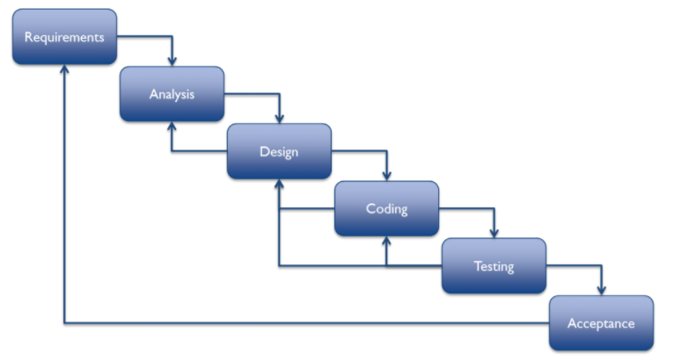

**System user**

1-student: use the system to attend exam.

2-Admin: Controls the whole system.

**Functional requirements**

1-Register: to have an access on the website by creating an account.

2-Log in: to be able to use the education website by having an active account.

3-Do Quiz: student use the system to attend exam.

4-View Result: student does it to know his grade.

5-Rate: system evaluates student and show top 10.

6- Give Feedback: student can give his opinion about system.

7-Put Question: Admin puts question in a bank.

8-Ask Help: student can ask for help during the exam.

9-Hear Music: Student can hear music during the taking the exam.

10-Update Exam: Admin is responsible for change content of the question.

11-Check Authentication: Admin is responsible for giving authority who can access the system.

**Nonfunctional requirements**

**1-efficiency**

The system reduces the student time in viewing questions to solve.

**2-User friendly**

The system interface is very clear, simple, easy to use.

**3-Useability**

The system is easy to learn.

**4-Security**

The system is protected with password**.**

**5-Reliability**

**The server is not down and reliable to the users.**

**6-availability**

The system is available for users most of time**.**

**System architecture**

System refers to both hardware and software. The system architecture describes the collection of inter-connected hardware nodes on which the software will eventually run.

We used 3-tier architecture (Client Tier, Business-tier, and Database-tier) to design our system. Because 3-tier Architecture increases performance, flexibility, maintainability, reusability, and scalability while hiding the complexity of distributed processing from the users/clients.

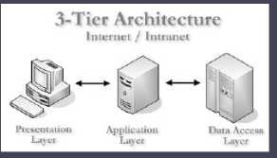

**Architectural strategies**

**Programming Language for Client Tier**

We use HTML and PHP to design the client tier. Because HTML and PHP are easy to use and it will be helpful for us to design the client tier using HTML and PHP.

**Programming Language for Business-tier**

We use PHP to design the Business-tier because it is an open source programming language that is widely popular on the web. PHP is well known for fast 1performance and it is also well known for its quick and easy web development capabilities. PHP is an easier programming language to learn than JavaScript because the core language is small. That is why it is easier to us to design the Business-tier using PHP.

**Programming Language for Database-tier**

We use MYSQL to design the database-tier. The MySQL database has become the world's most popular open source database because of its consistent fast performance, high reliability and ease of use. It's used in more than 11 million installations ranging from large corporations to specialized embedded applications on every continent in the world.

Not only is MySQL the world's most popular open source database, it's also become the database of choice for a new generation of applications built on the LAMP stack (Linux, Apache, MySQL, PHP / Perl / Python.) MySQL runs on more than 20 platforms including Linux, Windows, OS/X, HP-UX, AIX, Netware, giving user the kind of flexibility that puts user in control.

**Use case diagram**

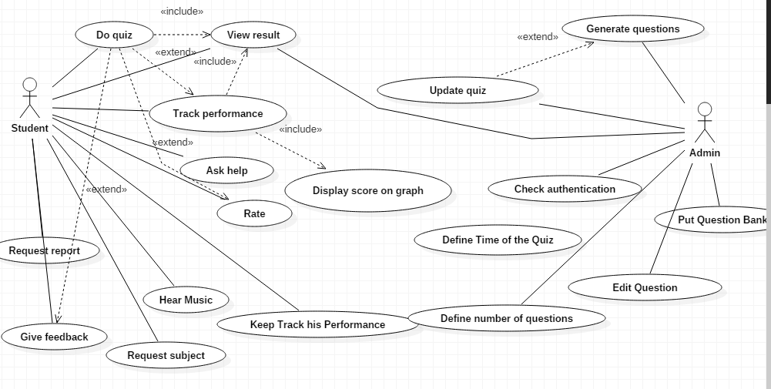

**Use case tables**

**1-Play quiz Use Case**

|  |  |  |
| --- | --- | --- |
| Use Case ID: | 1 | |
| Use Case Name: | Play quiz | |
| Actors: | Student | |
| Pre-conditions: | Register &Login | |
| Post-conditions: | View Result | |
| Flow of events: | User Action | System Action |
| 1- User Enter User Name and Password. |  |
|  | 2- System Verify user data |
| 3-Student select a level |  |
|  | 4- System retrieves the selected level. |
|  |  |
| 5-student select exam |  |
|  |  | 6-system return the selected exam |
|  | 7-student solve the quiz and submit answers. |  |
|  |  | 8-system saves the submitted answers. |
| Exceptions: | **User Action** | **System Action** |
| 1- user enters User name and Password. |  |
|  | 2-User Name or password are invalid  3- System show error message. |
| Includes: | Login | |

**2-Change Password Use Case**

|  |  |  |
| --- | --- | --- |
| Use Case ID: | 2 | |
| Use Case Name: | Change password | |
| Actors: | Student/admin | |
| Pre-conditions: | Login &Register | |
| Post-conditions: |  | |
| Flow of events: | **User Action** | **System Action** |
| 1- user select change password |  |
|  | 2- System return forms. |
| 3-user enter old password |  |
|  | 4- System verify password. |
| 5-user enter new password and confirm new password. |  |
|  |  | System saves new password, and send message to tell user. |
| Exceptions: | **User Action** | **System Action** |
| 1-user enter wrong old password. |  |
|  | 2- System show error message. |
|  | 3-error in confirming new password. |  |
|  |  | 4- System show error message. |
|  |  | |

**3-Put question bank Use Case**

|  |  |  |
| --- | --- | --- |
| Use Case ID: | 3 | |
| Use Case Name: | Put question bank | |
| Actors: | Admin | |
| Pre-conditions: | Login &Register | |
| Post-conditions: | Track Performance | |
| Flow of events: | **User Action** | **System Action** |
| 1- Admin enters User Name and Password. |  |
|  | 2- System Verify teacher’s data |
| 3-Admin enters Question ID and level |  |
|  | 4- System saves entered data |
|  | 5-system show new exam |
|  |  |  |
| Exceptions: | **User Action** | **System Action** |
| 1-Admin enters User name and Password. |  |
|  | 2-User Name or password are invalid  3- System show error message. |
|  |  |  |
|  |  | |

**4-View Result Use Case**

|  |  |  |
| --- | --- | --- |
| Use Case ID: | 4 | |
| Use Case Name: | View Result | |
| Actors: | Student | |
| Pre-conditions: | Do Quiz | |
| Post-conditions: | Track Performance | |
| Flow of events: | **User Action** | **System Action** |
| 1- Student does quiz and enter his answers. |  |
|  | 2- System record student’s answers. |
|  | 3-Shows result button |  |
|  |  | 4-Shows Student's Grade |
| Exceptions | 1-Student enters wrong answer |  |
|  |  | 2-System shows wrong answer |
| Includes |  |  |

**5-Track Performance Use Case**

|  |  |  |
| --- | --- | --- |
| Use Case ID: | 5 | |
| Use Case Name: | Track Performance | |
| Actors: | Student/Admin | |
| Pre-conditions: | View Result | |
| Post-conditions: |  | |
| Flow of events: | **User Action** | **System Action** |
| 1- Student/Teacher click track performance |  |
|  | 2- System history of student’s grade. |
|
|

**6-Edit question**

|  |  |  |
| --- | --- | --- |
| Use Case ID: | 6 | |
| Use Case Name: | Edit Question | |
| Actors: | Admin | |
| Pre-conditions: |  | |
| Post-conditions: | Put question bank | |
| Flow of events: | User Action | System Action |
| 1- Admin select subject |  |
|  | 2- System retrieves selected subject |
| 3-Admin chooses number of question |  |
|  | 4- System retrieves question itself |
| 5-Admin Changes question |  |
|  |  | 6- Changes saved |
| Exceptions: | User Action | System Action |
|  | 1-Admin select uncorrect subject |  |
|  |  | 2- System show error message. |
| Includes: |  | |

**7-Define number of questions**

|  |  |  |
| --- | --- | --- |
| Use Case ID: | 7 | |
| Use Case Name: | Define number of questions | |
| Actors: | Admin | |
| Pre-conditions: | Login&Register | |
| Post-conditions: | Define number of questions | |
| Flow of events: | **User Action** | **System Action** |
| 1- Teacher select subject |  |
|  | 2- System retrieves selected subject |
| 3-Teacher enters number of questions |  |
|  | 4- changes saved |
| Exceptions: | **User Action** | **System Action** |
|  | 1-Teacher select uncorrect subject |  |
|  |  | 2- System show error message. |
| Includes: |  | |

**8-Request subject**

|  |  |  |
| --- | --- | --- |
| Use Case ID: | 8 | |
| Use Case Name: | Request subject | |
| Actors: | Student | |
| Pre-conditions: | Login&Register | |
| Post-conditions: | Play quiz | |
| Flow of events: | **User Action** | **System Action** |
| 1- Student enters password and email |  |
|  | 2- Student enter subject he wants and clicks enter |
| 3-System retrieves selected subject |  |
|  | 4- changes saved |
| Exceptions: | **User Action** | **System Action** |
|  | 1-Teacher select uncorrect subject |  |
|  |  | 2- System shows error message. |
| Includes: |  | |

**Implementation**

1. **Requirement engineering**

Tools we used in our project are

1-StarUml

2-Pencil

3-Adope dream waver cs 6

1. **Code**

**Signup function : responsible for taking personal data from user and save it to the database in order to use it in login process.**

**Login function: responsible for making sure that the data which entered in the login form is correct . then transfers the admin or the user to the home page .**

**Do quiz function: represented as a subject button in our system which if user clicks on it . he/she will be transferred to the home page.**

**Insert question function : represented as a button in our system which if user clicks on it . he/she will be transferred to an html page to that enables you to add questions and answers . then saves it to the question bank.**

**Signout function: responsible for signing out the user to the login page again.**

**Rate us function: makes the user able to rate the website and its contents**

1. **Languages used is :html ,css, javascript,jquery,bootstrap,php,mysql,xmlfiles,**
2. **Plugins used : colorbox ,easing,fontawesome,greensock,masonry,owlcarousel,parallax-js-master,scrollmagic,video-js.**

**References**

1-ONLINE INTELLIGENT QUIZ SYSTEM previous doc we take it as guide for us ->we found it on the internet

2-https://www.youtube.com/watch?v=8pBEp4cRS9w&t=18s

3-https://www.youtube.com/watch?v=ShNcmyWrSuU

4-https://www.proprofs.com/quiz-school/story.php?title=odcxotq1gpme

**Lessons learned**

**The lessons learned approach describes how the document will be created, what it will consist of, and how lessons will be categorized, and team work, and how to analyze any project of customers, it is important that lessons learned approach is covered in the initial stages of project planning .The reason for this is the methodology along with an appropriate set of tools should be established to capture these lessons throughout the project's lifecycle, and team work**

**Related work**

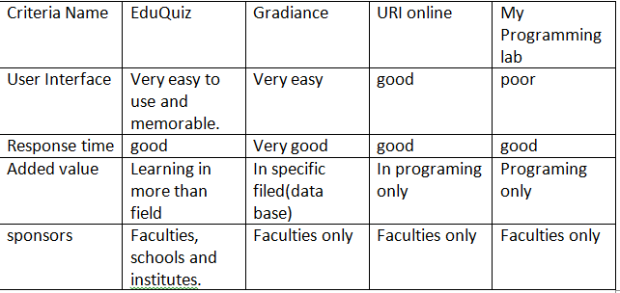

**Sequence diagram**

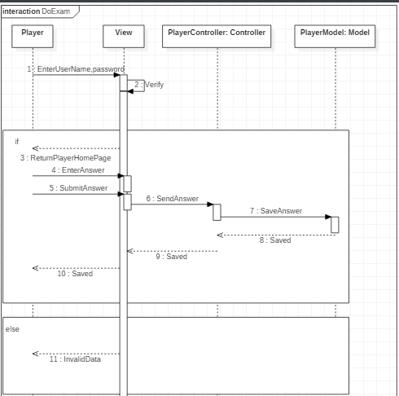

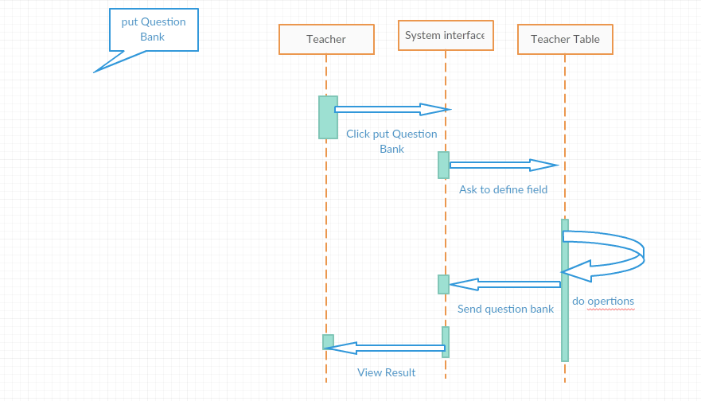

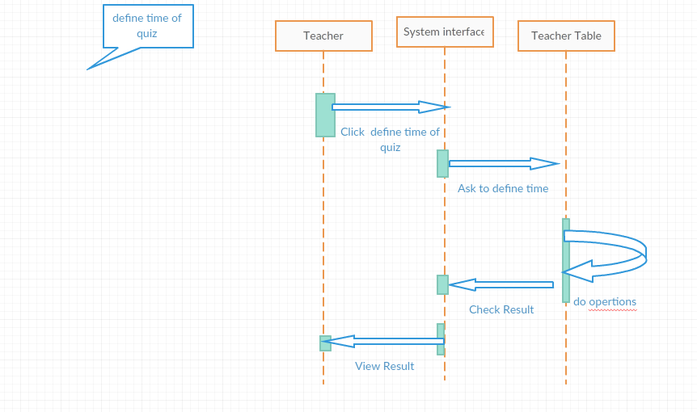

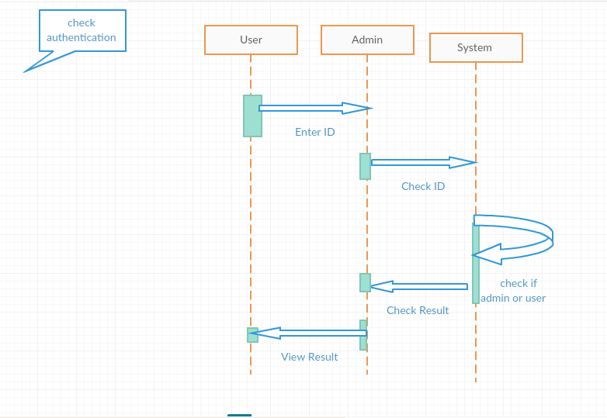

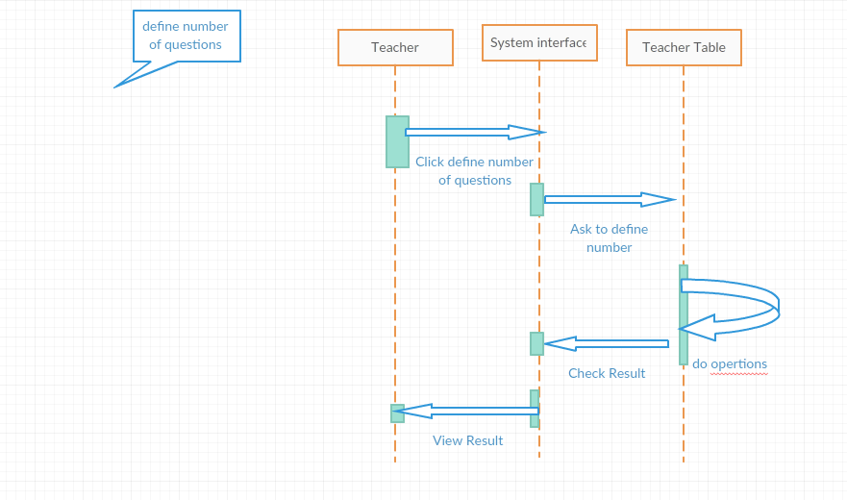

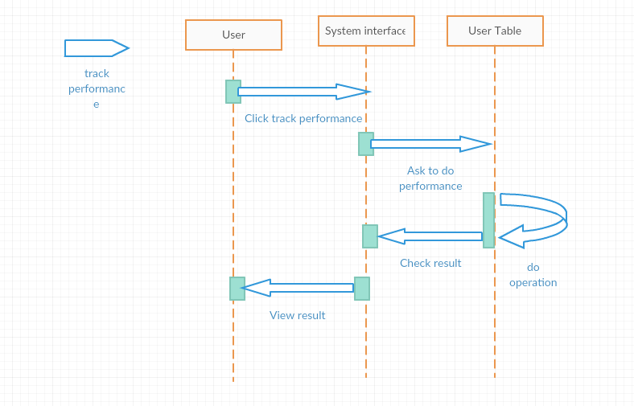

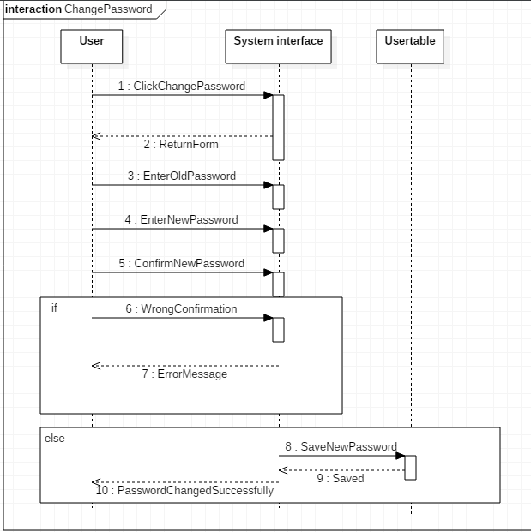

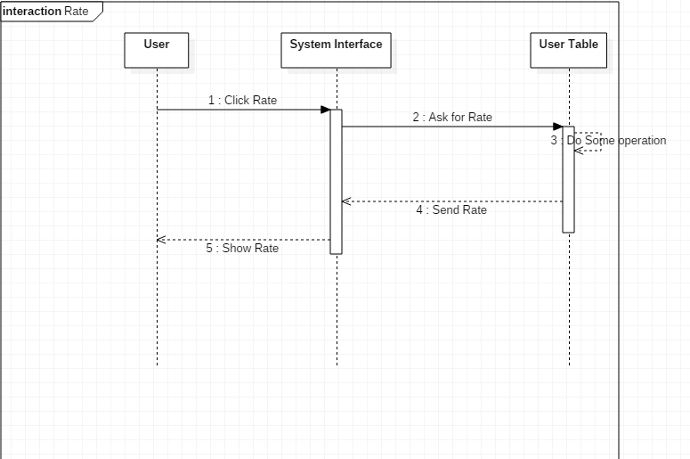

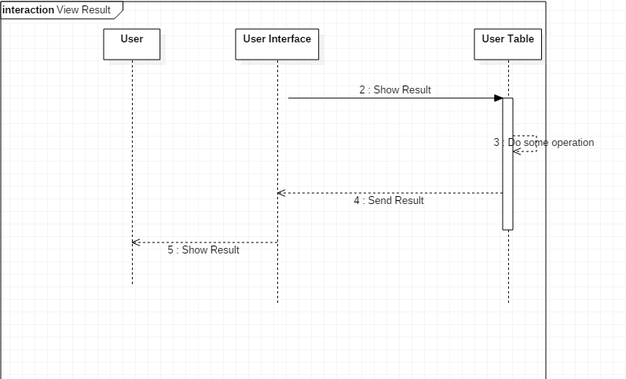

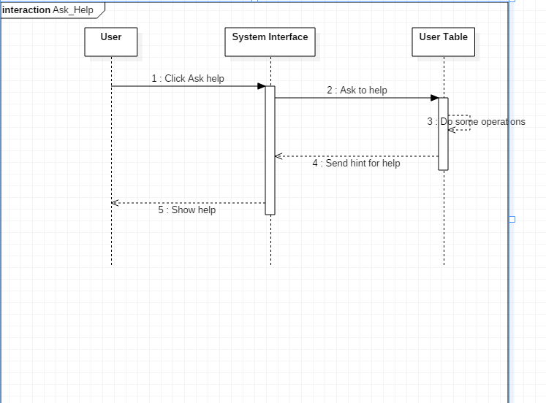

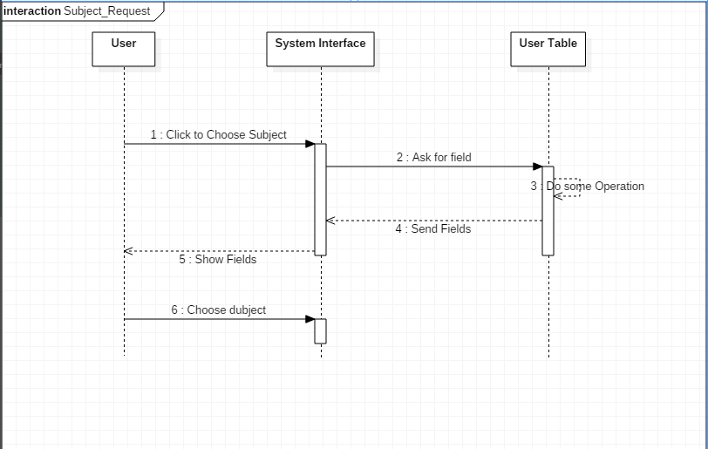

**Add question**

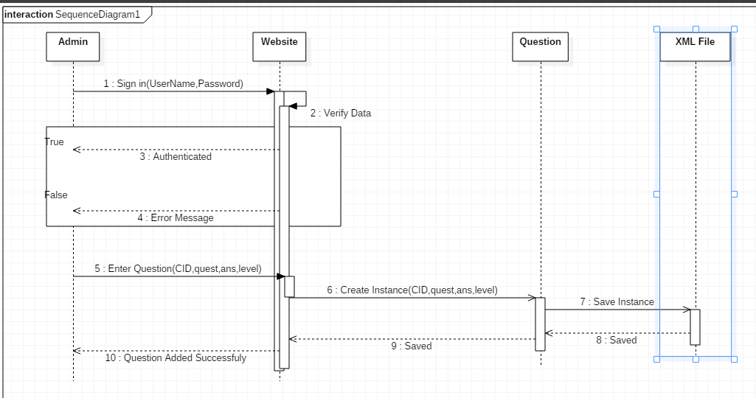

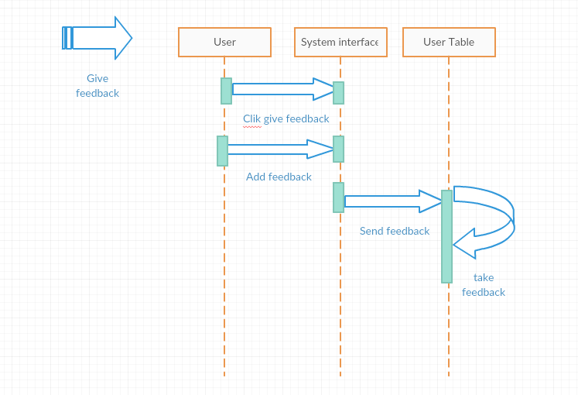

**Class diagram**

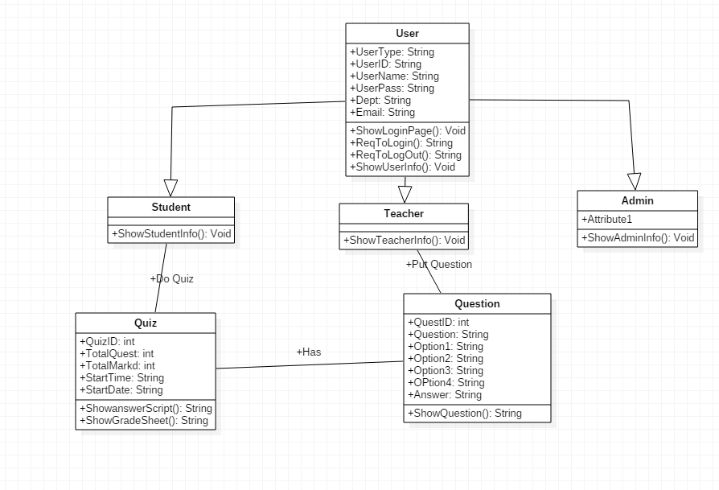

**Detailed class diagram**

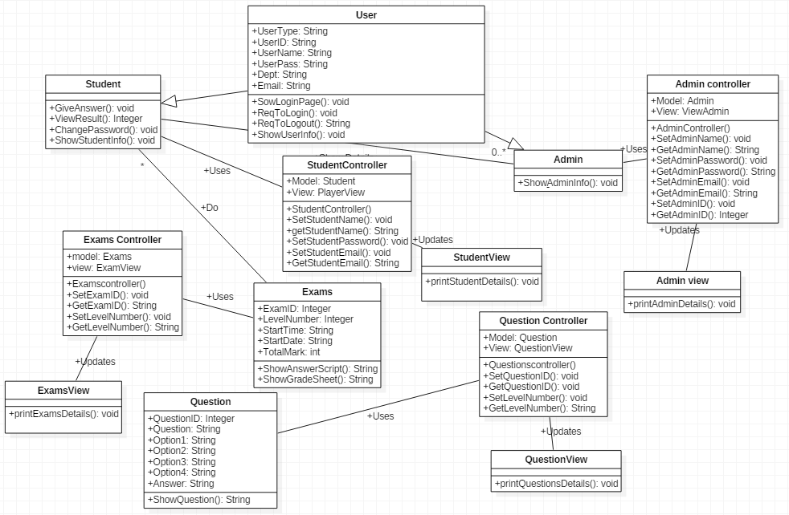

**Story board**

**Home Page**



**Registration**

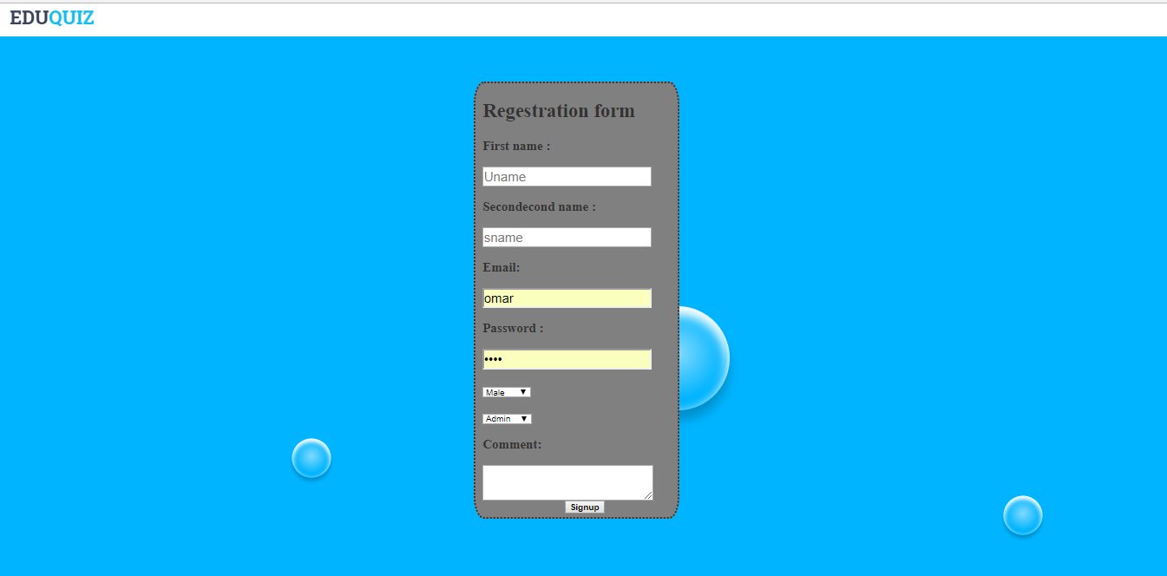

**Login**





**Do quiz**

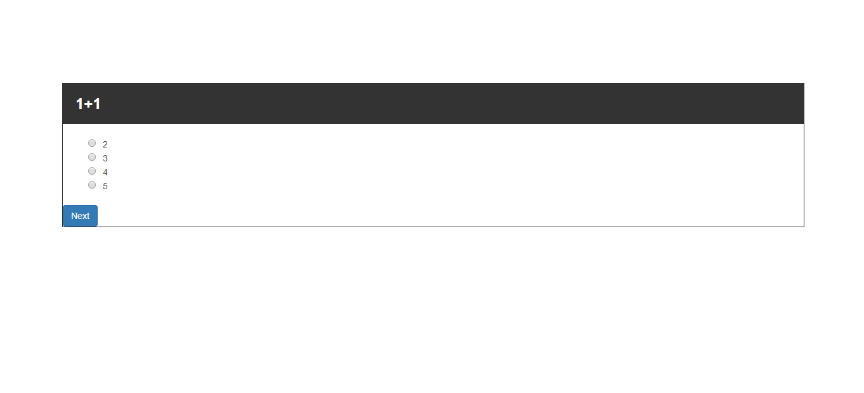

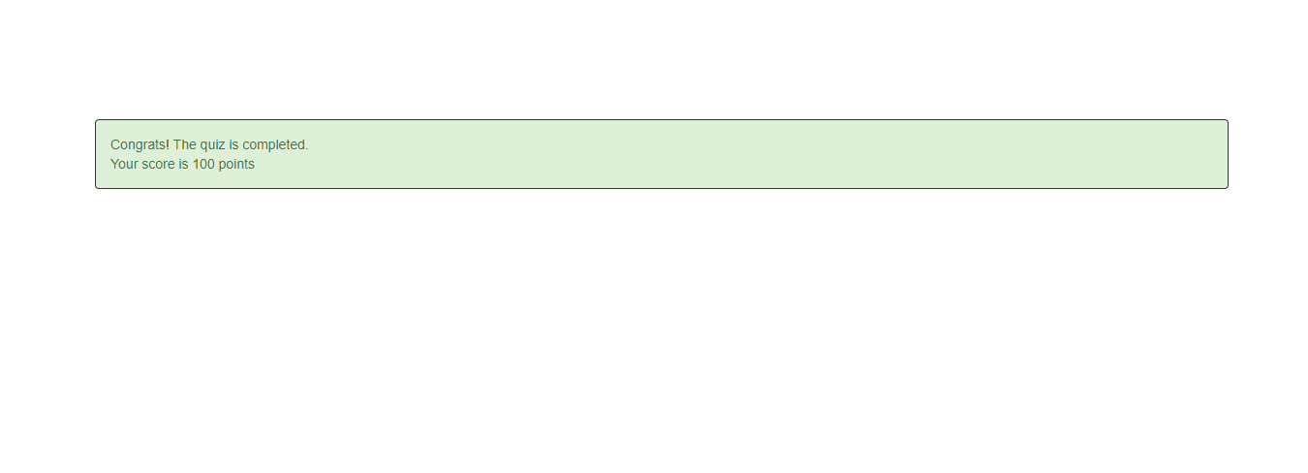

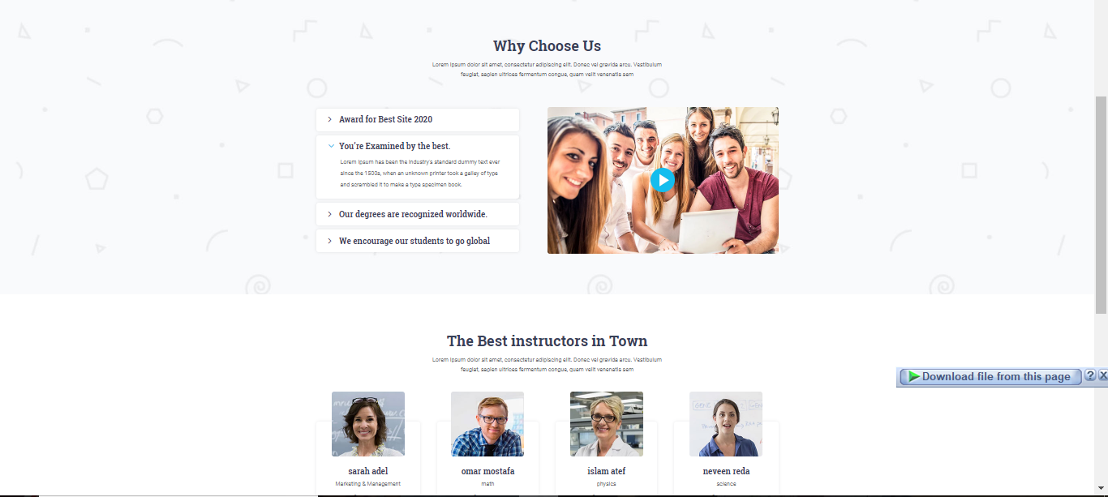

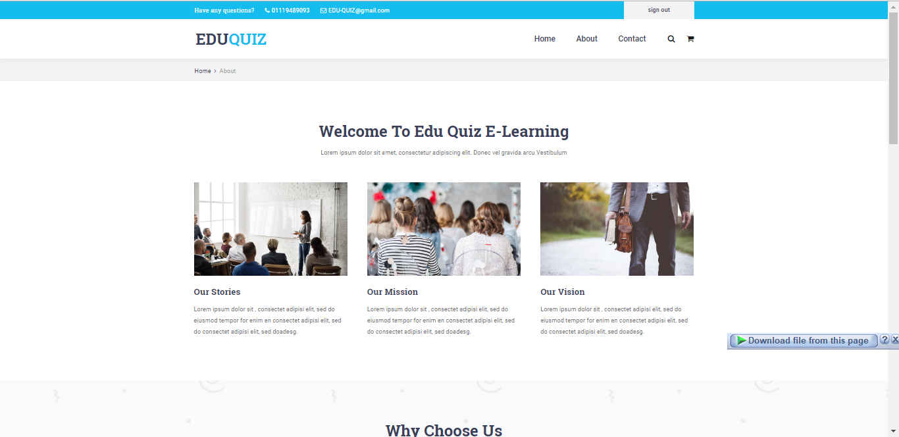



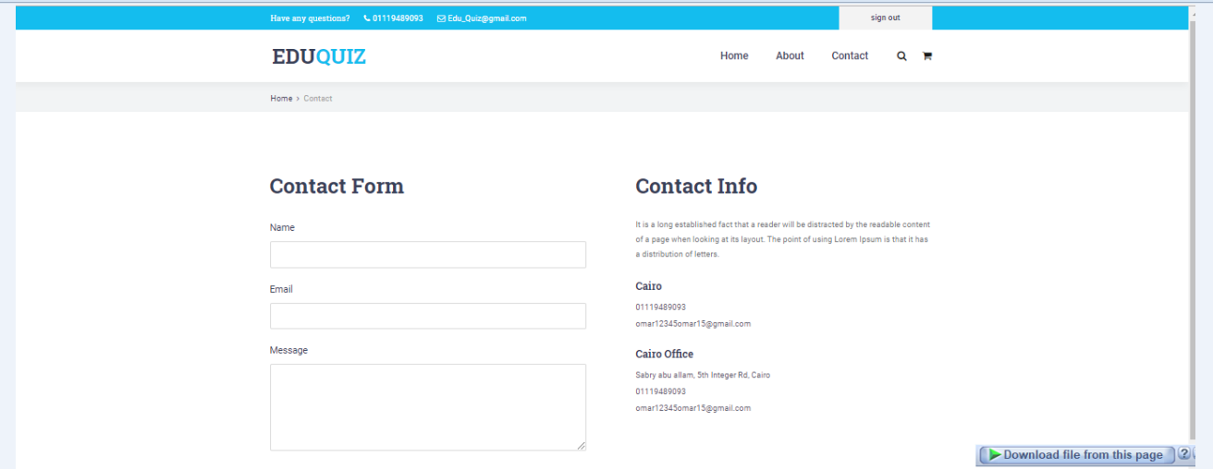

**Project management-Gantt chart**

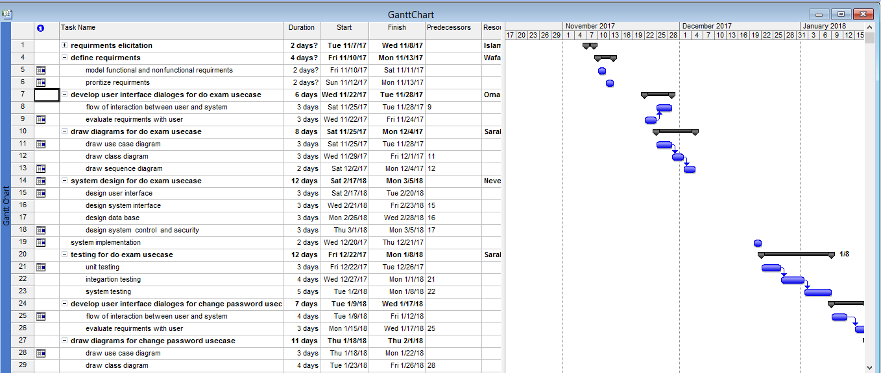

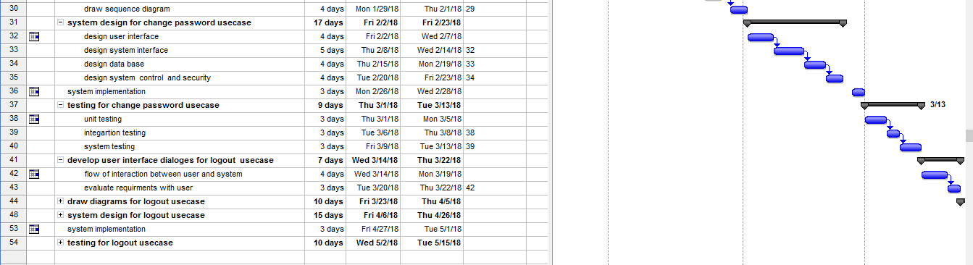

**Tree structure view**

User

Admin

(Control)

Add Question

Edit Question

View All Question

Teacher

View All User Information

Student

Start Quiz

Student

(Attend Exam)

Admin

View all user information

**Glossary**

**System**: System is a set of entities, real or abstract, comprising a whole where each component interacts with or is related to at least one other component and they all serve a common objective.

**User**: A person who uses the system. In our OIQS, there are three types of users.

**User ID**: Every user has different id, which will identify them.

**Admin**: A user who controls the whole system.

**Student:** attend the quiz.

**Question Bank**: The database where all data regarding quizzes are stored.

**Feedback**: Student gives feedback about system.