# Smart Appointment Booking System

Author: El Asri Omar

Academic Year: 2024–2025

## Abstract

The Smart Appointment Booking System is a web-based application developed using Django to simplify and optimize the process of scheduling and managing appointments for various services like sports activities, wellness sessions, and training programs. This system is designed to serve users by providing a quick and intuitive interface for booking, reviewing, and canceling appointments, while also empowering admins to manage services efficiently via the Django admin panel.

## Introduction

Manual scheduling of activities or services often leads to errors, double bookings, and inefficiency. This project addresses that problem by implementing a digital appointment management system that is fast, intuitive, and reliable. The system is ideal for sports centers, wellness institutions, and organizations that rely on fixed time slots for activities. The goal is to create a real-life, user-centered, full-stack application that integrates backend logic with user-friendly frontend design.

## Technologies Used

|  |  |
| --- | --- |
| Layer | Technology |
| Backend | Django (Python) |
| Database | SQLite (Django default) |
| Frontend | HTML5, CSS3, Bootstrap 5 |
| Authentication | Django built-in auth system |
| Messaging | Django messages framework |
| Static Content | Django static files ({% static %}) |

## System Features Overview

* User Registration and Login: Authentication using Django’s built-in user model.
* Service Display: Dynamic listing of available services with descriptions and prices.
* Booking Appointments: Users choose a date, time, and service; confirmation via form submission.
* View/Cancel Appointments: Users can manage their bookings in a dedicated section.
* Admin Panel Access: Admins can create and manage service offerings and monitor bookings.
* Success/Error Feedback: Uses Django messages to show user feedback.
* Responsive UI with Design Elements: Clean Bootstrap layout and themed background images.

## Implementation Breakdown

Models:  
- Service: Stores service name, description, duration, and price.  
- Appointment: Links a user to a service, with fields for date and time.

Views:  
- home(): Displays all available services.  
- book_appointment(): Handles the appointment form logic.  
- my_appointments(): Lists the user's upcoming bookings.  
- cancel_appointment(): Deletes a booking via POST.

Forms:  
- AppointmentForm: Handles input validation for booking (date and time).

Templates:  
- HTML pages extend from a common base.html.  
- CSS styling uses Bootstrap with background images for better user experience.

## Admin Dashboard

Admins log in through the /admin/ panel and can:  
- Add services like Personal Training, Team Yoga, Football Coaching, etc.  
- Monitor bookings made by users.  
- Manage user permissions.

## Activities/Services Examples

• Personal Training Session  
 Description: One-on-one workout with a certified personal trainer.  
 Duration: 60 minutes  
 Price: 50.00

• Yoga Class  
 Description: A group yoga session focused on flexibility and mindfulness.  
 Duration: 45 minutes  
 Price: 30.00

• Football Training  
 Description: Skill-building for beginners and intermediate players.  
 Duration: 90 minutes  
 Price: 40.00

• Nutrition Consultation  
 Description: Personalized diet planning with a certified nutritionist.  
 Duration: 30 minutes  
 Price: 35.00

• Meditation & Mindfulness Workshop  
 Description: Guided session to reduce stress and improve focus.  
 Duration: 40 minutes  
 Price: 25.00

## Screenshots

* Home Page – Displaying available services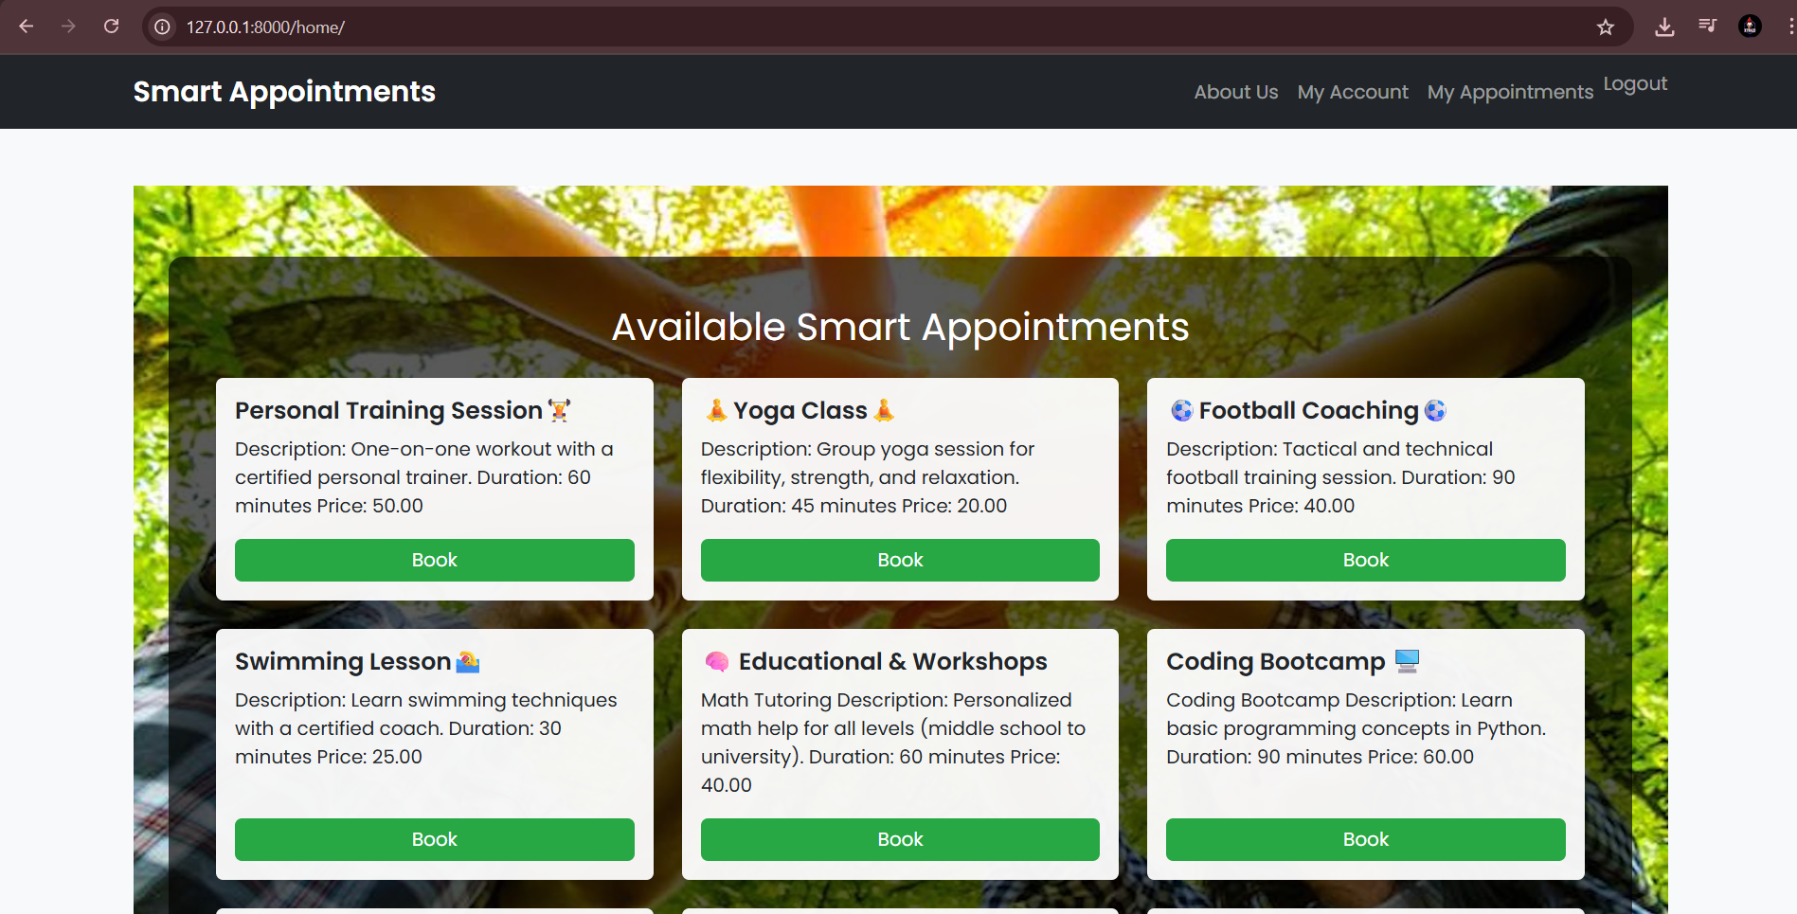
* Booking Page – Form for selecting date and time A screenshot of a computer

  AI-generated content may be incorrect.
* My Appointments Page – Booked appointments list with cancel option A screenshot of a computer

  AI-generated content may be incorrect.
* Admin Panel – Managing services A screenshot of a computer

  AI-generated content may be incorrect.

## Challenges Encountered

* NOT NULL Constraint Error: Resolved by checking form validity and ensuring fields were filled before saving.
* Cancel Button Non-functional: Required correct route linking, POST-only handling, and form wrapping around the button.
* Static Files Setup: Ensured static files were loaded using {% load static %} and correctly placed in static/booking/ directory.

## Conclusion

The Smart Appointment Booking System is a practical application of full-stack web development using Django. It demonstrates critical skills such as authentication, dynamic content rendering, user session management, and UI responsiveness. It addresses a common real-world need with flexibility and can be expanded with features like calendar selection, mobile responsiveness, and email reminders.

## Appendix

Project Structure:

smart_appointments/  
├── booking/  
│ ├── models.py  
│ ├── views.py  
│ ├── forms.py  
│ ├── templates/booking/  
│ ├── static/booking/  
├── smart_appointments/  
│ ├── settings.py  
│ ├── urls.py

Code Snippets to Highlight:

* book_appointment() view logic
* cancel_appointment() deletion logic
* Booking form with validation
* Static background integration