

**Faculty of engineering - Shoubra**

**Benha University**

# Research Project

in fulfillment of the requirements of

|  |  |
| --- | --- |
| **Department** | **Engineering Mathematics and Physics** |
| **Division** | **---------------** |
| **Academic Year** | **2019-2020 Preparatory** |
| **Course name** | **Computer** |
| **Course code** | **ECE001** |

## Title: - Build a website on recent computer engineering topics

By:

|  |  |  |  |  |
| --- | --- | --- | --- | --- |
|  | Name | Edu mail | B.N | |
| 1 | Omar Mohamed ramzy | Omar195623@feng.bu.edu.eg | | 563 |

**Approved by:**

|  |  |
| --- | --- |
| Examiners committee | Signature |
| Dr.Ahmed Bayoumi |  |
| Dr.Shady Elmashad |  |
| Dr. Abdelhamid Attaby |  |
|  |  |

**Topic:**artificial intelligence  
  
**gethub link:**<https://github.com/omarramzy11/Ai-html-project><https://omarramzy11.github.io/Ai-html-project/>  
**Application Breif:**artificial intelligence important:  
Man-made intelligence robotizes dull learning and disclosure through information. In any case, AI is not quite the same as equipment driven, mechanical mechanization. Rather than mechanizing manual assignments, AI performs visit, high-volume, automated undertakings reliably and without exhaustion. For this kind of mechanization, human request is as yet essential to set up the system and pose the correct inquiries.  
Computer based intelligence adds intelligence to existing items. As a rule, AI won't be sold as an individual application. Or maybe, items you as of now use will be improved with AI capacities, much like Siri was added as an element to another age of Apple items. Mechanization, conversational stages, bots and shrewd machines can be joined with a lot of information to improve numerous advances at home and in the working environment, from security intelligence to venture investigation.  
Computer based intelligence adjusts through dynamic learning calculations to let the information do the programming. Computer based intelligence discovers structure and regularities in information with the goal that the calculation gets an ability: The calculation turns into a classifier or an indicator. In this way, similarly as the calculation can show itself how to play chess, it can show itself what item to suggest next on the web. What's more, the models adjust when given new information. Back engendering is an AI procedure that permits the model to alter, through preparing and included information, when the primary answer isn't exactly right.  
  
  
  
  
  
  
  
screenshots:  
  
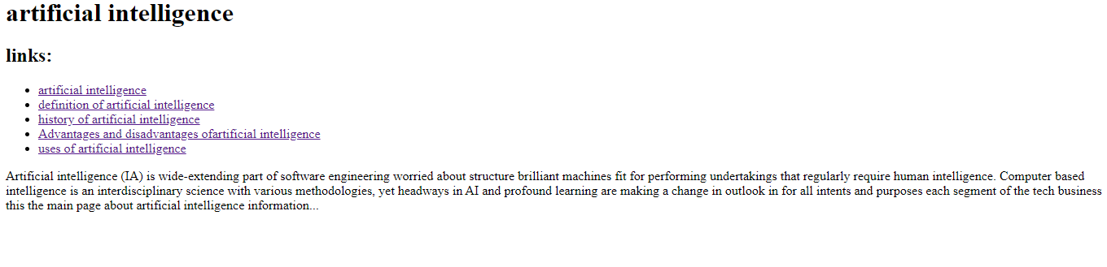

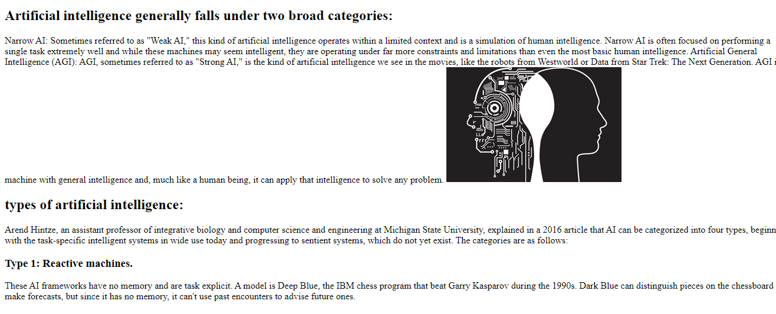  
  
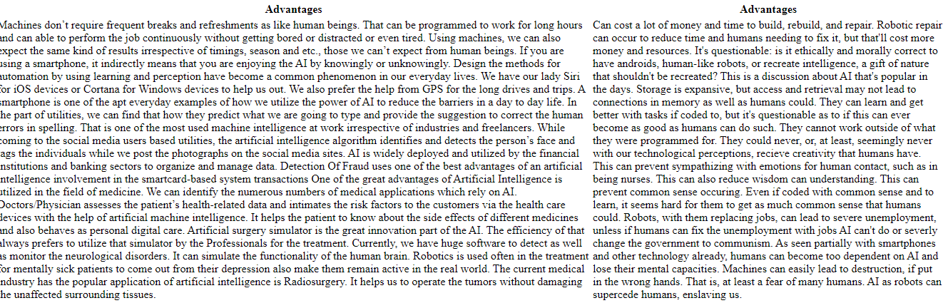  
  
  
source code:  
