Kinematic Model of the AL5D Arm: Verification Evidence
Robotic Arm 7E · Golf Ball Teeing Robot · UFMFV8-15-3 GDIP
Author | Omar, Robotics (control software and integration lead)
Version | 1.0
Date | 1 November 2026
Status | Model complete and verified in software. Calibration and physical testing on the real arm still to do.
Files | al5d_kinematics.zip: al5d_main.m, al5d_params.m, al5d_fk.m, al5d_fk_dh.m, al5d_ik.m, al5d_angles_to_ssc32.m, al5d_static_torque.m, al5d_test_on_arm.m, README.txt

Version history
Version | Date | What changed | Section
1.0 | 1 Nov 2026 | First issue: model, data sources, verification tests VER‑K1 to VER‑K5, planned tests | All
How this document is updated: earlier versions are never overwritten. Each update adds a new section at the end (“Update for version 1.x”) recording what changed, the old and new input values, the old and new results, and any test whose status changed. Sections 1 to 7 stay as the version 1.0 record.

1. Summary
This document records the kinematic model built for the team’s Lynxmotion AL5D arm, the data it uses, how it works, and the evidence that it is correct.
The model answers three questions the project needs answered before the arm can be built and programmed:
- Is the maths right? Yes. The forward kinematics was calculated two independent ways, and both agree to within 10⁻¹² mm over 2,000 random poses. The inverse kinematics was tested on 1,000 targets and returned every one to within 10⁻¹² mm. Both tests PASS.
- Can the standard arm meet the brief’s 50 cm working envelope? No. With the gripper pointing straight down to pick a ball off the table, the furthest the arm reaches is 340.5 mm. Every gripper angle tested falls short of 500 mm. A reach extension is needed: about 182 mm if picking from above, 120 mm at 45° or 98 mm from the side.
- Are the servos strong enough with that extension? Only just. With a 182 mm extension holding a ball at 520 mm, the shoulder servo works at 51% and the elbow at 55% of their stall torque, slightly above the 50% guideline for continuous holding.
These results feed directly into the mechanical team’s decisions on the gripper angle, the extension length and the extension’s weight.

2. Why this work was needed
The project brief (§5.3) requires a working envelope radius of at least 50 cm from the centre of the arm’s base to the object being picked. It also requires the arm to be controlled by the team’s own software, which must be able to move the gripper to a given position. Moving the gripper to a position needs inverse kinematics, and showing the 50 cm requirement is met needs forward kinematics. Both were taught in the module’s Kinematics Part 1 and Part 2 lectures.
The model also gives early verification evidence. The module’s V&V lectures recommend verifying designs by analysis and simulation before hardware is built, because problems are cheaper to fix then.
Brief requirement | How this model addresses it
§5.3 Working envelope ≥ 50 cm | Calculates the reach and the extension needed (Test VER‑K3)
§5.4.1 Mechanical: show the design works “across all relevant operating conditions” | Static torque check at full reach (Test VER‑K4)
§5.3 Teach mode and teleoperation; §5.4.3 software | Provides the inverse kinematics and angle-to-pulse conversion the control software will use (Tests VER‑K2, VER‑K5)
§4 AI integration | Provides the reachability and joint-limit check that will be used to reject unsafe AI-generated positions

3. The arm and the data used

3.1 The arm
The team’s arm is the 5-servo AL5D: base rotation, shoulder, elbow, wrist tilt and gripper. It has no wrist-rotate servo, as confirmed by a team member on 1 November 2026. The only CAD model available online is the 6-servo version with a wrist rotate, so data from that model was used only for the parts that are the same on both versions.
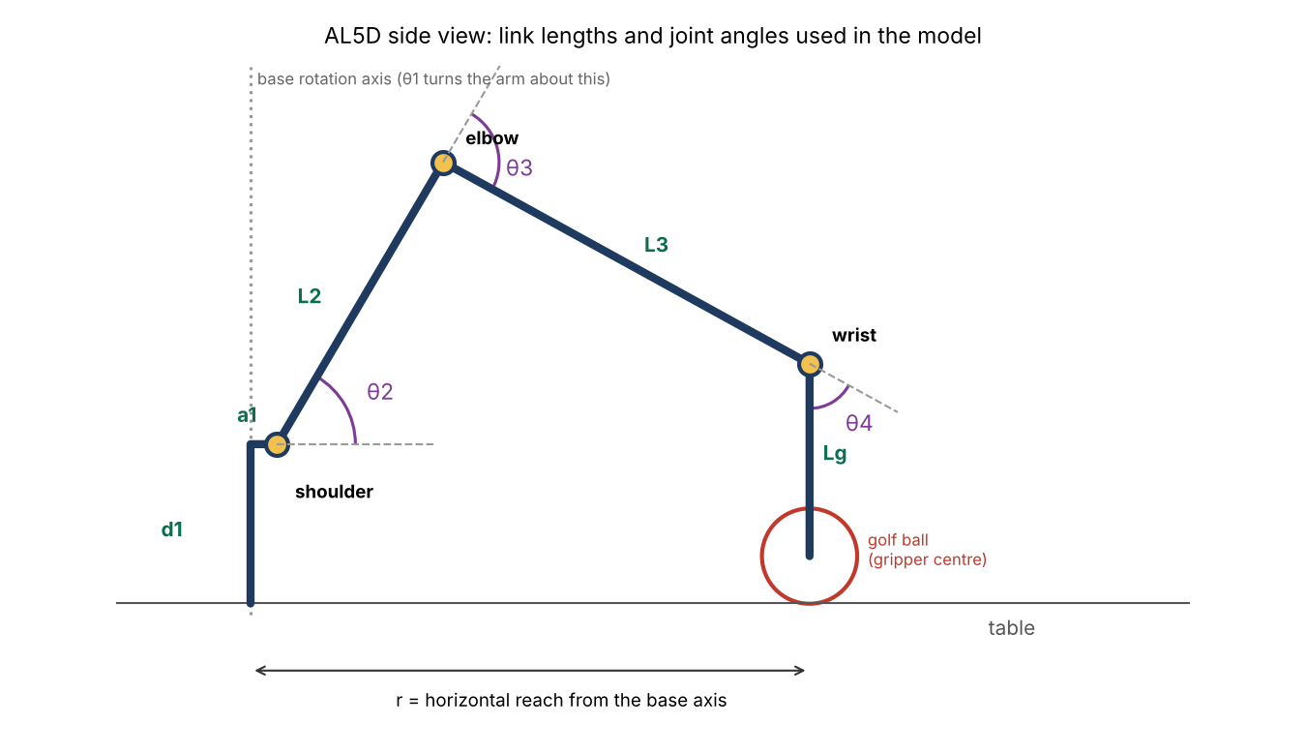
Figure 1. The link lengths and joint angles used in the model. The pose shown is the arm picking a ball at 250 mm.

3.2 Link lengths
Symbol | What it is | Value used | Source
d₁ | Height from the base underside to the shoulder joint | 71.2 mm | Lynxmotion AL5D CAD (STEP file), measured between joint centres
a₁ | How far the shoulder joint sits in front of the base rotation axis | 11.9 mm | Lynxmotion CAD. This was not in the published numbers and adds reach
L₂ | Shoulder to elbow | 146.3 mm | Lynxmotion CAD. Agrees with the official 5.75 in (146.1 mm)
L₃ | Elbow to wrist | 187 mm | Lynxmotion’s official AL5D breakdown sheet (7.375 in). The 6-servo CAD gives 180.7 mm, so this must be measured on the real arm
Lg | Wrist to gripper centre | 86 mm | Lynxmotion breakdown sheet, “wrist to tip of gripper” 3.375 in. Will change when the custom claws are fitted
The base, shoulder and elbow are identical on both arm versions, so their CAD values were used. The wrist end differs, so the official sheet for the 5-servo arm was used there instead.

3.3 Servos
Joint | Channel | Servo | Stall torque at 6 V | Degrees per µs of pulse
Base | 0 | HS-485HB | 6.0 kg·cm | 0.102 °/µs, so 9.8 µs per degree
Shoulder | 1 | HS-805BB | 24.7 kg·cm | 45° per 400 µs, so 8.9 µs per degree
Elbow | 2 | HS-755HB | 13.2 kg·cm | 45° per 400 µs, so 8.9 µs per degree
Wrist | 3 | HS-645MG | 9.6 kg·cm | 45° per 400 µs, so 8.9 µs per degree
Gripper | 4 | HS-422 | 3.9 kg·cm | n/a (only open or closed)
Stall torques come from the team’s AL5D servo spreadsheet. Pulse rates come from the Hitec datasheets. All the servos are centred at 1500 µs. The channel numbers follow the Lynxmotion breakdown sheet.

3.4 Golf ball and gripper
- Golf ball: diameter at least 42.67 mm and mass at most 45.93 g (R&A Rules of Equipment, Part 4). The model uses the largest mass and assumes a ball resting on the table, so its centre is 21.3 mm above the surface.
- Standard gripper: opens to only 1.25 in (31.8 mm), according to the Lynxmotion sheet. That is smaller than a golf ball, so the team’s custom claws are essential, not optional.
- Custom claws (team CAD, ClawTipv6 and ClawBracketv1): the claw tip is a curved arc 55.8 mm across, volume 2.76 cm³ (about 3 g printed solid). The bracket is 25.4 × 19.1 mm with two holes 12.7 mm apart, volume 1.63 cm³ (about 2 g). Two curved tips facing each other cup the ball and centre it as they close.
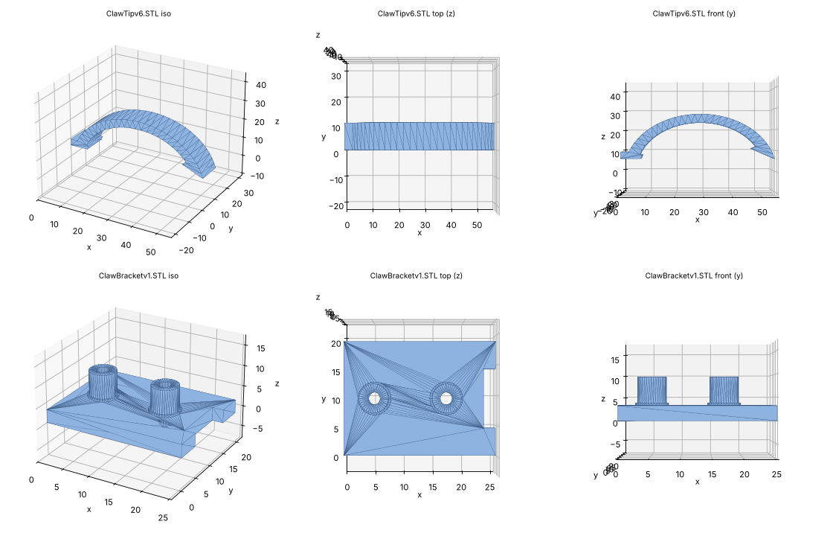
Figure 2. The team’s custom claw tip (top) and mounting bracket (bottom), rendered from the STL files.

3.5 Masses for the torque check
Item | Mass (g) | Source
Golf ball | 45.93 | R&A maximum
Elbow servo (HS-755HB) | 110 | Hitec datasheet
Wrist servo (HS-645MG) | 55 | Hitec datasheet
Gripper servo (HS-422) | 46 | Hitec datasheet
Claw end piece | 5 | Team estimate
Upper arm tube and brackets | 60 | Estimate
Forearm tube and brackets | 50 | Estimate
Reach extension | 40 | Estimate (mechanical team to confirm)

4. How the model works

4.1 Angle convention
All angles are in degrees. Figure 1 shows each one.
- θ₁, base: the direction the arm points, seen from above. 0° is straight ahead.
- θ₂, shoulder: the upper arm’s angle above horizontal. 90° is straight up.
- θ₃, elbow: the forearm’s angle relative to the upper arm. 0° is straight in line; negative means bent downwards.
- θ₄, wrist: the gripper’s angle relative to the forearm.
- φ = θ₂ + θ₃ + θ₄, gripper pitch: the gripper’s angle relative to horizontal. −90° means pointing straight down.

4.2 Forward kinematics: from joint angles to gripper position
Forward kinematics answers “if the joints are at these angles, where is the gripper?” Seen from the side, each link adds its length in the direction it points:
r = a₁ + L₂·cos θ₂ + L₃·cos(θ₂ + θ₃) + Lg·cos φ
z = d₁ + L₂·sin θ₂ + L₃·sin(θ₂ + θ₃) + Lg·sin φ
Here r is the horizontal distance from the base axis and z the height. The base angle then turns that side view into a 3D position: x = r·cos θ₁ and y = r·sin θ₁.
Second method (Denavit–Hartenberg). As an independent check, the same arm was also modelled with the standard Denavit–Hartenberg method from the Kinematics Part 2 lecture. Each joint is described by four numbers, and the gripper position comes from multiplying 4×4 transformation matrices:
Joint n | aₙ (mm) | αₙ | dₙ (mm) | θₙ
1 (base) | a₁ = 11.9 | 90° | d₁ = 71.2 | θ₁
2 (shoulder) | L₂ = 146.3 | 0° | 0 | θ₂
3 (elbow) | L₃ = 187 | 0° | 0 | θ₃
4 (wrist) | Lg = 86 | 0° | 0 | θ₄
T = A₁·A₂·A₃·A₄, where Aₙ = Rz(θₙ)·Tz(dₙ)·Tx(aₙ)·Rx(αₙ)
Because the two methods are calculated in completely different ways, agreement between them is strong evidence that both are right (Test VER‑K1).

4.3 Inverse kinematics: from gripper position to joint angles
Inverse kinematics is the reverse: “to put the gripper at this position, what angles do the joints need?” It’s what the robot actually uses to pick up a ball. The model uses the exact (closed-form) geometric method from Kinematics Part 1, in four steps:
- Base angle from the top view: θ₁ = atan2(y, x).
- Find the wrist. Step back from the gripper centre along the gripper’s direction: r_w = r − a₁ − Lg·cos φ and z_w = z − d₁ − Lg·sin φ.
- Solve the upper arm and forearm as a triangle with the cosine rule: D = (r_w² + z_w² − L₂² − L₃²) / (2·L₂·L₃), then θ₃ = −arccos D and θ₂ = atan2(z_w, r_w) − atan2(L₃·sin θ₃, L₂ + L₃·cos θ₃).
- Wrist angle to give the required gripper pitch: θ₄ = φ − θ₂ − θ₃.
If |D| > 1, the triangle can’t be made, meaning the target is out of reach. The code reports this, and also rejects any answer that would push a joint past its limits. This check is what will later protect the arm from unreachable positions, including ones suggested by the AI.
Of the two possible solutions (elbow up or elbow down), the code always uses elbow up. That keeps the forearm clear of the table.

4.4 Converting angles to servo pulses
Each servo is controlled by a pulse, 50 times a second. The pulse length sets the angle:
p = p_centre + s·(θ − θ_centre)·k
- p_centre is the pulse that puts the joint at a known angle θ_centre (1500 µs for these servos).
- k is the µs per degree from §3.3.
- s = ± 1 is the direction the joint turns as the pulse increases.
Every output is then clamped to 900–2100 µs, the Hitec datasheet range, so a calculation error can never drive a servo past its safe range. The function also builds the SSC-32U command string, for example #0P1500#1P1229#2P1515#3P955#4P1200T1500.
Important: p_centre, θ_centre and s depend on how each servo horn was fitted when the arm was assembled, so they are different on every arm. They can only be found by testing the real arm (§7). Until then they are placeholders.

4.5 Static torque check
To check the servos can hold the arm still, each part’s weight is multiplied by its horizontal distance from the joint. Each link’s mass is treated as sitting at its midpoint, and each servo at its joint:
τ_joint = Σ mᵢ·xᵢ (sum over every part i)
With masses in kg and distances in cm, the result is in kg·cm, the same unit as the servo datasheets. It is compared with each servo’s stall torque. A common rule of thumb is to keep continuous holding torque below 50% of stall, so the servo doesn’t overheat. This is a first estimate. The mechanical team’s FEA and hand calculations will refine it.

5. Verification tests and results
The model was run in MATLAB on 1 November 2026, with the parameters in §3. The full output is in Appendix A. The tests are laid out in the format of the module’s V&V example.

5.1 Verification cases
Case | Description | Method type | Success criterion | Input | Result
VER‑K1 | Forward kinematics: geometric method vs Denavit–Hartenberg method | Analysis and testing (white-box) | Max difference < 10⁻⁶ mm | 2,000 random joint poses within the joint limits | Max difference 1.28 × 10⁻¹³ mm. PASS
VER‑K2 | Inverse kinematics round trip: IK, then FK, back to the starting target | Analysis and testing (white-box) | Max position and pitch error < 10⁻⁶ | 1,000 random reachable targets, gripper vertical | Max error 1.39 × 10⁻¹³. PASS
VER‑K3 | Working envelope of the unmodified arm against brief §5.3 | Analysis (simulation) | Pick radius ≥ 520 mm (500 mm + 20 mm margin) | Ball on the table; gripper at −90°, −45° and 0° | 340.5 / 405.5 / 424.0 mm. FAIL, as expected without an extension. Gives the extension length needed (§5.2)
VER‑K4 | Static holding torque | Analysis | Below 50% of stall at every joint | Case 1: unmodified arm at full reach. Case 2: arm with a 182 mm extension at 520 mm | Case 1: 33% / 25% / 0%, PASS. Case 2: 51% / 55% / 0%, FAIL (just over)
VER‑K5 | Servo pulse safety clamp | Testing (white-box) | No command outside 900–2100 µs | The generated pick-and-place sequence | Base at 90° would need about 2,382 µs and was output as 2100. Wrist at −78° would need about 807 µs and was output as 900. Clamp works. PASS
Why the tiny errors in VER‑K1 and VER‑K2 count as zero: values around 10⁻¹³ mm are the rounding limit of computer arithmetic, a billion times smaller than anything a servo could position. They show the equations are exactly consistent.
Why the wrist torque is 0% in VER‑K4: with the gripper pointing straight down, the ball and gripper hang directly below the wrist joint, so their weight has no lever arm about it. If the team picks from the side instead, wrist torque will no longer be zero and must be rechecked.

5.2 Working envelope and the extension needed
How the gripper picks the ball | Furthest reach now | Extension needed (minimum, arm dead straight) | Extension needed (practical, elbow bent ≥ 20°)
From above (−90°) | 340.5 mm | 176 mm | 182 mm
At an angle (−45°) | 405.5 mm | 114 mm | 120 mm
From the side (0°) | 424.0 mm | 92 mm | 98 mm
Why the picking angle matters so much: when the gripper points down, its 86 mm length hangs below the wrist and adds nothing to the reach. When it points sideways, all 86 mm adds to the reach. So picking from the side needs an extension almost half as long as picking from above.
Why “practical” rather than “minimum”: the minimum value only works with the arm locked dead straight. That is a singular position: the arm can’t move smoothly away from it, and the motor load is at its highest. Keeping the elbow bent by at least 20° avoids both problems for about 6 mm more extension.
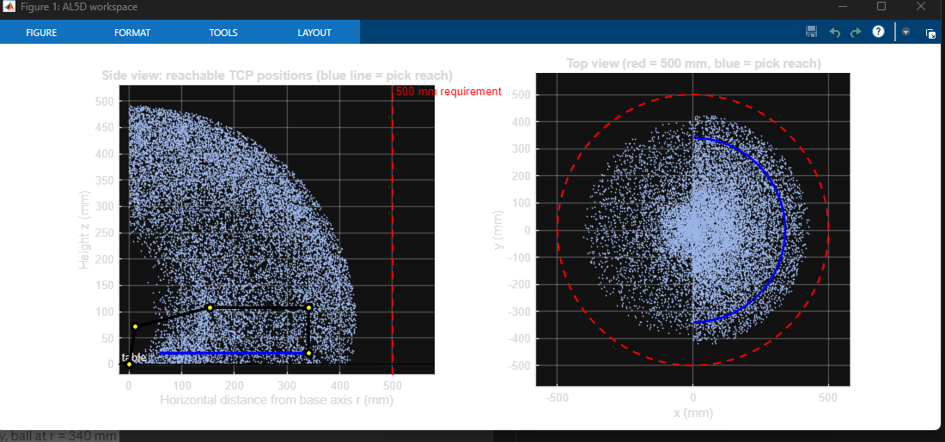
Figure 3. MATLAB output: every position the gripper can reach. Left: side view, with the arm drawn at its furthest pick (yellow and black) and the pick reach as a blue line. Right: top view. The red line and circle mark the 500 mm requirement.

5.3 What the results mean for the design
- An extension is essential. No gripper angle meets 500 mm without one. This confirms the brief’s statement that at least one mechanical change is needed.
- The gripper angle should be decided before the extension length. Picking at an angle or from the side cuts the extension by 60–85 mm, which also reduces the motor load.
- The motor load is borderline with the longest extension: shoulder 51%, elbow 55%. Ways to bring it under 50%: a shorter extension (by changing the picking angle), lighter extension and claw parts, a rack that holds the balls higher, or a spring or counterweight on the shoulder.
- The standard gripper can’t hold a golf ball (31.8 mm opening against a 42.7 mm ball), so the custom claws must open to at least about 48 mm.

6. Assumptions and limitations
Assumption or limitation | Effect | How it will be resolved
Servo calibration (centre angle and direction) is a placeholder | Generated commands would move the real arm to the wrong angles | Calibrate on the real arm (§7, step 2)
L₃ is 187 mm (official sheet) but 180.7 mm in the 6-servo CAD | Reach could be up to about 6 mm less than calculated | Measure with a ruler (§7, step 1)
Lg = 86 mm is for the standard gripper | The custom claws will change the reach and extension figures | Teammate to measure claw mount to ball centre in SolidWorks
Link and extension masses are estimates | Torque results are approximate | Weigh the parts; the mechanical team’s FEA
The joint limits are placeholders (±90°, etc.) | Some reachable poses may be wrongly accepted or rejected | Measure each joint’s safe range during calibration
The ball is assumed to rest on the table (centre at 21.3 mm) | Picking from a raised rack changes the reach | Update P.z_pick once the rack design is fixed
Static analysis only (arm holding still) | Doesn’t include extra load while accelerating | Use slow, smooth moves; dynamic effects are covered in the FEA

7. Next steps (planned verification)
Step | Test | Method | Success criterion | Evidence produced
1 | VER‑K6: measure elbow to wrist on the real arm | Inspection | Agrees with the model value within ±2 mm, otherwise the model is updated | Photo and measurement
2 | VER‑K7: servo calibration: each joint’s angle at 1500 µs, its direction, and its safe pulse range | Testing on the real arm (SSC-32U) | Every joint mapped; limits recorded | Calibration table
3 | VER‑K8: position accuracy, using al5d_test_on_arm.m to move to 5 points | Testing on the real arm | Position error ≤ 10 mm (proposed) | arm_test_log.csv
4 | VER‑K9: rerun VER‑K3 and VER‑K4 with the real extension, claw length and masses | Analysis | Reach ≥ 520 mm and torque < 50% of stall | Updated MATLAB output
5 | VAL‑K1: demonstrate picking a ball at ≥ 500 mm from the base centre | Demonstration (black-box validation) | Ball picked and placed on the tee | Video and measurement

Appendix A. Full MATLAB output (1 November 2026)
=== AL5D model: d1=71.2 a1=11.9 L2=146.3(+0) L3=187(+0) Lg=86 mm ===
[1] FK check (geometry vs DH), 2000 random poses: max difference = 1.28e-13 mm -> PASS
[2] Reach check: ball centre at z = 21.3 mm, target r = 520 mm (500 + 20 margin)
Pick pitch max r (mm) >=520? ext. min (mm) ext. practical
-90 deg (from above) * 340.5 FAIL 176 182
-45 deg 405.5 FAIL 114 120
+0 deg (from side) 424.0 FAIL 92 98
* = pitch selected in al5d_params (P.phi_pick). Extension figures assume Lg = 86 mm,
joint limits ignored for the extension sizing; "practical" keeps the elbow bent >= 20 deg.
[4] IK round-trip test: 1000 reachable targets, max position/pitch error = 1.39e-13 -> PASS
[5] Pick-and-place sequence (send each line to the SSC-32U, ending with CR):
Above rack q = [ 0.0 67.8 -79.9 -77.9] -> #0P1500#1P1302#2P1589#3P900#4P1200T2000
Down to ball q = [ 0.0 59.5 -88.3 -61.2] -> #0P1500#1P1229#2P1515#3P955#4P1200T1500
Grip q = [ 0.0 59.5 -88.3 -61.2] -> #0P1500#1P1229#2P1515#3P955#4P1900T800
Lift q = [ 0.0 67.8 -79.9 -77.9] -> #0P1500#1P1302#2P1589#3P900#4P1900T1500
Above tee q = [ 90.0 69.3 -74.1 -85.2] -> #0P2100#1P1316#2P1641#3P900#4P1900T2000
Down to tee q = [ 90.0 63.7 -85.8 -68.0] -> #0P2100#1P1266#2P1538#3P900#4P1900T1500
Release q = [ 90.0 63.7 -85.8 -68.0] -> #0P2100#1P1266#2P1538#3P900#4P1200T800
Retreat q = [ 90.0 69.3 -74.1 -85.2] -> #0P2100#1P1316#2P1641#3P900#4P1200T1500
!! Calibration in al5d_params.m is PLACEHOLDER. Calibrate before sending to the arm.
[6] Static holding torque (masses partly ESTIMATED - weigh the parts):
Case 1: current geometry, ball at r = 340 mm
Shoulder (HS-805BB) 8.2 kg*cm of 24.7 stall = 33% -> PASS
Elbow (HS-755HB) 3.3 kg*cm of 13.2 stall = 25% -> PASS
Wrist (HS-645MG) 0.0 kg*cm of 9.6 stall = 0% -> PASS
Case 2: with 182 mm forearm extension, ball at r = 520 mm
Shoulder (HS-805BB) 12.6 kg*cm of 24.7 stall = 51% -> FAIL
Elbow (HS-755HB) 7.3 kg*cm of 13.2 stall = 55% -> FAIL
Wrist (HS-645MG) 0.0 kg*cm of 9.6 stall = 0% -> PASS
(PASS = below 50% of stall torque, a common rule for continuous holding)
[opt] Robotics Toolbox not found - skipped (not needed).
Note on section [5]: these commands use the placeholder calibration, so they are not to be sent to the arm yet. They show the code producing complete command sequences, and that the 900–2100 µs safety clamp works (VER‑K5).

Appendix B. Code files and how to run them
File | What it does
al5d_params.m | Holds every number: lengths, joint limits, servo calibration, masses. The only file that needs editing
al5d_main.m | Runs all the checks, prints the results and draws Figure 3
al5d_fk.m | Forward kinematics, geometric method (§4.2)
al5d_fk_dh.m | Forward kinematics, Denavit–Hartenberg method (§4.2)
al5d_ik.m | Inverse kinematics with reach and joint-limit checks (§4.3)
al5d_angles_to_ssc32.m | Joint angles to servo pulses and SSC-32U commands, with the safety clamp (§4.4)
al5d_static_torque.m | Holding torque at the shoulder, elbow and wrist (§4.5)
al5d_test_on_arm.m | Sends test points to the real arm and logs the measured errors (§7, step 3)
To run: open the folder in MATLAB, open al5d_main.m and press Run. No toolboxes are needed. If Peter Corke’s Robotics Toolbox is installed, an extra cross-check runs automatically.

Appendix C. Change log
Date | Change | Reason
23 Oct 2026 | First model, using Lynxmotion’s published lengths (69 / 147 / 187 / 86 mm) | Start of kinematics work
23 Oct 2026 | Gripper end-piece mass set to 5 g (was a 40 g estimate) | Team’s measured claw weight
1 Nov 2026 | d₁ = 71.2 mm, L₂ = 146.3 mm, and the 11.9 mm shoulder offset a₁ added | Measured from the Lynxmotion AL5D CAD (STEP)
1 Nov 2026 | L₃ kept at 187 mm and Lg at 86 mm (not the CAD values) | The CAD is the 6-servo wrist-rotate version. The team’s arm has 5 servos, so the official sheet was used for the wrist end
1 Nov 2026 | Pulse rates set to 9.8 / 8.9 µs per degree (was a 11.1 guess); outputs clamped to 900–2100 µs | Hitec datasheets

References
- UWE Bristol (2026). UFMFV8-15-3 Group Design and Integration Project: Project Brief, version 15.Sep.2026.a.
- Western, D. Kinematics Part 1: Fundamentals and 2D Solutions and Kinematics Part 2: A Generalised Approach. UFMFV8-15-3 lecture slides, UWE Bristol.
- Western, D. Overview of V&V, V&V Techniques and Verification & Validation 2. UFMFV8-15-3 lecture slides, UWE Bristol.
- UFMFV8-15-3 Verification & Validation Application Example (2025-26), UWE Bristol.
- Lynxmotion. AL5D Breakdown (dimensions and specifications sheet) and AL5D_2017_12_17.STEP CAD model.
- Lynxmotion. Arms example code (PS2 with SSC-32 Control.bas), GitHub: https://github.com/Lynxmotion/Arms
- Lynxmotion. SSC-32U USB Servo Controller Board User Guide.
- Hitec RCD. Datasheets for HS-485HB, HS-805BB, HS-755HB, HS-645MG and HS-422.
- The R&A. Rules of Equipment, Part 4: Conformance of Balls. https://www.randa.org/roe/the-rules-of-equipment/part-4-conformance-of-balls
- Craig, J. J. (2005). Introduction to Robotics: Mechanics and Control. Pearson.

