There exist no time that is chosen by customers more than the number of mechanics(4) except 2:30 which means no appointment will be canceled except the fifth occurrence of 2:30. Furthermore, the code outputs people with no appointments first. Because only 2:30 is selected more than once all other dates will be assigned to the first mechanic Hamdy.

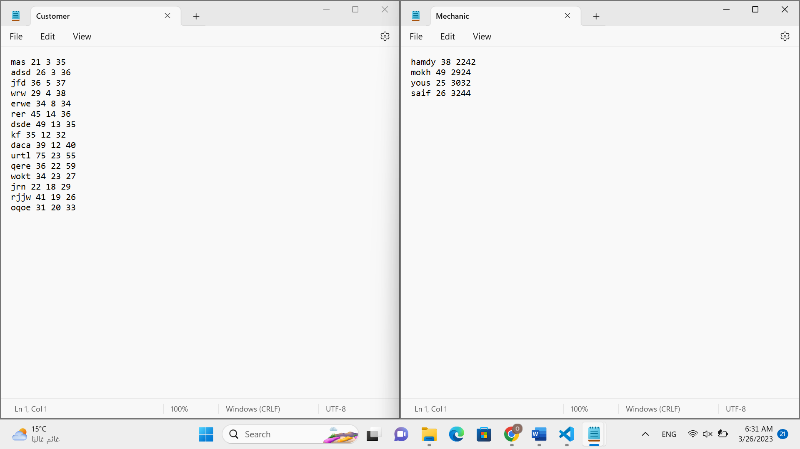

Because there exists no time that is chosen more than 4 times, no appointment will be cancelled. Because no value is chosen twice and because the number of appointments is less than 24, all appointments will be assigned to the first mechanic, hamdy.