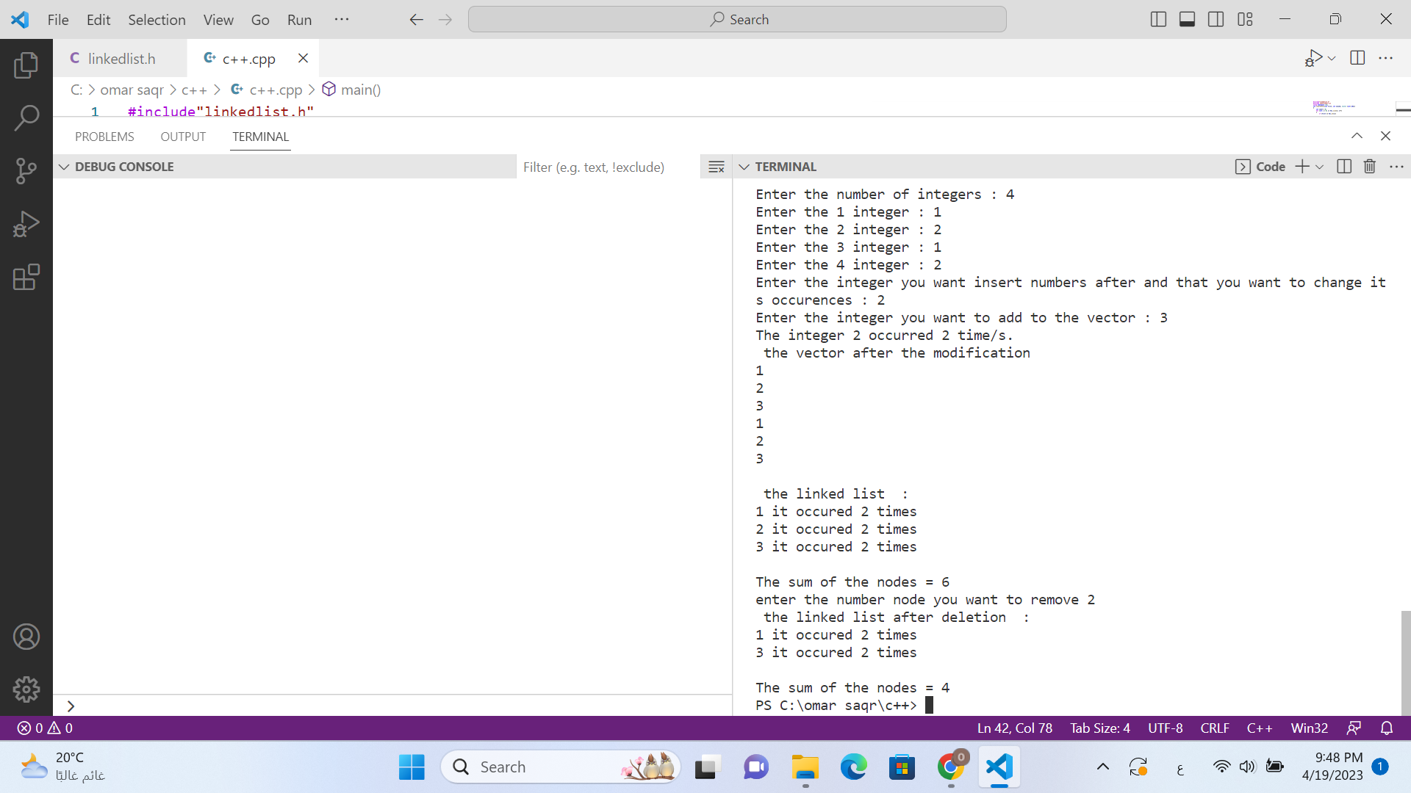

We first start by taking input from the user. The program inserts number two after each occurrence of the first number in the vector then it displays the number of occurrences of the first number and the vector after modification. A linked list is then created with the values from the vector, and each node is displayed with the number of occurrences. Then the sum of numbers in each node is displayed. Which are 1,2,3 in this case so the sum is 6. Then the user is asked about the number stored in the node he wants to remove. The user chooses to so the node that contains number 2 is removed. Then the linked list is displayed. The sum became 4 which is 3+1, the only two nodes after deletion.

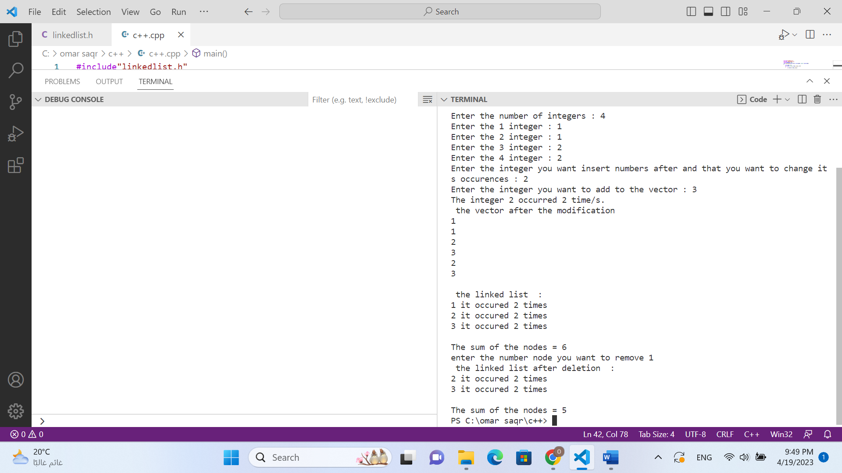

We first start by taking input from the user. The program inserts number two after each occurrence of the first number in the vector then it displays the number of occurrences of the first number and the vector after modification. A linked list is then created with the values from the vector, and each node is displayed with the number of occurrences. Then the sum of numbers in each node is displayed. Which are 1,2,3 in this case so the sum is 6. Then the user is asked about the number stored in the node he wants to remove. The user chooses to so the node that contains number 21is removed. Then the linked list is displayed. The sum became 5 which is 3+2, the only two nodes after deletion.