

Small office network

Graduation Project For DEPI



Omar shaban mohmaed ahmed

* Topology

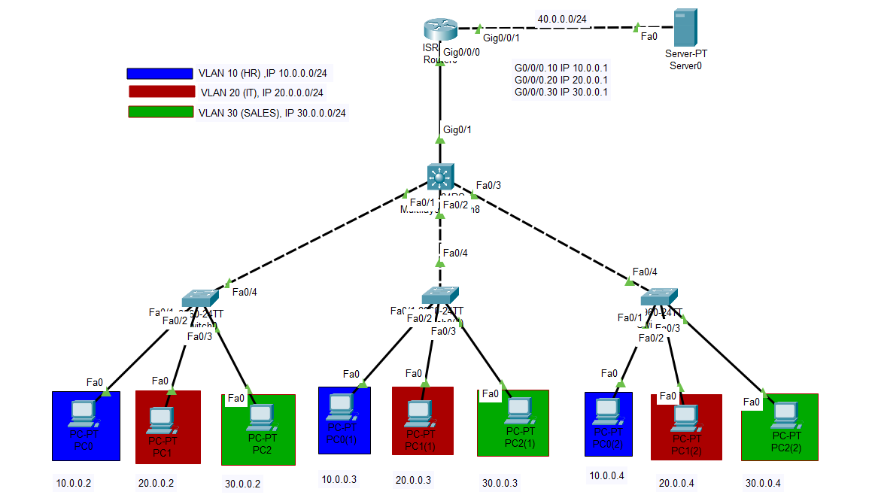

* Ips

VLAN 10 (HR) : (10.0.0.0/24)

* PC0 🡪 10.0.0.2
* PC0(1) 🡪 10.0.0.3
* PC0(2) 🡪 10.0.0.4

VLAN 20 (IT) : (20.0.0.0/24)

* PC1 🡪 20.0.0.2
* PC1(1) 🡪 20.0.0.3
* PC1(2) 🡪 20.0.0.4

VLAN 30 (SALES) : (30.0.0.0/24)

* PC2 🡪 30.0.0.2
* PC2(1) 🡪 30.0.0.3
* PC2(2) 🡪 30.0.0.4

VLANs Gateway Ips On Router :

* G0/0/0.10 🡪 10.0.0.1
* G0/0/0.20 🡪 10.0.0.2
* G0/0/0.30 🡪 10.0.0.3

Interfaces :

* G0/0/1 On router 🡪 40.0.0.2
* Server Interface 🡪 40.0.0.1
* Configurations
* Access Switches

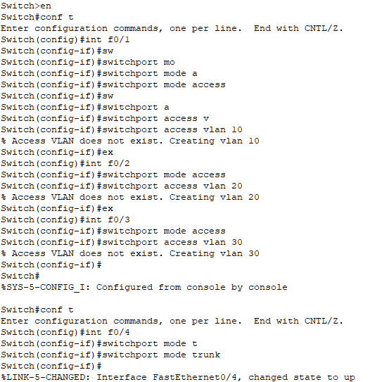

Creating VLANs and set the ports into it also set ports trunk and access

* Distribution Switch

Set ports connected to switches as trunk ports

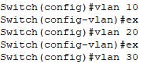

Creating VLANs

* Router

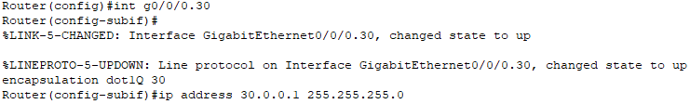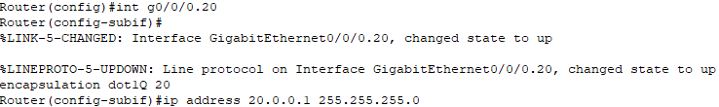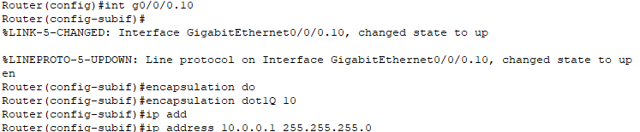

Creating routing per VLAN By router on stick method

Set Ip on the port connected to the server

DHCP Configurations

* Testing The ConnectivityA screenshot of a computer

  Description automatically generated

DHCP request successful

l

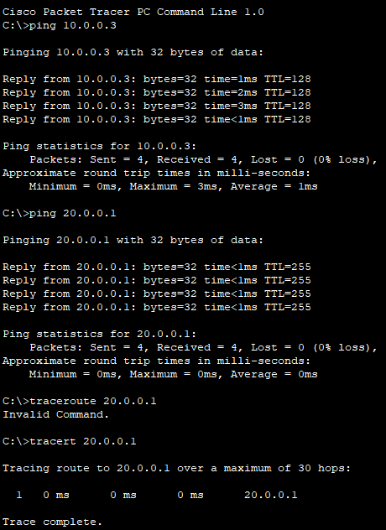

Ping and Traceroute

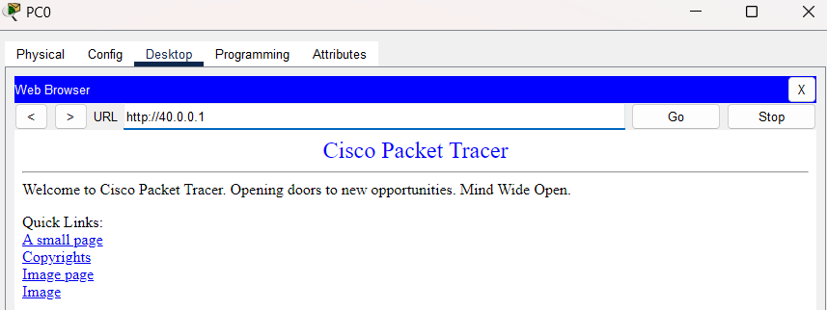

Internet Connectivity