**Mat-Lab Code**

**Name : omar Shawky Abd elSalam**

**Seat no: 43**

**Problem Statement :**

Make a MATLAB Program for binary, decimal and Hexa base number conversion.

\*\***NB:** Link to codes :

https://github.com/omarshawky15/MatLab-Codes/tree/master/BaseConverterCalculator/MatLab%20Codes

**Code Snippets :**

1. 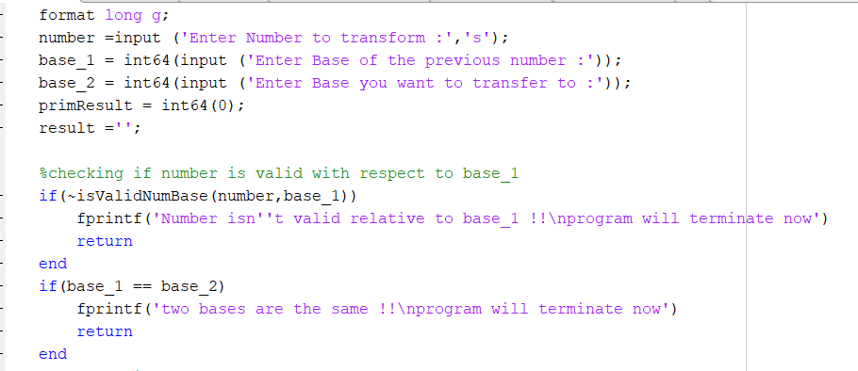**Main:**

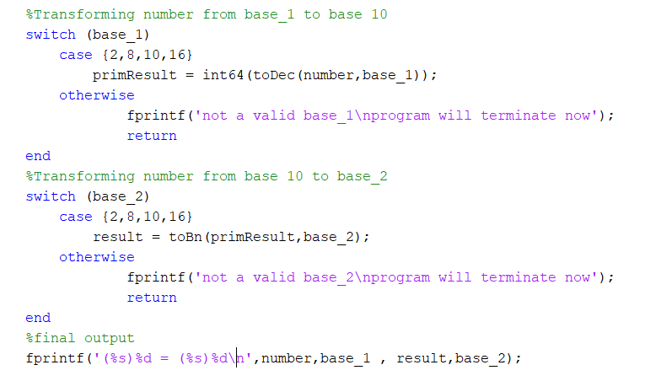

1. 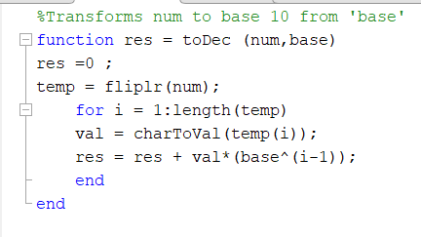**toDec :**
2. **toBn:**

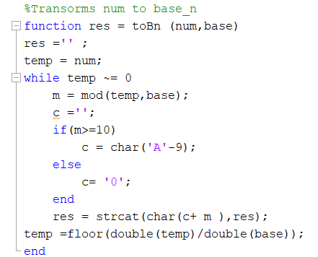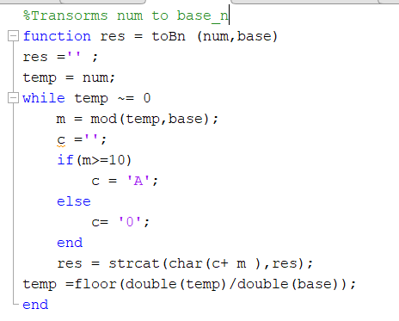

1. 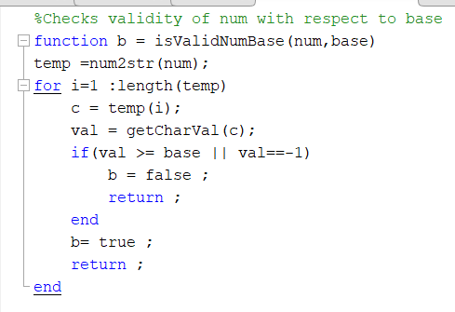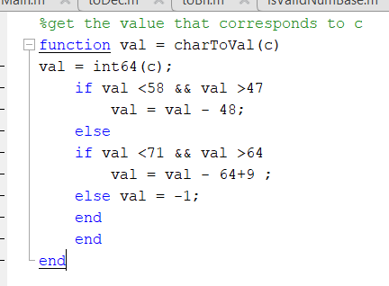**isValidNumBase: e.charToVal :**

**Run Samples :**

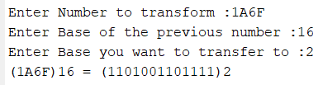

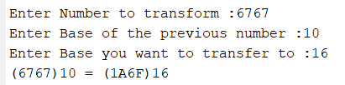

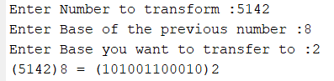

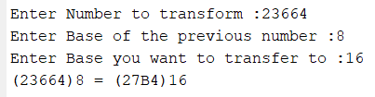

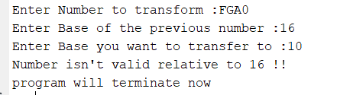**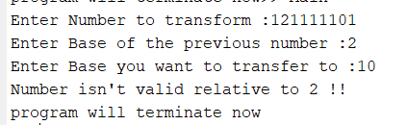Error Samples :**