|  |  |  |
| --- | --- | --- |
| **Requirement Number** | **Description** | **Contributor name** |
| 1 | Brainstorming on what the user will see when pressing the buttons that are available | Together |
| 2 | Finding suitable images for the cover page | Erkin |
| 3 | Designing the cover page | Together |
| 4 | Designing the sign-in page | Omer |
| 5 | Designing the sign-up page | Erkin |
| 6 | Finding suitable images for the sign-in page | Omer |
| 7 | Finding suitable images for the sign up page | Erkin |
| 8 | Designing the page the user will see after signing in | Omer |
| 9 | Writing the HTML and CSS code | Together |

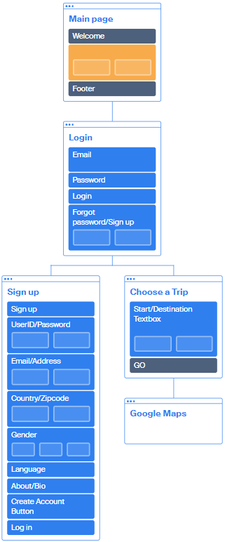

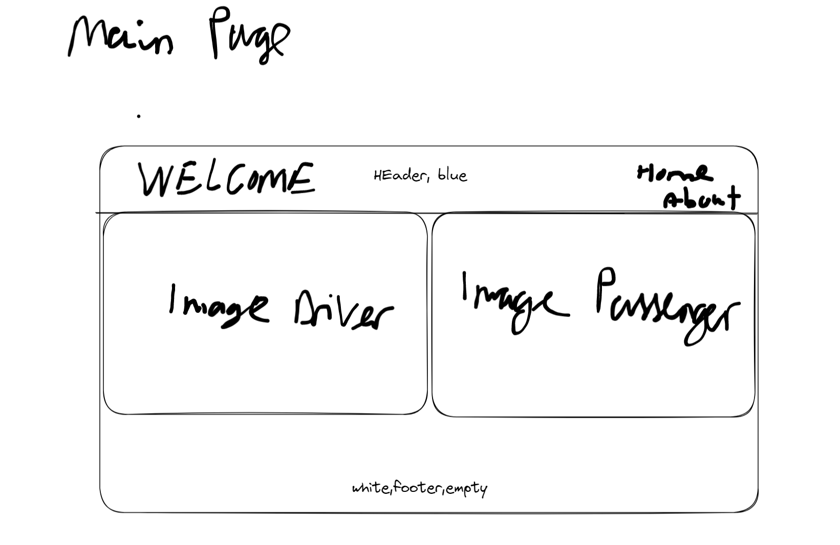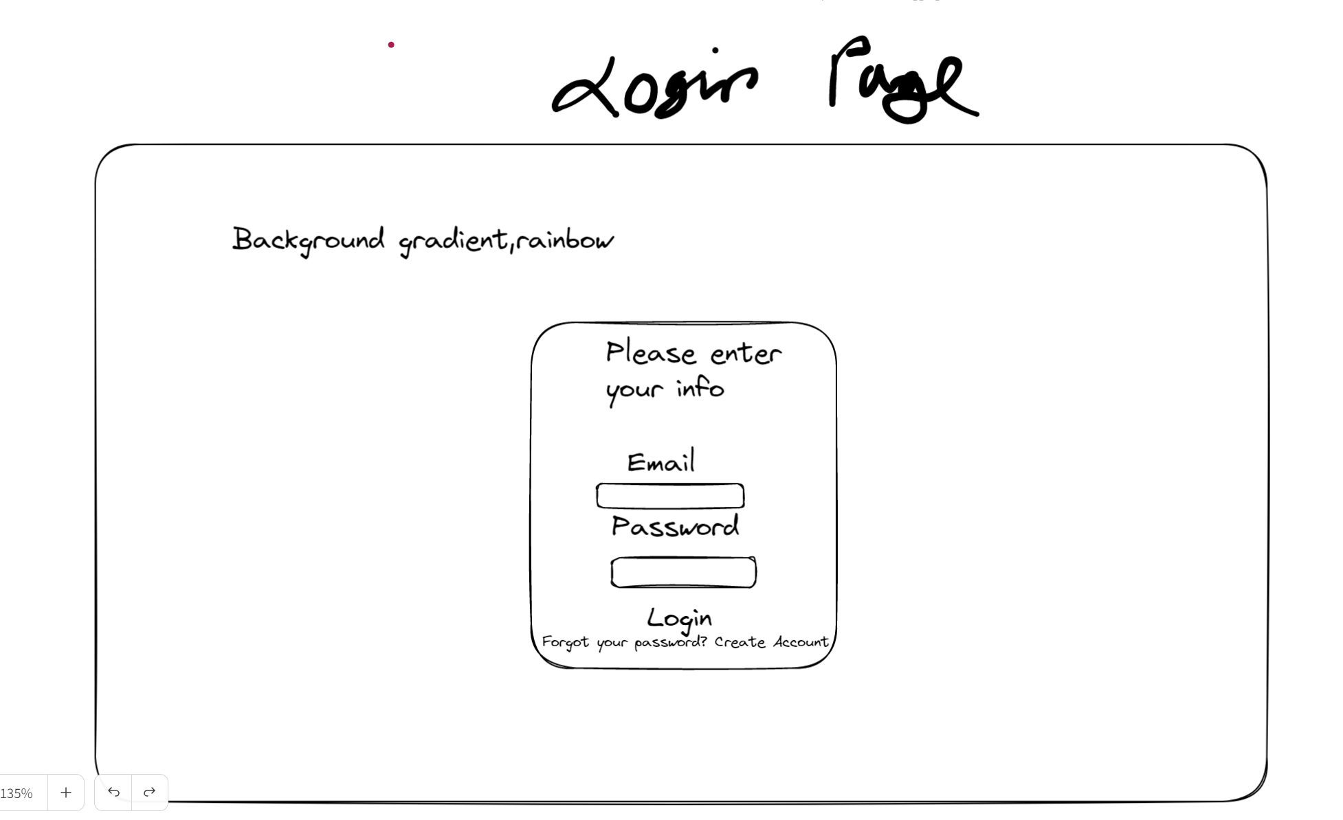

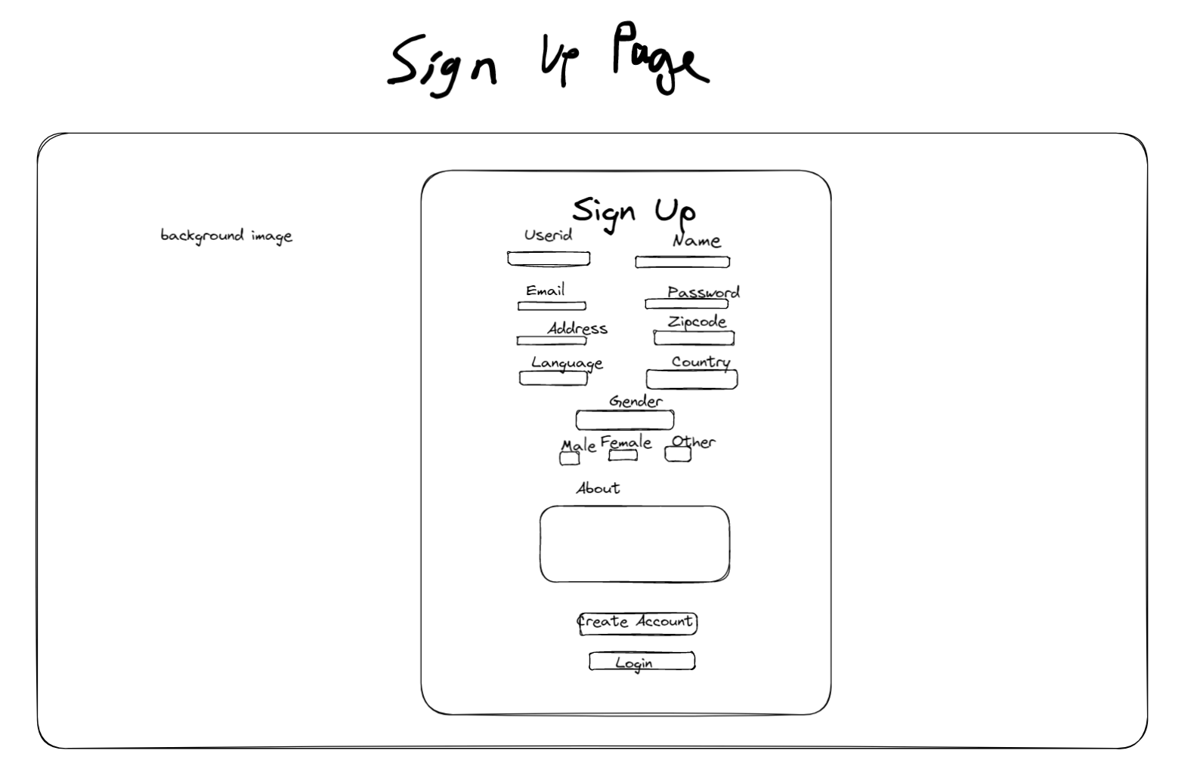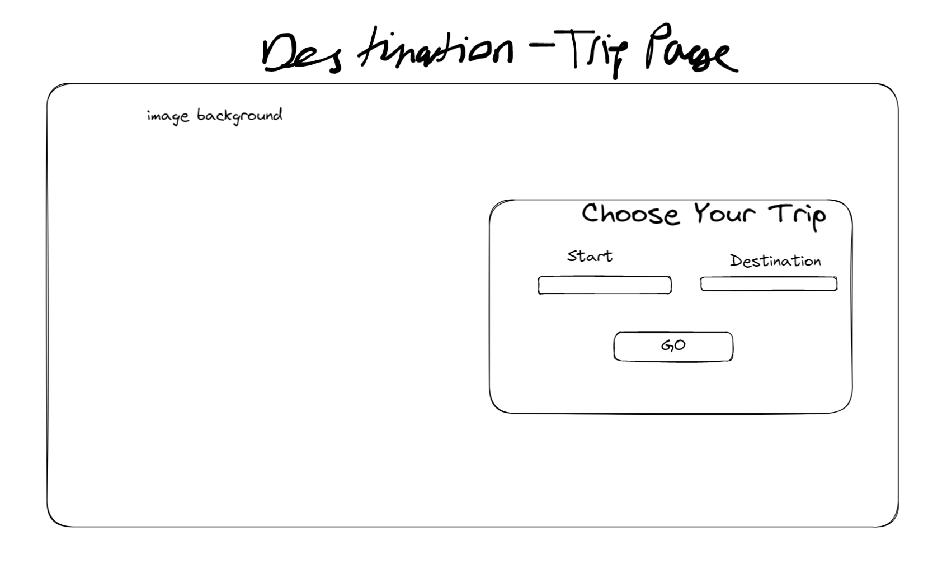

Main.html

<!DOCTYPE html>

<html>

<head>

<style>

h1 {

color: white;

}

img {

width:100%;

height:auto;

}

.button {

width: 50%;

float: left;

}

.header {

background-color: #243763;

color: white;

display: flex;

justify-content: space-between;

padding: 0 40px;

flex-wrap: wrap;

}

.nav {

list-style: none;

display: flex;

flex-wrap: wrap;

align-items: center;

}

.nav li {

margin-left: 10px;

}

.nav a {

text-decoration: none;

color: white;

}

.button:hover .driver {

visibility: visible;

opacity: 1;

}

.driver {

visibility: hidden;

opacity: 0;

transition: opacity .2s, visibility .2s;

position: absolute;

left: 150px;

top: 270px;

font-size: 60px;

color: aliceblue;

}

.button:hover .passenger {

visibility: visible;

opacity: 1;

}

.passenger {

visibility: hidden;

opacity: 0;

transition: opacity .2s, visibility .2s;

position: absolute;

left: 900px;

top: 270px;

font-size: 60px;

color: aliceblue;

}

img:hover {

filter: blur(4px);

}

</style>

</head>

<body style="background-color:aquamarine;">

<div class="header">

<h1 style="color:white">WELCOME</h1>

<ul class="nav">

<li><a href="#">Home</a></li>

<li><a href="#">About</a></li>

</ul>

</div>

<div>

<div class="button">

<a href="LogInPage.html">

<img src="..\images\img2.jpg">

</a>

<p class="driver">

Continue as driver

</p>

</div>

<div class="button">

<a href="LogInPage.html">

<img src="..\images\img3.png">

</a>

<p class="passenger">

Continue as passenger

</p>

</div>

</div>

</body>

</html>

LogInPage.html

<!DOCTYPE html>

<html>

<head>

<style>

.header {

background-image: linear-gradient(to right, red,orange,yellow,green,blue,indigo,violet);

color: white;

display: flex;

justify-content: space-between;

padding: 0 600px;

flex-wrap: wrap;

}

.box {

background-color:orange;

text-align: center;

width: 287px;

height: 400px;

position: absolute;

top:271px;

}

.logo {

position: absolute;

width: 315px;

left:610px;

top:60px;

}

.fname {

width: 150px;

}

button {

height:25px;

width:250px;

}

.forgotPassword {

position: relative;

right:60px;

}

.signUp {

position: relative;

bottom: 18.5px;

left: 60px;

}

</style>

</head>

<body class="header">

<img src="..\images\img4.png" class="logo" alt="Photo">

<fieldset class="box">

<p><br><br></p>

<h2 style="text-align:center">Please login to access login-protected services<br></h2>

<form method="post">

<label for="fname">Email:</label><br>

<input type="text" id="fname" name="fname"><br>

<label for="fname">Password:</label><br>

<input type="text" id="lname" name="lname"><br><br>

</form>

<a href="DestinationPlaces.html">

<button>Login</button><br><br><br><br><br>

</a>

<div class="forgotPassword">

<a href = "LogInPage.html">Forgot Password?</a>

</div>

<div class="signUp">

<a href = "CreateAccount.html">Sign up</a>

</div>

</fieldset>

</body>

</html>

DestinationPlaces.html

<!DOCTYPE html>

<html>

<head>

<style>

.header {

color: white;

display: flex;

justify-content: space-between;

flex-wrap: wrap;

}

.box {

text-align: center;

position: absolute;

top:100px;

right: 200px;

}

.backgroundimage {

background-image: url('..\images\img6.jpg');

position: absolute;

width:100%;

height:100%;

}

button {

height:25px;

width:250px;

}

.btn {

background: #4367e0;

background-image: -webkit-linear-gradient(top, #4367e0, #009dff);

background-image: -moz-linear-gradient(top, #4367e0, #009dff);

background-image: -ms-linear-gradient(top, #4367e0, #009dff);

background-image: -o-linear-gradient(top, #4367e0, #009dff);

background-image: linear-gradient(to bottom, #4367e0, #009dff);

-webkit-border-radius: 60;

-moz-border-radius: 60;

border-radius: 60px;

font-family: Arial;

color: #ffffff;

font-size: 26px;

padding: 10px 30px 32px 30px;

border: solid #080808 3px;

text-decoration: none;

}

.btn:hover {

background: #39cddb;

background-image: -webkit-linear-gradient(top, #39cddb, #040fd6);

background-image: -moz-linear-gradient(top, #39cddb, #040fd6);

background-image: -ms-linear-gradient(top, #39cddb, #040fd6);

background-image: -o-linear-gradient(top, #39cddb, #040fd6);

background-image: linear-gradient(to bottom, #39cddb, #040fd6);

text-decoration: none;

}

.destination {

color: hsla(210, 85%, 15%, 0.849);

font-size: 30px;

}

.maps {

transition-duration: 10s;

}

</style>

</head>

<body class="header">

<img src="..\images\img6.jpg" class="backgroundimage" alt="Photo">

<fieldset class="box">

<h1 style="font-size: 90px; color: hsla(210, 85%, 15%, 0.849);">Choose a trip<br></h1>

<form method="post">

<label class = "destination">Start</label>

<input style="font-size:20px" type="text" id = "emailbox"><span>&emsp13;&emsp13;&emsp13;&emsp13;</span>

<label class="destination">Destination</label>

<a class="maps" href="https://www.google.com/maps/dir/delft/eindhoven/@51.6685998,4.696368,9.37z/data=!4m13!4m12!1m5!1m1!1s0x47c5b5c3515f58fd:0x89b05ca3c54bd43d!2m2!1d4.3570677!2d52.0115769!1m5!1m1!1s0x47c6d91b5579c39f:0xf39ad2648164b998!2m2!1d5.4622897!2d51.4231423"><input style="font-size:20px" type="text"><span></span></a><br><br><br><br>

</form>

<a href="..\images\img7.png">

<button class="btn">GO</button><br><br><br>

</a>

</fieldset>

</body>

</html>

CreateAccount.html

<!DOCTYPE html>

<html>

<head>

<style>

.header {

background-color: blanchedalmond;

display: flex;

justify-content: space-between;

flex-wrap: wrap;

}

.box {

background-color:orange;

width: 560px;

height: 660px;

position: absolute;

top:35px;

right: 500px;

}

.logo {

width: 315px;

left:610px;

top:60px;

}

.fname {

width: 150px;

}

button {

height:25px;

width:250px;

}

.forgotPassword {

position: relative;

right:60px;

}

.lname{

font-size: 20px;

color:blue;

text-align: center;

align-items: center;

}

#box1{

text-align: right;

}

#emailbox{

position: relative;

left: 10px;

}

#countryinput{

position: relative;

right: 5px;

}

#unknown{

font-size: smaller;

}

#male{

font-size: smaller;

}

#female{

font-size: smaller;

}

#signup{

font-family: Cambria, Cochin, Georgia, Times, 'Times New Roman', serif;

color: white;

text-align: center;

}

.backgroundimage{

background-image: url('..\images\img1.jpg');

width:100%;

height:730px;

}

.btn {

-webkit-border-radius: 24;

-moz-border-radius: 24;

border-radius: 24px;

font-family: Arial;

color: #ffffff;

font-size: 20px;

background: #3498db;

padding: 10px 30px 35px 30px;

border: solid #1f628d 3px;

text-decoration: none;

}

.btn:hover {

background: #3cb0fd;

background-image: -webkit-linear-gradient(top, #3cb0fd, #3498db);

background-image: -moz-linear-gradient(top, #3cb0fd, #3498db);

background-image: -ms-linear-gradient(top, #3cb0fd, #3498db);

background-image: -o-linear-gradient(top, #3cb0fd, #3498db);

background-image: linear-gradient(to bottom, #3cb0fd, #3498db);

text-decoration: none;

}

.bottomPart {

text-align: center;

}

</style>

</head>

<body class="header">

<img src="..\images\img1.jpg" class = "backgroundimage" alt="Photo">

<fieldset class="box">

<h1 style="text-align:center" id ="signup">Sign Up</h1><br>

<form method="post" class="lname">

<div class="main">

<label>UserID</label>

<label><input type="text"> <span>&emsp13;</span></label>

<label>Password</label>

<label><input type="password"> <span></span></label><br><br>

</div>

<div class="level 2">

<label id = "email">Email</label>

<input type="text" id = "emailbox"><span>&emsp13;&emsp13;&emsp13;&emsp13;</span>

<label>Address</label>

<input type="text"><span></span><br><br>

</div>

<div class="level 3">

<label id ="countryID">Country</label>

<input type="text" id = "countryinput"><span>&emsp13;&emsp13;</span>

<label>Zipcode</label>

<input type="text"><span></span><br><br>

</div>

<div class="checkboxes">

<label for="fname">Gender</label><br>

<label id = "male"><input type="radio" name="gender"><span>Male</span></label>

<label id = "female"><input type="radio" name="gender"><span>Female</span></label>

<label id = "unknown"><input type="radio" name="gender"><span>Don't want to share</span></label>

</div>

<label for="fname"><br>Language</label><br>

<input type="text"><br><br>

<label for="fname">About/Bio</label><br>

<textarea rows="4" cols="50" maxlength="100"></textarea><br><br>

</form>

<div class="bottomPart">

<a href="LogInPage.html">

<button class="btn">Create Account</button><br><br><br>

</a>

<a href = "LogInPage.html">Log in</a>

</div>

</fieldset>

</body>

</html>