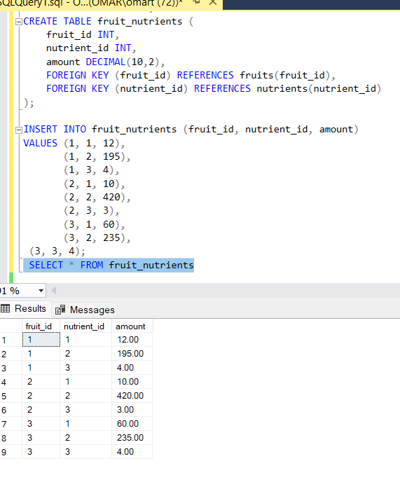

Q1- Insert a new fruit, "Avocado," with a green color, sweet and creamy taste, and available in the fall season. Assign it a unique fruit_id.

Avocado added to **fruits** table

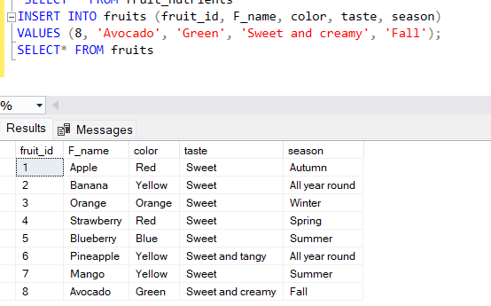

Q2-Find all fruits from the fruits table whose names start with the letter 'A'.

Apple and avocado are displayed as they start with A

Q3-List all fruit’s (name, amount and taste) with their corresponding vitamin C.

Name of fruit selected with amount of nutrients, and taste. Vitamin id=1 corresponding to specific vitamin in fruit. Fruits with vitamin C selected.

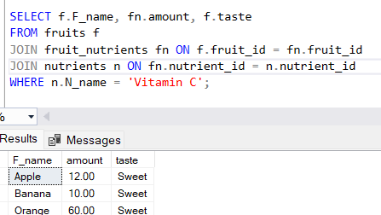

Q4-Change the taste of the fruit with fruit_id 5 to "Tart."

Fruit id=5 of Blueberry taste changed to “tart”

Q5-Remove all records from the fruit_nutrients table where the fruit_id is 3.

All records with idea of “3” were deleted

Q6-What is the average vitamin C content among all fruits?

Since there are only two other values of fruits containing vitaminc C, 10 and 12, 10+12/2=11

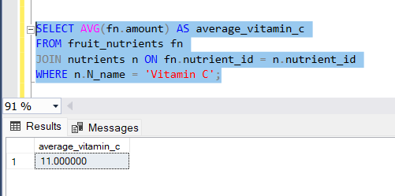

Q7-Find all fruits that are red in color and have a sweet taste, ordered by their amount in descending order.

