Omar Tawfik

202102088

**SQL Query Documentation**

**Creating Tables:**

- Create Users table

CREATE TABLE Users (

National_ID VARCHAR(20) NOT NULL,

User_ID VARCHAR(20) PRIMARY KEY,

First_Name VARCHAR(50) NOT NULL,

Last_Name VARCHAR(50) NOT NULL,

Email VARCHAR(100) NOT NULL,

Phone_Number VARCHAR(20) NOT NULL,

Role VARCHAR(20) CHECK (Role IN ('Citizen', 'Officer', 'Admin')) NOT NULL

);

SELECT *FROM USERS

-- Create Cases table

CREATE TABLE Cases (

Case_ID VARCHAR(20) PRIMARY KEY,

Case_Title VARCHAR(100) NOT NULL,

Case_Description TEXT NOT NULL,

Status VARCHAR(20) CHECK (Status IN ('Open', 'In Progress', 'Resolved')) NOT NULL,

Date_Opened DATE NOT NULL,

Date_Closed DATE NULL,

Assigned_Officer_ID VARCHAR(20) FOREIGN KEY REFERENCES Users(User_ID)

);

-- Create Officers table

CREATE TABLE Officers (

Officer_ID VARCHAR(20) PRIMARY KEY,

Rank VARCHAR(50) NOT NULL,

Badge_Number VARCHAR(20) UNIQUE NOT NULL,

Availability_Status VARCHAR(20) CHECK (Availability_Status IN ('Available', 'Unavailable')) NOT NULL,

FOREIGN KEY (Officer_ID) REFERENCES Users(User_ID)

);

-- Create Complaints table

CREATE TABLE Complaints (

Complaint_ID VARCHAR(20) PRIMARY KEY,

Citizen_ID VARCHAR(20) FOREIGN KEY REFERENCES Users(User_ID),

Complaint_Description TEXT NOT NULL,

Date_Registered DATE NOT NULL,

Case_ID VARCHAR(20) FOREIGN KEY REFERENCES Cases(Case_ID)

);

-- Create Criminals table

CREATE TABLE Criminals (

Criminal_ID VARCHAR(20) PRIMARY KEY,

First_Name VARCHAR(50) NOT NULL,

Last_Name VARCHAR(50) NOT NULL,

Known_Aliases TEXT NULL,

Arrest_History TEXT NULL,

Conviction_History TEXT NULL

);

-- Create Duty_Schedule table

CREATE TABLE Duty_Schedule (

Schedule_ID VARCHAR(20) PRIMARY KEY,

Officer_ID VARCHAR(20),

Shift_Start DATETIME NOT NULL,

Shift_End DATETIME NOT NULL,

Assigned_Location VARCHAR(100) NOT NULL,

FOREIGN KEY (Officer_ID) REFERENCES Officers(Officer_ID)

);

-- Create Incidents table

CREATE TABLE Incidents (

Incident_ID VARCHAR(20) PRIMARY KEY,

Officer_ID VARCHAR(20) FOREIGN KEY REFERENCES Officers(Officer_ID),

Description TEXT NOT NULL,

Location VARCHAR(100) NOT NULL,

Date_Time DATETIME NOT NULL

);

-- Create Feedback table

CREATE TABLE Feedback (

Feedback_ID VARCHAR(20) PRIMARY KEY,

Citizen_ID VARCHAR(20) FOREIGN KEY REFERENCES Users(User_ID),

Feedback_Text TEXT NOT NULL,

Feedback_Date DATE NOT NULL

);

-- Create Stations table

CREATE TABLE Stations (

Station_ID VARCHAR(20) PRIMARY KEY,

Station_Name VARCHAR(100) NOT NULL,

Location VARCHAR(100) NOT NULL,

Contact_Number VARCHAR(20) NOT NULL

);

-- Create InterStation_Communication table

CREATE TABLE InterStation_Communication (

Communication_ID VARCHAR(20) PRIMARY KEY,

Sender_Station_ID VARCHAR(20) FOREIGN KEY REFERENCES Stations(Station_ID),

Reciever_Station_ID VARCHAR(20) FOREIGN KEY REFERENCES Stations(Station_ID),

Message TEXT NOT NULL,

Date_Time DATETIME NOT NULL

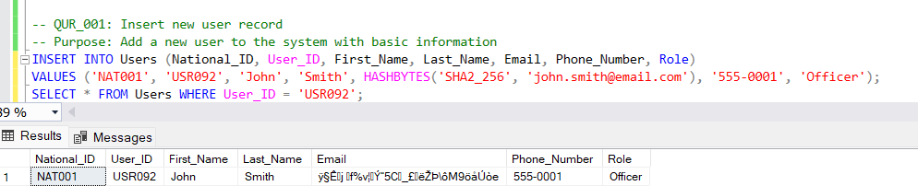

\

For Cases, unresolved cases aren’t deleted

