Lab 04: Drive Letter Assignments in Linux

Lab 04 report Name: Kevin Ubilla

This Lab is required for Unit 9. It is worth 15 points. The Challenge Flags are worth 2.5 Extra Credit points.

1. **Examining Linux Drive Letter Assignments and Mounting Drives, Step 21.** You are in Kali and have just requested root**@**kali:~#**mount**. Please capture the command line and approximately 30 of the following lines and paste it below.

**→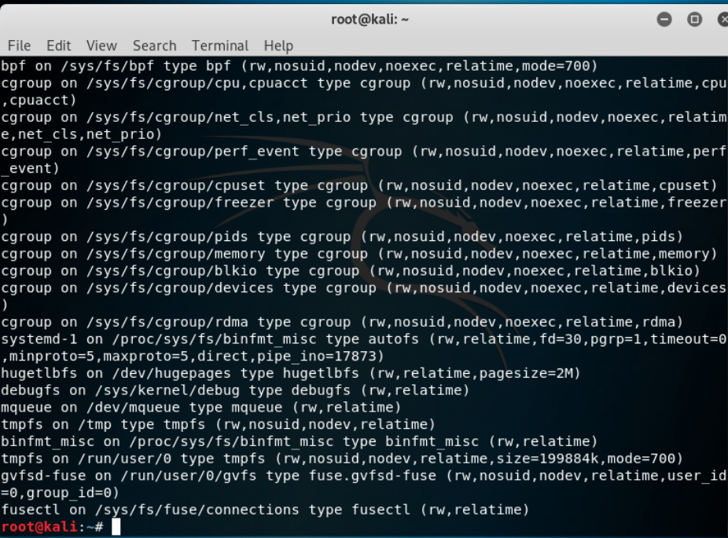 ←**

1. **Examining Linux Drive Letter Assignments and Mounting Drives, Step 26.** You have been asked to type **ifconfig > /mnt/sdb2/if.txt**. (1) What does this command attempt to do? (2) Why was it not successful? (3) Why is the fact it was not successful meaningful to a forensic examiner? Please place your responses to these three questions below.

**→ This command is trying to write to the partition. This is because the disk was mounted as read only with the ‘ro’ command. This is meaningful because if a disk is mounted as read/write then the evidence can be changed rendering it contaminated. ←**

1. **Creating Primary and Extended Partitions in Linux, Step 29.**  You have just created three partitions using Kali Linux running on the Windows 7 system (/dev/sde1, dev/sde2, and dev/sde3). Please capture the result of typing **p** in fdisk from the command to the end of the report and paste it below.

**→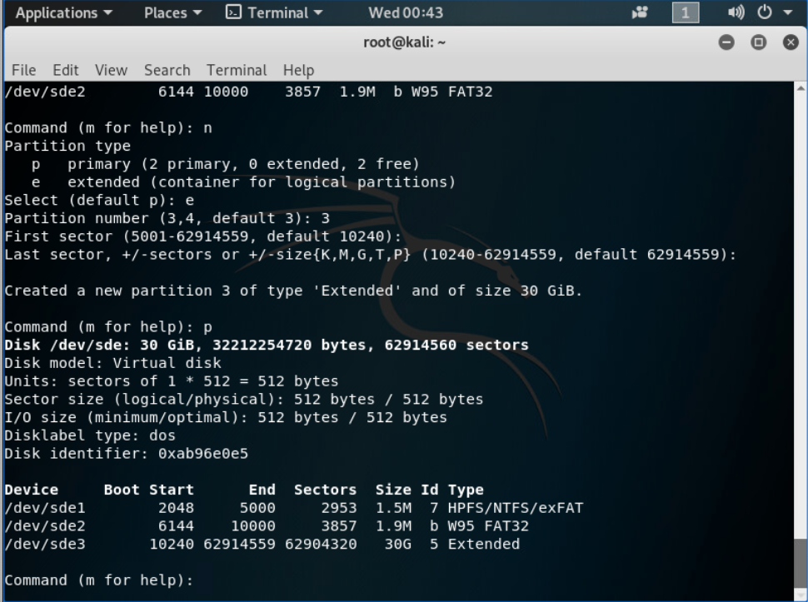 ←**

1. **Creating Primary and Extended Partitions in Linux, General.**  How many extended partitions can a disk have?

**→ Only one extended partition.←**

1. **Formatting Drives in Linux and Utilizing the Storage, Step 21.** You have now mounted thee partitions for drive sde. Please capture the command and response to **root@kali: ~#mount | grep sde** and paste it below.

**←**

**If you encountered any issues, either positive or negative, with this Lab, please let me know by commenting here. (This IS an experiment, after all.) I am tuning this according to what you say.**

**→ ←**