Lab 07: Introduction to Autopsy Forensic Browser

Lab 07 report Name: Kevin Ubilla

This Lab is required for Unit 8. It is worth 15 points. The Challenge Flags are worth 2.5 Extra Credit points.

1. **Installing the Autopsy Forensic Browser, General.** In your own words, please explain why a skilled Forensic Examiner might wish to use Autopsy rather than simply using direct commands to create and examine disk images by providing at least two reasons (remember, three sentences or less, please).

**→** For one, a GUI can be a lot more visual and easier to keep track of different folders and files than just a CLI (although still possible). For example, we can see image file names, but observe a thumbnail as well. **←**

1. **Creating a Case in Autopsy Forensic Browser, General.** Please do a little outside research about the **E01** format used by EnCase. Please list all of the tools that can read this format below.

**→** Encase, Autopsy, FTK, **←**

1. **Examining an Image with Autopsy, Step 13.**  You have just opened the Documents category under **Views/File Types**, clicked on Office and selected ‘**Osuny Articles courtesy…**’ to look at the Text View of that file. Please capture the major three panes of that view, including the left-hand hierarchy pane, and both the pane with the file name and the top of the pane with the file content at the right and past it below.

**→ 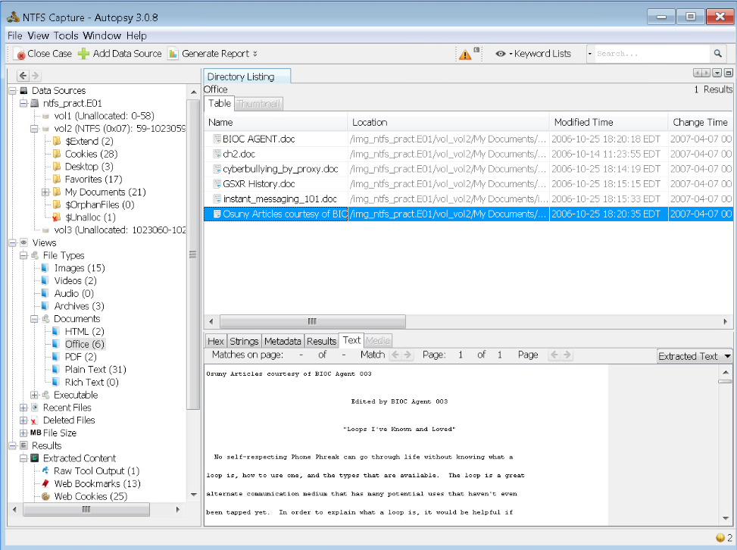 ←**

1. **Examining an Image with Autopsy, General.**  If you look at the Autopsy screen carefully, specifically the pane at the left, you can see how to recover files that have been deleted. Please describe what needs to be done in the space below.

**→** Under ‘Views’, we need to expand ‘Deleted Files’ and observe the directory listing from those in the filesystem. **←**

1. **Report Generation, Step 3.** As you select a picture (I won’t confuse things by calling it an “image”) and tag it as “bookmark”, you can be a bit creative in your comment by stating how this is a significant photo (“the motorcycle identified as being used in the robbery”?) and capture the dialog box with your bookmark entry as you save it and past it below.

**→ 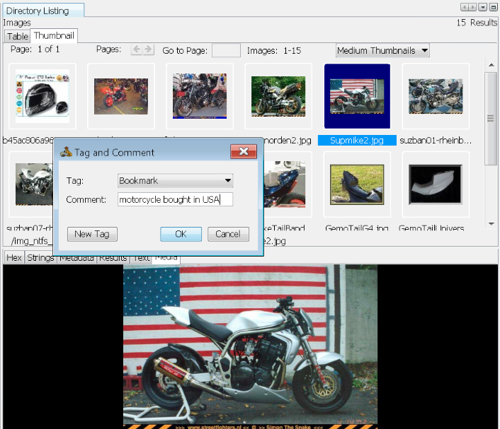←**

1. **Report Generation, Step 10.** Now that you have created an HTML report and opened it with the browser, capture the browser page as it displays the first page of the report, including the Report Navigation links, and paste it below.

**→ 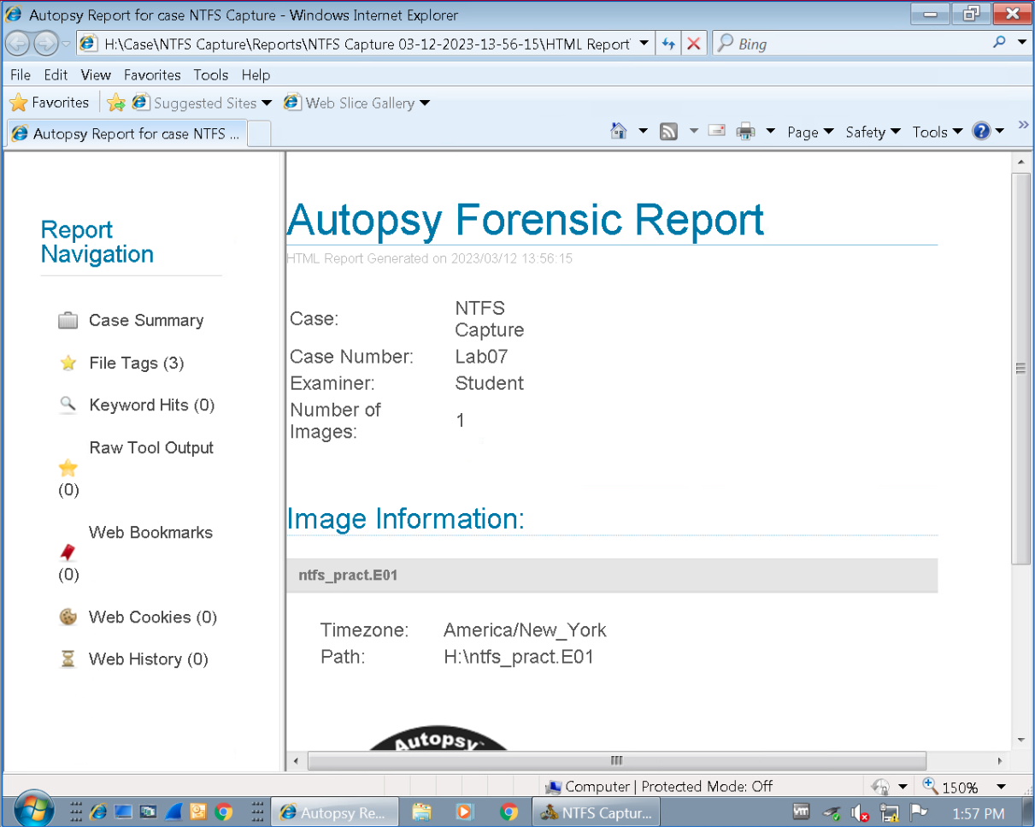 ←**

**If you encountered any issues, either positive or negative, with this Lab, please let me know by commenting here. (This IS an experiment, after all.) I am tuning this according to what you say.**

**→ ←**