Lab 10: Browser Artifact Analysis

Lab 10 report Name: Kevin Ubilla

This Lab is required for Unit 7. It is worth 15 points. The Challenge Flags are worth 2.5 Extra Credit points.

1. **Analyzing Internet Explorer, Step 6.** You are now using the History Viewer tool to inspect events related to Internet Explorer and you have just clicked ‘OK’ in the Choose Index.dat file dialog box. Capture the History Viewer screen that results and paste it below. (Please pay close attention to the readability of the items on the list.)

**→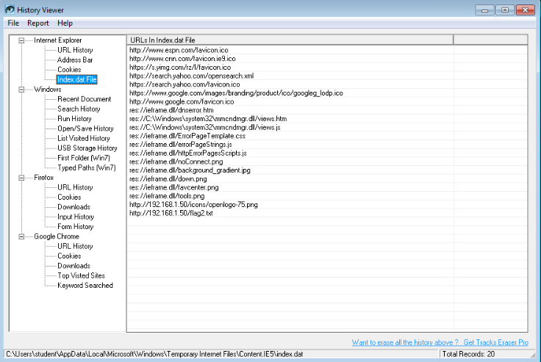 ←**

1. **Analyzing Google Chrome, Step 1.** You are being asked to open the SQLite Database Browser on the desktop. Please do a little research and tell us why you are opening SQLite to look at Google Chrome browsing data.

**→ We are using SQLite because Google stores its history as files in the SQLite database. ←**

1. **Analyzing Google Chrome, Step 8.** Once you have completed the steps to list the keywords that were typed in the search field of the browser, capture the SQLite Data Browser screen to show us the results and paste it below.

**←**

1. **Analyzing Google Chrome, Step 15.** Once you have completed the steps to list the cookies that were placed by the various websites visited, capture the SQLite screen that lists them, showing approximately the first 15 cookie, and paste it below

**→ 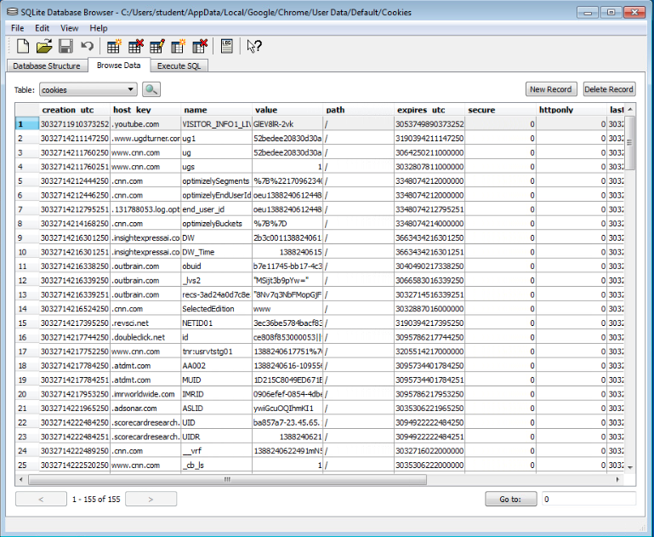 ←**

1. **Analyzing Mozilla Firefox, Step 2.** Please tell us how the method you use to access the SQLite data regarding the Firefox browser differs from that used for Chrome and place those sentences below.

**→ In Google Chrome, the SQLite analyzer was a separate app used to browse the history files. In Mozilla Firefox, SQLite is a browser extension that we can access directly once opening Firefox. This is interesting because I think the browser extension is more intuitive, e.g. it makes sense for the browser that generated the files to also store the files. However, the Chrome way drives home the point that these logs are really just stored as files on the computer, and can be accessed as such. ←**

1. **Analyzing Mozilla Firefox, Step 9.** You have generated a table that lists the cookies that now reside in this copy of Firefox. Please capture a copy of this table in the SQLite Manager window and paste it below. (Remember, readability is important.)

**→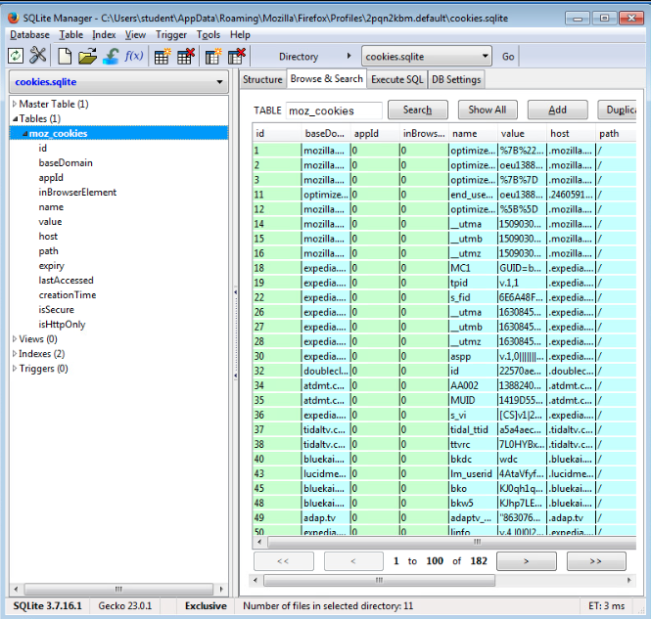 ←**

**If you encountered any issues, either positive or negative, with this Lab, please let me know by commenting here. (This IS an experiment, after all.) I am tuning this according to what you say.**

**→ ←**