Lab 15: Forensic Case Capstone

Lab 15 report Name: Kevin Ubilla

This Lab is extra credit for Unit 10. It is worth 15 points. The Challenge Flags are worth 2.5 Extra Credit points.

1. **Forensic Challenge 1 – Analysis and Reporting in Autopsy, Step 35.** Now that you have used Autopsy to search for evidence of where Susie Stapleton may be, please post any photos that you think might be appropriate below (there may be multiple, so there is double credit for this one).

**→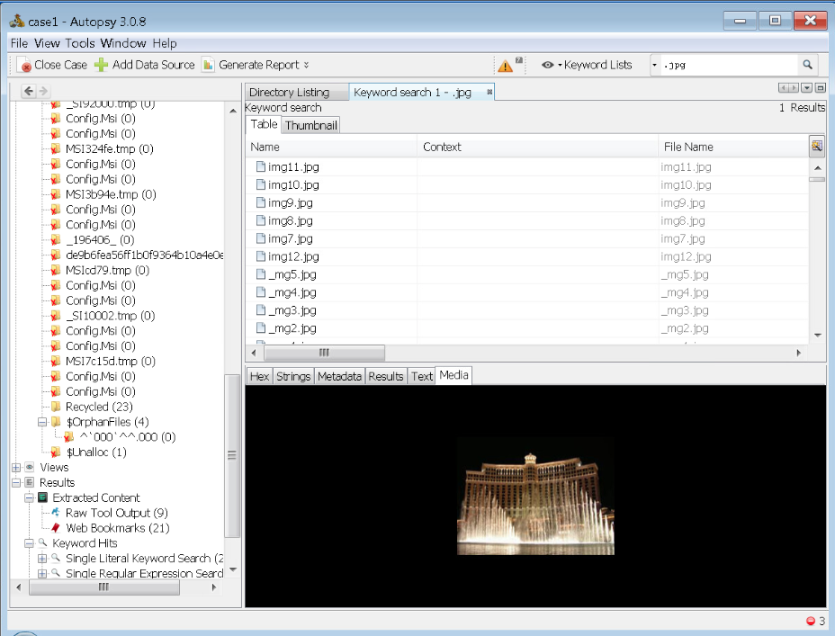 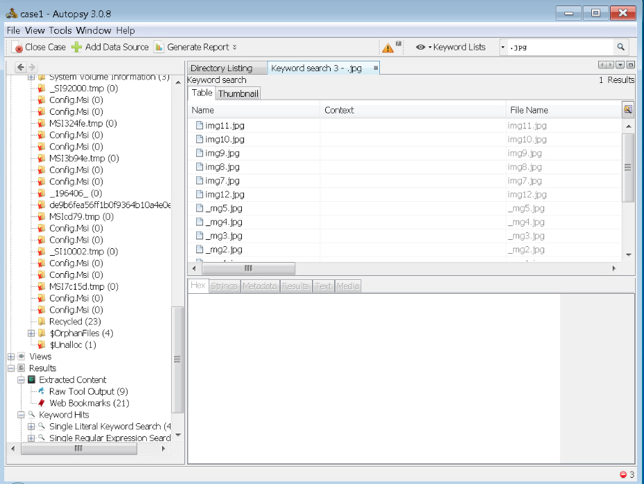←**

1. **Verifying and Viewing the Image Details, Step 11.** Place the picture of the notepad content of **case2dd.text** and the Properties of the **case2.dd** file (containing hash numbers) next to each other and capture them both, being sure to show the headers of both windows. Paste the resulting picture below.

**←**

1. **Analyzing an NTFS Partition with Autopsy, Step 14.** Please assemble any information that you find in the case 2 Autopsy analysis of the **case2.dd** image file that you think relates to Jimmy Jamison’s theft of credit cards and summarize it in a forensic report in HTML format. Capture the highlights of that report and paste them below, being sure to include bookmarks and all evidence you feel will be pertinent. (This might require multiple pages of data so, again, there is double credit here.)

**→ 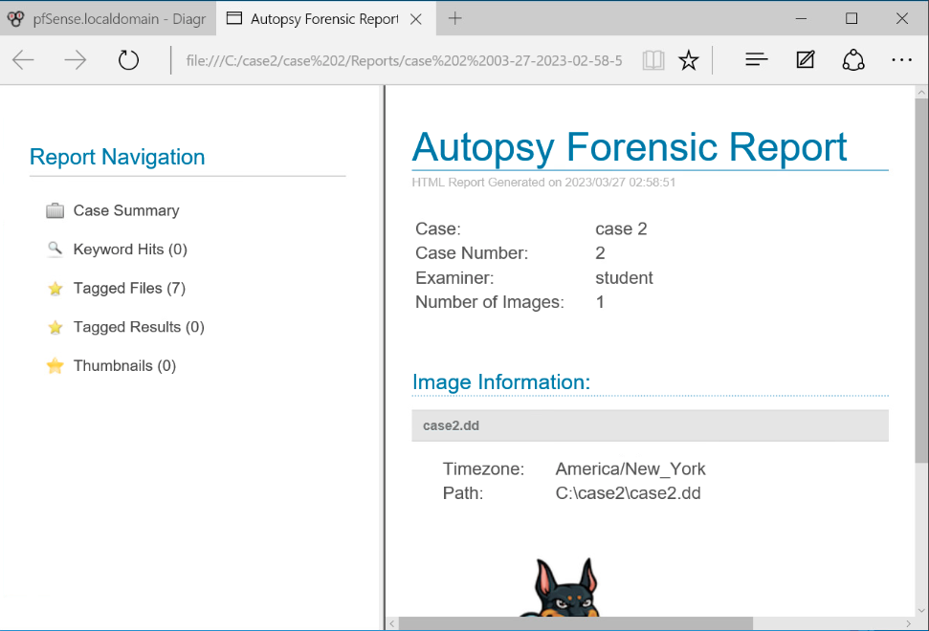 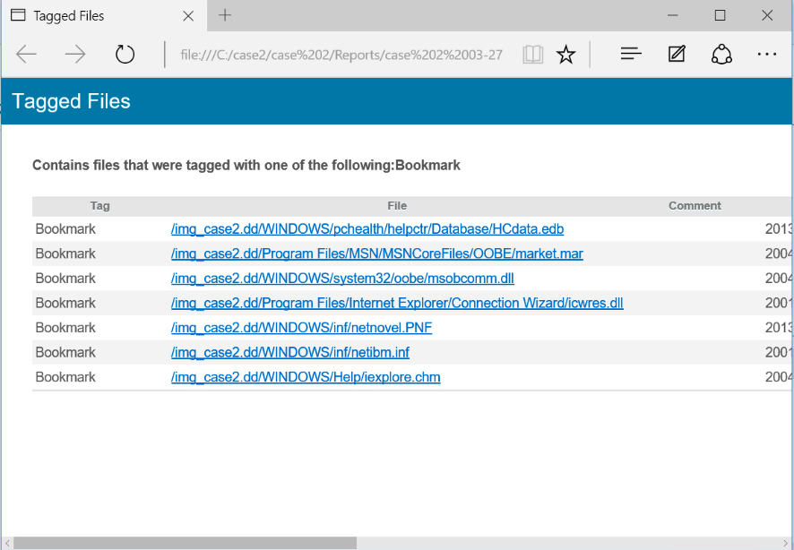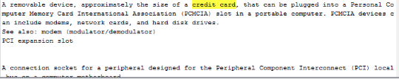←**

**If you encountered any issues, either positive or negative, with this Lab, please let me know by commenting here. (This IS an experiment, after all.) I am tuning this according to what you say.**

**→ I wanted to see more jpg images but the VM kept freezing, even after restart ←**