Lab 05: Crafting and Deploying Malware Using a Remote Access Trojan (RAT)

Lab report template Name: Kevin Ubilla

This Lab is required for Unit 4. It is worth 15 points. The Challenge exercise is worth 2.5 Extra Credit points.

1. **Launching an Attack, Step 7:** Please take a moment to research what Bruter.exe was designed to do and tell us here, in your own words, what Bruter really does.

**→ Bruter uses dictionaries of commonly used passwords to launch brute force attacks against a login and then reports the password that worked. It is a tool intended to show the importance of choosing strong passwords. ←**

1. **Building and Deploying the Malware, Step 8:** At this point you are preparing to use DarkComet to deliver some malware. Take a moment to visit **https://en.wikipedia.org/wiki/DarkComet** via another browser window on your own machine to see what Dark Comet is really all about. Capture any portion that you feel is most informative and paste it into your lab here:

**→ 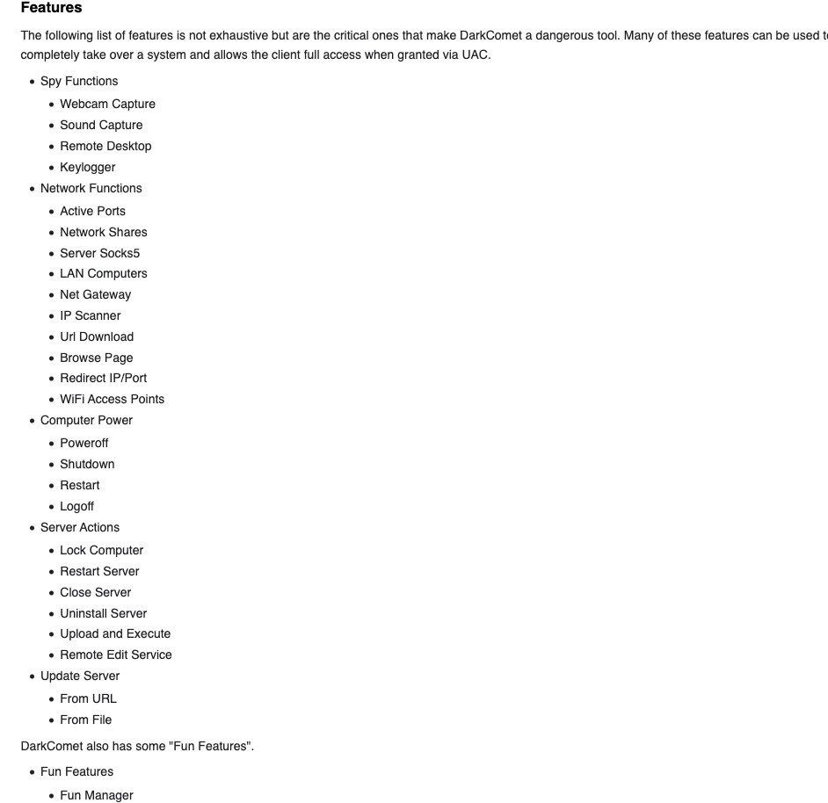←**

1. **Building and Deploying the Malware, Step 22:** When you have prepared your malware and placed in on the desktop with the Firefox icon, please capture an image of the desktop showing the malware present (this should include a portion of the entire desktop) and paste it here.

**→ 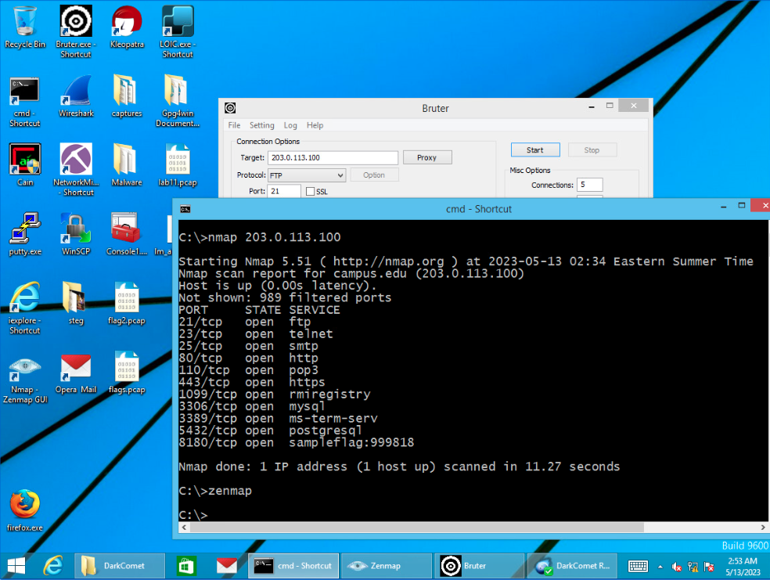←**

1. **Building and Deploying the Malware, Step 25:** Please capture an image of the command prompt box showing your command “**nmap 203.0.113.100 -p 3389**” and the response to this command and paste it here:

**→ 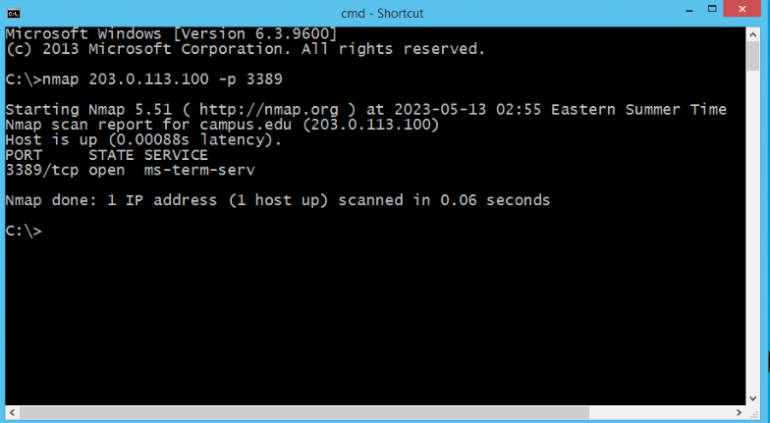←**

1. **Building and Deploying the Malware, Step 34:** Please capture an image of the DarkComet RAT console showing the internal IP address of the victim and paste it below:

**←**

1. **Exploiting the Victim, Step 4:** Now that you have clicked on System info on left portion of the screen, selected the “computer information” tab on the right and the “refresh button at the bottom , go to the Files manager and double-click on “Explorer files” at the left and capture the resulting screen and paste it here:

**←**

1. **Exploiting the Victim, Step 20:** Now that you have the blueprints of the DeathStar, please capture the screen showing Blueprint #1 **(the blueprint itself and not just the filename)** and paste it here:

**→ 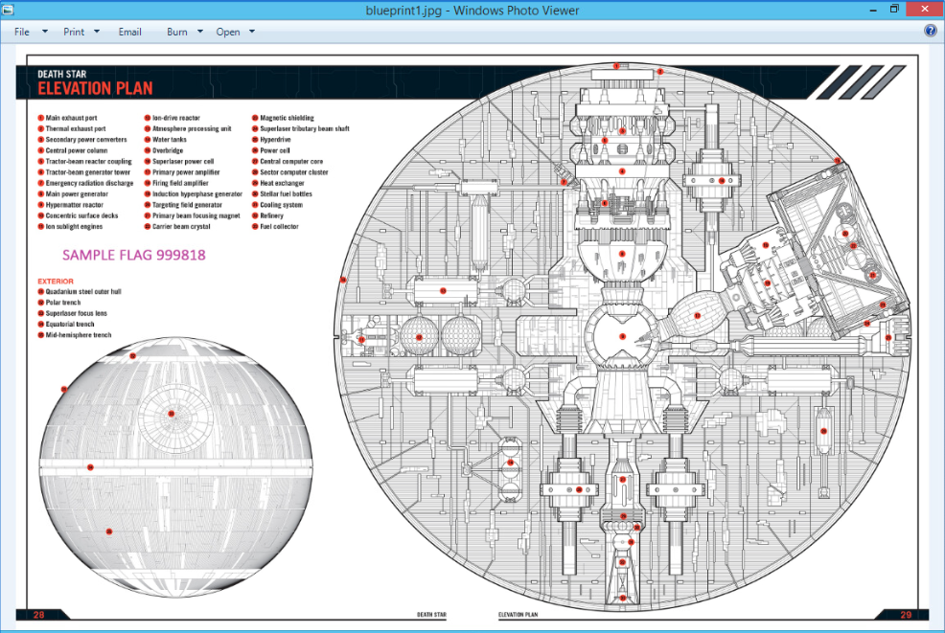 ←**

**If you encountered any issues, either positive or negative, with this Lab, please let me know by commenting here. (This IS an experiment, after all.) I am tuning this according to what you say.**

**→ ←**