Lab 07: Social Engineering Using SET

Lab report template Name: Kevin Ubilla

This Lab is required for Unit 5. It is worth 15 points. The Challenge Exercise is worth 2.5 Extra Credit points.

1. **Launching an Attack, Step 16:** Please take the time to research exactly what you are doing when you select the number 46 to set the payloads value to the Metasploit Browser Autopwn. - Tell us, in your own words, what Metasploit will do when you select this option. Please keep it to no more than 3 or 4 sentences and write it here:

**→ The 46 commands means that a Metasploit Browser named Autopwn will open and work as the browser with a list of exploits to choose from. These exploits interact with the target’s browser and Meterpreter reports back if successful. ←**

1. **Launching an Attack, Step 19:** Once you get the message that the server has started (**server started**), please capture that line and roughly 15 prior lines and paste the image here:

**→ 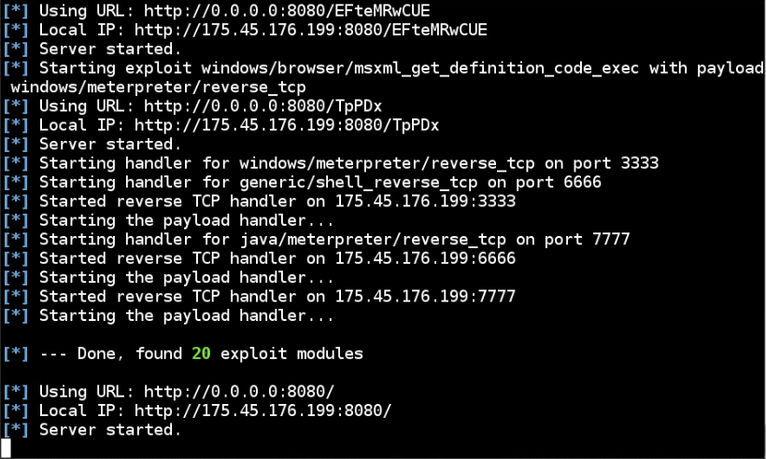 ←**

1. **Getting Spear Phished, Step 4:** Before you click on the link to "facebook updates" in the email from “Mark Zukerburg”, please capture the Opera Mail screen showing the several panes displayed that include the Zukerburg e-mail (with special attention to highlighting the link to be clicked on by the target) and paste it here:

**→ 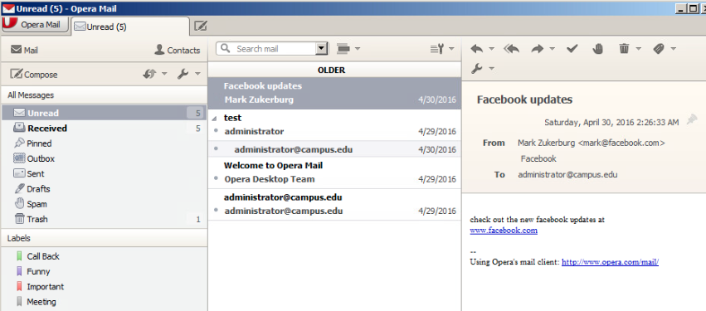 ←**

1. **Stealing Data, Step 2:**  Please take a moment to explain, in your own words, just how the active session with **203.0.113.100** came to be here (include events at both your own “attacking” system and the “target” system). Just short summary of a couple sentences will do. Type your answer here, please:

**→ My attacking system sent a link created by Autopwn, the target system clicked on the link and in doing so, sent over their IP address.←**

1. **Stealing Data, Step 11:** Please capture your command to list the directory “**DeathStar**” and the system response and paste it here:

**→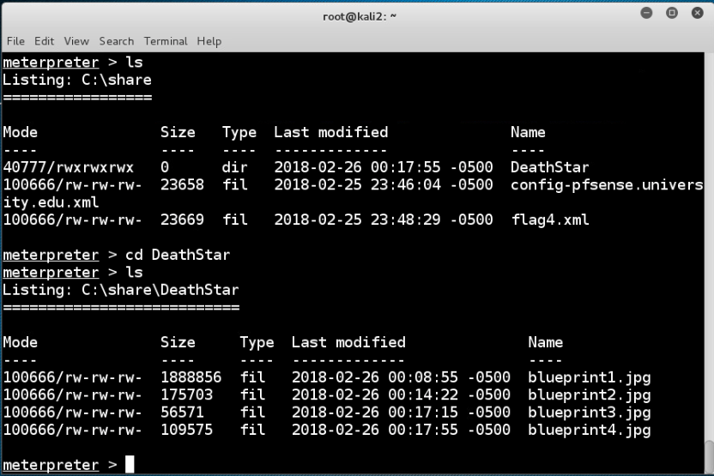 ←**

1. **Stealing Data, Step 13:** Capture a detailed view of Blueprint 3 (the actual content of Blueprint3.jpg) and paste it here:

**→ 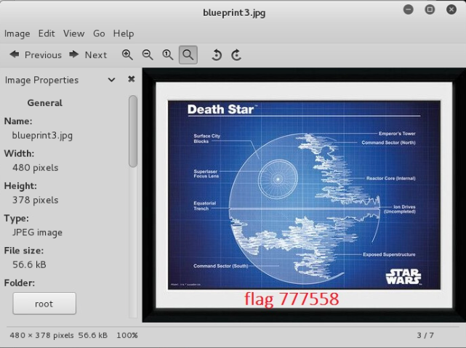 ←**

**If you encountered any issues, either positive or negative, with this Lab, please let me know by commenting here. (This IS an experiment, after all.) I am tuning this according to what you say.**

**→ ←**