Lab 15: Performing SQL Injection to Manipulate Tables in a Database.

Lab report template Name: Kevin Ubilla

This Lab is Required for Unit 7. It is worth 15 points. The Challenge exercise is worth 2.5 Extra Credit points.

1. **Scanning, Step 22:** In the command prompt box, please capture your request to "run" the auxiliary module, and the response to that request, and paste it here:

**←**

1. **Connecting to the Database and Viewing the Tables, Step 2:** You are submitting the command "**mysql -h 203.0.113.100 -u root**," please take a moment to research what the **-h** and **-u** command switches do and enter your answer, in your own words, here:

**→ The -h command specifies name of connecting remote host and the -u command indicates the username. ←**

1. **Connecting to the Database and Viewing the Tables, Step 17:** You are showing the tables in the owasp10 database. Please capture the lines in the command interface that display your ‘show tables’ command and the system's response and paste it here:

**←**

1. **Stealing Data and Creating a Backdoor, Step 4:** In addition to looking at the content of the credit_cards table, please examine the hitlog table as well, using “**select * from hitlog**”. Please capture your command to display the hitlog table plus the system's response and past it here:

**→ 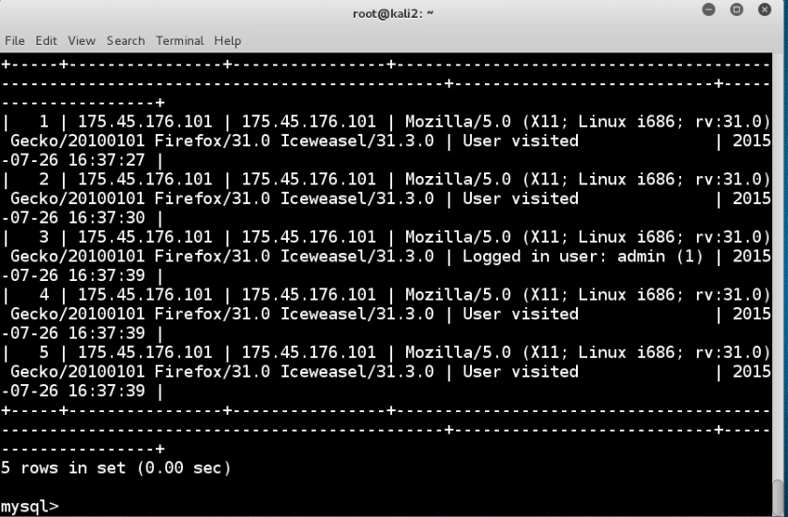 ←**

1. **Stealing Data and Creating a Backdoor, Step 10:** Now that you have demonstrated that you have successfully added the user "hacker" and now have complete administrative control of the database as "hacker," please consider whether you have hidden your tracks. What simple steps might you have taken to be a bit stealthier about having access to the system? Please place the text of your answer here:

**→ I have not hidden my tracks. The hitlog screen captures from the previous question show ‘user visited’ details. A necessary step would have been to either delete these log entries entirely or at least change the timestamps. ←**

**If you encountered any issues, either positive or negative, with this Lab, please let me know by commenting here. (This IS an experiment, after all.) I am tuning this according to what you say.**

**→ ←**