OVD

2023-03-16

# Abstract

The polarization of US politics has impacted the management of state pension funds. More than a dozen Republican state legislatures have passed or introduced legislation that either outright forbids ESG investment or blocklists money managers that promote it. A similar number of Democratic states are debating legislation, or have already enacted it, that encourages pension investments to include ESG considerations or prevents public funds from funding polluters or weapon manufacturers.

The legal rhetoric used to justify the political position against ESG investing deals with potential breaches of the managers’ duty of loyalty. The hypothesis is that managers who consider ESG factors when investing the state pension funds pursue a political agenda at the expense of their trustees. However, workers—including conservative workers—may well prefer a constrained pension optimization strategy that aligns with their ethical values. This work is the first to use conjoint analysis to examine people’s willingness to sacrifice profits to pursue social causes, and the first to analyze the preferences of American retirement fund investors to assess the legitimacy of anti-ESG legislation.

The experiment results show an overall preference for funds that restrict their investments to firms that promote social goals. There are important differences among respondents that identify as Democrats or Republicans, but even the latter are willing to sacrifice profits to reward firms that ensure no children are employed in the supply chain, and promote gender equality in management. There are good reasons to be skeptical about ESG investing, but potential breaches of fiduciary duties that assume people want to maximize profits at all cost is not one.

options(scipen=999)  
  
options(digits = 3)

library(readr)  
  
dfcj <- read_csv("rds_prod.experiment.420656.stacked(9).csv")

## Rows: 45528 Columns: 87  
## ── Column specification ────────────────────────────────────────────────────────  
## Delimiter: ","  
## chr (28): EXPECTED_PENSION, INVESTS_IN_FIREARMS, INVESTS_IN_FOSSIL_FUELS, I...  
## dbl (57): RESPONDENT_ID, SURVEY_ID, CHOICE_SET, LABEL, CHOICE_INDICATOR, RE...  
## dttm (2): RESPONDENT_TIME_OF_OPENING_SURVEY, RESPONDENT_TIME_OF_COMPLETING_...  
##   
## ℹ Use `spec()` to retrieve the full column specification for this data.  
## ℹ Specify the column types or set `show_col_types = FALSE` to quiet this message.

library(cregg)  
library(janitor)  
library(tidyverse)

Import data and filter responses 0.5 or 1.5 * median completion time

dfcj = dfcj %>%   
 clean_names()

#Transform variables to factors  
dfcj = dfcj %>%   
 mutate(expected_pension_num = factor(expected_pension),  
 firearms = factor(invests_in_firearms,  
 levels = c("Invests in firearms", "Does not invest in firearms")),   
 fossil_fuels = factor(invests_in_fossil_fuels,  
 levels = c("Invests in fossil fuels", "Does not invest in fossil fuels")),  
 may_employ_children = factor(invests_in_firms_that_may_employ_children,  
 levels = c("Invests in firms that may employ children", "Invests in firms that ensure no children are employed")),  
 racial_diversity = factor(advocates_for_racial_diversity_in_management,  
 levels = c("Does not advocate for racial diversity in management",  
 "Advocates for racial diversity in management")),  
 gender_equal_pay = factor(advocates_for_equal_pay_for_men_and_women,  
 levels = c("Does not advocate for equal pay for men and women",  
 "Advocates for equal pay for men and women")),  
 choice_indicator = as.numeric(choice_indicator),  
 choice = as.factor(choice_indicator),  
 prior = factor(ifelse(q9_taking_into_account_esg_factors_o1_yes ==1, "anti-esg", "pro=esg")),  
 republican = factor(ifelse(q11_party_id_o1_republican==1 |  
 q12_party_leanings_o1_republican ==1, 1,0)),  
 florida = factor(ifelse(q15_state_us_o1_florida==1, 1,0)),  
 california = factor(ifelse(q15_state_us_o2_california==1,1,0)))

dfcjshort = dfcj %>%   
 select(survey_id,   
 choice_set,   
 expected_pension,  
 expected_pension_num,  
 choice_indicator,   
 choice,  
 firearms,  
 fossil_fuels,  
 may_employ_children,  
 racial_diversity,  
 gender_equal_pay,  
 republican,  
 prior,  
 q22_openended_feedback)

dfus = dfcj %>%   
 filter(florida==0 & california==0)

mmus <- cj(dfus, choice_indicator ~ expected_pension_num + firearms + fossil_fuels + may_employ_children + racial_diversity + gender_equal_pay, id = ~ survey_id,  
 estimate = "mm")

## Warning in logLik.svyglm(x): svyglm not fitted by maximum likelihood.  
  
## Warning in logLik.svyglm(x): svyglm not fitted by maximum likelihood.  
  
## Warning in logLik.svyglm(x): svyglm not fitted by maximum likelihood.  
  
## Warning in logLik.svyglm(x): svyglm not fitted by maximum likelihood.  
  
## Warning in logLik.svyglm(x): svyglm not fitted by maximum likelihood.  
  
## Warning in logLik.svyglm(x): svyglm not fitted by maximum likelihood.

plot(mmus, vline = 0.5) #'*# See what is going on with fossil fuels*

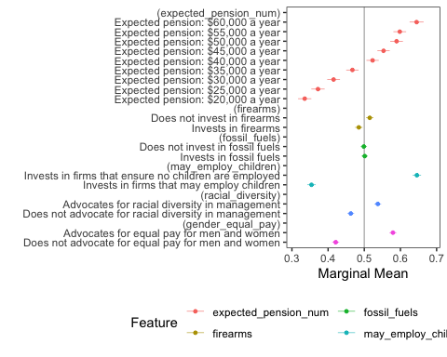

Let’s try with weights

dfcjw = dfcj %>%   
 mutate(weight = case_when(florida == 1 ~ 0.066,  
 california == 1 ~ 0.12,  
 florida == 0 & california == 0 ~ 0.814))  
  
table(dfcjw$weight) # Looks good

##   
## 0.066 0.12 0.814   
## 8784 9408 27336

# weight = dfcjw$weights  
  
mmusw <- cj(dfcjw, choice_indicator ~ expected_pension_num + firearms + fossil_fuels + may_employ_children + racial_diversity + gender_equal_pay, id = ~ survey_id,  
 estimate = "mm", weights = ~ weight)

## Warning in logLik.svyglm(x): svyglm not fitted by maximum likelihood.  
  
## Warning in logLik.svyglm(x): svyglm not fitted by maximum likelihood.  
  
## Warning in logLik.svyglm(x): svyglm not fitted by maximum likelihood.  
  
## Warning in logLik.svyglm(x): svyglm not fitted by maximum likelihood.  
  
## Warning in logLik.svyglm(x): svyglm not fitted by maximum likelihood.  
  
## Warning in logLik.svyglm(x): svyglm not fitted by maximum likelihood.

plot(mmusw, vline = 0.5) +   
 ggtitle("U.S. Weighted Sample")

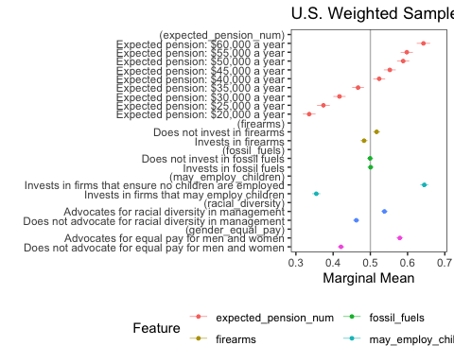

mmusw_by <- cj(dfcjw, choice_indicator ~ expected_pension_num + firearms + fossil_fuels + may_employ_children + racial_diversity + gender_equal_pay, id = ~ survey_id,  
 estimate = "mm", weights = ~ weight,  
 by = ~republican)

## Warning in logLik.svyglm(x): svyglm not fitted by maximum likelihood.  
  
## Warning in logLik.svyglm(x): svyglm not fitted by maximum likelihood.  
  
## Warning in logLik.svyglm(x): svyglm not fitted by maximum likelihood.  
  
## Warning in logLik.svyglm(x): svyglm not fitted by maximum likelihood.  
  
## Warning in logLik.svyglm(x): svyglm not fitted by maximum likelihood.  
  
## Warning in logLik.svyglm(x): svyglm not fitted by maximum likelihood.  
  
## Warning in logLik.svyglm(x): svyglm not fitted by maximum likelihood.  
  
## Warning in logLik.svyglm(x): svyglm not fitted by maximum likelihood.  
  
## Warning in logLik.svyglm(x): svyglm not fitted by maximum likelihood.  
  
## Warning in logLik.svyglm(x): svyglm not fitted by maximum likelihood.  
  
## Warning in logLik.svyglm(x): svyglm not fitted by maximum likelihood.  
  
## Warning in logLik.svyglm(x): svyglm not fitted by maximum likelihood.

plot(mmusw_by, group = "republican", vline = 0.5) +  
 scale_colour_manual(na.translate = F, values = c("royalblue", "red3")) +  
 ggtitle("U.S. Weighted Sample")

## Scale for colour is already present.  
## Adding another scale for colour, which will replace the existing scale.

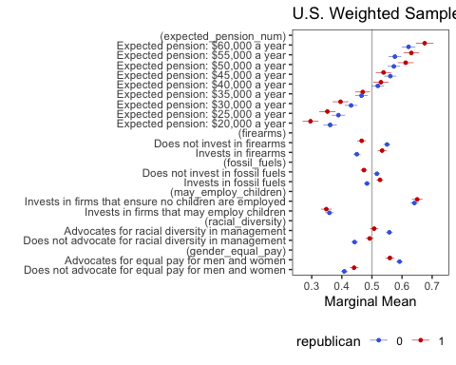

Vector for AMCE model and plot:

Now trying with larger df

mm_by <- cj(dfcj, choice_indicator ~ expected_pension_num + firearms + fossil_fuels + may_employ_children + racial_diversity + gender_equal_pay, id = ~ survey_id,  
 estimate = "mm",   
 by = ~republican)

## Warning in logLik.svyglm(x): svyglm not fitted by maximum likelihood.  
  
## Warning in logLik.svyglm(x): svyglm not fitted by maximum likelihood.  
  
## Warning in logLik.svyglm(x): svyglm not fitted by maximum likelihood.  
  
## Warning in logLik.svyglm(x): svyglm not fitted by maximum likelihood.  
  
## Warning in logLik.svyglm(x): svyglm not fitted by maximum likelihood.  
  
## Warning in logLik.svyglm(x): svyglm not fitted by maximum likelihood.  
  
## Warning in logLik.svyglm(x): svyglm not fitted by maximum likelihood.  
  
## Warning in logLik.svyglm(x): svyglm not fitted by maximum likelihood.  
  
## Warning in logLik.svyglm(x): svyglm not fitted by maximum likelihood.  
  
## Warning in logLik.svyglm(x): svyglm not fitted by maximum likelihood.  
  
## Warning in logLik.svyglm(x): svyglm not fitted by maximum likelihood.  
  
## Warning in logLik.svyglm(x): svyglm not fitted by maximum likelihood.

amce_by <- cj(dfcj, choice_indicator ~ expected_pension_num + firearms + fossil_fuels + may_employ_children + racial_diversity + gender_equal_pay, id = ~ survey_id,  
 estimate = "amce",   
 by = ~republican)

## Warning in logLik.svyglm(x): svyglm not fitted by maximum likelihood.  
  
## Warning in logLik.svyglm(x): svyglm not fitted by maximum likelihood.

amce <- cj(dfcj, choice_indicator ~ expected_pension_num + firearms + fossil_fuels + may_employ_children + racial_diversity + gender_equal_pay, id = ~ survey_id,  
 estimate = "amce")

## Warning in logLik.svyglm(x): svyglm not fitted by maximum likelihood.

plot(mm_by, group = "republican", vline = 0.5) +  
 scale_colour_manual(na.translate = F, values = c("royalblue", "red3"))

## Scale for colour is already present.  
## Adding another scale for colour, which will replace the existing scale.

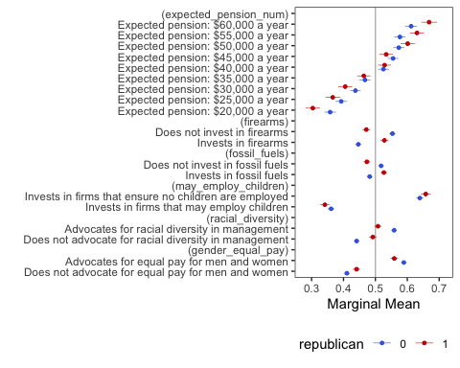

plot(amce_by, group = "republican") +  
 scale_colour_manual(na.translate = F, values = c("royalblue", "red3"))

## Scale for colour is already present.  
## Adding another scale for colour, which will replace the existing scale.

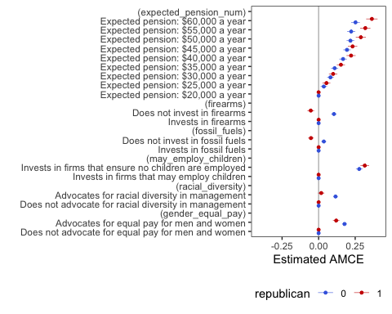

mm <- cj(dfcj, choice_indicator ~ expected_pension_num + firearms + fossil_fuels + may_employ_children + racial_diversity + gender_equal_pay, id = ~ survey_id,  
 estimate = "mm")

## Warning in logLik.svyglm(x): svyglm not fitted by maximum likelihood.  
  
## Warning in logLik.svyglm(x): svyglm not fitted by maximum likelihood.  
  
## Warning in logLik.svyglm(x): svyglm not fitted by maximum likelihood.  
  
## Warning in logLik.svyglm(x): svyglm not fitted by maximum likelihood.  
  
## Warning in logLik.svyglm(x): svyglm not fitted by maximum likelihood.  
  
## Warning in logLik.svyglm(x): svyglm not fitted by maximum likelihood.

plot(mm, vline = 0.5) #'*# See what is going on with fossil fuels*

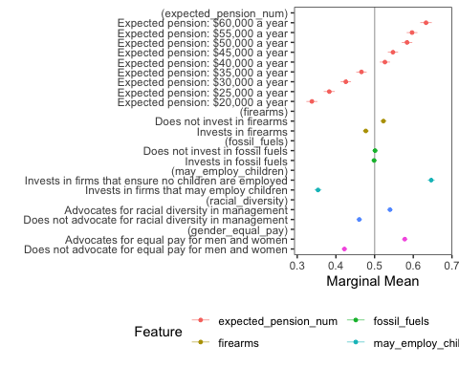

mm_byfl <- cj(dfcj, choice_indicator ~ expected_pension_num + firearms + fossil_fuels + may_employ_children + racial_diversity + gender_equal_pay, id = ~ survey_id,  
 estimate = "mm",   
 by = ~florida)

## Warning in logLik.svyglm(x): svyglm not fitted by maximum likelihood.  
  
## Warning in logLik.svyglm(x): svyglm not fitted by maximum likelihood.  
  
## Warning in logLik.svyglm(x): svyglm not fitted by maximum likelihood.  
  
## Warning in logLik.svyglm(x): svyglm not fitted by maximum likelihood.  
  
## Warning in logLik.svyglm(x): svyglm not fitted by maximum likelihood.  
  
## Warning in logLik.svyglm(x): svyglm not fitted by maximum likelihood.  
  
## Warning in logLik.svyglm(x): svyglm not fitted by maximum likelihood.  
  
## Warning in logLik.svyglm(x): svyglm not fitted by maximum likelihood.  
  
## Warning in logLik.svyglm(x): svyglm not fitted by maximum likelihood.  
  
## Warning in logLik.svyglm(x): svyglm not fitted by maximum likelihood.  
  
## Warning in logLik.svyglm(x): svyglm not fitted by maximum likelihood.  
  
## Warning in logLik.svyglm(x): svyglm not fitted by maximum likelihood.

plot(mm_byfl, group = "florida", vline = 0.5) +  
 scale_colour_manual(na.translate = F, values = c("royalblue", "red3"))

## Scale for colour is already present.  
## Adding another scale for colour, which will replace the existing scale.

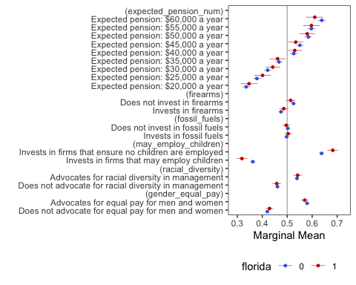

WTP analysis. The logitr package uses a Hierarchical Bayesian model to estimate WTP and utilities from each attribute.

library(logitr)

## Version: 1.0.1  
## Author: John Paul Helveston (George Washington University)  
##   
## Consider submitting praise at  
## https://github.com/jhelvy/logitr/issues/8.  
##   
## Please cite the JSS article in your publications, see:  
## citation("logitr")

dfcjtest = dfcj %>%   
 mutate(pension = expected_pension)  
  
  
dfcjtest$pension <- recode(dfcjtest$pension,  
 "Expected pension: $20,000 a year" = "20,000",   
 "Expected pension: $25,000 a year" = "25,000",   
 "Expected pension: $30,000 a year" = "30,000",   
 "Expected pension: $35,000 a year" = "35,000",   
 "Expected pension: $40,000 a year" = "40,000",   
 "Expected pension: $45,000 a year" = "45,000",   
 "Expected pension: $50,000 a year" = "50,000",  
 "Expected pension: $55,000 a year" = "55,000",  
 "Expected pension: $60,000 a year" = "60,000"  
 )

#transform to numeric  
  
dfcjtest = dfcjtest %>%  
 mutate(pension_num = readr::parse_number(pension))

Not creating var to test MLogit

Careful with grouping!!! Didn’t ungroup before

#This code below worked!  
  
dfcjtest2 = dfcjtest %>%  
 group_by(survey_id, choice_set) %>%  
 mutate(obs_id = cur_group_id()) %>%   
 ungroup() # I had forgotten to do this!

mean(dfcjtest2$pension_num)

## [1] 39998

dflogitr = dfcjtest2 %>%   
 select(survey_id,   
 obs_id,   
 choice_set,   
 pension_num,  
 choice_indicator,   
 choice,  
 firearms,  
 fossil_fuels,  
 may_employ_children,  
 racial_diversity,  
 gender_equal_pay,  
 republican)

dflogitr = dflogitr %>%   
 mutate(price = -1 * pension_num,  
 firearms.num = ifelse(firearms == "Invests in firearms", 1, 0),  
 fossil_fuels.num = ifelse(fossil_fuels == "Invests in fossil fuels", 1, 0),  
 may_employ_children.num = ifelse(may_employ_children == "Invests in firms that may employ children", 1, 0),  
 racial_diversity.num = ifelse(racial_diversity == "Does not advocate for racial diversity in management", 1, 0),  
 gender_equal_pay.num = ifelse(gender_equal_pay == "Does not advocate for equal pay for men and women", 1, 0))  
  
dflogitr = dflogitr %>%   
 rename(no_racial_diversity.num = racial_diversity.num,  
 no_gender_equal_pay.num = gender_equal_pay.num)

#Word cloud with reliable data  
  
#Create a vector containing only the text  
txt = as.character(dfcj$q22_openended_feedback)  
  
  
## Loading packages for word clouds  
library(wordcloud)

## Loading required package: RColorBrewer

library(RColorBrewer)  
library(wordcloud2)  
library(tm)

## Loading required package: NLP

##   
## Attaching package: 'NLP'

## The following object is masked from 'package:ggplot2':  
##   
## annotate

# Create a corpus   
docs <- Corpus(VectorSource(txt))

# clean text data  
docs <- docs %>%  
 tm_map(removeNumbers) %>%  
 tm_map(removePunctuation) %>%  
 tm_map(stripWhitespace)

## Warning in tm_map.SimpleCorpus(., removeNumbers): transformation drops documents

## Warning in tm_map.SimpleCorpus(., removePunctuation): transformation drops  
## documents

## Warning in tm_map.SimpleCorpus(., stripWhitespace): transformation drops  
## documents

docs <- tm_map(docs, content_transformer(tolower))

## Warning in tm_map.SimpleCorpus(docs, content_transformer(tolower)):  
## transformation drops documents

docs <- tm_map(docs, removeWords, stopwords("english"))

## Warning in tm_map.SimpleCorpus(docs, removeWords, stopwords("english")):  
## transformation drops documents

#Document term matrix  
  
dtm <- TermDocumentMatrix(docs)   
matrix <- as.matrix(dtm)   
words <- sort(rowSums(matrix),decreasing=TRUE)   
df <- data.frame(word = names(words),freq=words)

# Create word cloud  
set.seed(1234) # for reproducibility   
  
wordcloud(words = df$word, freq = df$freq, min.freq = 1,   
 max.words=10, random.order=FALSE, rot.per=0.35,   
 colors=brewer.pal(8, "Dark2"))

