Assignment 1

introduction: -

The target of this assignment is to start building digital circuit using Verilog language that contain both combinational logic and sequential logic using always block.

Block Interface

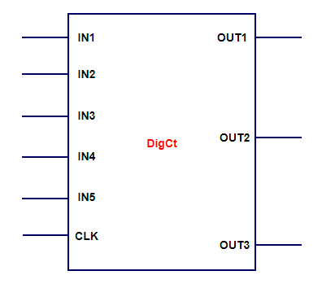

Block(Module) Name: DigCt

Inputs: IN1, IN2, IN3, IN4, CLK (all inputs of 1-bit width)

Outputs: OUT1, OUT2, OUT3 (output of 1-bit width)

Circuit Implementation: -

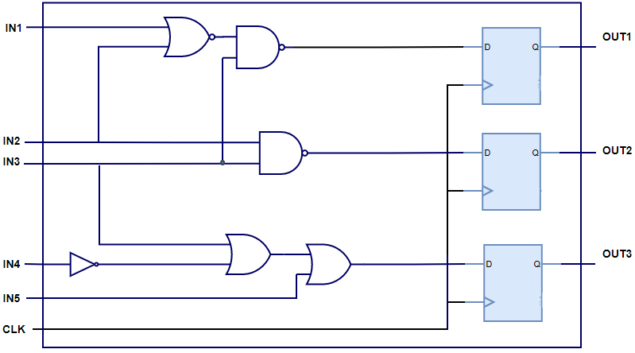

Requirements: -

Design the above circuit using Verilog language. -