

User Guide

**COVID-19**

|  |  |
| --- | --- |
| **Faculty Name** | Miss. Wajiha Siddiqui |
| **Batch Coordinator Name** | Miss. Maham Haider |
| **Batch Code** | 2308B1 |
| **Group** | A |

|  |  |
| --- | --- |
| **Enrollment No.** | **Student Name** |
| Student**1503124** | Omymah |
| Student**1500557** | Ahmed Raza |
| Student**1499166** | Muhammad Affan Vohra |
| Student**1501352** | Arooba Jahan |
| Student**1501393** | Ayesha |

**INTRODUCTION**

Across the world, people are facing unforeseen challenges due to Coronavirus

pandemic. Design and develop a web application for online test and vaccination booking system for patient. The Covid 19 web app connects the people with the hospital and the administration to come together and fight the pandemic. With this web app, one can track the vaccination appointment, history and covid solution guidelines for symptoms.

**Proposed Solution: –**

App will provide Online Registration System (ORS) is a framework to link various

hospitals across the country for mobile number based online registration and

appointment system. Portal facilitates online appointments for vaccination. Detail

reports showing information about test and vaccination patients taking appointment through this portal can be seen. Hospitals can come on board this platform and provide their appointment slots for online booking by patients. The system facilitates Hospitals to easily manage their registration and appointment process and monitor the flow of patients.

**SCREENSHOTS**

PATIENT REGISTER

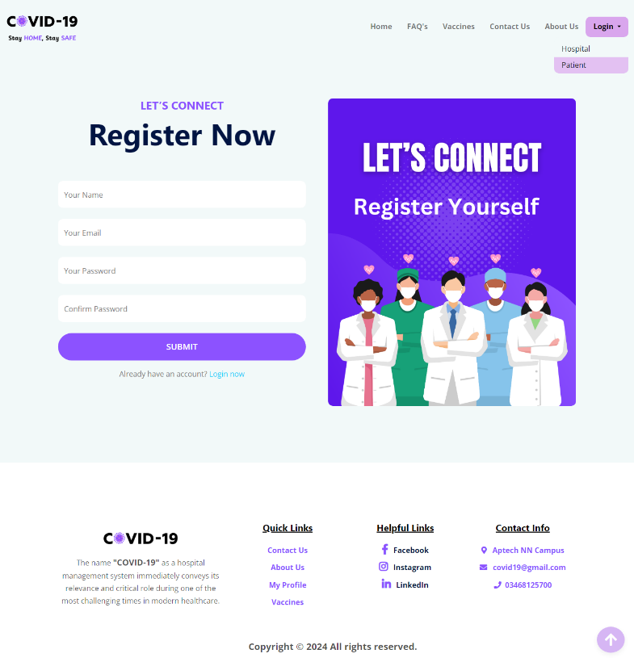

Login button for Hospital and Patient

PATIENT LOGIN

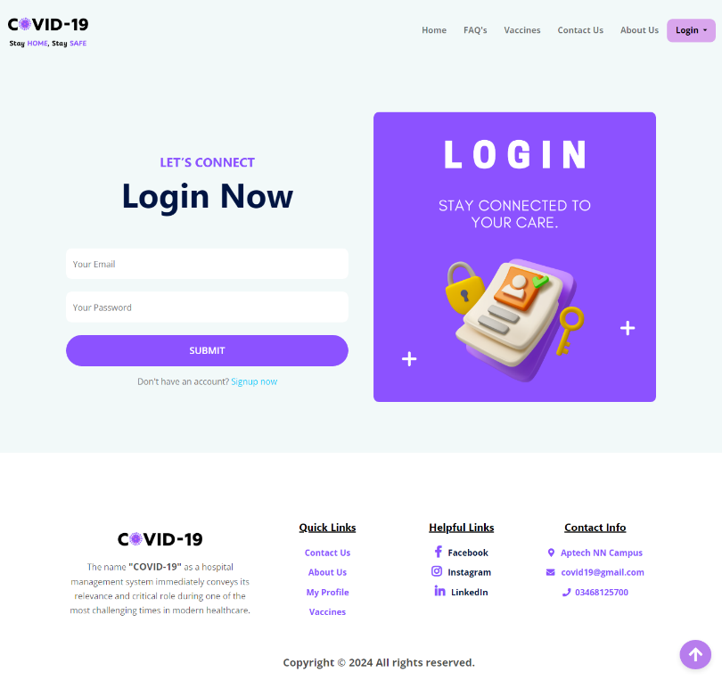

INDEX PAGE

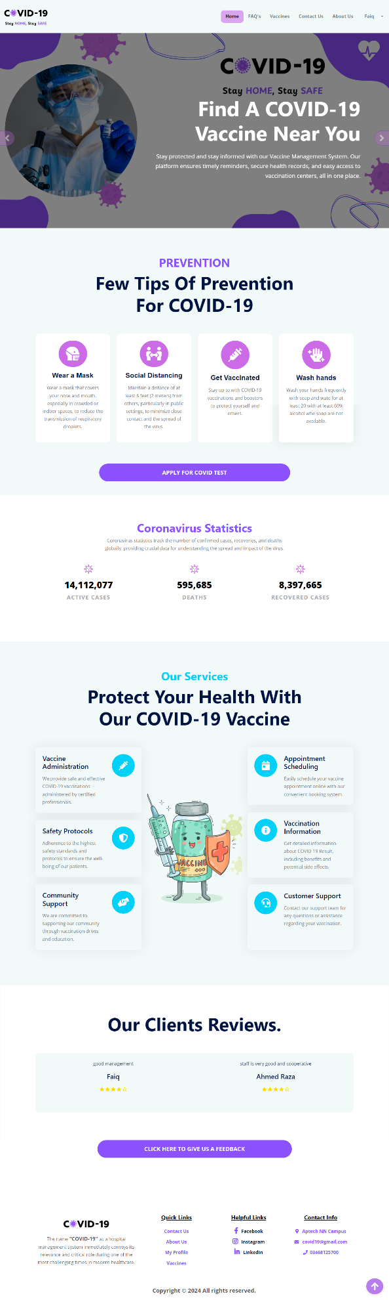

Services Section

Footer

Logo

Navbar

Button for apply Covid-19 test

Button for Give Feedback

APPLY FOR COVID TEST FORM

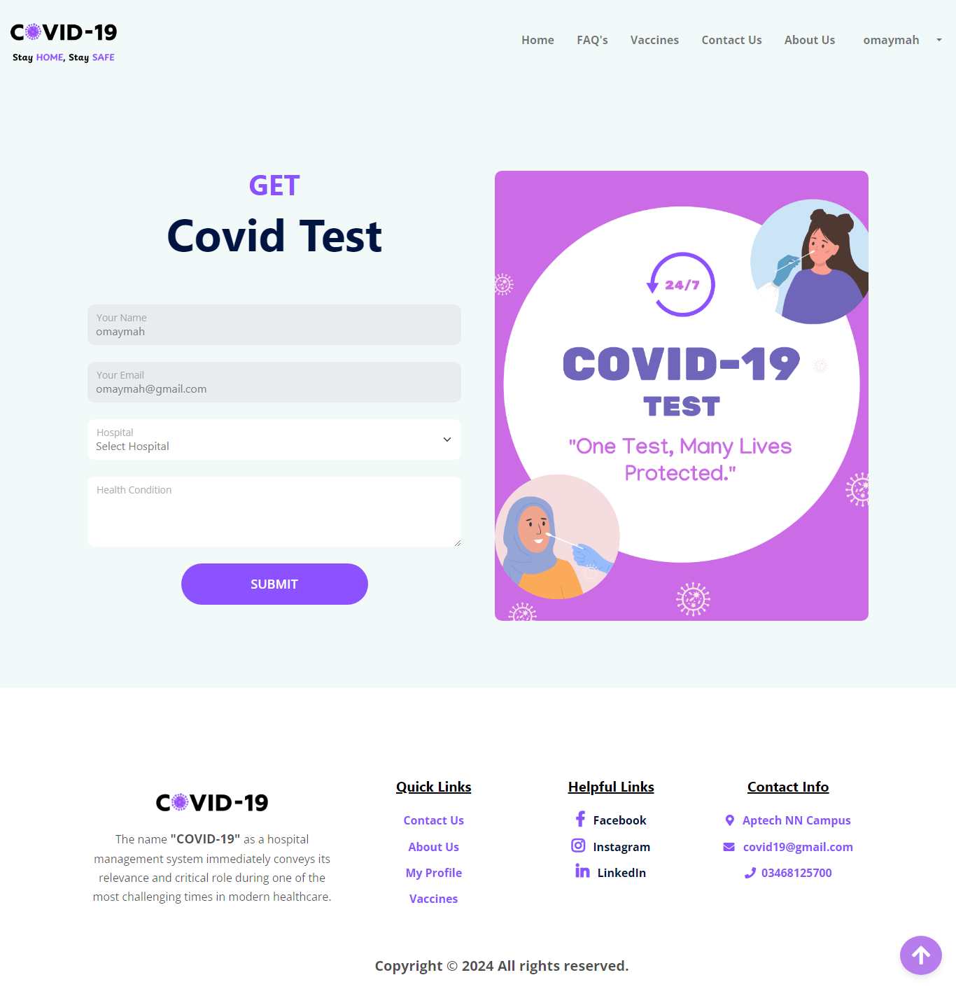

VACCINE APPOINTMENT FORM

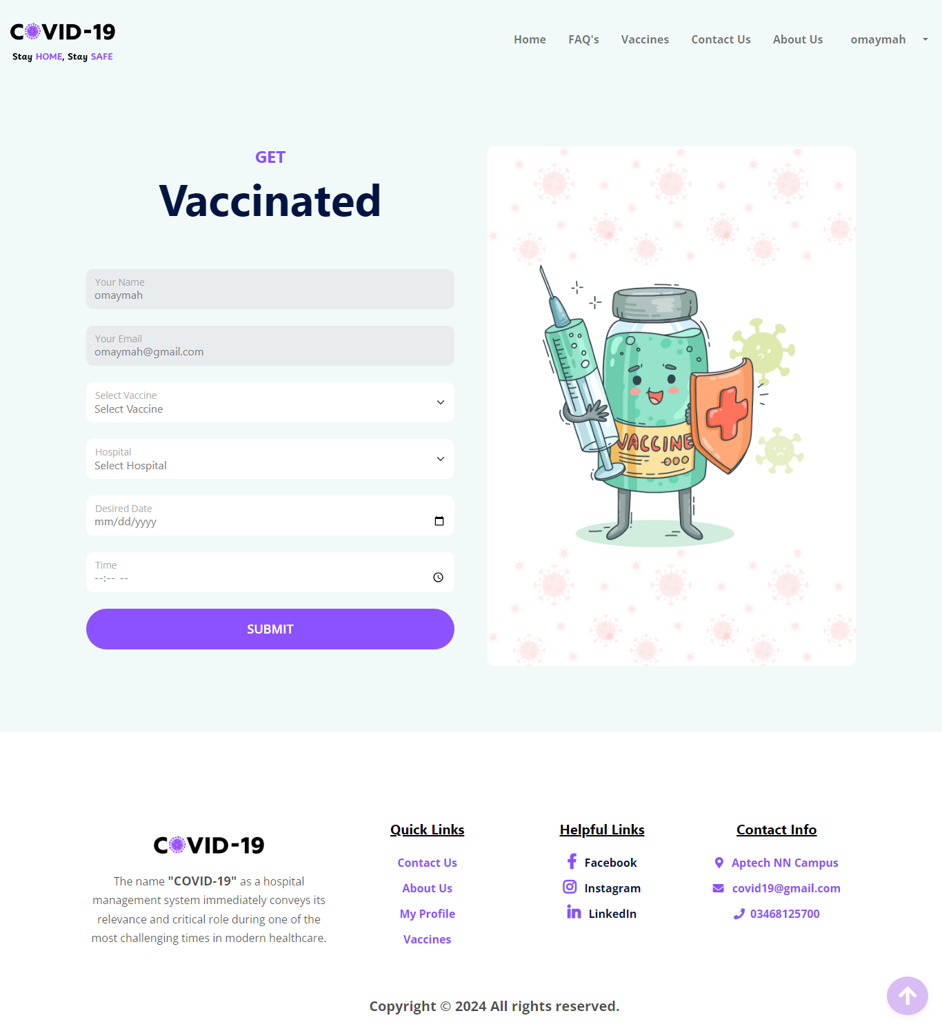

FAQ’S PAGE

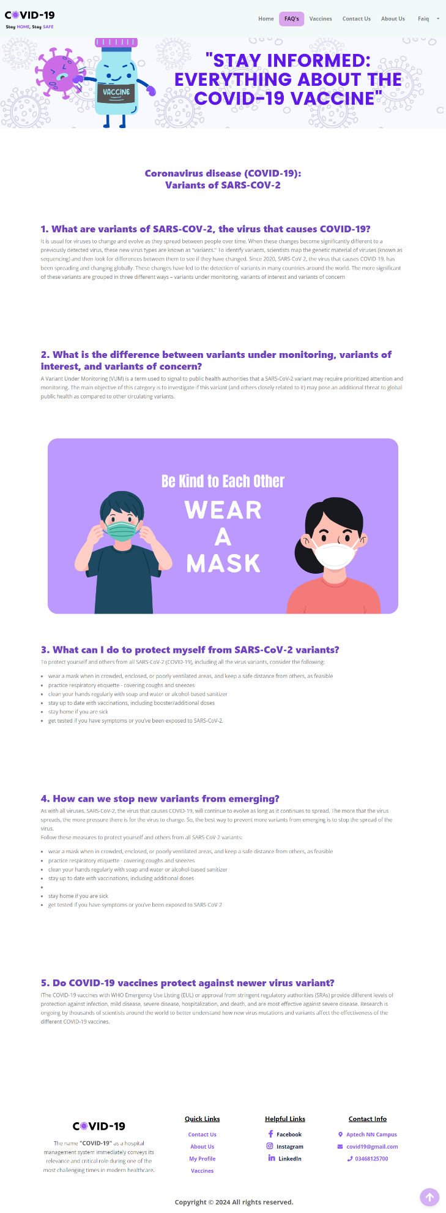

Banner

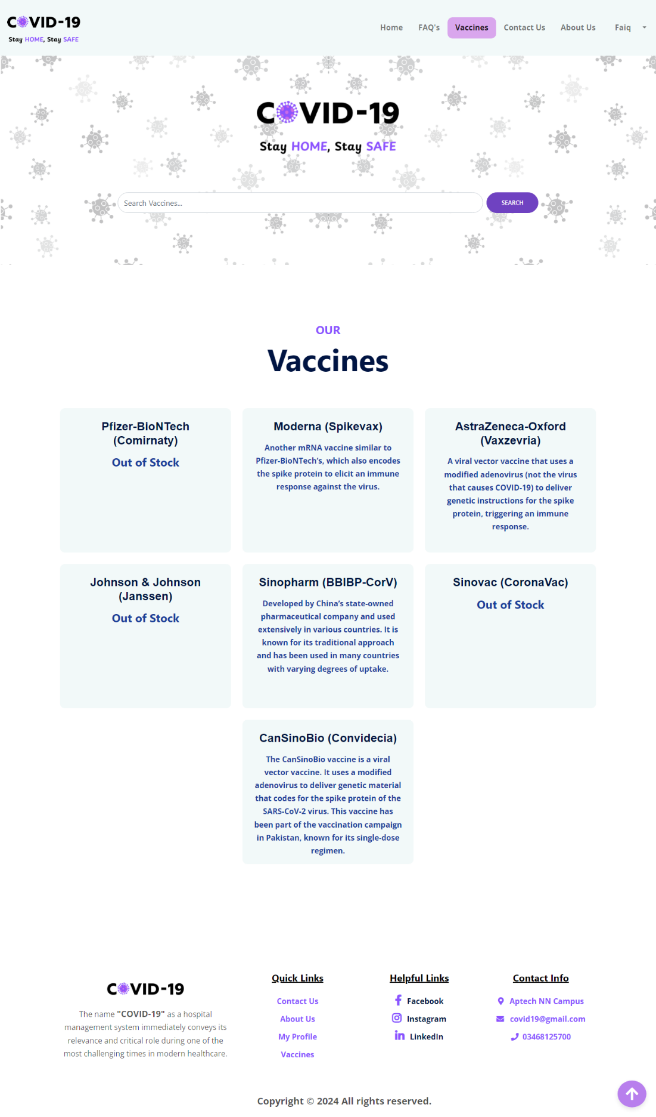

Search Bar

VACCINES AVAILABLE PAGE

ABOUT US PAGE

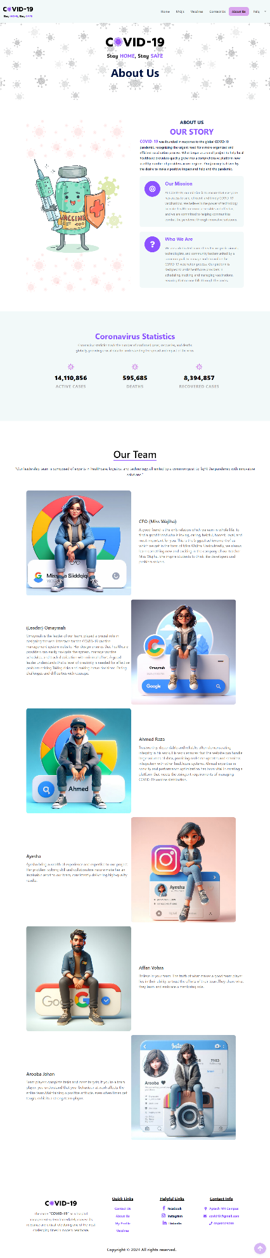

Our Team Section

Counter

Header

CONTACT US PAGE

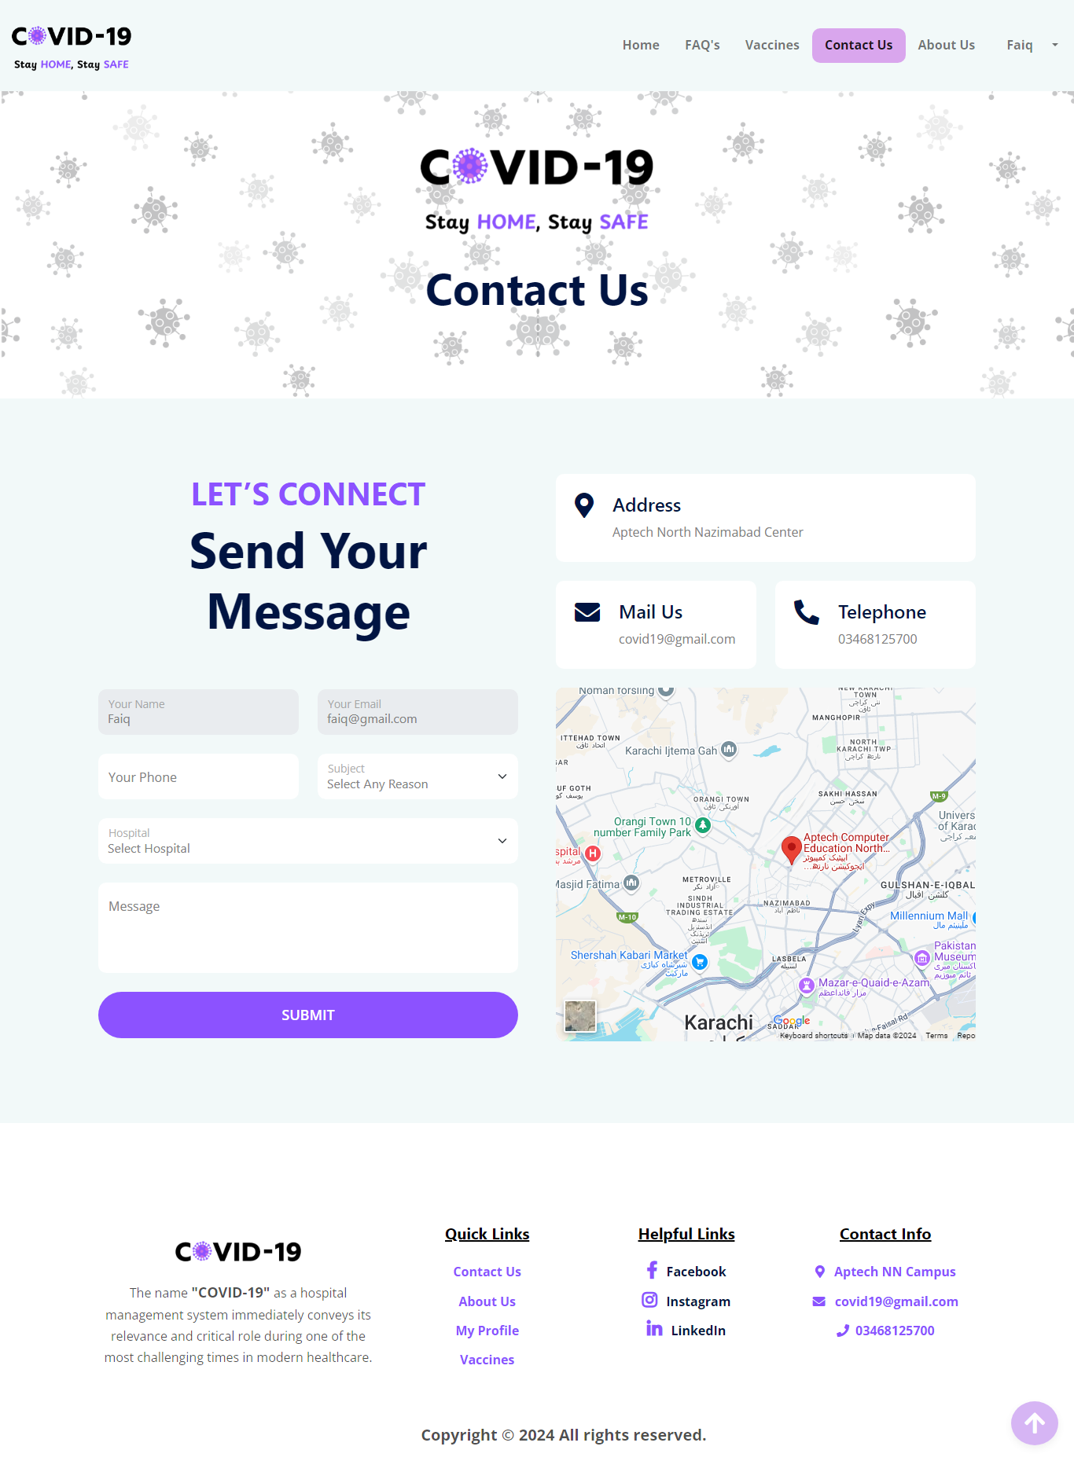

HOSPITAL REGISTER PAGE

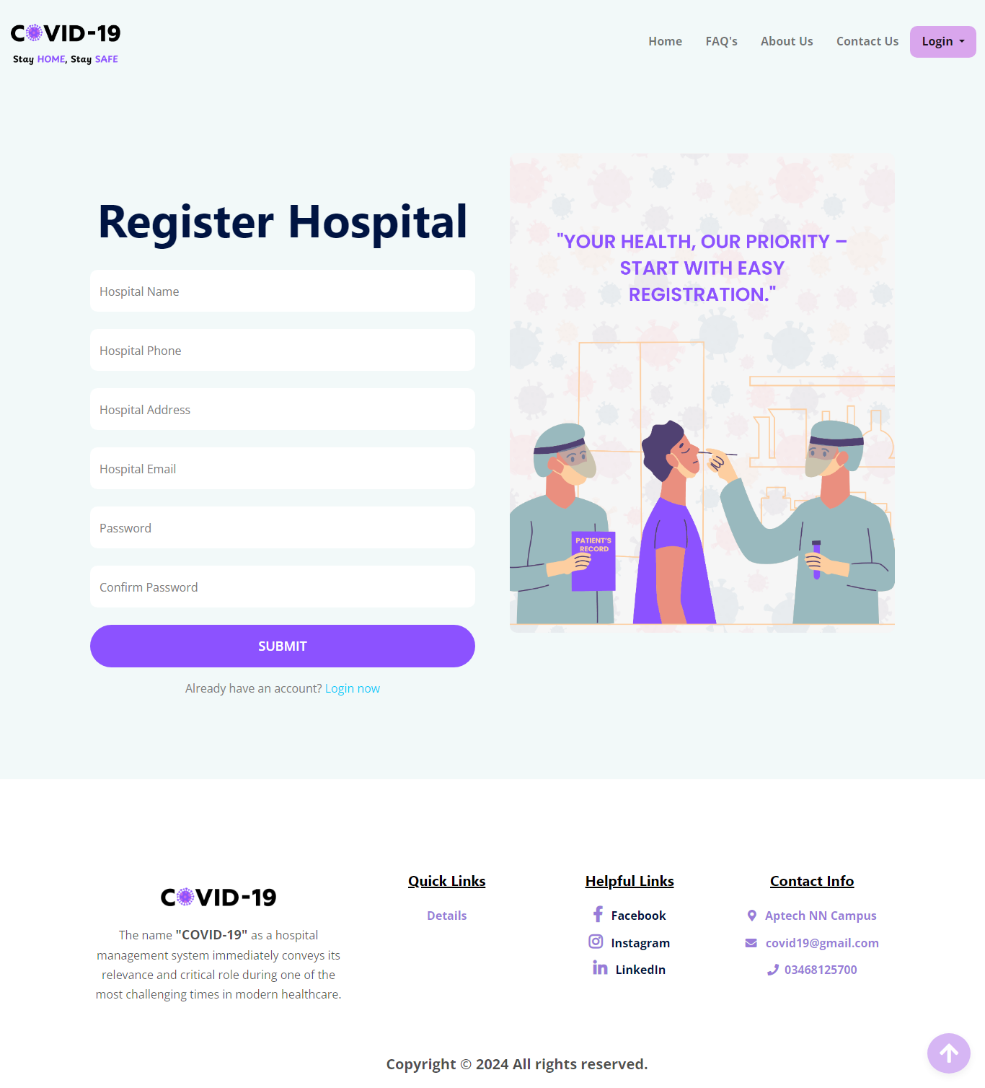

HOSPITAL LOGIN PAGE

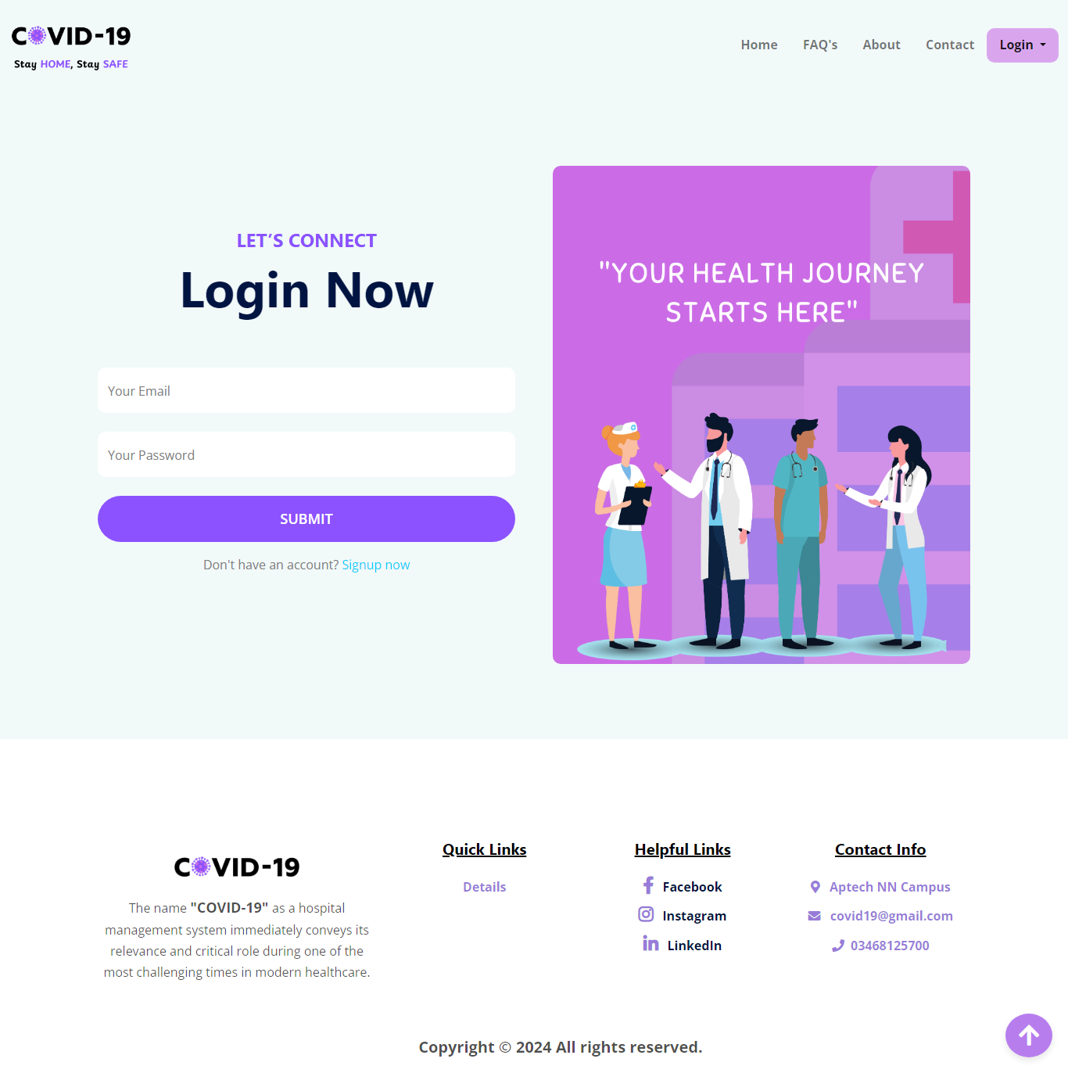

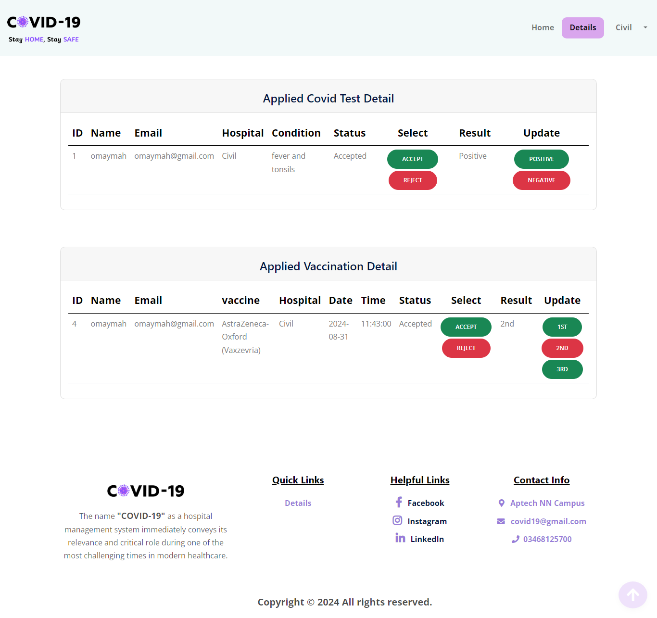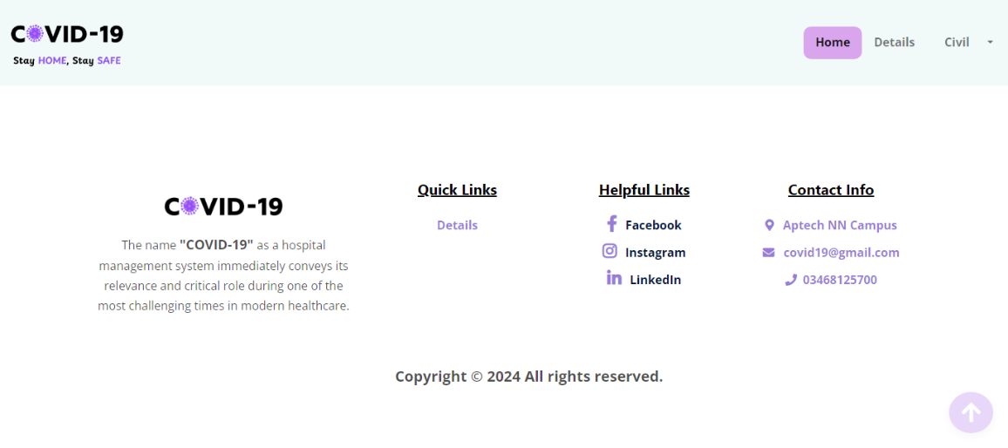

HOSPITAL DETAILS PAGE

Footer

Navbar

HOSPITAL INDEX PAGE